Date: 05 Aug. 2011
File No.: PI80551
Fire Resistance Instrument Cable to IEC60331

300/500V 1X2X1.5mmsq Stranded Tinned Cu/SIR( Mica+XLPE)/OSCR/FRLSHF/SWB/FR-PVC
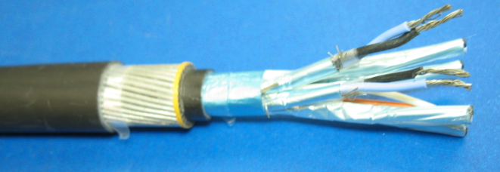

Application
Instrumentation cables are designed for transmission of analog and digital signals, and the interconnection of electrical equipment, such as monitoring or controlling electrical power systems and instruments, particular for the process control industry. The armoured versions are suitable for direct burial or installed in the duct.

On request, the outer sheath is oil, solvent, and hydrocarbon resistant, suitable for chemical and petrochemical environments.
Standard
- BS5308
- Fire Resistance: IEC 60331-21
- Flame Retardancy: IEC 60332-1
- Corrosive Acid Gas Emission: IEC 60754-1,2
- Smoke Emissions: IEC 61034-1,2

Construction

Tinned Copper Conductor
SIR /Mica+XLPE Insulation
A/P Screen
FRLSHF Inner Sheath
Steel Wire Braiding
FR-PVC Outer Jacket

Conductors: Stranded Tinned copper wire to IEC 60228 class 2.
1.5mmsq=7/0.53mm
Insulation: SIR (or Mica glass tape + XLPE)
Core Color: Black/White
Twisting: The cores shall twist together in pair
Overall Screen: Aluminium/ p.e.t.p. laminated tape applied with the metallic side in contact with a 0.5mm2 tinned copper drain wire over the p.e.t.p. binder tape.
A 23 micron polyester tape is applied over the screening tape with a minimum 25% overlap.
Bedding: FRLSHF PO compound
Armour: One layer of galvanized steel wire braiding, coverage≥95%
Outer Sheath: FR-PVC compound, which is Hydrocarbon, UV & Oil Resisting
Sheath Color: Black with red strip
Packing: The cables are delivered on non-returnable drums.

Technical data

Size of Conductor | Nominal Insulation Thickness  (mm) | Nominal Sheath Thickness  (mm) |  | Nominal Overall Diameter  (mm) | Nominal Weight  (kg/km)
Size of Conductor | Nominal Insulation Thickness  (mm) | Inner | Outer | Nominal Overall Diameter  (mm) | Nominal Weight  (kg/km)
1×2×1.5mmsq | 0.7 | 0.8 | 1.4 | 11.6 | 195

Physical characteristics
Temperature rating:
- During operation: -20 to + 70℃
- During Installation: 0 to + 70℃
Minimum bending radius:
During installation: 5 x Overall Diameter
Fire resistance: IEC60331
Flame retardant: IEC60332-1
Flexibility: Rigid

Electrical characteristics

Rated voltage: 300/500V
Max. conductor resistance at 20ºC: <12.3 ohm/km
Min insulation resistance: ≥5G Ohm×Km
Max inductance / resistance (L/R) ratio: <60 uH/ Ohm
Max. mutual capacitance at 1KHz: 115 pF/m
Test voltage:
- core:core 2000V
- core:screen 1000V

