IEC Standard Caledonian Offshore & Marine Cables

MariSig Fire Resistant Instrumentation & Control Cables

www.caledonian-cables.co.uk


MRE-M2XH 150/250V Mica Tape + XLPE Insulated, LSOH (SHF1) Sheathed Fire Resistant Instrumentation & Control Cables (Multicore)

Application

These cables are used on board of ships in all locations for fixed installations not subject to mechanical risk complying with IEC standards 60092-352 in safety circuit, where fire resistance is required. These cables are fire resistant, flame retardant, low smoke & halogen free, suitable for installations on passenger ships, as on other commercial vessels.




Standards

● IEC 60092-350/351/376/359
● IEC 60331-21
● IEC 60332-1
● IEC 60332-3-22
● IEC 60754-1/2
● IEC 61034

Stranded Copper Conductor Mica Tape + XLPE Insulation LSOH (SHF1) Sheath

Construction

- Conductors: Class 2 stranded copper conductor.
- Insulation: Mica tape + XLPE.
- Outer Sheath: LSOH (SHF1). SHF2 can be offered upon request.

Core Identification

White with printed number.

Mechanical and Thermal Properties

Bending Radius for Fixed Installations: 4×OD Temperature Range: -30℃ ~ +80℃

www.addison-cables.com
ADDISON 69

IEC Standard Caledonian Offshore & Marine Cables

MariSig Fire Resistant Instrumentation & Control Cables

www.caledonian-cables.co.uk


Dimensions and Weight

Part No. | Construction  No. of cores×Cross  section(mm²) | Nominal Insulation Thickness  mm | Nominal Sheath Thickness  mm | Nominal Overall Diameter  mm | Nominal Weight kg/km
MRE-M2XH-2C0.75 | 2×0.75 | 0.5 | 1.1 | 6.3 | 63
MRE-M2XH-4C0.75 | 4×0.75 | 0.5 | 1.2 | 6.7 | 84

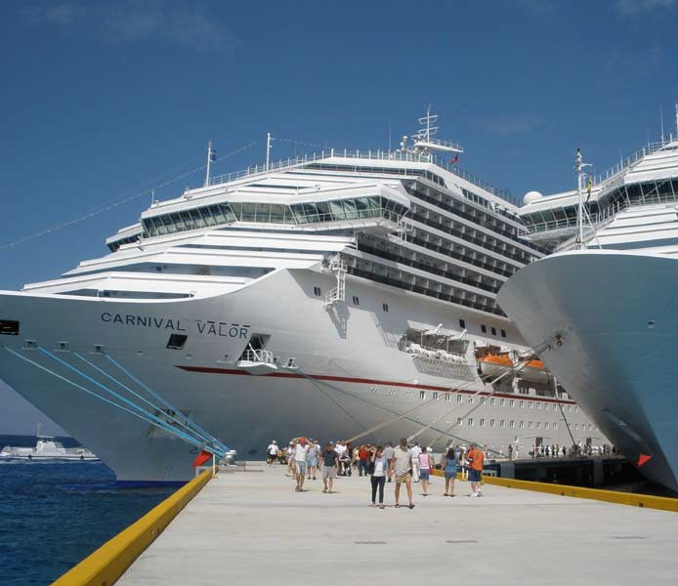

70 ADDISON www.addison-cables.com

