 ADDISON

Fire resistant RG6 QUAD Coaxial cables

RG6 QUAD FR
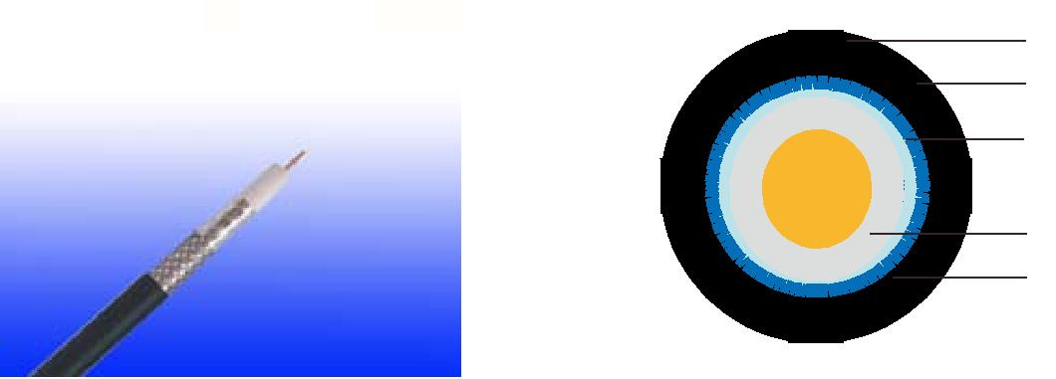

LSZH Outer Sheath

AL Foil+AL Braid

Glass Tape

Copper Clad Steel

(PE+Silicone Rubber)/FEP Insulation

AL Foil+AL Braid

APPLICATION

The cables are designed for CCTV, security, smoke detection and evacuation monitoring applications, where continued functionality is required during a fire situationDue. to the zero halogen low smoke construction, this cable is ideal for use in public, commercial and industrial environments.

Standards

Basic design to MIL-C-17

FIRE PERFORMANCE

 | IEC 60331-23; BS 6387 CWZ; DIN VDE 0472-814(FE180);
Circuit Integrity | CEI 20-36/2-1; SS229-1; NBN C 30-004 (cat. F3);
 | NF C32-070-2.3(CR1)
System circuit integrity | DIN 4102-12, E30 depending on lay system
Flame Retardance (Single Vertical | EN 60332-1-2; IEC 60332-1-2; BS EN 60332-1-2; VDE
Wire Test) | 0482-332-1 ; NBN C 30-004 (cat. F1); NF C32-070-2.1(C2);
Wire Test) | CEI 20-35/1-2; EN 50265-2-1*; DIN VDE 0482-265-2-1*
Reduced Fire Propagation | EN 60332-3-24 (cat. C); IEC 60332-3-24; BS EN 60332-3-24;
(Vertically-mounted bundled wires | VDE 0482-332-3; NBN C 30-004 (cat. F2); NF C32-070-2.2(C1);
& cable test) | CEI 20-22/3-4; EN 50266-2-4*; DIN VDE 0482-266-2-4
Halogen Free | IEC 60754-1; EN 50267-2-1; DIN VDE 0482-267-2-1;
Halogen Free | CEI 20-37/2-1 ; BS 6425-1*
No Corrosive Gas Emission | IEC 60754-2; EN 50267-2-2; DIN VDE 0482-267-2-2;
No Corrosive Gas Emission | CEI 20-37/2-2 ; BS 6425-2*
Minimum Smoke Emission | IEC 61034-1&2; EN 61034 -1&2; DIN VDE 0482-1034-1&2;
Minimum Smoke Emission | CEI 20-37/3-1&2; EN 50268-1&2*; BS 7622-1&2*
No Toxic gases | NES 02-713; NF C 20-454

Note: Asterisk * denotes superseded standard.

126 Caledonian sales@caledonian-cables.net uk@caledonian-cables.net


Caledonian

Fire Resistant Coaxial Cables
www.caledonian-tech.net www.caledonian-tech.com

CABLE CONSTRUCTION

Conductors: Copper clad steel, solid according to IEC(EN) 60228 class 1.

Insulation: Foamed PE wrapped with fire resistant silicone rubber compound type EI2 as per BS 7655-1.1 or fluoropolymer(FEP) compound.
Binder: Glass tape

Overall Screen:

Screen1: Al-maylar Tape ≥25% Screen2: Aluminium Braid Screen3: Al-maylar Tape ≥25% Screen4: Aluminium Braid

Outer Sheath: Thermoplastic LSZH compound type LTS3 as per BS 7655-6.1 (Thermosetting LSZH compound type SW2-SW4 as per BS 7655-2.6 can be offered.)

Physical AND THERMAL PROPERTIES

Temperature range during operation (fixed state):-30°C - +70°C

Temperature range during installation (mobile state): -5ºC - +60ºC

Minimum bending radius: 8 x Overall Diameter

Electrical Properties

Impedance | 75±5Ω
Capacitance | 54 nF/km
Velocity ratio(%) | 82
Insulation resistance | >5000 Mohm.Km
Shield coverage | ≥60%
Max.conductor resistance | 24.1 Ω/km

Attenuation
Frequency(MHz) | Attenuation (dB/100 m) | Attenuation (dB/100ft)
50 | 4.8 | 1.5
100 | 6.7 | 2.0
200 | 9.3 | 2.8
500 | 15.0 | 4.6
600 | 16.9 | 5.1
800 | 19.4 | 5.9
1000 | 21.6 | 6.6
1350 | 24.2 | 7.4
1750 | 28.0 | 8.4
2150 | 31.5 | 9.6

 ADDISON 127

ADDISON

2400 | 32.8 | 10.0
3000 | 37.9 | 11.5

Return Loss
Frequency(MHz) | Return Loss (dB)
30-300 | >28dB
300-600 | >24dB
600-900 | >22dB

CONSTRUCTION PARAMETERS

Cable | Conductor | Nominal | Nominal | Nominal | Nominal | Approx.
Cable | Conductor | Insulation | Screen2 | Screen4 | Overall | Approx.
Code | Diameter |  |  |  |  | Weight
Code | Diameter | Diameter | No.x Diameter | No.x Diameter | Diameter | Weight
 | mm | mm | No. x mm | No. x mm | mm | kg/km
RG6 QUAD FR | 1.02 | 4.60 ± 0.20 | 80 x 0.12 | 64 x 0.12 | 7.55 ± 0.20 | 92.4

300/500V _{N}MIL-C-17
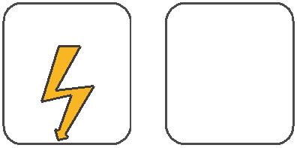
W

E
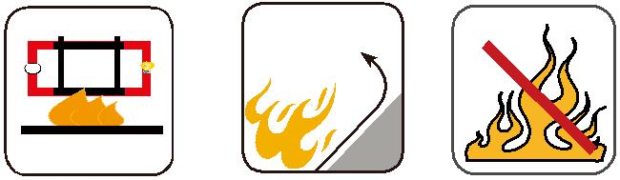

 |  | Circuit Integrity | Reduced Fire Propagation | Flame Retardancy
 |  | IEC 60331/BS 6387 | NF C32-070-2.2(C1) | NF C32-070-2.1(C2)
Rated Voltage | Standard | NF C32-070-2.3(CR1) | IEC60332-3-24/EN50266-2-4 IEC60332-1-2/EN50265-2-1
 |  |  | Zero | W | E
 | Low Corrosivity | Low Smoke Emission | Halogen Free
Low Toxicity | IEC60754-2 | IEC 61034-1&2 | IEC60754-1 | Functional Integrity
Low Toxicity | EN50267-2-2/3 | IEC 61034-1&2 | IEC60754-1
NES 02-713/NF C 20-454 | EN50267-2-2/3 | EN 50268-1&2/NF C32-073 | EN50267-2-1
NES 02-713/NF C 20-454 | NF C 32-074 | EN 50268-1&2/NF C32-073 | EN50267-2-1 |  | DIN 4102-12
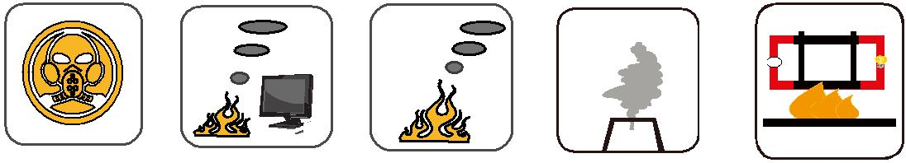

128 Caledonian sales@caledonian-cables.net uk@caledonian-cables.net

