 ADDISON

Fire resistant RG59 B/U Coaxial cables

RG59 B/U FR
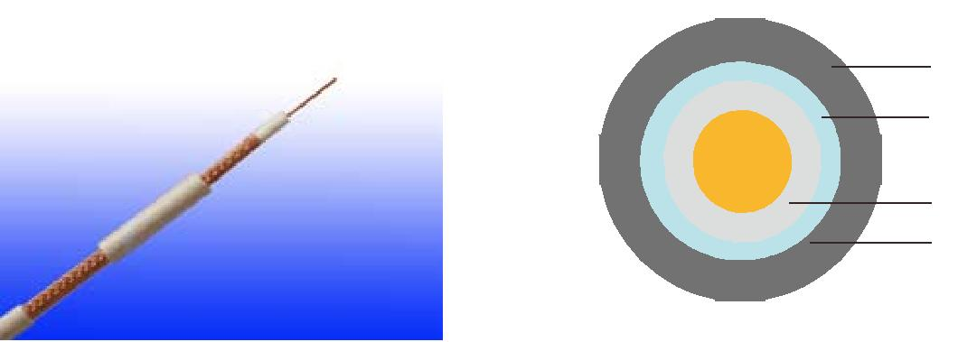

LSZH Outer Sheath

Glass Tape

Bare Copper

(PE+Silicone Rubber)/FEP Insulation

Copper Wire Braid Screen

APPLICATION

The cables are designed for CCTV, security, smoke detection and evacuation monitoring applications, where continued functionality is required during a fire situationDue. to the zero halogen low smoke construction, this cable is ideal for use in public, commercial and industrial environments.

Standards

Basic design to MIL-C-17

FIRE PERFORMANCE

 | IEC 60331-23; BS 6387 CWZ; DIN VDE 0472-814(FE180);
Circuit Integrity | CEI 20-36/2-1; SS229-1; NBN C 30-004 (cat. F3);
 | NF C32-070-2.3(CR1)
System circuit integrity | DIN 4102-12, E30 depending on lay system
Flame Retardance (Single Vertical | EN 60332-1-2; IEC 60332-1-2; BS EN 60332-1-2; VDE
Wire Test) | 0482-332-1 ; NBN C 30-004 (cat. F1); NF C32-070-2.1(C2);
Wire Test) | CEI 20-35/1-2; EN 50265-2-1*; DIN VDE 0482-265-2-1*
Reduced Fire Propagation | EN 60332-3-24 (cat. C); IEC 60332-3-24; BS EN 60332-3-24;
(Vertically-mounted bundled wires | VDE 0482-332-3; NBN C 30-004 (cat. F2); NF C32-070-2.2(C1);
& cable test) | CEI 20-22/3-4; EN 50266-2-4*; DIN VDE 0482-266-2-4
Halogen Free | IEC 60754-1; EN 50267-2-1; DIN VDE 0482-267-2-1;
Halogen Free | CEI 20-37/2-1 ; BS 6425-1*
No Corrosive Gas Emission | IEC 60754-2; EN 50267-2-2; DIN VDE 0482-267-2-2;
No Corrosive Gas Emission | CEI 20-37/2-2 ; BS 6425-2*
Minimum Smoke Emission | IEC 61034-1&2; EN 61034 -1&2; DIN VDE 0482-1034-1&2;
Minimum Smoke Emission | CEI 20-37/3-1&2; EN 50268-1&2*; BS 7622-1&2*
No Toxic gases | NES 02-713; NF C 20-454

Note: Asterisk * denotes superseded standard.

120 Caledonian sales@caledonian-cables.net uk@caledonian-cables.net


Caledonian

Fire Resistant Coaxial Cables
www.caledonian-tech.net www.caledonian-tech.com

CABLE CONSTRUCTION

Conductors: Copper clad steel, solid according to IEC(EN) 60228 class 1.

Insulation: PE wrapped with fire resistant silicone rubber compound type EI2 as per BS 7655-1.1 or fluoropolymer(FEP) compound.

Binder: Glass tape

Overall Screen: Plain copper wire braid

Outer Sheath: Thermoplastic LSZH compound type LTS3 as per BS 7655-6.1(Thermosetting LSZH compound type SW2-SW4 as per BS 7655-2.6 can be offered.)

Physical AND THERMAL PROPERTIES

Temperature range during operation (fixed state):-30°C - +70°C

Temperature range during installation (mobile state): -5ºC - +60ºC Minimum bending radius: 8 x Overall Diameter

Electrical Properties

Impedance | 75±5Ω
Capacitance | 67 nF/km
Velocity ratio(%) | 66
Insulation resistance | >2000 Mohm.Km
Shield coverage | 95%
DC resistance
Inner conductor | 158 Ω/km
Outer conductor | 9.0 Ω/km

Attenuation
Frequency(MHz) | Attenuation (dB/100 m) | Attenuation (dB/100ft)
50 | 7.4 | 2.26
100 | 10.7 | 3.26
200 | 15.7 | 4.79
400 | 22.7 | 6.92
500 | 25.7 | 7.84
600 | 28.7 | 8.75
860 | 34.8 | 10.61
1000 | 38.0 | 11.59

Return Loss
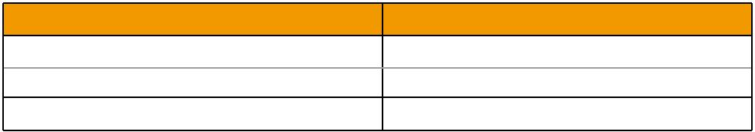
Frequency(MHz) | Return Loss (dB)
30-300 MHz | >31dB
300-600 MHz | >28dB
600-900 MHz | >24dB

 ADDISON 121

ADDISON

CONSTRUCTION PARAMETERS

Cable | Conductor | Nominal | Nominal | Nominal | Approx.
Cable | Conductor | Insulation | Screen | Overall | Approx.
Code | Diameter | Insulation | Screen | Overall | Weight
Code | Diameter | Diameter | No.x Diameter | Diameter | Weight
 | mm | mm | No. x mm | mm | kg/km
RG59 B/U FR | 0.58 ± 0.03 | 3.70 ± 0.10 m | 120 x 0.15 | 6.20 ± 0.10 | 60.3

300/500V _{N}MIL-C-17
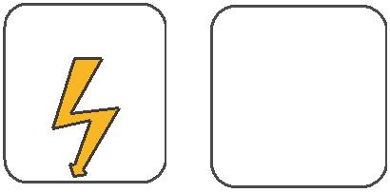
W

E
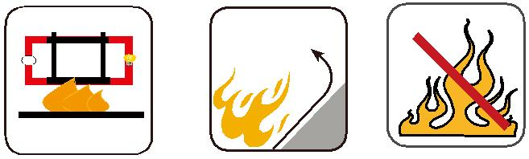

 |  | Circuit Integrity | Reduced Fire Propagation | Flame Retardancy
 |  | Circuit Integrity | NF C32-070-2.2(C1) | NF C32-070-2.1(C2)
Rated Voltage | Standard | IEC 60331/BS 6387 | NF C32-070-2.2(C1)
Rated Voltage | Standard | NF C32-070-2.3(CR1) | IEC60332-3-24/EN50266-2-4 IEC60332-1-2/EN50265-2-1
 |  |  | Zero | W | E
 | Low Corrosivity | Low Smoke Emission | Halogen Free
 | IEC60754-2 | Low Smoke Emission | Halogen Free
Low Toxicity | IEC60754-2 | IEC 61034-1&2 | IEC60754-1 | Functional Integrity
Low Toxicity | EN50267-2-2/3 | IEC 61034-1&2 | IEC60754-1
NES 02-713/NF C 20-454 | NF C 32-074 | EN 50268-1&2/NF C32-073 | EN50267-2-1 |  | DIN 4102-12
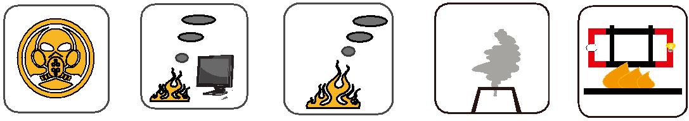

122 Caledonian sales@caledonian-cables.net uk@caledonian-cables.net

