 ADDISON

Fire resistant Multi Loose Tube Fiber Optic cables

Application

The multi loose tube non metallic cables are designed for outside plant, which is prone to electrical interference. They are mainly installed inside buildings, tunnels,subways or closed areas in general, specially designed to guarantee the signal transmission even in case of fire. The cable can also be used for direct burial for armoured version.

Standards

Basic design to Telcordia GR-20 / RUS 7 CFR 1755.900 (REA PE-90) / ICEA S 87-640

FIRE PERFORMANCE

 | IEC 60331-25; BS 6387 CWZ; DIN VDE 0472-814(FE180);
Circuit Integrity | CEI 20-36/2-1; SS229-1; NBN C 30-004 (cat. F3);
 | NF C32-070-2.3(CR1)
System circuit integrity | DIN 4102-12, E30 depending on lay system
Flame Retardance (Single Vertical | EN 60332-1-2; IEC 60332-1-2; BS EN 60332-1-2; VDE
Wire Test) | 0482-332-1 ; NBN C 30-004 (cat. F1); NF C32-070-2.1(C2);
Wire Test) | CEI 20-35/1-2; EN 50265-2-1*; DIN VDE 0482-265-2-1*
Reduced Fire Propagation | EN 60332-3-24 (cat. C); IEC 60332-3-24; BS EN 60332-3-24;
(Vertically-mounted bundled wires | VDE 0482-332-3; NBN C 30-004 (cat. F2); NF C32-070-2.2(C1);
& cable test) | CEI 20-22/3-4; EN 50266-2-4*; DIN VDE 0482-266-2-4
Halogen Free | IEC 60754-1; EN 50267-2-1; DIN VDE 0482-267-2-1;
Halogen Free | CEI 20-37/2-1 ; BS 6425-1*
No Corrosive Gas Emission | IEC 60754-2; EN 50267-2-2; DIN VDE 0482-267-2-2;
No Corrosive Gas Emission | CEI 20-37/2-2 ; BS 6425-2*
Minimum Smoke Emission | IEC 61034-1&2; EN 61034 -1&2; DIN VDE 0482-1034-1&2;
Minimum Smoke Emission | CEI 20-37/3-1&2; EN 50268-1&2*; BS 7622-1&2*
No Toxic gases | NES 02-713; NF C 20-454
Note: Asterisk * denotes superseded standard.

CABLE CONSTRUCTION

Fibers: Singlemode and multimode fibers, with loose tube technology.

Structure: The cable consists of 5 to 36 fibers containing tubes or fillers stranded in up to 3 layers around a central strength member and bound under a LSZH sheath. Each tube contains 4 -12 fibers, which is filled with water blocking gel.

Central Strength Member: Solid or stranded steel wire coated with polyethylene is usually used as central strength member. Fiber glass reinforced plastics (FRP) will be used as central strength member if non metallic construction is required.

Fire Barrier: The jelly filled tubes containing the fibers are individually wound with fire blocking mica glass tape and are cabled around a central strength member

Water Blocking: The jelly filled tube is waterblocked by using swellable tape and thread.

Reinforcement: Either aramid yarn or fiber glass is wound around the tube to provide physical protection and tensile strength, with added fire protection.
140 Caledonian sales@caledonian-cables.net uk@caledonian-cables.net


Caledonian

Fire Resistant Optic Fiber Cables

www.caledonian-tech.net www.caledonian-tech.com

Inner Sheath (optional): The cable can be jacketed with either PE or Thermoplastic LSZH inner sheath. PE is the preferred option in outdoor environment for water protection purpose. Armouring(optional): For diect burial, either galvanized steel wire braid, corrugated steel tape

armour or galvanized steel wire armour is applied over an inner polyethylene or LSZH sheath.

For steel tape armour, the 0.15mm thick steel tape is coated with a copolymer and applied with an overlap. For steel wire braid or armour, single layer of galvanized steel wire braid or armour is applied.

Moisture Barrier Tape (optional): An aluminum moisture tape can be incorporated under the sheath for water blocking and shielding purpose.

Ripcord (optional): An optional ripcord can be located under the jacket to facilitate jacket removal.

Outer Sheath: Thermoplastic LSZH compound type LTS3 as per BS 7655-6.1(Thermosetting LSZH compound type SW2-SW4 as per BS 7655-2.6 can be offered.)

Fiber colour code

Fiber colour code | 1 | Red | 7 | Brown
 | 2 | Green | 8 | Violet
 | 3 | Blue | 9 | Turquoise
 | 4 | Yellow | 10 | Black
 | 5 | White | 11 | Orange
 | 6 | Grey | 12 | Pink
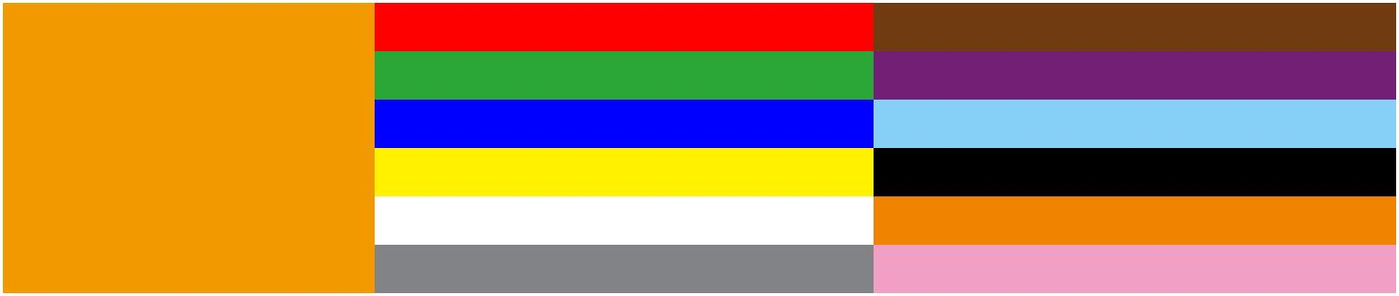

Construction

Unarmoured type

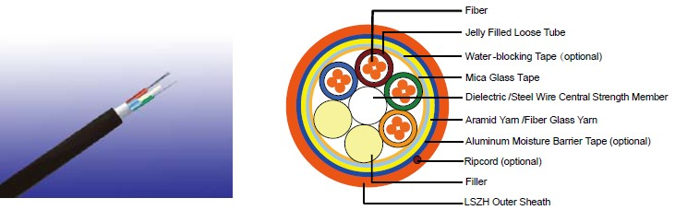

 ADDISON 141

ADDISON

CONSTRUCTION PARAMETERS
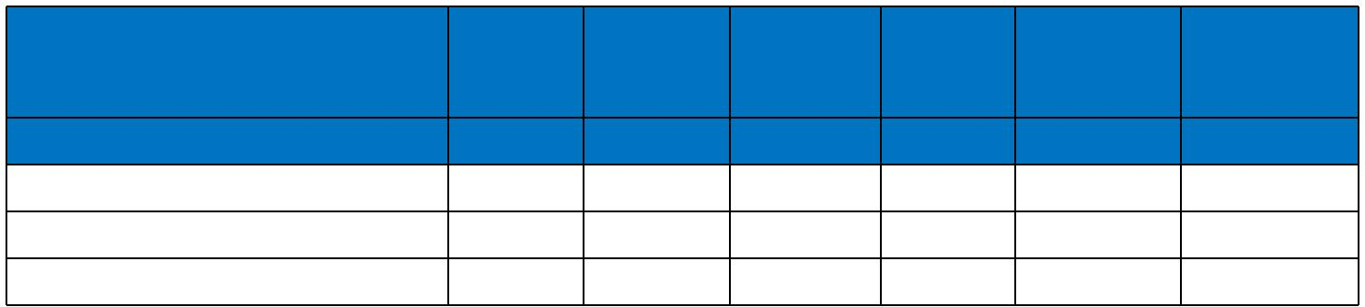
 | Fiber | Tube | Nominal | Approx. | Tension
Cable Code | Fiber | Tube | Diameter^{Overall} | Approx. | Tension | Crush
Cable Code | Count | Diameter | Diameter^{Overall} | Weight | load | Crush
 | (n°) | mm | mm | kg/km | N | N/100mm
MLA-B-C×D-F-H-J-FR | 72 | 2.5 | 15.0 | 230 | 4000 | 3000
MLA-B-C×D-F-H-J-FR | 96 | 2.5 | 16.5 | 250 | 4000 | 3000
MLA-B-C×D-F-H-J-FR | 144 | 2.5 | 20.5 | 280 | 4000 | 3000
Steel Wire BRAID
 |  |  |  | Fiber
 |  |  |  | Jelly Filled Loose Tube
 |  |  |  | Water -blocking Tape (optional)
 |  |  |  | Mica Glass Tape
 |  |  |  | Dielectric /Steel Wire Central Strength Member
 |  |  |  | Aramid Yarn /Fiber Glass Yarn
 |  |  |  | Aluminum Moisture Barrier Tape (optional)
 |  |  |  | PE/LSZH Inner Sheath (optional)
 |  |  |  | Ripcord (optional)
 |  |  |  | Filler
 |  |  |  | Steel Wire Braid
 |  |  |  | LSZH Outer Sheath
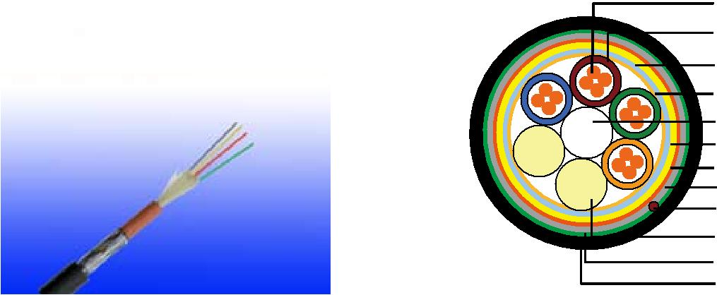
CONSTRUCTION PARAMETERS

 | Fiber | Tube | Nominal | Approx. | Tension
Cable Code | Fiber | Tube | Diameter^{Overall} | Approx. | Tension | Crush
Cable Code | Count | Diameter | Diameter^{Overall} | Weight | load | Crush
 | (n°) | mm | mm | kg/km | N | N/100mm
MLA-B-C×D-F-2Y(SWB)H-J-FR | 72 | 2.5 | 15.0 | 280 | 3000 | 3500
MLA-B-C×D-F-2Y(SWB)H-J-FR | 96 | 2.5 | 17.5 | 310 | 3000 | 3500
MLA-B-C×D-F-2Y(SWB)H-J-FR | 144 | 2.5 | 21.5 | 350 | 3500 | 3500

Corrugated steel tape armour
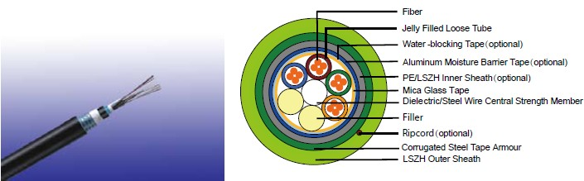

142 Caledonian sales@caledonian-cables.net uk@caledonian-cables.net

Caledonian

Fire Resistant Optic Fiber Cables

www.caledonian-tech.net www.caledonian-tech.com

CONSTRUCTION PARAMETERS

 | Fiber | Tube | Nominal | Approx. | Tension
Cable Code | Fiber | Tube | Diameter^{Overall} | Approx. | Tension | Crush
Cable Code | Count | Diameter | Diameter^{Overall} | Weight | load | Crush
 | (n°) | mm | mm | kg/km | N | N/100mm
MLA-B-C×D-F-2Y(STA)H-J-FR | 72 | 2.5 | 16.5 | 290 | 3000 | 7500
MLA-B-C×D-F-2Y(STA)H-J-FR | 96 | 2.5 | 18.5 | 350 | 3000 | 7500
MLA-B-C×D-F-2Y(STA)H-J-FR | 144 | 2.5 | 22.5 | 450 | 3500 | 7500

Steel Wire armour

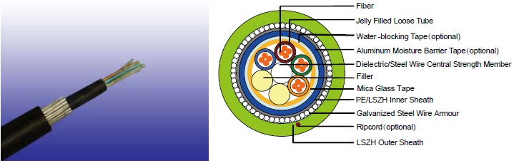

CONSTRUCTION PARAMETERS

 | Fiber | Tube | Nominal | Approx. | Tension
Cable Code | Fiber | Tube | Diameter^{Overall} | Approx. | Tension | Crush
Cable Code | Count | Diameter | Diameter^{Overall} | Weight | load | Crush
 | (n°) | mm | mm | kg/km | N | N/100mm
MLA-B-C×D-F-2Y(SWA)H-J-FR | 72 | 2.0 | 15.0 | 360 | 3500 | 5000
MLA-B-C×D-F-2Y(SWA)H-J-FR | 96 | 2.0 | 16.5 | 390 | 4000 | 5000
MLA-B-C×D-F-2Y(SWA)H-J-FR | 144 | 2.0 | 18.5 | 430 | 4500 | 5000

Physical AND THERMAL PROPERTIES

Temperature range during operation (fixed state):-20°C - +60°C

Temperature range during installation (mobile state): 0°C - +50°C Minimum Installation Bending Radius: 20 times the outer diameter

Minimum operation Bending Radius: 10 times the outer diameter for unarmoured cables 20 times the outer diameter for armoured cables

ADDISON 143

ADDISON

MECHANICAL Properties
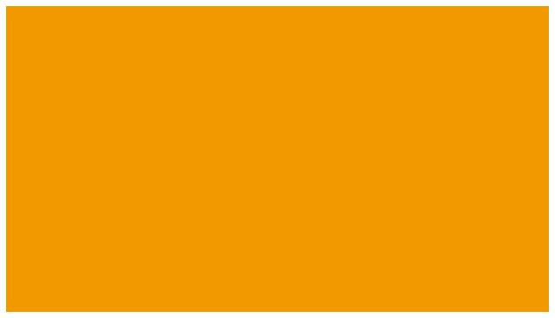
Maximum Compressive Load: | 4000N for unarmoured cables
Maximum Compressive Load: | 6000N for armoured cables
Repeated Impact: | 4.4 N.m (J)
Twist (Torsion): | 180×10 times, 125×OD
Cyclic Flexing: | 25 cycles for armoured cables
Cyclic Flexing: | 100 cycles for unarmoured cables
Crush Resistance: | 220N/cm(125lb/in)
Fiber Compliance
Temperature Cycling | IEC60794-1-2-F2
Tensile Strength | IEC60794-1-2-E1A
Crush | IEC60794-1-2-E3
Impact | IEC60794-1-2-E4
Repeated Bending | IEC60794-1-2-E6
Torsion | IEC60794-1-2-E7
Kink | IEC60794-1-2-E10
Cable Bend | IEC60794-1-2-E11
Cool Bend | IEC60794-1-2-E11


144 Caledonian sales@caledonian-cables.net uk@caledonian-cables.net

Caledonian

Fire Resistant Optic Fiber Cables

www.caledonian-tech.net www.caledonian-tech.com

TYPE CODEs

MLA-B-CxD-E-F-G-H-I-FR
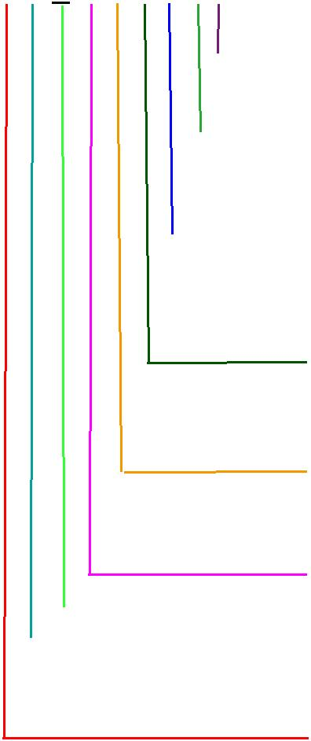
FR: Fire Resisting
Water blocking gel in tubes

X: No water-blocking J: Water blocking gel between jackets; D: Dry water-blocking between cable jackets
Outer Sheath
2Y: PE
Y: PVC
H: LSZH
Armour
Blank: No armour

STA: Corrugated steel tape SWA: Steel wire

SWB: Armour steel wire braided
Inner Sheath
2Y: PE
Y: PVC
H: LSZH
Central strength member
S: Solid steel SR: Stranded steel

F: Fiber reinforced plastic(FRP)

Fiber per tubes: 2-12 C No of tubes: 1-36
Fiber Type
- 50/125 um(OM3) 7: NZDS SM fiber per ITU-T G.656
- 50/125 um(OM2) 8: NZDS SM fiber per ITU-T G.655
- 62.5/125um(OM1) 9: Standard SM fiber per ITU-T G.652.D
Loose Tube Diameter
- 2.0mm D: 3.0mm
- 2.5mm E: 3.2mm
- 2.8mm

GR-20/RUS 7 CFR1755N.900 (REA PE-90)
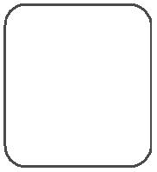

Standard
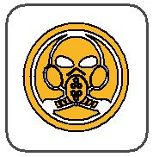
ICEA_{N}S87-640
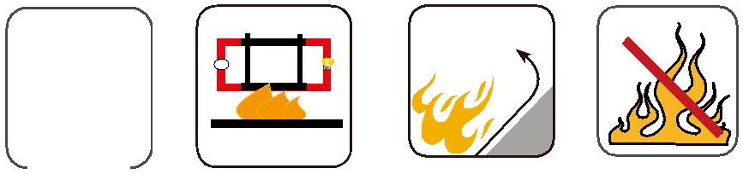
W E

 |  |  |  |  | Circuit Integrity |  |  |  |  |  | Reduced Fire Propagation |  |  | Flame Retardancy
 |  |  |  |  |  |  |  |  |  |  | NF C32-070-2.2(C1) |  |  | NF C32-070-2.1(C2)
 |  | Standard |  |  | IEC 60331/BS 6387
 |  |  |  |  | _{NF C32-070-2.3(CR1)} IEC60332-3-24/EN50266-2-4 IEC60332-1-2/EN50265-2-1
 |  |  |  |  |  |  |  |  |  |  |  | Zero
 |  |  |  |  |  |  |  |  |  |  |  | Zero |  | W | E
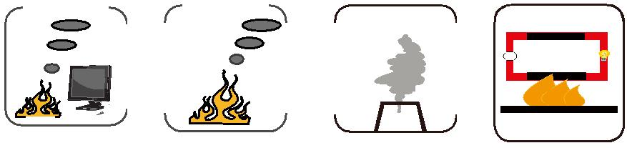

 | Low Corrosivity | Low Smoke Emission | Halogen Free
 | IEC60754-2 | Low Smoke Emission | Halogen Free
Low Toxicity | IEC60754-2 | IEC 61034-1&2 | IEC60754-1
Low Toxicity | EN50267-2-2/3 | IEC 61034-1&2 | IEC60754-1 | Functional Integrity
NES 02-713/NF C 20-454 | NF C 32-074 | EN 50268-1&2/NF C32-073 | EN50267-2-1 | Functional Integrity
 |  |  |  | DIN 4102-12

ADDISON 145

