 ADDISON

Fire Resistant UTP CAT5 Data Cables

FFX-CAT5UTP4P24FR
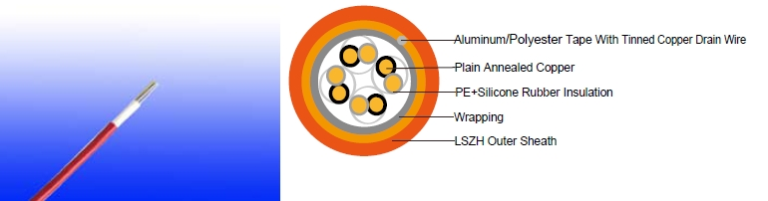

APPlICATION

The cables are desgined for structure wiring, compatible with all known connection systems according to EN 50173.

Based on the design for structured wiring (found in IEC 61156 and BS EN 50288), this cable brings together high frequency data transmission and circuit integrity in four pair cable that will continue to transmit data even when being directly attacked by fire.

STANDARDS

Basic design to EN50173

Fire Performance

 |  |  | IEC 60331-23; BS 6387 CWZ; DIN VDE 0472-814(FE180);
 | Circuit Integrity |  | CEI 20-36/2-1; SS229-1; NBN C 30-004 (cat. F3);
 |  |  | NF C32-070-2.3(CR1)
 | System circuit integrity |  | DIN 4102-12, E30 depending on lay system
 | Flame Retardance (Single Vertical |  | EN 60332-1-2; IEC 60332-1-2; BS EN 60332-1-2; VDE
 | Wire Test) |  | 0482-332-1 ; NBN C 30-004 (cat. F1); NF C32-070-2.1(C2);
 | Wire Test) |  | CEI 20-35/1-2; EN 50265-2-1*; DIN VDE 0482-265-2-1*
 | Reduced Fire Propagation |  | EN 60332-3-24 (cat. C); IEC 60332-3-24; BS EN 60332-3-24;
 | (Vertically-mounted bundled wires |  | VDE 0482-332-3; NBN C 30-004 (cat. F2); NF C32-070-2.2(C1);
 | & cable test) |  | CEI 20-22/3-4; EN 50266-2-4*; DIN VDE 0482-266-2-4
 | Halogen Free |  | IEC 60754-1; EN 50267-2-1; DIN VDE 0482-267-2-1;
 | Halogen Free |  | CEI 20-37/2-1 ; BS 6425-1*
 | No Corrosive Gas Emission |  | IEC 60754-2; EN 50267-2-2; DIN VDE 0482-267-2-2;
 |  |  | CEI 20-37/2-2 ; BS 6425-2*
 | Minimum Smoke Emission |  | IEC 61034-1&2; EN 61034 -1&2; DIN VDE 0482-1034-1&2;
 |  |  | CEI 20-37/3-1&2; EN 50268-1&2*; BS 7622-1&2*
112 | Caledonian | sales@caledonian-cables.net uk@caledonian-cables.net


Caledonian

Fire Resistant Signal & Data Cables
www.caledonian-tech.net www.caledonian-tech.com

No Toxic gases | NES 02-713; NF C 20-454

Note: Asterisk * denotes superseded standard.

VOLTAGE RATING

60V

CABLE CONSTRUCTION

Conductors: Plain annealed copper wire, solid according to IEC(EN) 60228 class 1.

Insulation: PE wrapped with fire resistant silicone rubber compound type EI2 as per BS 7655-1.1.

Twisted Pairs: Insulated conductors are twisted into pairs with varying lay length to minimize crosstalk.

Cabling Elements: Insulated cores are twisted to form pairs with varying lay length to minimize crosstalk. Two-pair cable had four cores laid in quad formation.

Cabling: Pairs are cabled together in concentric layers.

Outer Sheath: Thermoplastic LSZH compound type LTS3 as per BS 7655-6.1 (Thermosetting LSZH compound type SW2-SW4 as per BS 7655-2.6 can be offered.)

Physical AND THERMAL PROPERTIES

Temperature range during operation (fixed state):-5°C - +50°C

Temperature range during installation (mobile state): -20°C - +90°C Minimum bending radius: 8 x Overall Diameter

Electrical Properties

Characteristic Impedance | 100 Ohm±15%
Nominal Velocity of Propagation (NVP) | 69%
Max. Dc Resistance | 9.38 Ohm/100m
Max. Resistance Unbalance | 5%
Max. Mutual Capacitance: | 5.6 nF/100m
Maximum Capacitance Unbalance | 330 pF/100m
Max. Propagation Delay Skew | 30 ns/100m
Max. Propagation Delay | 536 ns/100m@100 mhz
Max. Pulling Load | 80N

 ADDISON 113

ADDISON

Transmission Properties
FREQ | NEXT(dB/100m) | IL | SRL (dB/100m)
FREQ | Minimum Value/Typical Value/ | IL | Minimum Value/Typical Value/
(MHz) | Minimum Value/Typical Value/ | (dB/100m) | Minimum Value/Typical Value/
(MHz) | Standard Value | (dB/100m) | Standard Value
1 | 64.0/71.0/62.0 | 2.0 | 24.5/26.0/23.0
4 | 55.0/62.0/53.0 | 4.0 | 24.5/26.0/23.0
8 | 49.5/57.0/48.0 | 5.7 | 24.5/26.0/23.0
10 | 49.0/56.0/47.0 | 6.4 | 24.5/26.0/23.0
16 | 44.9/52.0/44.0 | 8.2 | 24.5/26.0/23.0
20 | 42.5/48.0/42.0 | 9.2 | 24.5/26.0/23.0
25 | 42.0/48.0/41.0 | 10.3 | 24.5/26.0/23.0
31.25 | 40.6/48.0/39.0 | 11.6 | 22.5/24.0/21.0
62.5 | 36.1/43.0/35.0 | 16.9 | 19.5/22.0/18.0
100 | 34.0/40.0/32.0 | 21.8 | 17.5/20.0/16.0
CONSTRUCTION PARAMETERS

 | Conductor | Nominal | Nominal
Cable Code | Conductor | Insulation | Overall
Cable Code | Diameter | Insulation | Overall
 | Diameter | Thickness | Diameter
 | mm | mm | mm
FFX-CAT5UTP4P24FR | 0.5 | 0.25 | 5.3

60V _{N}EN50173
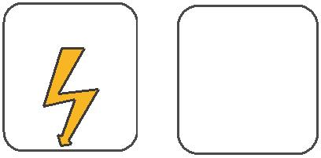
W

E
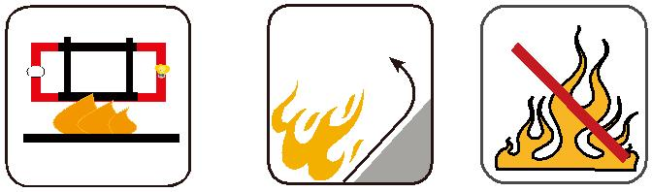

 |  | Circuit Integrity | Reduced Fire Propagation | Flame Retardancy
Rated Voltage | Standard | IEC 60331/BS 6387 | NF C32-070-2.2(C1) | NF C32-070-2.1(C2)
Rated Voltage | Standard | NF C32-070-2.3(CR1) | IEC60332-3-24/EN50266-2-4 IEC60332-1-2/EN50265-2-1
 |  |  | Zero | W | E
 | Low Corrosivity | Low Smoke Emission | Halogen Free
 | IEC60754-2 | Low Smoke Emission | Halogen Free
Low Toxicity | IEC60754-2 | IEC 61034-1&2 | IEC60754-1
Low Toxicity | EN50267-2-2/3 | IEC 61034-1&2 | IEC60754-1 | Functional Integrity
NES 02-713/NF C 20-454 | NF C 32-074 | EN 50268-1&2/NF C32-073 | EN50267-2-1 |  | DIN 4102-12
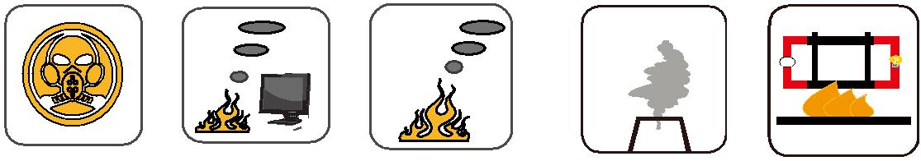

114 Caledonian sales@caledonian-cables.net uk@caledonian-cables.net

