 ADDISON

Fire Resistant Tight Buffered Distribution Fiber Optic cables

MTA-B-C-D-H-FR
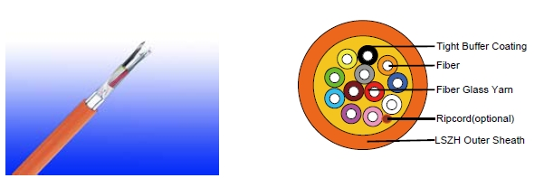

APPLICATION

This cables are used for interconnection of distribution boxes and end devices, where continued functionality is required during a fire situation. The cables are very suitable for various indoor and outdoor applications, including routing between buildings within ducts and inside building up to riser shafts.

Standards

Basic design to Telcordia GR409-CORE / TIA/EIA 568B.3 / ICEA-S-83-596

FIRE PERFORMANCE

 | IEC 60331-25; BS 6387 CWZ; DIN VDE 0472-814(FE180);
Circuit Integrity | CEI 20-36/2-1; SS229-1; NBN C 30-004 (cat. F3);
 | NF C32-070-2.3(CR1)
System circuit integrity | DIN 4102-12, E30 depending on lay system
Flame Retardance (Single Vertical | EN 60332-1-2; IEC 60332-1-2; BS EN 60332-1-2; VDE
Wire Test) | 0482-332-1 ; NBN C 30-004 (cat. F1); NF C32-070-2.1(C2);
Wire Test) | CEI 20-35/1-2; EN 50265-2-1*; DIN VDE 0482-265-2-1*
Reduced Fire Propagation | EN 60332-3-24 (cat. C); IEC 60332-3-24; BS EN 60332-3-24;
(Vertically-mounted bundled wires | VDE 0482-332-3; NBN C 30-004 (cat. F2); NF C32-070-2.2(C1);
& cable test) | CEI 20-22/3-4; EN 50266-2-4*; DIN VDE 0482-266-2-4
Halogen Free | IEC 60754-1; EN 50267-2-1; DIN VDE 0482-267-2-1;
Halogen Free | CEI 20-37/2-1 ; BS 6425-1*
No Corrosive Gas Emission | IEC 60754-2; EN 50267-2-2; DIN VDE 0482-267-2-2;
No Corrosive Gas Emission | CEI 20-37/2-2 ; BS 6425-2*
Minimum Smoke Emission | IEC 61034-1&2; EN 61034 -1&2; DIN VDE 0482-1034-1&2;
Minimum Smoke Emission | CEI 20-37/3-1&2; EN 50268-1&2*; BS 7622-1&2*
No Toxic gases | NES 02-713; NF C 20-454

Note: Asterisk * denotes superseded standard.

132 Caledonian sales@caledonian-cables.net uk@caledonian-cables.net


Caledonian

Fire Resistant Optic Fiber Cables

www.caledonian-tech.net www.caledonian-tech.com

CABLE CONSTRUCTION

Optical fibers: Singlemode and multimode tight fibers, with tight buffer coating.

Fire Barrier: The tight buffered fibers are wrapped with fire blocking fiber glass yarns.

Inner Sheath(optional): Thermoplastic LSZH compound type LTS3 as per BS 7655-6.1 Ripcord(optional): An optional ripcord can be located under the outer sheath to facilitate jacket removal.

Armouring(optional):

STA: Corrugated steel tape armour SWB: Steel wire braid

Outer Sheath: Thermoplastic LSZH compound type LTS3 as per BS 7655-6.1 (Thermosetting LSZH compound type SW2-SW4 as per BS 7655-2.6 can be offered.)

Physical AND THERMAL PROPERTIES

Temperature range during operation (fixed state):-20°C - +60°C

Temperature range during installation (mobile state): 0°C - +50°C

Minimum bending radius: 10 times the outer diameter for unarmoured cables 20 times the outer diameter for armoured cables

CONSTRUCTION PARAMETERS

 | N° of | Nominal | Max Tensile | Minimum | Approx.
Cable Code | N° of | Overall | Max Tensile | bending | Approx.
Cable Code | Fibers | Overall | Strength | bending | Weight
 | Fibers | Diameter | Strength | radius | Weight
 |  | mm | N | mm | kg/km
MTA-B-2-0-H-FR | 2 | 7,6 | 250 | 76 | 55
MTA-B-4-0-H-FR | 4 | 7,8 | 250 | 78 | 67
MTA-B-6-0-H-FR | 6 | 8,6 | 400 | 86 | 77
MTA-B-8-0-H-FR | 8 | 8,8 | 400 | 88 | 81
MTA-B-12-0-H-FR | 12 | 9,3 | 400 | 93 | 90


 ADDISON 133

ADDISON

TYPE CODES
MTA-B-C-D-E-F-G-H-FR
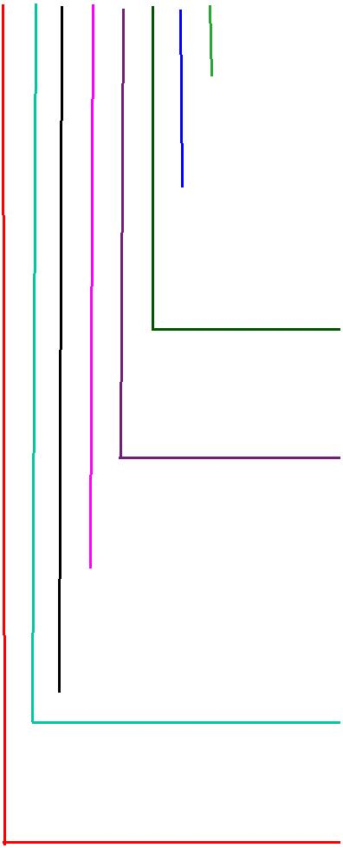
FR: Fire Resisting

Outer Sheath
2Y: PE
Y: PVC
H: LSZH

Armour
Blank: No armour

STA: Corrugated steel tape armour SWB: Steel wire braid

Inner Sheath
2Y: PE
Y: PVC
H: LSZH

Central strength member
Blank: No Central strength member A: Aramid yarn
F: Fiber reinforced plastic(FRP)
Sub Unit
0: No Sub Unit Y: PVC

H: LSZH

C No of Fibers

Fiber Type

4: 50/125 um(OM3) 7: NZDS SM fiber per ITU-T G.656 5: 50/125 um(OM2) 8: NZDS SM fiber per ITU-T G.655

6: 62.5/125um(OM1) 9: Standard SM fiber per ITU-T G.652.D

Sub Unit Diameter
- 0.9mm (up to 12 fibers)
- 3.6mm (12-36 fibers)
- 4.2mm (24-72 fibers)

GR-20/RUS 7 CFR1755N.900 (REA PE-90)


Standard
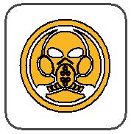

Low Toxicity
NES 02-713/NF C 20-454

ICEA_{N}S87-640 | W | E | Reduced Fire Propagation | Flame Retardancy
 | Circuit Integrity |  | Reduced Fire Propagation
 |  |  | NF C32-070-2.2(C1) | NF C32-070-2.1(C2)
Standard | IEC 60331/BS 6387 |  | NF C32-070-2.2(C1)
Standard | NF C32-070-2.3(CR1) |  | IEC60332-3-24/EN50266-2-4 IEC60332-1-2/EN50265-2-1
 |  |  | Zero | W | E
Low Corrosivity | Low Smoke Emission |  | Halogen Free
IEC60754-2 |  |  | Halogen Free
IEC60754-2 |  | IEC 61034-1&2 | IEC60754-1
EN50267-2-2/3 |  | IEC 61034-1&2 | IEC60754-1 | Functional Integrity
NF C 32-074 | EN 50268-1&2/NF C32-073 |  | EN50267-2-1 |  | DIN 4102-12
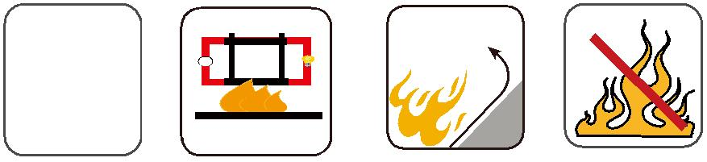
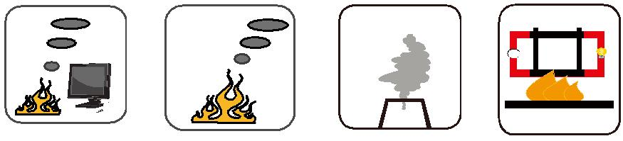

134 Caledonian sales@caledonian-cables.net uk@caledonian-cables.net

