
Caledonian

Fire Resistant Signal & Data Cables
www.caledonian-tech.net www.caledonian-tech.com

Fire Resistant RS485 Databus Cables

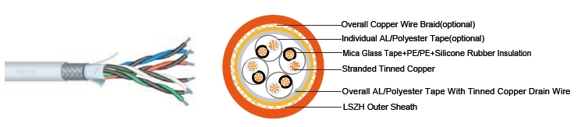

APPLICATION

The cables are designed for RS485 data connections where continued functionality is required during a fire situation. This cable combines low capacitance insulation with one of the highest levels of screening to provide high speed, interference free, data transmission where continued functionality is required during a fire situation.

STANDARDS

Basic design to EIA/TIA 485

FIRE PERFORMANCE

 | IEC 60331-23; BS 6387 CWZ; DIN VDE 0472-814(FE180);
Circuit Integrity | CEI 20-36/2-1; SS229-1; NBN C 30-004 (cat. F3);
 | NF C32-070-2.3(CR1)
System circuit integrity | DIN 4102-12, E30 depending on lay system
Flame Retardance (Single Vertical | EN 60332-1-2; IEC 60332-1-2; BS EN 60332-1-2; VDE
Wire Test) | 0482-332-1 ; NBN C 30-004 (cat. F1); NF C32-070-2.1(C2);
Wire Test) | CEI 20-35/1-2; EN 50265-2-1*; DIN VDE 0482-265-2-1*
Reduced Fire Propagation | EN 60332-3-24 (cat. C); IEC 60332-3-24; BS EN 60332-3-24;
(Vertically-mounted bundled wires | VDE 0482-332-3; NBN C 30-004 (cat. F2); NF C32-070-2.2(C1);
& cable test) | CEI 20-22/3-4; EN 50266-2-4*; DIN VDE 0482-266-2-4
Halogen Free | IEC 60754-1; EN 50267-2-1; DIN VDE 0482-267-2-1;
Halogen Free | CEI 20-37/2-1 ; BS 6425-1*
No Corrosive Gas Emission | IEC 60754-2; EN 50267-2-2; DIN VDE 0482-267-2-2;
No Corrosive Gas Emission | CEI 20-37/2-2 ; BS 6425-2*
Minimum Smoke Emission | IEC 61034-1&2; EN 61034 -1&2; DIN VDE 0482-1034-1&2;
Minimum Smoke Emission | CEI 20-37/3-1&2; EN 50268-1&2*; BS 7622-1&2*
No Toxic gases | NES 02-713; NF C 20-454

Note: Asterisk * denotes superseded standard..

CABLE CONSTRUCTION

Multipair RS 485 Overall Screened Databus Cable

Conductors: tinned copper wire, stranded according to IEC(EN) 60228 class 2.

 ADDISON 115

 ADDISON

Insulation: mica glass tape wrapped with PE or PE wrapped with silicone rubber insulation. Cabling Elements: Insulated cores are twisted to form pairs with varying lay length to minimize crosstalk. Two pair cable had four cores laid in quad formation.

Cabling: Pairs are cabled together in concentric layers.

Overall screen: Aluminum/polyester tape with tinned copper drain wire.

Outer Sheath: Thermoplastic LSZH compound type LTS3 as per BS 7655-6.1 (Thermosetting LSZH compound type SW2-SW4 as per BS 7655-2.6 can be offered.)

Multipair RS 485 Overall Double Screened Databus Cable

Conductors: tinned copper wire, stranded according to IEC(EN) 60228 class 2. Insulation: mica glass tape wrapped with PE or PE wrapped with silicone rubber insulation.

Cabling Elements: Insulated cores are twisted to form pairs with varying lay length to minimize crosstalk. Two pair cable had four cores laid in quad formation.

Cabling: Pairs are cabled together in concentric layers. Overall screen: Aluminium/polyester tape+copper wire braid.

Outer Sheath: Thermoplastic LSZH compound type LTS3 as per BS 7655-6.1 (Thermosetting LSZH compound type SW2-SW4 as per BS 7655-2.6 can be offered.)

Multipair RS 485 Individual & Overall screened Databus Cable Conductors: tinned copper wire, stranded according to IEC(EN) 60228 class 2.

Insulation: mica glass tape wrapped with PE or PE wrapped with silicone rubber insulation. Cabling Elements: Insulated cores are twisted to form pairs with varying lay length to minimize crosstalk. Two pair cable had four cores laid in quad formation.

Cabling: Pairs are cabled together in concentric layers. Individual Screen: Individual aluminium/polyester tape. Overall Screen: Copper wire braid.

outer Sheath: Thermoplastic LSZH compound type LTS3 as per BS 7655-6.1 (Thermosetting LSZH compound type SW2-SW4 as per BS 7655-2.6 can be offered.)

Multipair RS 485 Overall Screened Databus Cable

Conductors: tinned copper wire, stranded according to IEC(EN) 60228 class 2. Insulation: mica glass tape wrapped with PE or PE wrapped with silicone rubber insulation.

Cabling Elements: Insulated cores are twisted to form pairs with varying lay length to minimize crosstalk. Two pair cable had four cores laid in quad formation.

Cabling: Pairs are cabled together in concentric layers. Overall Screen: Copper wire braid.

Outer Sheath: Thermoplastic LSZH compound type LTS3 as per BS 7655-6.1 (Thermosetting LSZH compound type SW2-SW4 as per BS 7655-2.6 can be offered.)

Physical AND THERMAL PROPERTIES

Temperature range during operation (fixed state):-20°C - +90°C

Temperature range during installation (mobile state): -5°C - +60°C

Minimum bending radius: 8 x Overall Diameter

116 Caledonian sales@caledonian-cables.net uk@caledonian-cables.net

Caledonian

Fire Resistant Signal & Data Cables
www.caledonian-tech.net www.caledonian-tech.com

Electrical Properties

Dielectric test | 1000 | V r.m.s. for 5’ (core-core)
 | 1000 | V r.m.s. for 5’ (core-screen)
Impedance | 120Ω
Capacitance | 45 nF/km conductor to conductor
 | 90 nF/km conductor to shield

CONSTRUCTION PARAMETERS

Multipair RS 485 Overall Screened Databus Cable

RE-m02Y(ST)H-FR / RE-m02YS(ST)H-FR

RE-S02Y(ST)H-FR / RE-S02YS(ST)H-FR

 | Nominal |  |  | No./Nominal |  |  | Nominal |  |  | Nominal |  |  | Nominal
No.of | Cross |  |  |  |  |  |  |  |  |  |  |  | Nominal | Approx.
No.of |  |  |  | Diameter of |  |  | Insulation |  |  | Sheath |  |  | Overall
pair x | Sectional |  |  |  |  |  |  |  |  |  |  |  | Overall | Weight
pair x |  |  |  | Strands |  |  | Thickness |  |  | Thickness |  |  | Diameter
 | Area |  |  |  |  |  |  |  |  |  |  |  | Diameter
 | mm² |  |  | No/mm |  |  | mm |  |  | mm |  |  | mm | kg/km
1 | 0.22 |  |  | 7/0.2 |  |  | 0.55 |  |  | 0.40 |  |  | 4.6 | 29
2 | 0.22 |  |  | 7/0.2 |  |  | 0.55 |  |  | 0.40 |  |  | 8.1 | 60
4 | 0.22 |  |  | 7/0.2 |  |  | 0.55 |  |  | 0.40 |  |  | 9.6 | 100
1 | 0.50 |  |  | 16/0.2 |  |  | 0.55 |  |  | 0.40 |  |  | 5.2 | 44
2 | 0.50 |  |  | 16/0.2 |  |  | 0.55 |  |  | 0.40 |  |  | 9.3 | 91
4 | 0.50 |  |  | 16/0.2 |  |  | 0.55 |  |  | 0.40 |  |  | 11.1 | 158
1 | 0.75 |  |  | 24/0.2 |  |  | 0.55 |  |  | 0.40 |  |  | 5.6 | 56
2 | 0.75 |  |  | 24/0.2 |  |  | 0.55 |  |  | 0.40 |  |  | 10.3 | 117
4 | 0.75 |  |  | 24/0.2 |  |  | 0.55 |  |  | 0.40 |  |  | 12.2 | 207
1 | 1.00 |  |  | 30/0.2 |  |  | 0.55 |  |  | 0.40 |  |  | 5.8 | 61.4
2 | 1.00 |  |  | 30/0.2 |  |  | 0.55 |  |  | 0.40 |  |  | 10.6 | 128
4 | 1.00 |  |  | 30/0.2 |  |  | 0.55 |  |  | 0.40 |  |  | 12.5 | 228
Multipair RS 485 Overall Double Screened Databus Cable
RE-m02Y(ST)CH-FR / RE-m02YS(ST)CH-FR
RE-S02Y(ST)CH-FR / RE-S02YS(ST)CH-FR
 |  | Nominal |  |  | No./Nominal |  |  | Nominal |  |  | Nominal |  | Nominal
No.of |  | Cross |  |  |  |  |  |  |  |  |  |  | Nominal |  | Approx.
No.of |  |  |  |  | Diameter of |  |  | Insulation |  |  | Sheath |  | Overall |  | Approx.
pair x |  | Sectional |  |  |  |  |  |  |  |  |  |  | Overall |  | Weight
pair x |  |  |  |  | Strands |  |  | Thickness |  |  | Thickness |  | Diameter |  | Weight
 |  | Area |  |  |  |  |  |  |  |  |  |  | Diameter
 |  | mm² |  |  | No/mm |  |  | mm |  |  | mm |  | mm |  | kg/km
1 |  | 0.22 |  |  | 7/0.2 |  |  | 0.55 |  |  | 0.40 |  | 5.0 |  | 45
2 |  | 0.22 |  |  | 7/0.2 |  |  | 0.55 |  |  | 0.40 |  | 8.6 |  | 88


ADDISON 117

ADDISON

 | 4 |  | 0.22 |  | 7/0.2 |  |  |  | 0.55 |  |  | 0.40 | 10.1 |  | 134
 | 1 |  | 0.50 |  | 16/0.2 |  |  |  | 0.55 |  |  | 0.40 | 5.6 |  | 61
 | 2 |  | 0.50 |  | 16/0.2 |  |  |  | 0.55 |  |  | 0.40 | 9.8 |  | 124
 | 4 |  | 0.50 |  | 16/0.2 |  |  |  | 0.55 |  |  | 0.40 | 11.5 |  | 197
 | 1 |  | 0.75 |  | 24/0.2 |  |  |  | 0.55 |  |  | 0.40 | 6.1 |  | 75
 | 2 |  | 0.75 |  | 24/0.2 |  |  |  | 0.55 |  |  | 0.40 | 10.7 |  | 154
 | 4 |  | 0.75 |  | 24/0.2 |  |  |  | 0.55 |  |  | 0.40 | 12.7 |  | 250
 | 1 |  | 1.00 |  | 30/0.2 |  |  |  | 0.55 |  |  | 0.40 | 6.3 |  | 81
 | 2 |  | 1.00 |  | 30/0.2 |  |  |  | 0.55 |  |  | 0.40 | 11.0 |  | 166
 | 4 |  | 1.00 |  | 30/0.2 |  |  |  | 0.55 |  |  | 0.40 | 13.0 |  | 273
Multipair RS 485 Individual & Overall screened Databus Cable
RE-m02Y(ST)H pimf-FR / RE-m02YS(ST)H pimf-FR
RE-S02Y(ST)H pimf-FR / RE-S02YS(ST)H pimf-FR
 |  |  | Nominal
 |  |  |  |  | No./Nominal |  |  | Nominal |  |  |  | Nominal | Nominal
 | No.of pair |  | Cross |  |  |  |  |  |  |  |  | Nominal |  |  |  | Approx.
 |  |  | Cross |  | Diameter of |  |  | Insulation |  |  |  | Sheath | Overall |  |  | Approx.
 | x |  | Sectional |  |  |  |  |  |  |  |  | Sheath |  |  |  | Weight
 |  |  |  |  | Strands |  |  | Thickness |  |  |  | Thickness | Diameter |  |  | Weight
 |  |  | Area |  |  |  |  |  |  |  |  | Thickness
 |  |  | mm² |  | No/mm |  |  | mm |  |  |  | mm | mm |  |  | kg/km
 | 1 |  | 0.22 |  | 7/0.2 |  |  | 0.55 |  |  |  | 0.40 | 4.9 |  |  | 46
 | 2 |  | 0.22 |  | 7/0.2 |  |  | 0.55 |  |  |  | 0.40 | 8.6 |  |  | 91
 | 4 |  | 0.22 |  | 7/0.2 |  |  | 0.55 |  |  |  | 0.40 | 10.1 |  |  | 144
 | 1 |  | 0.50 |  | 16/0.2 |  |  | 0.55 |  |  |  | 0.40 | 5.5 |  |  | 62
 | 2 |  | 0.50 |  | 16/0.2 |  |  | 0.55 |  |  |  | 0.40 | 9.8 |  |  | 127
 | 4 |  | 0.50 |  | 16/0.2 |  |  | 0.55 |  |  |  | 0.40 | 11.6 |  |  | 209
 | 1 |  | 0.75 |  | 24/0.2 |  |  | 0.55 |  |  |  | 0.40 | 6.0 |  |  | 76
 | 2 |  | 0.75 |  | 24/0.2 |  |  | 0.55 |  |  |  | 0.40 | 10.7 |  |  | 157
 | 4 |  | 0.75 |  | 24/0.2 |  |  | 0.55 |  |  |  | 0.40 | 12.7 |  |  | 263
 | 1 |  | 1.00 |  | 30/0.2 |  |  | 0.55 |  |  |  | 0.40 | 6.2 |  |  | 83
 | 2 |  | 1.00 |  | 30/0.2 |  |  | 0.55 |  |  |  | 0.40 | 11.0 |  |  | 170
 | 4 |  | 1.00 |  | 30/0.2 |  |  | 0.55 |  |  |  | 0.40 | 13.0 |  |  | 286
Multipair RS 485 Overall Screened Databus Cable
RE-m02YCH-FR / RE-m02YSCH-FR
RE-S02YCH-FR / RE-S02YSCH-FR
 |  |  | Nominal |  |  | No./Nominal |  | Nominal |  |  |  | Nominal |  | Nominal
 | No.of pair |  | Cross |  |  |  |  |  |  |  |  | Nominal |  | Nominal |  | Approx.
 |  |  | Cross |  |  | Diameter of |  | Insulation |  |  |  | Sheath |  | Overall |  | Approx.
 | x |  | Sectional |  |  |  |  |  |  |  |  | Sheath |  | Overall |  | Weight
 |  |  |  |  |  | Strands |  | Thickness |  |  |  | Thickness |  | Diameter |  | Weight
 |  |  | Area |  |  |  |  |  |  |  |  | Thickness |  | Diameter
 |  |  | mm² |  |  | No/mm |  | mm |  |  |  | mm |  | mm |  | kg/km
 | 1 |  | 0.22 |  |  | 7/0.2 |  | 0.55 |  |  |  | 0.40 |  | 4.8 |  | 41
118 | Caledonian |  |  | sales@caledonian-cables.net |  |  |  | uk@caledonian-cables.net
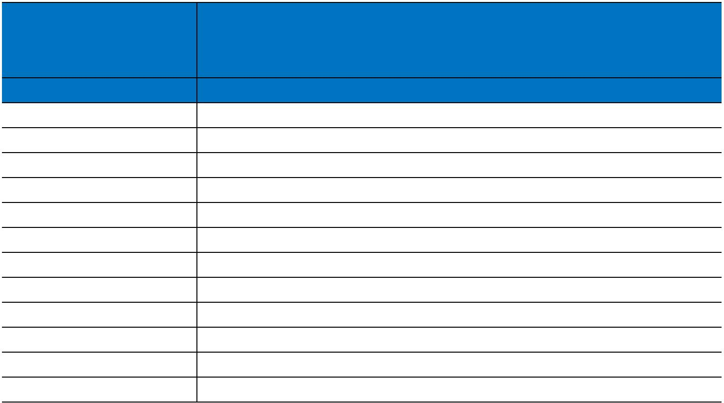


Caledonian

Fire Resistant Signal & Data Cables
www.caledonian-tech.net www.caledonian-tech.com

2 | 0.22 | 7/0.2 | 0.55 | 0.40 | 8.4 | 82
4 | 0.22 | 7/0.2 | 0.55 | 0.40 | 9.9 | 127
1 | 0.50 | 16/0.2 | 0.55 | 0.40 | 5.4 | 57
2 | 0.50 | 16/0.2 | 0.55 | 0.40 | 9.6 | 117
4 | 0.50 | 16/0.2 | 0.55 | 0.40 | 11.4 | 189
1 | 0.75 | 24/0.2 | 0.55 | 0.40 | 5.9 | 71
2 | 0.75 | 24/0.2 | 0.55 | 0.40 | 10.5 | 146
4 | 0.75 | 24/0.2 | 0.55 | 0.40 | 12.4 | 241
1 | 1.00 | 30/0.2 | 0.55 | 0.40 | 6.0 | 77
2 | 1.00 | 30/0.2 | 0.55 | 0.40 | 10.8 | 158
4 | 1.00 | 30/0.2 | 0.55 | 0.40 | 12.8 | 264

TYPE CODES
RE-A-B-D-FR
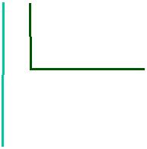
FR: Fire Resisting

Outer Sheath

H: LSZH

Screen

St: Aluminum tape C: Copper braid
Insulation

m02Y: Mica Tape+Foam PE S2Y: Silicone Rubber+Foam PE m02YS: Mica Tape+Foam Skin PE

S2YS: Silicone Rubber+Foam Skin PE

300/500V _{N}EIA/TIA485
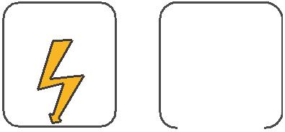
W

E
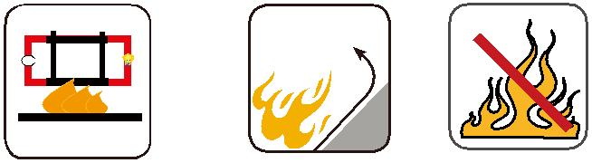

 |  | Circuit Integrity | Reduced Fire Propagation | Flame Retardancy
 |  | Circuit Integrity | NF C32-070-2.2(C1) | NF C32-070-2.1(C2)
Rated Voltage | Standard | IEC 60331/BS 6387 | NF C32-070-2.2(C1) | NF C32-070-2.1(C2)
Rated Voltage | Standard | NF C32-070-2.3(CR1) | IEC60332-3-24/EN50266-2-4 | IEC60332-1-2/EN50265-2-1
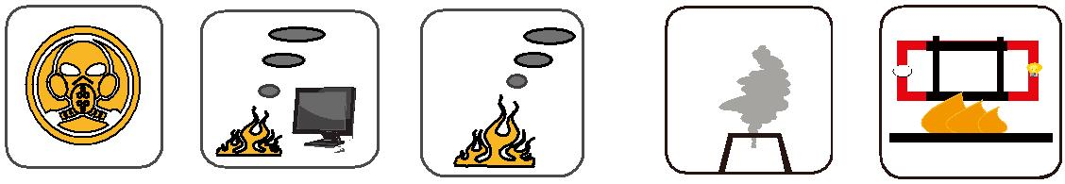

Zero

W

E

 | Low Corrosivity | Low Smoke Emission | Halogen Free
Low Toxicity | IEC60754-2 | IEC 61034-1&2 | IEC60754-1 | Functional Integrity
Low Toxicity | EN50267-2-2/3 | IEC 61034-1&2 | IEC60754-1 | Functional Integrity
NES 02-713/NF C 20-454 | NF C 32-074 | EN 50268-1&2/NF C32-073 | EN50267-2-1 | DIN 4102-12

ADDISON 119

