 ADDISON

600/1000V Mica+XLPE Insulated, LSZH Sheathed Power Cables (2-4 cores)

FFX400 1mRZ1-R (CU/MGT+XLPE/LSZH 600/1000V Class 2)

FFX400 1mRMZ1-R (CU/MGT+XLPE/LSZH/SWA/LSZH 600/1000V Class 2)
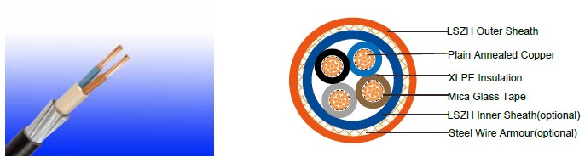
APPLICATION

This cable is designed for areas where the integrity of the electrical properties circuit is critical in maintaining power supply. Applications can be found in emergency lightings, control and power circuits, power stations, fire alarm systems, underground tunnels, communications systems, sewage treatment plants, lifts, escalators, and high-rise buildings.

STANDARDS

Basic design to IEC 60502-1/BS 7846

FIRE PERFORMANCE
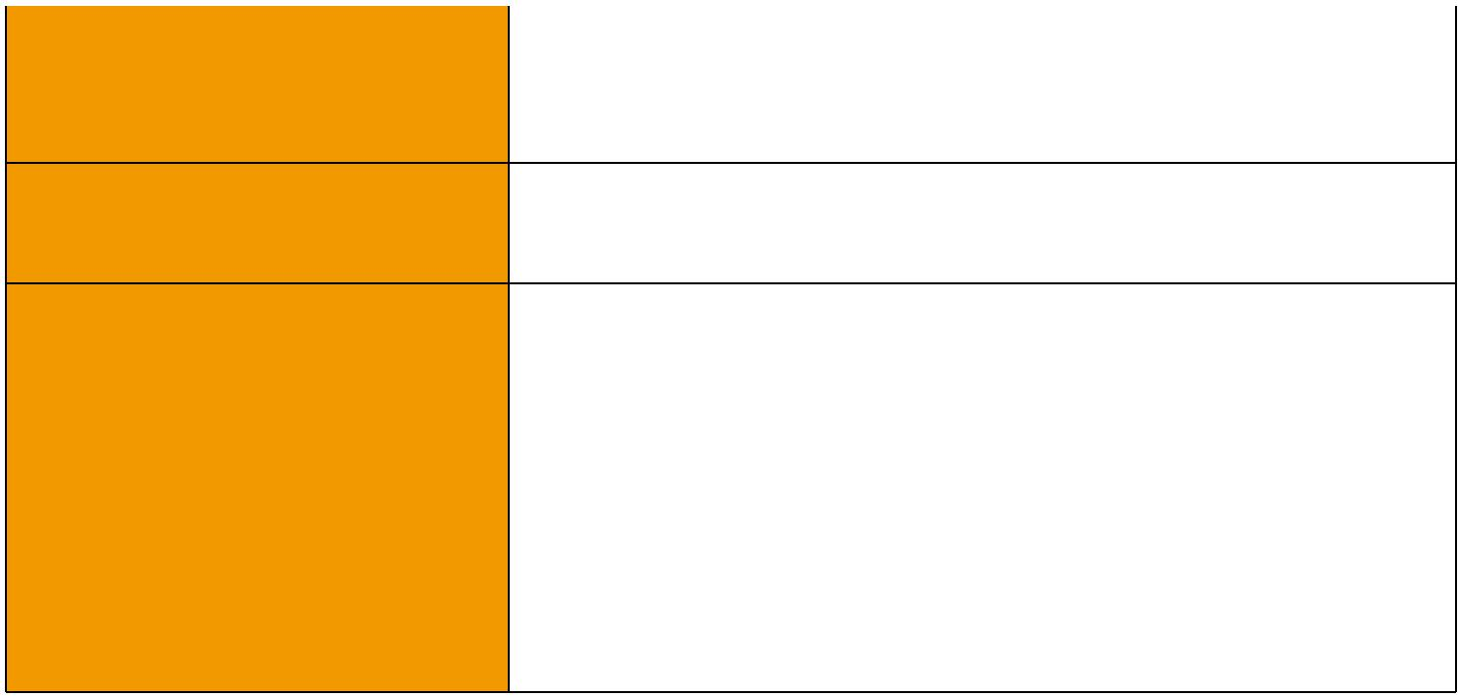
 | IEC 60331-21; BS 6387 CWZ; DIN VDE 0472-814(FE180);
Circuit Integrity | CEI 20-36/2-1; SS229-1; NBN C 30-004 (cat. F3);
 | NF C32-070-2.3(CR1); BS 7846-(F2)
System circuit integrity | DIN 4102-12, E30 depending on lay system
Flame Retardance (Single Vertical EN 60332-1-2; IEC 60332-1-2; BS EN 60332-1-2;

_{Wire Test)} VDE 0482-332-1 ; NBN C 30-004 (cat. F1); NF C32-070-2.1(C2); CEI 20-35/1-2; EN 50265-2-1*; DIN VDE 0482-265-2-1*

Reduced Fire Propagation | EN 60332-3-24 (cat. C); IEC 60332-3-24; BS EN 60332-3-24;
(Vertically-mounted bundled wires VDE 0482-332-3; NBN C 30-004 (cat. F2); NF C32-070-2.2(C1);
& cable test) | CEI 20-22/3-4; EN 50266-2-4*; DIN VDE 0482-266-2-4
Halogen Free | IEC 60754-1; EN 50267-2-1; DIN VDE 0482-267-2-1;
Halogen Free | CEI 20-37/2-1 ; BS 6425-1*
No Corrosive Gas Emission | IEC 60754-2; EN 50267-2-2; DIN VDE 0482-267-2-2;
No Corrosive Gas Emission | CEI 20-37/2-2 ; BS 6425-2*
Minimum Smoke Emission | IEC 61034-1&2; EN 61034 -1&2; DIN VDE 0482-1034-1&2;
Minimum Smoke Emission | CEI 20-37/3-1&2; EN 50268-1&2*; BS 7622-1&2*
No Toxic gases | NES 02-713; NF C 20-454

Note: Asterisk * denotes superseded standard.

44 Caledonian sales@caledonian-cables.net uk@caledonian-cables.net


Caledonian

Fire Resistant Power & Control Cables

www.caledonian-tech.net www.caledonian-tech.com

VOLTAGE RATING

600/1000V

CABLE CONSTRUCTION

Conductor: Plain annealed copper wire, stranded according to IEC(EN) 60228 class 2.

Insulation: Mica glass tape covered by extruded cross-linked XLPE compound

Cabling: The cores are cabled together in concentric layers with suitable non-hygroscopic fillers.

Inner Sheath(optional): Thermoplastic LSZH compound type LTS3 as per BS 7655-6.1 Armouring(optional): Galvanized steel wire armour

Outer Sheath: Thermoplastic LSZH compound type LTS3 as per BS 7655-6.1 (Thermosetting LSZH compound type SW2-SW4 as per BS 7655-2.6 can be offered.)

COLOUR CODE

Insulation Colour

2 - Core: (Brown & Blue)

3 - Core: (Brown, Black & Grey)

4 - Core: (Brown, Black, Grey & Blue)

Sheath Colour

Orange (other colors upon request)

Physical AND THERMAL PROPERTIES

Temperature range during operation (fixed state):-30°C – +90°C

Temperature range during installation (mobile state): -20°C – +50°C

Minimum bending radius: 8 x Overall Diameter (unarmoured cable)

10 x Overall Diameter (armoured cable)

Electrical PROPERTIES

Dielectric test: | 3500 | V r.m.s. x 5’ (core/core)
Insulation resistance | 1000 | MΩ x km (at 20°C)
Short circuit temperature | 250°C

CONSTRUCTION PARAMETERS

 | Conductor |  |  | FFX400 1mRZ1-R |  | FFX400 1mRMZ1-R
 | Conductor |  |  | Unarmoured Cable |  | Armoured Cable
 | No./ |  | Nominal | Nominal |  | Nominal
Nominal | Nominal | Dia. of | Nominal | Nominal | Approx. | Nominal | Approx.
Nominal | Nominal | Dia. of | Insulation | Overall | Approx. | Overall | Approx.
Area | Diameter of | Conductor | Insulation | Overall | Weight | Overall | Weight
Area | Diameter of | Conductor | Thickness | Diameter | Weight | Diameter | Weight
 | Strands
mm² | No./mm | mm | mm | mm | kg/km | mm | kg/km
 |  |  | 2-CORE
1.5 | 7/0.53 | 1.59 | 0.7 | 12.2 | 150 | 15.3 | 390
2.5 | 7/0.67 | 2.01 | 0.7 | 12.6 | 180 | 16.5 | 450
4 | 7/0.85 | 2.55 | 0.7 | 14.7 | 250 | 17.6 | 525

 ADDISON 45

ADDISON

6 | 7/1.04 | 3.12 | 0.7 | 16.2 | 290 | 18.8 |  | 620
10 | 7/1.35 | 4.05 | 0.7 | 17.1 | 450 | 21 |  | 800
16 | 7/1.70 | 5.1 | 0.7 | 19.2 | 550 | 23 |  | 1100
25 | 7/2.14 | 6.42 | 0.9 | 20 | 680 | 27 |  | 1480
35 | 19/1.53 | 7.65 | 0.9 | 22 | 940 | 30 |  | 2000
50 | 19/1.78 | 8.9 | 1 | 24 | 1250 | 33 |  | 2450
70 | 19/2.14 | 10.7 | 1.1 | 27 | 1700 | 37 |  | 3200
95 | 19/2.52 | 12.6 | 1.1 | 31 | 2300 | 42 |  | 4350
120 | 37/2.03 | 14.21 | 1.2 | 36 | 3150 | 48 |  | 6500
 |  |  | 3-CORE
1.5 | 7/0.53 | 1.59 | 0.7 | 12.3 | 170 |  | 16.5 | 420
2.5 | 7/0.67 | 2.01 | 0.7 | 13.8 | 200 |  | 17 | 500
4 | 7/0.85 | 2.55 | 0.7 | 15.2 | 300 |  | 18.5 | 600
6 | 7/1.04 | 3.12 | 0.7 | 16.8 | 380 |  | 19.8 | 785
10 | 7/1.35 | 4.05 | 0.7 | 18 | 550 |  | 22.6 | 1030
16 | 1/1.70 | 5.1 | 0.7 | 21 | 760 |  | 25 | 1370
25 | 7/2.14 | 6.42 | 0.9 | 22 | 960 |  | 29 | 1900
35 | 19/1.53 | 7.65 | 0.9 | 24 | 1300 |  | 32 | 2300
50 | 19/1.78 | 8.9 | 1 | 28 | 1700 |  | 35 | 2900
70 | 19/2.14 | 10.7 | 1.1 | 31 | 2400 |  | 40 | 4000
95 | 19/2.52 | 12.6 | 1.1 | 36 | 3250 |  | 45 | 5400
120 | 37/2.03 | 14.21 | 1.2 | 38 | 4000 |  | 49 | 6450
150 | 37/2.25 | 15.75 | 1.4 | 42 | 5000 |  | 55 | 8200
185 | 37/2.52 | 17.64 | 1.6 | 47 | 6100 |  | 60 | 9800
240 | 61/2.25 | 20.25 | 1.7 | 52 | 8000 |  | 68 | 12300
300 | 61/2.52 | 22.68 | 1.8 | 59 | 9850 |  | 74 | 14800
400 | 61/2.85 | 25.65 | 2 | 63 | 13000 |  | 83 | 17600
 |  |  | 4-CORE
1.5 | 7/0.53 | 1.59 | 0.7 | 14.3 | 210 |  | 16 | 475
2.5 | 7/0.67 | 2.01 | 0.7 | 15.2 | 270 |  | 17.8 | 570
4 | 7/0.85 | 2.55 | 0.7 | 17.2 | 380 |  | 19.8 | 690
6 | 7/1.04 | 3.12 | 0.7 | 19 | 440 |  | 21 | 940
10 | 7/1.35 | 4.05 | 0.7 | 20.6 | 670 |  | 23.3 | 1200
16 | 1/1.70 | 5.1 | 0.7 | 23.6 | 820 |  | 26.5 | 1400
25 | 7/2.14 | 6.42 | 0.9 | 26 | 1320 |  | 30.5 | 2400
35 | 19/1.53 | 7.65 | 0.9 | 29 | 1730 |  | 34 | 2800
50 | 19/1.78 | 8.9 | 1 | 32 | 2300 |  | 38 | 3500

46 Caledonian sales@caledonian-cables.net uk@caledonian-cables.net

Caledonian
ADDISON

ElectricAl PROPERTIES
Conductor Operating Temperature : 90°C Ambient Temperature : 30°C
FFX400 1mRZ1-R Current-Carrying Capacities (Amp)

Fire Resistant Power & Control Cables

www.caledonian-tech.net www.caledonian-tech.com

70 | 19/2.14 | 10.7 | 1.1 | 38 | 3180 | 44 | 5300
95 | 19/2.52 | 12.6 | 1.1 | 41.9 | 4370 | 48.5 | 6700
120 | 37/2.03 | 14.21 | 1.2 | 44 | 5400 | 54 | 8500
150 | 37/2.25 | 15.75 | 1.4 | 50.8 | 6500 | 59 | 10000
185 | 37/2.52 | 17.64 | 1.6 | 55 | 8200 | 64.5 | 12200
240 | 61/2.25 | 20.25 | 1.7 | 60.5 | 10600 | 74 | 15400
300 | 61/2.52 | 22.68 | 1.8 | 68.5 | 13200 | 82 | 19500
400 | 61/2.85 | 25.65 | 2 | 76 | 17000 | 92 | 25500


 | Reference
 | Method 4 | Reference Method 3 |  |  |  | Reference Method 11
 | (enclosed in |  |  | Reference Method 1
 | an conduit |  |  | (clipped direct)
 | insulated
 | insulated | (enclosed in conduit on |  |  |  | (on a perforated cable
Nominal | wall etc) | a wall or ceiling, or in |  |  |  | tray), or Reference
Cross |  | trunking) |  |  |  | Method 13 (free air)
Section |  |  |  |  |  | one 2-core | one
Area |  |  |  |  | one 3-core | one 2-core | 3-core
 | one 3-core | one 2-core | one 3-core | one 2-core | cable or | cable | cable or
 | cable or one | cable single | cable or one | cable single | one 4-core | singlephase | one
 | 4-core cable | phase a.c. or | 4-core cable | phase a.c. or | cable
 |  |  |  |  |  | a.c. or | 4-core
 | 3-phase a.c. | d.c. | 3-phase a.c. | d.c. | 3-phase | a.c. or | 4-core
 |  |  |  |  |  |  | cable
 |  |  |  |  | a.c. |  | cable
 |  |  |  |  | a.c. | d.c. | 3-phase
 |  |  |  |  |  | d.c. | a.c.
1 | 2 | 3 | 4 | 5 | 6 | 7 | 8
mm² | A | A | A | A | A | A | A
1.5 | 16.5 | 22 | 19.5 | 24 | 22 | 26 | 23
2.5 | 22 | 30 | 26 | 33 | 30 | 36 | 32
4 | 30 | 40 | 35 | 45 | 40 | 49 | 42
6 | 38 | 51 | 44 | 58 | 52 | 63 | 54
10 | 51 | 69 | 60 | 80 | 71 | 86 | 75
16 | 68 | 91 | 80 | 107 | 96 | 115 | 100
25 | 89 | 119 | 105 | 138 | 119 | 149 | 127
35 | 109 | 146 | 128 | 171 | 147 | 185 | 158
50 | 130 | 175 | 154 | 209 | 179 | 225 | 192

47
ADDISON

70 | 164 | 221 | 194 | 269 | 229 | 289 | 246
95 | 197 | 265 | 233 | 328 | 278 | 352 | 298
120 | 227 | 305 | 268 | 382 | 322 | 410 | 346
150 | 259 | 334 | 300 | 441 | 371 | 473 | 399
185 | 295 | 384 | 340 | 506 | 424 | 542 | 456
240 | 346 | 459 | 398 | 599 | 500 | 641 | 538
300 | 396 | 532 | 455 | 693 | 576 | 741 | 621
400 | - | 625 | 536 | 803 | 667 | 865 | 741

Voltage Drop (Per Amp Per Meter)

Nominal Cross | 2-core | 2-core cable single-phase a.c |  |  | 3-core or 4-core cable 3-phase
Section Area | cable d.c. |  |  |  |  | a.c.
1 | 2 |  | 3 |  |  | 4
mm² | mV/A/m |  | mV/A/m |  |  | mV/A/m
1.5 | 31 |  | 31 |  |  | 27
2.5 | 19 |  | 19 |  |  | 16
4 | 12 |  | 12 |  |  | 10
6 | 7.9 |  | 7.9 |  |  | 6.8
10 | 4.7 |  | 4.7 |  |  | 4
16 | 2.9 |  | 2.9 |  |  | 2.5
 |  | r | x | z | r | x | z
25 | 1.85 | 1.85 | 0.16 | 1.9 | 1.6 | 0.14 | 1.65
35 | 1.35 | 1.35 | 0.155 | 1.35 | 1.15 | 0.135 | 1.15
50 | 0.98 | 0.99 | 0.155 | 1 | 0.86 | 0.135 | 0.87
70 | 0.67 | 0.67 | 0.15 | 0.69 | 0.59 | 0.13 | 0.6
95 | 0.49 | 0.5 | 0.15 | 0.52 | 0.43 | 0.13 | 0.45
120 | 0.39 | 0.4 | 0.145 | 0.42 | 0.34 | 0.13 | 0.37
150 | 0.31 | 0.32 | 0.145 | 0.35 | 0.28 | 0.125 | 0.3
185 | 0.25 | 0.26 | 0.145 | 0.29 | 0.22 | 0.125 | 0.26
240 | 0.195 | 0.2 | 0.14 | 0.24 | 0.175 | 0.125 | 0.21
300 | 0.155 | 0.16 | 0.14 | 0.21 | 0.14 | 0.12 | 0.185
400 | 0.12 | 0.13 | 0.14 | 0.19 | 0.115 | 0.12 | 0.165

FFX400 1mRMZ1-R

Current-Carrying Capacities (Amp)

48 Caledonian sales@caledonian-cables.net uk@caledonian-cables.net

Caledonian

Fire Resistant Power & Control Cables

www.caledonian-tech.net www.caledonian-tech.com


 |  |  |  |  |  |  | Reference Method
 |  |  | Reference Method |  |  |  | 11 (on a perforated
Nominal Cross |  |  |  |  |  |  | horizontal cable
Section Area |  |  |  |  | 1 (clipped |  | tray or Reference |  |  |  | In single-way ducts |  |  | Laid direct in ground
 |  |  |  |  | direct) |  | Method 13 [free
 |  |  |  |  |  |  |  | air] )
 |  |  |  | one |  |  | one |  |  |  | one |  |  |  | one
 |  |  |  | 2-core |  | one 3-core | 2-core |  | one 3-core |  | 2-core | one 3-core |  | 2-core |  |  | one 3-core
 |  |  |  | cable |  | or 4-core | cable |  | or 4-core |  | cable | or 4-core |  | cable
 |  |  |  |  |  | or 4-core | cable |  |  |  | cable | or 4-core |  |  |  |  |  | or 4-core
 |  |  |  | single |  | cable | single |  | cable |  | single | cable |  | single
 |  |  |  |  |  | cable | single |  |  |  | single | cable |  |  |  |  |  |  | cable
 |  |  |  | phase |  | 3-phase | phase |  | 3-phase |  | phase | 3-phase |  | phase |  |  |  |  | cable
 |  |  |  |  |  | 3-phase | phase |  |  |  | phase | 3-phase |  |  |  | 3-phase a.c.
 |  |  |  | a.c. or |  | a.c. | a.c. or |  | a.c. |  | a.c. or | a.c. |  | a.c. or
 |  |  |  | d.c. |  |  | d.c. |  |  |  | d.c. |  |  |  | d.c.
1 |  |  |  |  | 2 | 3 | 4 |  | 5 |  | 6 | 7 |  | 8 |  |  |  |  | 9
mm² |  |  |  |  | A | A | A |  | A |  | A | A |  |  | A |  |  |  | A
1.5 |  |  |  |  | 27 | 23 | 29 |  | 25 |  | - | 23 |  | - |  |  |  |  | 28
2.5 |  |  |  |  | 36 | 31 | 39 |  | 33 |  | - | 30 |  | - |  |  |  |  | 36
4 |  |  |  |  | 49 | 42 | 52 |  | 44 |  | - | 40 |  | - |  |  |  |  | 48
6 |  |  |  |  | 62 | 53 | 66 |  | 56 |  | - | 50 |  | - |  |  |  |  | 60
10 |  |  |  |  | 85 | 73 | 90 |  | 78 |  | - | 65 |  | - |  |  |  |  | 80
16 |  |  |  | 110 |  | 94 | 115 |  | 99 |  | 115 | 94 |  | 140 |  |  |  |  | 115
25 |  |  |  | 146 |  | 124 | 152 |  | 131 |  | 145 | 125 |  | 180 |  |  |  |  | 150
35 |  |  |  | 180 |  | 154 | 188 |  | 162 |  | 175 | 150 |  | 215 |  |  |  |  | 180
50 |  |  |  | 219 |  | 187 | 228 |  | 197 |  | 210 | 175 |  | 255 |  |  |  |  | 215
70 |  |  |  | 279 |  | 238 | 291 |  | 251 |  | 260 | 215 |  | 315 |  |  |  |  | 265
95 |  |  |  | 338 |  | 289 | 354 |  | 304 |  | 310 | 260 |  | 380 |  |  |  |  | 315
120 |  |  |  | 392 |  | 335 | 410 |  | 353 |  | 355 | 300 |  | 430 |  |  |  |  | 360
150 |  |  |  | 451 |  | 386 | 472 |  | 406 |  | 400 | 335 |  | 480 |  |  |  |  | 405
185 |  |  |  | 515 |  | 441 | 539 |  | 463 |  | 455 | 380 |  | 540 |  |  |  |  | 460
240 |  |  |  | 607 |  | 520 | 636 |  | 546 |  | 520 | 440 |  | 630 |  |  |  |  | 530
300 |  |  |  | 698 |  | 599 | 732 |  | 628 |  | 590 | 495 |  | 700 |  |  |  |  | 590
400 |  |  |  | 787 |  | 673 | 847 |  | 728 |  | 660 | 560 |  | 790 |  |  |  |  | 670
Voltage Drop (Per Amp Per Meter)
 |  |  |  |  |  |  |  |  |  |  |  |  |  |  | 2 cables, |  |  |  | 3 or 4
Nominal |  |  |  |  |  |  |  |  |  |  |  |  |  |  | single- |  |  |  | cables,
Nominal |  | 2-core |  |  |  |  |  |  |  |  |  |  |  |  | phase |  |  |  | 3-phase
Cross |  |  |  |  | 2 cables, single-phase a.c. |  |  |  |  | 3 or 4 cables, 3-phase a.c. |  |  |  |  |  |  |  |  | 3-phase
Cross |  |  |  |  |  |  |  |  |  |  |  |  |  |  | a.c. |  |  |  | a.c.
Section | cable d.c. |  |  |  |  |  |  |  |  |  |  |  |  |  |  |  |  |  | a.c.
Section |  |  |  |  |  |  |  |  |  |  |  |  |  |  | In ducts |  |  |  | In ducts
Area |  |  |  |  |  |  |  |  |  |  |  |  |  |  |  |  |  |  | In ducts
Area |  |  |  |  |  |  |  |  |  |  |  |  |  |  | or |  |  |  | or
 |  |  |  |  |  |  |  |  |  |  |  |  |  |  | in ground |  |  |  | in ground
1 |  | 2 |  |  |  | 3 |  |  |  |  | 4 |  |  |  | 5 |  |  |  | 6
mm² |  | mV/A/m |  |  |  | mV/A/m |  |  |  |  | mV/A/m |  |  |  | mV/A/m |  |  |  | mV/A/m
1.5 |  | 31 |  |  |  | 31 |  |  |  |  | 27 |  |  |  | 31 |  |  |  | 25
2.5 |  | 19 |  |  |  | 19 |  |  |  |  | 16 |  |  |  | 19 |  |  |  | 15
4 |  | 12 |  |  |  | 12 |  |  |  |  | 10 |  |  |  | 12 |  |  |  | 9.7


 ADDISON 49

ADDISON

6 | 7.9 |  | 7.9 |  |  | 6.8 |  | 7.9 | 6.5
10 | 4.7 |  | 4.7 |  |  | 4 |  | 4.7 | 3.9
16 | 2.9 |  | 2.9 |  |  | 2.5 |  | 2.9 | 2.6
 |  | r | x | z | r | x | z
25 | 1.85 | 1.35 | 0.16 | 1.9 | 1.6 | 0.14 | 1.65 | 1.9 | 1.6
35 | 1.35 | 1.35 | 0.155 | 1.35 | 1.15 | 0.135 | 1.15 | 1.35 | 1.2
50 | 0.98 | 0.99 | 0.155 | 1 | 0.86 | 0.135 | 0.87 | 1 | 0.87
70 | 0.67 | 0.67 | 0.15 | 0.69 | 0.59 | 0.13 | 0.6 | 0.69 | 0.61
95 | 0.49 | 0.5 | 0.15 | 0.52 | 0.43 | 0.13 | 0.45 | 0.52 | 0.45
120 | 0.39 | 0.4 | 0.145 | 0.42 | 0.34 | 0.13 | 0.37 | 0.42 | 0.36
150 | 0.31 | 0.32 | 0.145 | 0.35 | 0.28 | 0.125 | 0.3 | 0.35 | 0.3
185 | 0.25 | 0.26 | 0.145 | 0.29 | 0.22 | 0.125 | 0.26 | 0.29 | 0.25
240 | 0.195 | 0.2 | 0.14 | 0.24 | 0.175 | 0.125 | 0.21 | 0.24 | 0.21
300 | 0.155 | 0.16 | 0.14 | 0.21 | 0.14 | 0.12 | 0.185 | 0.21 | 0.19
400 | 0.12 | 0.13 | 0.14 | 0.19 | 0.115 | 0.12 | 0.165 | 0.19 | 0.18

Note : r = conductor resistance at operating temperature x = reactance

z = impedance
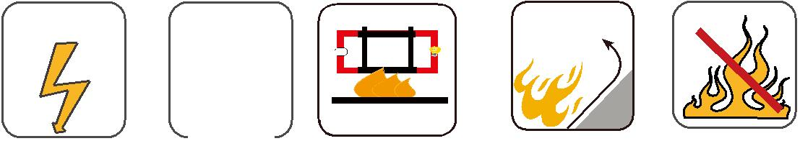

 | BS 7846
600/1000V | IEC_{N}60502-1

W

E

 |  |  |  |  | Circuit Integrity | Reduced Fire Propagation | Flame Retardancy
 |  |  |  |  | Circuit Integrity | NF C32-070-2.2(C1) | NF C32-070-2.1(C2)
Rated Voltage |  |  |  | Standard | IEC 60331/BS 6387 | NF C32-070-2.2(C1) | NF C32-070-2.1(C2)
 |  |  |  | Standard | NF C32-070-2.3(CR1) | IEC60332-3-24/EN50266-2-4 IEC60332-1-2/EN50265-2-1
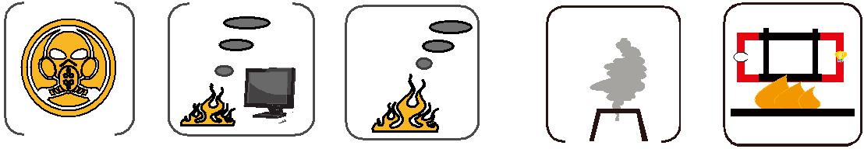

Zero

W

E

 |  |  | Low Corrosivity | Low Smoke Emission
 |  |  | Low Corrosivity | Low Smoke Emission | Halogen Free
 | Low Toxicity |  | IEC60754-2 | IEC 61034-1&2 | IEC60754-1 | Functional Integrity
 |  |  | EN50267-2-2/3 | IEC 61034-1&2 | IEC60754-1 | Functional Integrity
NES 02-713/NF C 20-454 |  |  | EN50267-2-2/3 | EN 50268-1&2/NF C32-073 |  | Functional Integrity
 |  |  | NF C 32-074 | EN 50268-1&2/NF C32-073 | EN50267-2-1 | DIN 4102-12

50 Caledonian sales@caledonian-cables.net uk@caledonian-cables.net

