 ADDISON

450/750V SR Insulated Control Cables (2-5 Cores)

FFX200 07SZ1-R (PH60) (CU/SR/LSZH 450/750V Class 2)
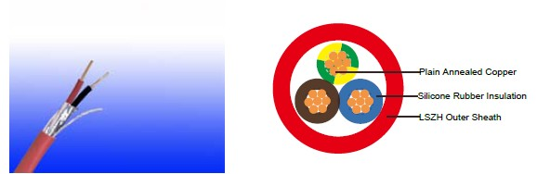

APPLICATION

The cables are designed, manufactured and tested for general application in power supply and signal wiring, for emergency circuit and fire circuit control.

STANDARDS

Basic design adapted from BS 7629-1

FIRE PERFORMANCE
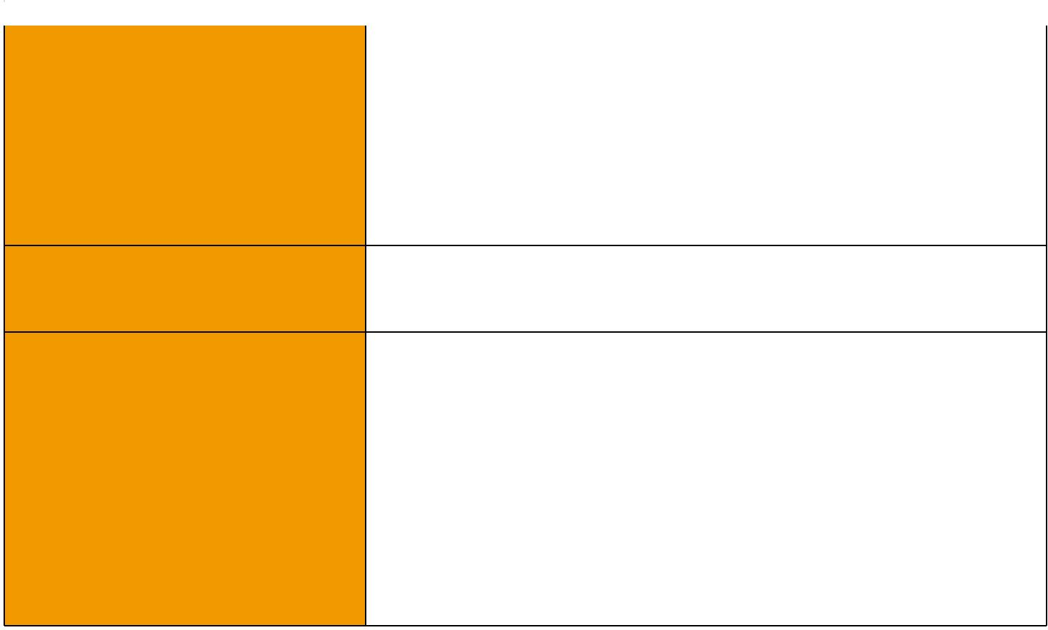
 | IEC 60331-21; BS 6387 CWZ; DIN VDE 0472-814(FE180);
Circuit Integrity | BS 8434-1 (30mins); BS 5839-1 Clause 26 2d; CEI 20-36/2-1;
 | SS229-1; NBN C 30-004 (cat. F3); NF C32-070-2.3(CR1)
Circuit Integrity with mechanical | EN 50200(PH60); CEI 20-36/4-0
shock | EN 50200(PH60); CEI 20-36/4-0
Circuit Integrity with mechanical | EN 50200 annex E
shock & water spray | EN 50200 annex E
System circuit integrity | DIN 4102-12, E30 depending on lay system
Flame Retardance (Single Vertical EN 60332-1-2; IEC 60332-1-2; BS EN 60332-1-2;

_{Wire Test)} VDE 0482-332-1 ; NBN C 30-004 (cat. F1); NF C32-070-2.1(C2); CEI 20-35/1-2; EN 50265-2-1*; DIN VDE 0482-265-2-1*

Reduced Fire Propagation | EN 60332-3-24 (cat. C); IEC 60332-3-24; BS EN 60332-3-24;
(Vertically-mounted bundled wires VDE 0482-332-3; NBN C 30-004 (cat. F2); NF C32-070-2.2(C1);
& cable test) | CEI 20-22/3-4; EN 50266-2-4*; DIN VDE 0482-266-2-4
Halogen Free | IEC 60754-1; EN 50267-2-1; DIN VDE 0482-267-2-1;
Halogen Free | CEI 20-37/2-1 ; BS 6425-1*
No Corrosive Gas Emission | IEC 60754-2; EN 50267-2-2; DIN VDE 0482-267-2-2;
No Corrosive Gas Emission | CEI 20-37/2-2 ; BS 6425-2*
Minimum Smoke Emission | IEC 61034-1&2; EN 61034 -1&2; DIN VDE 0482-1034-1&2;
Minimum Smoke Emission | CEI 20-37/3-1&2; EN 50268-1&2*; BS 7622-1&2*
No Toxic gases | NES 02-713; NF C 20-454

Note: Asterisk * denotes superseded standard.

64 Caledonian sales@caledonian-cables.net uk@caledonian-cables.net


Caledonian

Fire Resistant Power & Control Cables

www.caledonian-tech.net www.caledonian-tech.com

VOLTAGE RATING

450/750 V

CABLE CONSTRUCTION

Conductors: Plain annealed copper wire, stranded according to IEC(EN) 60228 class 2. Insulation: Fire resistant silicone rubber compound type EI2 as per BS 7655-1.1.

Cabling: The cores are cabled together in concentric layers with suitable non-hygroscopic fillers.

Outer Sheath: Thermoplastic LSZH compound type LTS3 as per BS 7655-6.1 (Thermosetting LSZH compound type SW2-SW4 as per BS 7655-2.6 can be offered.)

COLOUR CODE

Insulation Colour:

Without earth conductor

2 cores blue - brown

3 cores brown - black - grey

4 cores blue - brown - black - grey

5 cores blue - brown - black - grey - black With earth conductor

3 cores yellow/green - blue - brown

4 cores yellow/green - brown - black - grey

5 cores yellow/green - blue - brown - black - grey

Sheath Colour: Colour red (other colours on request)

Physical AND THERMAL PROPERTIES

Temperature range during operation (fixed state):-30°C – +90°C

Temperature range during installation (mobile state): -20°C – +50°C Minimum bending radius: 7.5 x Overall Diameter

Electrical PROPERTIES

Dielectric test: |  | 2500 V r.m.s. x 5’ (core/core)
Insulation resistance |  | ≥300 MΩ x km (at 20°C)
Short circuit temperature |  | 350°C
CONSTRUCTION PARAMETERS
 | No. of Core X |  | Nominal | Nominal | Nominal | Approx.
Cable Code |  |  | Insulation | Sheath | Overall | Approx.
Cable Code | Cross Section |  | Insulation | Sheath | Overall | Weight
 |  |  | Thickness | Thickness | Diameter | Weight
 | mm² |  | mm | mm | mm | kg/km
 |  |  | 2 core
FFX200 07SZ1-R (PH60) | 2x1.5 |  | 0.8 | 1.0 | 7,8 | 96
FFX200 07SZ1-R (PH60) | 2x2.5 |  | 0.9 | 1.1 | 9,2 | 138


 ADDISON 65

ADDISON

FFX200 07SZ1-R (PH60) | 2x4.0 | 0.9 | 1.2 | 10,5 | 189
 |  | 3 core
FFX200 07SZ1-R (PH60) | 3x1.5 | 0.8 | 1.0 | 8,3 | 116
FFX200 07SZ1-R (PH60) | 3x2.5 | 0.9 | 1.1 | 9,8 | 169
FFX200 07SZ1-R (PH60) | 3x4.0 | 0.9 | 1.2 | 11,6 | 246
 |  | 4 core
FFX200 07SZ1-R (PH60) | 4x1.5 | 0.8 | 1.1 | 9,3 | 147
FFX200 07SZ1-R (PH60) | 4x2.5 | 0.9 | 1.2 | 11,3 | 222
FFX200 07SZ1-R (PH60) | 4x4.0 | 0.9 | 1.3 | 12,5 | 299
 |  | 5 core
FFX200 07SZ1-R (PH60) | 5x1.5 | 0.8 | 1.1 | 10,5 | 180
FFX200 07SZ1-R (PH60) | 5x2.5 | 0.9 | 1.2 | 12,3 | 259
FFX200 07SZ1-R (PH60) | 5x4.0 | 0.9 | 1.3 | 14,0 | 359

ELECTRICAL PROPERTIES

Conductor Operating Temperature : 90°C

Ambient Temperature : 30°C

Current-Carrying Capacities (Amp)
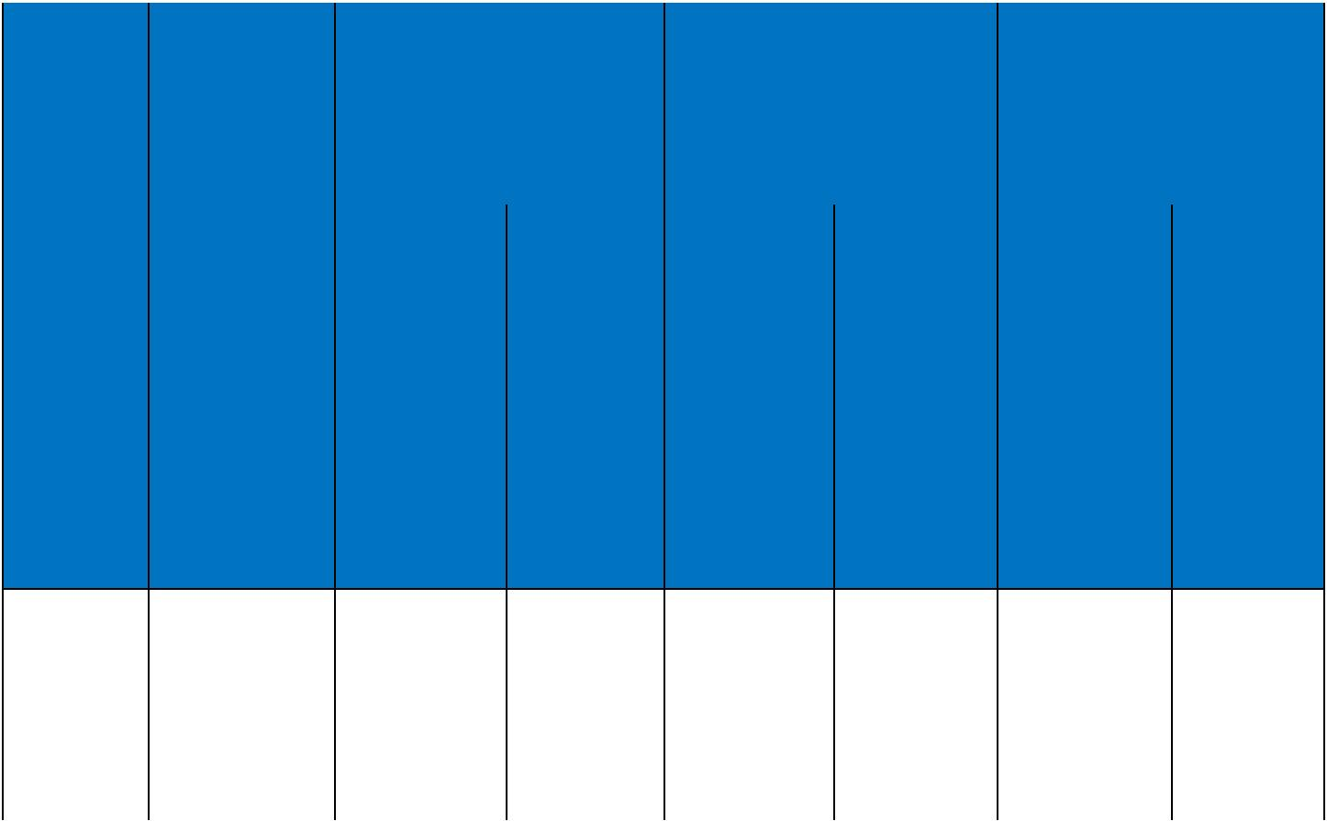
 | Reference
 | Method 4 | Reference Method 3 |  |  |  | Reference Method 11
 | (enclosed in | (enclosed in conduit on |  | Reference Method 1 |  | (on a perforated cable
 | an conduit | a wall or ceiling, or in |  | (clipped direct) |  | tray), or Reference Method
 | insulated wall | trunking) |  |  |  | 13 (free air)
 | etc)
Conductor
cross-
sectional |  |  |  |  |  | one 2-core
area | one 3-core | one 2-core | one 3-core | one 2-core | one 3-core | one 2-core | one 3-core
 |  |  |  |  |  | cable | one 3-core
 | cable or one | cable | cable or one | cable | cable or one | singlephase ^{cable or one}
 | 4-core cable | singlephase | 4-core cable | singlephase | 4-core cable | a.c. or | 4-core cable
 | 3-phase a.c. | a.c. or d.c. | 3-phase a.c. | a.c. or d.c. | 3-phase a.c. | a.c. or | 3-phase a.c.
 |  |  |  |  |  | d.c. | 3-phase a.c.

1 | 2 | 3 | 4 | 5 | 6 | 7 | 8
mm² | A | A | A | A | A | A | A
1.5 | 16.5 | 22 | 19.5 | 24 | 22 | 26 | 23
2.5 | 22 | 30 | 26 | 33 | 30 | 36 | 32
4 | 30 | 40 | 35 | 45 | 40 | 49 | 42

66 Caledonian sales@caledonian-cables.net uk@caledonian-cables.net

Caledonian

Fire Resistant Power & Control Cables

www.caledonian-tech.net www.caledonian-tech.com

Voltage Drop (Per Amp Per Meter)

Nominal Cross | 2-core cable d.c. | 2-core cable single- | 3-core or 4-core cable
Section Area | 2-core cable d.c. | phase a.c | 3-phase a.c.
1 | 2 | 3 | 4
mm² | mV/A/m | mV/A/m | mV/A/m
1.5 | 31 | 31 | 27
2.5 | 19 | 19 | 16
4 | 12 | 12 | 10

450/750V _{N}^{BS7629-1}
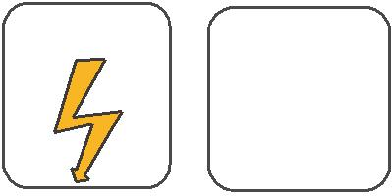
W

E
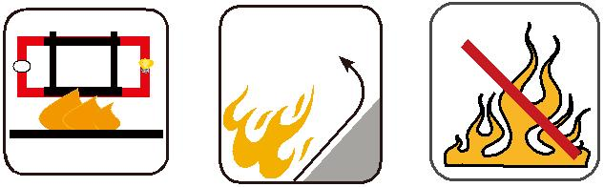

 |  | Circuit Integrity | Reduced Fire Propagation | Flame Retardancy
 |  | IEC 60331/BS 6387 | Reduced Fire Propagation
 |  | IEC 60331/BS 6387 | NF C32-070-2.2(C1) | NF C32-070-2.1(C2)
Rated Voltage | Standard | EN 50200 | NF C32-070-2.2(C1)
 |  | NF C32-070-2.3(CR1) IEC60332-3-24/EN50266-2-4 IEC60332-1-2/EN50265-2-1
 |  |  | Zero | W | E
 | Low Corrosivity | Low Smoke Emission | Halogen Free
 | IEC60754-2 | Low Smoke Emission | Halogen Free
Low Toxicity | IEC60754-2 | IEC 61034-1&2 | IEC60754-1
Low Toxicity | EN50267-2-2/3 | IEC 61034-1&2 | IEC60754-1 | Functional Integrity
NES 02-713/NF C 20-454 | NF C 32-074 | EN 50268-1&2/NF C32-073 | EN50267-2-1 |  | DIN 4102-12
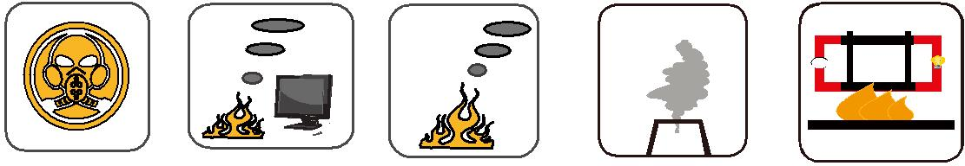

 ADDISON 67

