 ADDISON

450/750V SR Insulated & Overall Screened Control Cables (1-4 Cores & Multicores)

FFX200 07SOZ1-F (PH30/60)(CU/SR/OSCR/LSZH 450/750V Class 5)
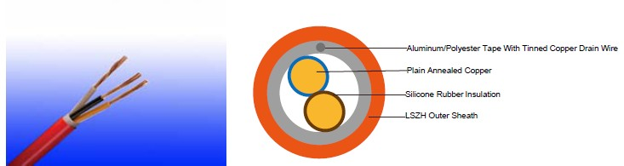

APPLICATION

The cables are designed, manufactured and tested for general application in power and signal wiring, for emergency circuit and fire circuit control where high rejection to electrostatic noise is needed.

STANDARDS

Basic design adapted from BS 7629-1

FIRE PERFORMANCE
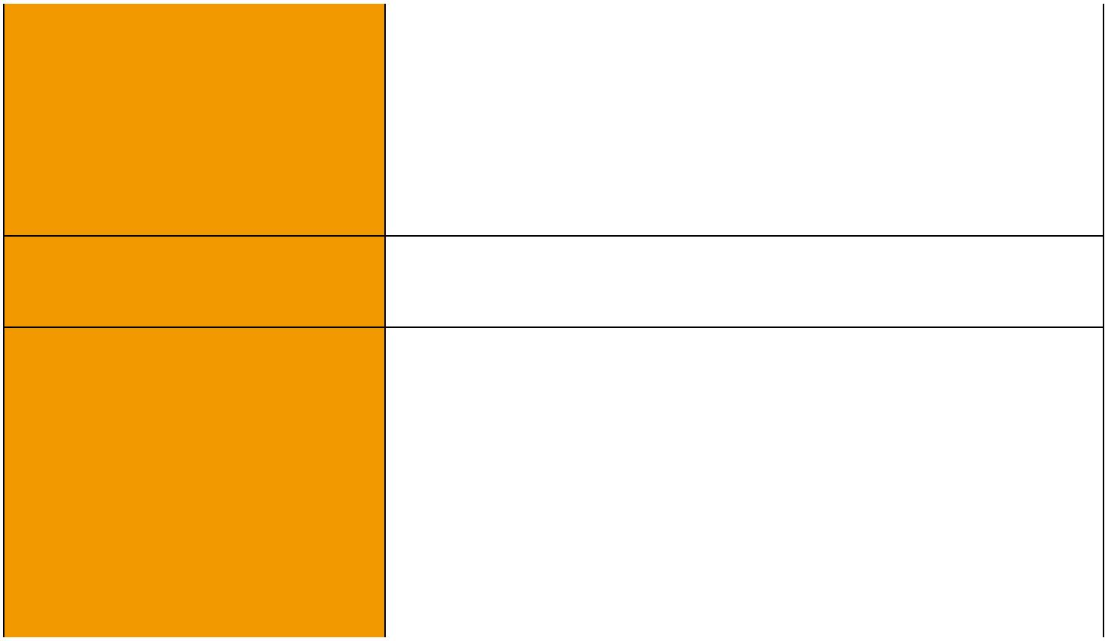
 | IEC 60331-21; BS 6387 CWZ; DIN VDE 0472-814(FE180);
Circuit Integrity | BS 8434-1 (30mins); BS 5839-1 Clause 26 2d; CEI 20-36/2-1;
 | SS229-1; NBN C 30-004 (cat. F3); NF C32-070-2.3(CR1)
Circuit Integrity with mechanical | EN 50200(PH30/60); CEI 20-36/4-0
shock | EN 50200(PH30/60); CEI 20-36/4-0
Circuit Integrity with mechanical | EN 50200 annex E
shock & water spray | EN 50200 annex E
System circuit integrity | DIN 4102-12, E30 depending on lay system
Flame Retardance (Single Vertical EN 60332-1-2; IEC 60332-1-2; BS EN 60332-1-2;

_{Wire Test)} VDE 0482-332-1 ; NBN C 30-004 (cat. F1); NF C32-070-2.1(C2); CEI 20-35/1-2; EN 50265-2-1*; DIN VDE 0482-265-2-1*

Reduced Fire Propagation | EN 60332-3-24 (cat. C); IEC 60332-3-24; BS EN 60332-3-24;
(Vertically-mounted bundled wires VDE 0482-332-3; NBN C 30-004 (cat. F2); NF C32-070-2.2(C1);
& cable test) | CEI 20-22/3-4; EN 50266-2-4*; DIN VDE 0482-266-2-4
Halogen Free | IEC 60754-1; EN 50267-2-1; DIN VDE 0482-267-2-1;
Halogen Free | CEI 20-37/2-1 ; BS 6425-1*
No Corrosive Gas Emission | IEC 60754-2; EN 50267-2-2; DIN VDE 0482-267-2-2;
No Corrosive Gas Emission | CEI 20-37/2-2 ; BS 6425-2*
Minimum Smoke Emission | IEC 61034-1&2; EN 61034 -1&2; DIN VDE 0482-1034-1&2;
Minimum Smoke Emission | CEI 20-37/3-1&2; EN 50268-1&2*; BS 7622-1&2*
No Toxic gases | NES 02-713; NF C 20-454

68 Caledonian sales@caledonian-cables.net uk@caledonian-cables.net


Caledonian

Fire Resistant Power & Control Cables

www.caledonian-tech.net www.caledonian-tech.com

Note: Asterisk * denotes superseded standard.

VOLTAGE RATING

450/750 V

CABLE CONSTRUCTION

Conductors: Plain annealed copper wire, flexible according to IEC(EN) 60228 class 5.

Insulation: Fire resistant silicone rubber compound type EI2 as per BS 7655-1.1.

Cabling: The cores are cabled together in concentric layers with suitable non-hygroscopic fillers.

Overall screen: Aluminum/polyester tape with tinned copper drain wire.

Outer Sheath: Thermoplastic LSZH compound type LTS3 as per BS 7655-6.1 Thermosetting LSZH compound type SW2-SW4 as per BS 7655-2.6 can be offered.)

COLOUR CODE

Insulation Colour:

Without earth conductor

2 cores blue - brown

3 cores brown - black - grey

4 cores blue - brown - black - grey

7 cores and above black numbered With earth conductor

3 cores yellow/green - blue - brown

4 cores yellow/green - brown - black - grey

5 cores yellow/green - blue - brown - black - grey 7 cores and above yellow/green - black numbered
Sheath Colour: Colour red (other colours on request)

Physical AND THERMAL PROPERTIES

Temperature range during operation (fixed state):-30°C – +90°C

Temperature range during installation (mobile state): -20°C – +50°C Minimum bending radius: 7.5 x Overall Diameter

Electrical PROPERTIES

Dielectric test: | 2500 V r.m.s. x 5’ (core/core)
Insulation Resistance | ≥300 MΩ x km (at 20°C)
Short circuit Temperature | 350°C

 ADDISON 69

ADDISON

CONSTRUCTION PARAMETERS

 | No. of Core X |  | Nominal | Nominal | Nominal | Approx.
Cable Code | No. of Core X |  | Insulation | Sheath | Overall | Approx.
Cable Code | Cross Section |  | Insulation | Sheath | Overall | Weight
 | Cross Section |  | Thickness | Thickness | Diameter | Weight
 | mm² |  | mm | mm | mm | kg/km
 |  | 2 core
FFX200 07SOZ1-F(PH30/60) | 2x0.75 |  | 0.7 | 0.9 | 7,6 | 69
FFX200 07SOZ1-F(PH30/60) | 2x1.0 |  | 0.7 | 1.0 | 8,0 | 78
FFX200 07SOZ1-F(PH30/60) | 2x1.5 |  | 0.8 | 1.0 | 8,3 | 88
FFX200 07SOZ1-F(PH30/60) | 2x2.5 |  | 0.9 | 1.1 | 9,8 | 123
 |  | 3 core
FFX200 07SOZ1-F(PH30/60) | 3x0.75 |  | 0.7 | 0.9 | 8,0 | 84
FFX200 07SOZ1-F(PH30/60) | 3x1.0 |  | 0.7 | 1.0 | 8,2 | 86
FFX200 07SOZ1-F(PH30/60) | 3x1.5 |  | 0.8 | 1.0 | 8,8 | 112
FFX200 07SOZ1-F(PH30/60) | 3x2.5 |  | 0.9 | 1.1 | 10,4 | 159
 |  | 4 core
FFX200 07SOZ1-F(PH30/60) | 4x0.75 |  | 0.7 | 1.0 | 8,7 | 103
FFX200 07SOZ1-F(PH30/60) | 4x1.0 |  | 0.7 | 1.1 | 8,9 | 110
FFX200 07SOZ1-F(PH30/60) | 4x1.5 |  | 0.8 | 1.1 | 9,8 | 141
FFX200 07SOZ1-F(PH30/60) | 4x2.5 |  | 0.9 | 1.2 | 11,4 | 196
 |  | 7 core
FFX200 07SOZ1-F(PH30/60) | 7x1.0 |  | 0.7 | 1.1 | 10,8 | 176
FFX200 07SOZ1-F(PH30/60) | 7x1.5 |  | 0.8 | 1.2 | 11,7 | 218
FFX200 07SOZ1-F(PH30/60) | 7x2.5 |  | 0.9 | 1.3 | 13,4 | 305
 |  | 12 core
FFX200 07SOZ1-F(PH30/60) | 12x1.0 |  | 0.7 | 1.2 | 13,9 | 275
FFX200 07SOZ1-F(PH30/60) | 12x1.5 |  | 0.8 | 1.3 | 15,3 | 352
FFX200 07SOZ1-F(PH30/60) | 12x2.5 |  | 0.9 | 1.5 | 17,9 | 505
 |  | 19 core
FFX200 07SOZ1-F(PH30/60) | 19x1.0 |  | 0.7 | 1.4 | 16,4 | 408
FFX200 07SOZ1-F(PH30/60) | 19x1.5 |  | 0.8 | 1.5 | 18,2 | 535
FFX200 07SOZ1-F(PH30/60) | 19x2.5 |  | 0.9 | 1.6 | 21,1 | 760

ELECTRICAL PROPERTIES

Conductor Operating Temperature : 90°C

Ambient Temperature : 30°C

70 Caledonian sales@caledonian-cables.net uk@caledonian-cables.net

Caledonian

Fire Resistant Power & Control Cables

www.caledonian-tech.net www.caledonian-tech.com

Current-Carrying Capacities (Amp)

 | Reference
 | Method 4 | Reference Method 3 |  |  |  |  |  |  | Reference Method 11
 | (enclosed in | (enclosed in conduit on |  |  |  | Reference Method 1 |  |  | (on a perforated cable
 | an conduit | a wall or ceiling, or in |  |  |  | (clipped direct) |  |  | tray), or Reference Method
Conductor | insulated wall | trunking) |  |  |  |  |  |  | 13 (free air)
cross- | etc)
sectional |  |  |  |  |  |  |  |  | one 2-core
area | one 3-core | one 2-core |  | one 3-core |  | one 2-core | one 3-core |  | one 2-core | one 3-core
 |  |  |  |  |  |  |  |  | cable | one 3-core
 | cable or one | cable |  | cable or one |  | cable | cable or one |  | cable | cable or one
 |  |  |  |  |  |  |  |  | singlephase | cable or one
 | 4-core cable | singlephase |  | 4-core cable |  | singlephase | 4-core cable |  | singlephase | 4-core cable
 | 3-phase a.c. | a.c. or d.c. |  | 3-phase a.c. |  | a.c. or d.c. | 3-phase a.c. |  | a.c. or | 3-phase a.c.
 |  |  |  |  |  |  |  |  | d.c. | 3-phase a.c.
1 | 2 | 3 |  | 4 |  | 5 | 6 |  | 7 | 8
mm² | A | A |  | A |  | A | A |  | A | A
1.5 | 16.5 | 22 |  | 19.5 |  | 24 | 22 |  | 26 | 23
2.5 | 22 | 30 |  | 26 |  | 33 | 30 |  | 36 | 32
4 | 30 | 40 |  | 35 |  | 45 | 40 |  | 49 | 42
Voltage Drop (Per Amp Per Meter)
Nominal Cross |  |  | 2-core cable d.c. |  |  | 2-core cable single- |  |  | 3-core or 4-core cable
Section Area |  |  |  |  |  | phase a.c |  |  | 3-phase a.c.
 | 1 |  | 2 |  |  | 3 |  |  | 4
 | mm² |  | mV/A/m |  |  | mV/A/m |  |  | mV/A/m
 | 1.5 |  | 31 |  |  | 31 |  |  | 27
 | 2.5 |  | 19 |  |  | 19 |  |  | 16
 | 4 |  | 12 |  |  | 12 |  |  | 10


450/750V _{N}^{BS7629-1}
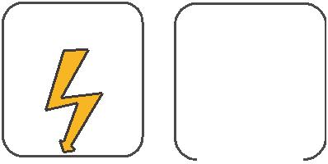
W

E
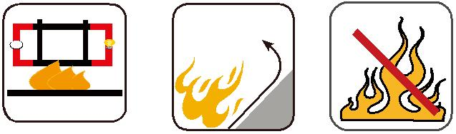

 |  |  |  |  | Circuit Integrity | Reduced Fire Propagation | Flame Retardancy
 |  |  |  |  | IEC 60331/BS 6387 | Reduced Fire Propagation | Flame Retardancy
 |  |  |  |  | EN 50200 | NF C32-070-2.2(C1) | NF C32-070-2.1(C2)
Rated Voltage |  |  | Standard |  | NF C32-070-2.3(CR1) | IEC60332-3-24/EN50266-2-4 IEC60332-1-2/EN50265-2-1
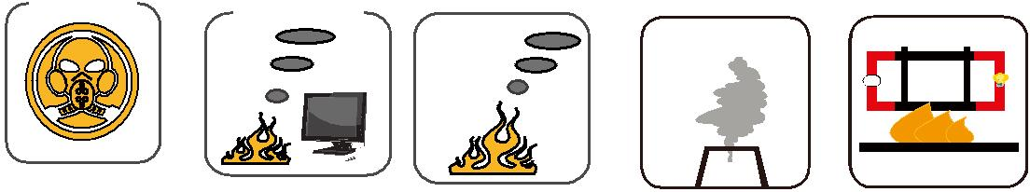

Zero

W

E

Low Toxicity | Low Corrosivity | Low Smoke Emission | Halogen Free
Low Toxicity | IEC60754-2 | Low Smoke Emission | Halogen Free
NES 02-713/NF C 20-454 | EN50267-2-2/3 | IEC 61034-1&2 | IEC60754-1 | Functional Integrity
 | NF C 32-074 | EN 50268-1&2/NF C32-073 | EN50267-2-1 | DIN 4102-12

ADDISON 71

