IEC Standard Caledonian Offshore & Marine Cables

MariFlex Marine Fire Resistant Power & Control Cables

www.caledonian-cables.co.uk


MFX300 0.6/1 kV Fire Barriers + HEPR Insulated, LSOH (SHF1) Sheathed, Screened Fire Resistant Power & Control Cables (Single Core)

Application

These cables are used for fixed installations on ships and offshore units in all locations and on open deck in safety circuits, where fire resistance is required. The good screening qualities of the copper braid also reduce radio interference and electrical influences to electronics installations. These cables are fire resistant, flame retardant, low smoke & halogen free.



Standards

● DIN 89160/98
● IEC 60092-353
● IEC 60331-21
● IEC 60332-1
● IEC 60332-3-22
● IEC 60754-1/2
● IEC 61034

Stranded Copper Conductor Fire Barriers + HEPR Insulation Copper Wire Braid Screen LSOH (SHF1) Sheath

Construction

- Conductors: Class 2 stranded copper conductor.
- Insulation: Fire barriers + HEPR.
- Overall Screen: Copper wire braid.
- Outer Sheath: LSOH (SHF1).

Core Identification

Single core: Natural colour (beige).

40 ADDISON www.addison-cables.com

IEC Standard Caledonian Offshore & Marine Cables

MariFlex Marine Fire Resistant Power & Control Cables

www.caledonian-cables.co.uk


Mechanical and Thermal Properties

Bending Radius for Fixed Installations: 6×OD Temperature Range: -20℃ ~ +75℃

Dimensions and Weight

Part No. | Construction  No. of cores×Cross  section(mm²) | Nominal Insulation Thickness mm | Nominal Sheath Thickness  mm | Nominal Overall Diameter  mm | Nominal Weight kg/km
MFX300-1mG7MZ1-R-1C25 | 1×25 | 0.9 | 1.2 | 12.5 | 380
MFX300-1mG7MZ1-R-1C35 | 1×35 | 0.9 | 1.2 | 13.5 | 480
MFX300-1mG7MZ1-R-1C50 | 1×50 | 1.0 | 1.3 | 15.5 | 670
MFX300-1mG7MZ1-R-1C70 | 1×70 | 1.1 | 1.4 | 17.5 | 900
MFX300-1mG7MZ1-R-1C95 | 1×95 | 1.1 | 1.4 | 19.5 | 1170
MFX300-1mG7MZ1-R-1C120 | 1×120 | 1.6 | 1.5 | 21.0 | 1430

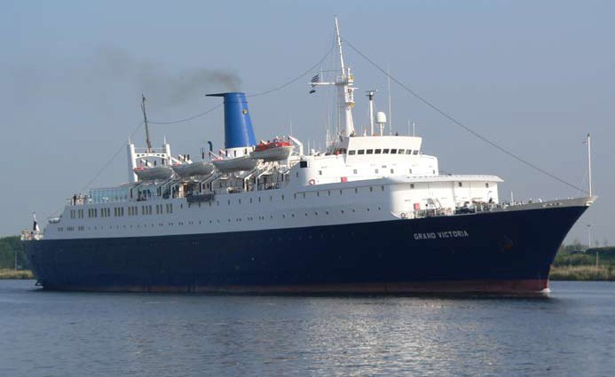

www.addison-cables.com
ADDISON 41

