IEC Standard Caledonian Offshore & Marine Cables

MariFlex Marine Fire Resistant Power & Control Cables

www.caledonian-cables.co.uk


MFX300 0.6/1 kV Mica Tape + XLPE Insulated, LSOH (SHF1) Sheathed, Armoured Fire Resistant Power & Control Cables (Single Core)

Application

These armoured fire resistant cables are used on board of ships in all locations for fixed installations where cable protection is required. These cables are fire resistant, flame retardant, low smoke & halogen free.

Standards

● IEC 60092-350/351/353/359
● IEC 60331-21
● IEC 60332-1
● IEC 60332-3-22
● IEC 60754-1/2
● IEC 61034



Stranded Copper Conductor Mica Tape + XLPE Insulation Copper Wire Braid Armour LSOH (SHF1) Sheath

Construction

- Conductors: Class 2 stranded copper conductor. Class 5 stranded conductors can be offered upon request.
- Insulation: Mica tape + XLPE.
- Armour: Copper wire braid.
- Outer Sheath: LSOH (SHF1). SHF2 can be offered upon request.

Core Identification

Single core: Black.

www.addison-cables.com
ADDISON 35

IEC Standard Caledonian Offshore & Marine Cables

MariFlex Marine Fire Resistant Power & Control Cables

www.caledonian-cables.co.uk


Mechanical and Thermal Properties

Bending Radius for Fixed Installations: 6×OD Temperature Range: -30℃ ~ +80℃

Dimensions and Weight

MFX300 1mRMZ1-R Single Core Armoured 0.6/1kV (-R stands for class 2 conductor. For class 5 conductor, please change –R to –F)

Part No. | Construction  No. of cores×Cross  section(mm²) | Nominal Insulation Thickness mm | Nominal Sheath Thickness  mm | Nominal Overall Diameter  mm | Nominal Weight kg/km
MFX300-1mRMZ1-R-1C25 | 1×25 | 0.9 | 1.2 | 13.0 | 410
MFX300-1mRMZ1-R-1C35 | 1×35 | 0.9 | 1.2 | 14.6 | 550
MFX300-1mRMZ1-R-1C50 | 1×50 | 1.0 | 1.3 | 15.8 | 720
MFX300-1mRMZ1-R-1C70 | 1×70 | 1.1 | 1.4 | 17.8 | 960
MFX300-1mRMZ1-R-1C95 | 1×95 | 1.1 | 1.4 | 20.7 | 1250
MFX300-1mRMZ1-R-1C120 | 1×120 | 1.2 | 1.5 | 22.8 | 1540

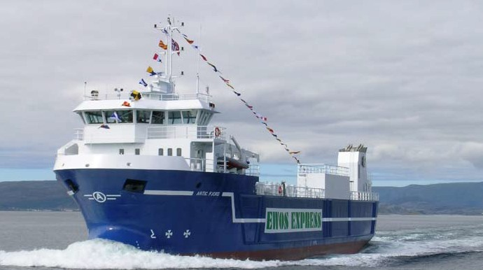

36 ADDISON www.addison-cables.com

