
Caledonian

Fire Resistant Fire Alarm Cables
www.caledonian-tech.net www.caledonian-tech.com

300V Mica+LSZH Insulated & LSZH Sheathed Fire Alarm Cables

JE-H(St)H…Bd FE180 E90. (CU/MICA+LSZH/OSCR/LSZH 300V Class 1 ) JE-H(St)H…Bd FE180 E90 BMK* (CU/MICA+LSZH/OSCR/LSZH 300V Class 1)
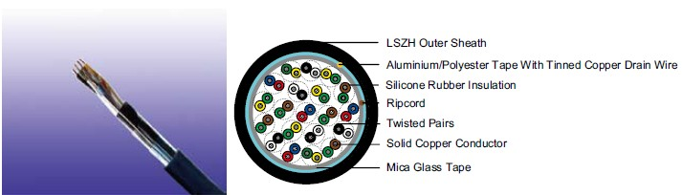

APPLICATION

The cables are used for the internal wiring of building when the circuit integrity during fire is paramount. The cables are intended for use in fire fighting plants with mica tapes, with and without Aluminum foil and LSZH outer sheath.The fire alarm cables with 30 to 90 minutes circuit integrity should be used for control voltages and data transfer in alarm and fire alarm systems, where a system circuit integrity E30/E60/E90 depending on lay system in accordance with DIN 4102-12 is required. The circuit integrity is guaranteed with a test voltage of 110V.

STANDARDS

Basic design to VDE 0815

FIRE PERFORMANCE

 | IEC 60331-23; BS 6387 CWZ; DIN VDE 0472-814(FE180);
Circuit Integrity | CEI 20-36/2-1; SS229-1; NBN C 30-004 (cat. F3);
 | NF C32-070-2.3(CR1)
System circuit integrity | DIN 4102-12, E90 depending on lay system
Flame Retardance (Single Vertical | EN 60332-1-2; IEC 60332-1-2; BS EN 60332-1-2;
Wire Test) | VDE 0482-332-1; NBN C 30-004 (cat. F1); NF C32-070-2.1(C2);
Wire Test) | CEI 20-35/1-2; EN 50265-2-1*; DIN VDE 0482-265-2-1*
Reduced Fire Propagation | EN 60332-3-24 (cat. C); IEC 60332-3-24; BS EN 60332-3-24;
(Vertically-mounted bundled wires | VDE 0482-332-3; NBN C 30-004 (cat. F2); NF C32-070-2.2(C1);
& cable test) | CEI 20-22/3-4; EN 50266-2-4*; DIN VDE 0482-266-2-4
Halogen Free | IEC 60754-1; EN 50267-2-1; DIN VDE 0482-267-2-1;
Halogen Free | CEI 20-37/2-1 ; BS 6425-1*
No Corrosive Gas Emission | IEC 60754-2; EN 50267-2-2; DIN VDE 0482-267-2-2;
No Corrosive Gas Emission | CEI 20-37/2-2 ; BS 6425-2*
Minimum Smoke Emission | IEC 61034-1&2; EN 61034 -1&2; DIN VDE 0482-1034-1&2;
Minimum Smoke Emission | CEI 20-37/3-1&2; EN 50268-1&2*; BS 7622-1&2*
No Toxic gases | NES 02-713; NF C 20-454

Note: Asterisk * denotes superseded standard.

 ADDISON 97

 ADDISON

CABLE CONSTRUCTION

Conductors: Solid annealed bare or tinned copper sized 0.8mm as per class 1 of VDE 0295/IEC 60228.

Fire Barrier: Mica glass tape.

Insulation: Thermoplastic LSZH compound HI1 as per DIN VDE 0207-23.

Cabling Elements: Insulated cores are twisted to form pairs with varying lay length to minimize crosstalk. Two-pair cable had four cores laid in quad formation.

Cabling: Pairs are cabled together. In cables with 8 pairs or more, 4 pairs are assembled to form a bunch, the bunches are then cabled together.

Cable Core Assembly: The twisted pairs are stranded to the core in layers.

Core Wrapping: One or more non hygroscopic polyester tapes are helically or longitudinally laid with an overlap prior to sheathing.

Screen: A laminated Aluminum/Polyester tape in contact with solid copper 0.6mm or 0.8mm drain wire.

Ripcord: Nylon ripcord may be placed parallel to the cores to facilitate sheath removal. Drain Wire: A solid tinned earth/continuity wire shall be laid longitudinally for screened cables. Outer Sheath: Thermoplastic LSZH compound HM2 as per DIN VDE 0207-24 .

COLOUR CODE

Quad colour in each bundle:

Pair 1: Blue-Red

Pair 2: Green-Yellow

Pair 3: Green-Brown

Pair 4: White-Black

The individual bundles are identified by a numbered helix.

TYPE CODE

JE- | Fire alarm cable | (St) | Static shield of Aluminum tape
H | Halogen free & zero halogen | FE180 Insulation integrity (950°C 180 minutes)
Bd | Unit stranding | E90 | 90 minutes circuit integrity

Physical AND THERMAL PROPERTIES

Temperature range during operation (fixed state): -30°C – +90°C

Temperature range during installation (mobile state): -20°C – +50°C

Minimum bending radius: 8 x Overall Diameter

ELECTRICAL PROPERTIES

 | Nominal Conductor Diameter |  | mm | 0.8
 | Conductor Size |  | mm² | 0.5
 | Maximum Conductor Resistance @20°C |  | Ω/km | 34.6
 | Maximum Loop Resistance @20°C |  | Ω/km | 73.2
 | Minimum Insulation Resistance @500V DC @20°C |  | MΩ.km | 100
 | Maximum Average Attenuation @0.8KHz |  | dB/km | 1.1
 | Average Mutual Capacitance |  | nF/km | 120
 | Capacitance Unbalance K1 @0.8KHz pair-to-pair |  | pF/100m | 200
 | Working Voltage |  | V | 300
98 | Caledonian | sales@caledonian-cables.net uk@caledonian-cables.net

Caledonian

Fire Resistant Fire Alarm Cables
www.caledonian-tech.net www.caledonian-tech.com

Nominal Insulation Thickness | mm | 0.4
Nominal Insulated Conductor Diameter | mm | 1.6

CONSTRUCTION PARAMETERS

VDE CODE: JE-mH(St)H…x2x0.8 Bd FE180 E90 /JE-H(St)H…x2x0.8 Bd FE180/E90 BMK*

 | No. | Nominal | Nominal | Nominal | Approx.
Cable Code | of | Insulation | Sheath | Overall | Approx.
 |  |  |  |  | Weight
 | Pairs | Thickness | Thickness | Diameter | Weight
 |  | mm | mm | mm | kg/km
0.8mm Conductor, 1.6mm Insulated Wire
JE-H(St)H...2x2x0.8 Bd FE180/E90 BMK* | 2 | 0.4 | 1.0 | 12.8 | 177
JE-H(St)H...4x2x0.8 Bd FE180/E90 BMK* | 4 | 0.4 | 1.0 | 16.3 | 284
JE-H(St)H...8x2x0.8 Bd FE180/E90 BMK* | 8 | 0.4 | 1.0 | 20.3 | 447
JE-H(St)H...12x2x0.8 Bd FE180/E90 BMK* | 12 | 0.4 | 1.2 | 23.9 | 615
JE-H(St)H...16x2x0.8 Bd FE180/E90 BMK* | 16 | 0.4 | 1.2 | 26.6 | 756
JE-H(St)H...20x2x0.8 Bd FE180/E90 BMK* | 20 | 0.4 | 1.2 | 29.4 | 921
JE-H(St)H...32x2x0.8 Bd FE180/E90 BMK* | 32 | 0.4 | 1.4 | 30.7 | 1074
JE-H(St)H...40x2x0.8 Bd FE180/E90 BMK* | 40 | 0.4 | 1.4 | 33.6 | 1278
JE-H(St)H...52x2x0.8 Bd FE180/E90 BMK* | 52 | 0.4 | 1.6 | 43.7 | 2011

300V _{N}VDE0815

W

E
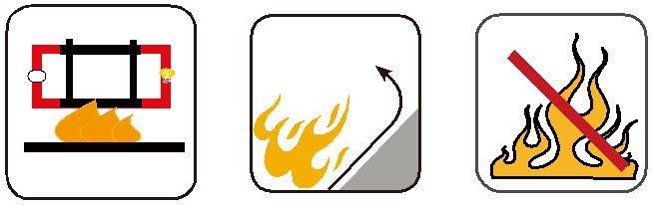

 |  | Circuit Integrity | Reduced Fire Propagation | Flame Retardancy
 |  | Circuit Integrity | NF C32-070-2.2(C1) | NF C32-070-2.1(C2)
Rated Voltage | Standard | IEC 60331/BS 6387 | NF C32-070-2.2(C1)
 |  | _{NF C32-070-2.3(CR1)} IEC60332-3-24/EN50266-2-4 |  | IEC60332-1-2/EN50265-2-1
 |  |  | Zero | W | E
 | Low Corrosivity | Low Smoke Emission | Halogen Free
Low Toxicity | IEC60754-2 | IEC 61034-1&2 | IEC60754-1 | Functional Integrity
Low Toxicity | EN50267-2-2/3 | IEC 61034-1&2 | IEC60754-1
NES 02-713/NF C 20-454 | NF C 32-074 | EN 50268-1&2/NF C32-073 | EN50267-2-1 |  | DIN 4102-12
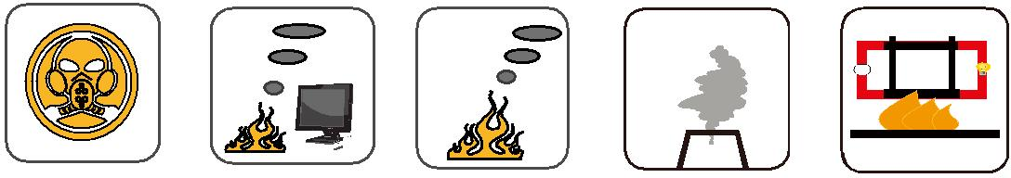

ADDISON 99

