
Caledonian

Fire Resistant Fire Alarm Cables
www.caledonian-tech.net www.caledonian-tech.com

300/500V SR Insulated & LSZH Sheathed Fire Alarm Cables

FFX200P 05SOZ1-U (PH30) (CU/SR/OSCR/LSZH 300/500V Class 1)

FFX200P 05SOZ1-R (PH30) (CU/SR/OSCR/LSZH 300/500V Class 2)

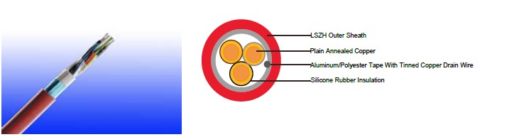

APPLICATION

The cables are designed, manufactured and tested as data transmission cables for emergency services. These are primarily intended for for indoor instrumentation and control cabling, electrically noisy environments and fire alarm systems in office buildings when high frequency signal transmission has to be assured in the event of a fire.

STANDARDS

Basic design to BS 7629-1

Fire Performance

 | IEC 60331-21; BS 6387 CWZ; DIN VDE 0472-814(FE180);
Circuit Integrity | BS 8434-1 (30mins); BS 5839-1 Clause 26 2d; CEI 20-36/2-1;
 | SS229-1; NBN C 30-004 (cat. F3); NF C32-070-2.3(CR1)
Circuit Integrity with mechanical | EN 50200(PH30); CEI 20-36/4-0
shock | EN 50200(PH30); CEI 20-36/4-0
Circuit Integrity with mechanical | EN 50200 annex E
shock & water spray | EN 50200 annex E
System circuit integrity | DIN 4102-12, E30 depending on lay system
Flame Retardance (Single Vertical EN 60332-1-2; IEC 60332-1-2; BS EN 60332-1-2;

_{Wire Test)} VDE 0482-332-1 ; NBN C 30-004 (cat. F1); NF C32-070-2.1(C2); CEI 20-35/1-2; EN 50265-2-1*; DIN VDE 0482-265-2-1*

Reduced Fire Propagation | EN 60332-3-24 (cat. C); IEC 60332-3-24; BS EN 60332-3-24;
(Vertically-mounted bundled wires VDE 0482-332-3; NBN C 30-004 (cat. F2); NF C32-070-2.2(C1);
& cable test) | CEI 20-22/3-4; EN 50266-2-4*; DIN VDE 0482-266-2-4
Halogen Free | IEC 60754-1; EN 50267-2-1; DIN VDE 0482-267-2-1;
Halogen Free | CEI 20-37/2-1 ; BS 6425-1*
No Corrosive Gas Emission | IEC 60754-2; EN 50267-2-2; DIN VDE 0482-267-2-2;
No Corrosive Gas Emission | CEI 20-37/2-2 ; BS 6425-2*

 ADDISON 103

 ADDISON


Minimum Smoke Emission | IEC 61034-1&2; EN 61034 -1&2; DIN VDE 0482-1034-1&2;
Minimum Smoke Emission | CEI 20-37/3-1&2; EN 50268-1&2*; BS 7622-1&2*
No Toxic gases | NES 02-713; NF C 20-454

Note: Asterisk * denotes superseded standard.

CABLE CONSTRUCTION

Conductors: Plain annealed copper wire, solid according to IEC(EN) 60228 class 1, stranded according to IEC(EN) 60228 class 2.

Insulation: Fire resistant silicone rubber compound type EI2 as per BS 7655-1.1.

Cabling Elements: Insulated cores are twisted to form pairs with varying lay length to minimize crosstalk. Two-pair cable had four cores laid in quad formation.

Cabling: Pairs are cabled together in concentric layers with suitable non-hygroscopic fillers.

Overall screen: Aluminum/polyester tape with tinned copper drain wire.

Outer Sheath: Thermoplastic LSZH compound type LTS3 as per BS 7655-6.1 (Thermosetting LSZH compound type SW2-SW4 as per BS 7655-2.6 can be offered.)

Colour code

Insulation Colour:

Cables up to 6 pairs black-red / black-blue / red-blue / yellow-black /yellow-red / yellow-blue Cables above 6 pairs all pairs black-red numbered on the wrapping tape.
Sheath Colour: Colour red (other colours on request).

Physical AND THERMAL PROPERTIES

Temperature range during operation (fixed state):-30°C – +90°C

Temperature range during installation (mobile state): -20°C – +50°C

Minimum bending radius: 7.5 x Overall Diameter

CONSTRUCTION PARAMETERS

 | Nominal | Nominal | Nominal | Approx.
Cable Code | Insulation | Sheath | Overall | Approx.
 |  |  |  | Weight
 | Thickness | Thickness | Diameter | Weight
mm² | mm | mm | mm | kg/km
1 Pairs
1x2x1 stranded FFX200P 05SOZ1-R (PH30) | 0.6 | 0.9 | 7.4 | 77
1x2x1.5 stranded FFX200P 05SOZ1-R (PH30) | 0.7 | 0.9 | 8,7 | 100
2 Pairs
2x2x1 stranded FFX200P 05SOZ1-R (PH30) | 0.6 | 1.0 | 10.6 | 130
2x2x1.5 stranded FFX200P 05SOZ1-R (PH30) | 0.7 | 1.0 | 10.2 | 188
3 Pairs
3x2x1 stranded FFX200P 05SOZ1-R (PH30) | 0.6 | 1.1 | 11.2 | 196

104 Caledonian sales@caledonian-cables.net uk@caledonian-cables.net

Caledonian

Fire Resistant Fire Alarm Cables
www.caledonian-tech.net www.caledonian-tech.com

3x2x1.5 stranded FFX200P 05SOZ1-R (PH30) | 0.7 | 1.1 | 12.9 | 223
5 Pairs
5x2x1 stranded FFX200P 05SOZ1-R (PH30) | 0.6 | 1.2 | 13.7 | 245
5x2x1.5 stranded FFX200P 05SOZ1-R (PH30) | 0.7 | 1.3 | 16.7 | 346
6 Pairs
6x2x1 stranded FFX200P 05SOZ1-R (PH30) | 0.6 | 1.2 | 14.8 | 300
6x2x1.5 stranded FFX200P 05SOZ1-R (PH30) | 0.7 | 1.3 | 17.5 | 426
10 Pairs
10x2x1 stranded FFX200P 05SOZ1-R (PH30) | 0.6 | 1.4 | 18.9 | 378
10x2x1.5 stranded FFX200P 05SOZ1-R (PH30) | 0.7 | 1.5 | 23.4 | 541
15 Pairs
15x2x1 stranded FFX200P 05SOZ1-R (PH30) | 0.6 | 1.5 | 23.2 | 567
15x2x1.5 stranded FFX200P 05SOZ1-R (PH30) | 0.7 | 1.6 | 28.9 | 892
20 Pairs
20x2x1 stranded FFX200P 05SOZ1-R (PH30) | 0.6 | 1.6 | 26.2 | 831
20x2x1.5stranded FFX200P 05SOZ1-R (PH30) | 0.7 | 1.8 | 32.5 | 1182

approximate values
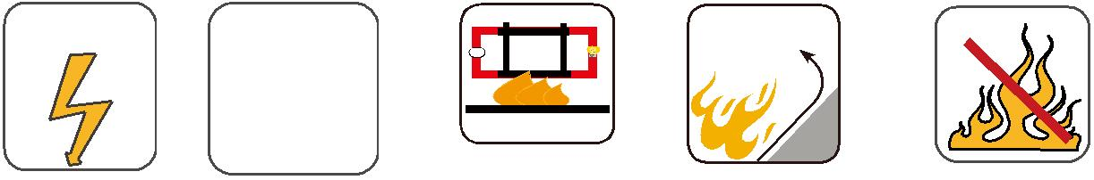
300/500V | BS 7629-1
 |  | W | E
 | N _{IEC}Circuit_{60331/BS}Integrity₆₃₈₇ |  |  | Reduced Fire Propagation | Flame Retardancy
 |  |  | EN 50200 | NF C32-070-2.2(C1) | NF C32-070-2.1(C2)
Rated Voltage |  | NF C32-070-2.3(CR1) |  | NF C32-070-2.2(C1) | NF C32-070-2.1(C2)
Rated Voltage | Standard |  |  | IEC60332-3-24/EN50266-2-4 | IEC60332-1-2/EN50265-2-1
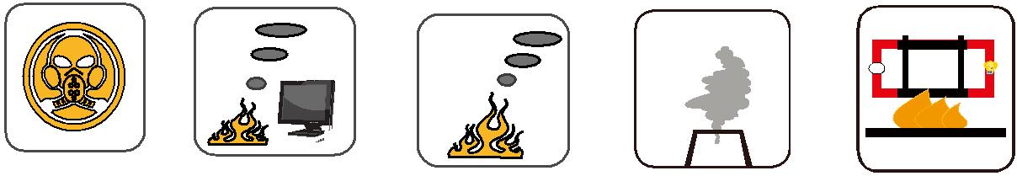

Zero

W

E

 | Low Corrosivity | Low Smoke Emission | Halogen Free
Low Toxicity | IEC60754-2 | Low Smoke Emission | Halogen Free
Low Toxicity | IEC60754-2 | IEC 61034-1&2 | IEC60754-1
NES 02-713/NF C 20-454 | EN50267-2-2/3 | IEC 61034-1&2 | IEC60754-1 | Functional Integrity
 | NF C 32-074 | EN 50268-1&2/NF C32-073 | EN50267-2-1 | DIN 4102-12

ADDISON 105

