 ADDISON

300/500V Mica+XLPE Insulated, LSZH Sheathed Power Cables (2-4cores)

FFX200 05mRZ1-R ( CU/MGT+XLPE/LSZH 300/500V Class 2)
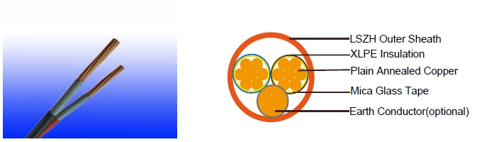

APPLICATION

The cables are designed for areas where the integrity of the electrical circuit is critical in maintaining power supply. Applications can be found in emergency lightings, control and power circuits, power stations, fire alarm systems, underground tunnels, lifts, escalators, and high-rise buildings.

STANDARDS

Basic design to IEC 60502-1

FIRE PERFORMANCE
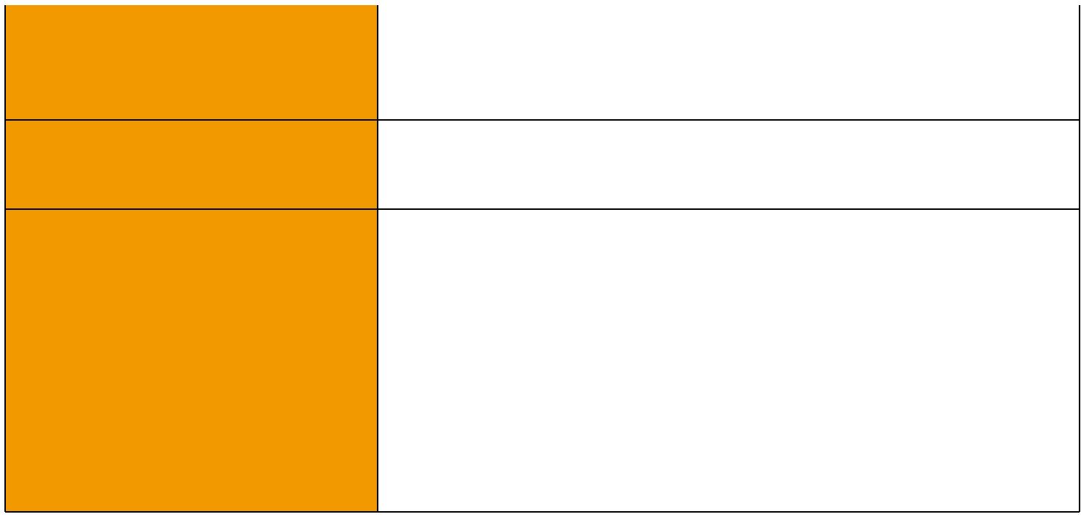
 | IEC 60331-21; BS 6387 CWZ; DIN VDE 0472-814(FE180);
Circuit Integrity | CEI 20-36/2-1; SS229-1; NBN C 30-004 (cat. F3);
 | NF C32-070-2.3(CR1)
System circuit integrity | DIN 4102-12, E30 depending on lay system
Flame Retardance (Single Vertical EN 60332-1-2; IEC 60332-1-2; BS EN 60332-1-2;

_{Wire Test)} VDE 0482-332-1 ; NBN C 30-004 (cat. F1); NF C32-070-2.1(C2); CEI 20-35/1-2; EN 50265-2-1*; DIN VDE 0482-265-2-1*

Reduced Fire Propagation | EN 60332-3-24 (cat. C); IEC 60332-3-24; BS EN 60332-3-24;
(Vertically-mounted bundled wires VDE 0482-332-3; NBN C 30-004 (cat. F2); NF C32-070-2.2(C1);
& cable test) | CEI 20-22/3-4; EN 50266-2-4*; DIN VDE 0482-266-2-4
Halogen Free | IEC 60754-1; EN 50267-2-1; DIN VDE 0482-267-2-1;
Halogen Free | CEI 20-37/2-1 ; BS 6425-1*
No Corrosive Gas Emission | IEC 60754-2; EN 50267-2-2; DIN VDE 0482-267-2-2;
No Corrosive Gas Emission | CEI 20-37/2-2 ; BS 6425-2*
Minimum Smoke Emission | IEC 61034-1&2; EN 61034 -1&2; DIN VDE 0482-1034-1&2;
Minimum Smoke Emission | CEI 20-37/3-1&2; EN 50268-1&2*; BS 7622-1&2*
No Toxic gases | NES 02-713; NF C 20-454

Note: Asterisk * denotes superseded standard.

40 Caledonian sales@caledonian-cables.net uk@caledonian-cables.net


Caledonian

Fire Resistant Power & Control Cables

www.caledonian-tech.net www.caledonian-tech.com

VOLTAGE RATING

300/500 V

CABLE CONSTRUCTION

Conductor: Plain annealed copper wire, stranded according to IEC(EN) 60228 class 2.

Insulation: Mica glass tape covered by extruded cross-linked XLPE compound

Earth Conductor(optional): Uninsulated solid or stranded tinned copper conductor.

Cabling: The cores are cabled together in concentric layers with suitable non-hygroscopic fillers.

Outer Sheath: Thermoplastic LSZH compound type LTS3 as per BS 7655-6.1 (Thermosetting LSZH compound type SW2-SW4 as per BS 7655-2.6 can be offered.)

COLOUR CODE

Insulation Colour

2 - Core: (Brown & Blue)

3 - Core: (Brown, Black & Grey)

4 - Core: (Brown, Black, Grey & Blue)

Sheath Colour

Orange (other colors upon request)

Physical AND THERMAL PROPERTIES

Temperature range during operation (fixed state):-30°C – +90°C

Temperature range during installation (mobile state): -20°C – +50°C

Minimum bending radius: 8 x Overall Diameter

Electrical PROPERTIES

Dielectric test: | 2000 | V r.m.s. x 5’ (core/core)
Insulation resistance | 1000 | MΩ x km (at 20°C)
Short circuit temperature | 250°C

 ADDISON 41

ADDISON

CONSTRUCTION PARAMETERS

 |  |  |  |  | FFX200 05mRZ1-R
Conductor |  |  |  | Without |  | With
 |  |  |  | Earth Conductor |  | Earth Conductor
No. of Core X | No./Nominal | Nominal | Nominal | Nominal | Approx. | Nominal |  | Approx.
No. of Core X | Diameter of | Insulation | Sheath | Overall | Approx. | Overall |  | Approx.
Cross Section | Strands | Thickness | Thickness | Diameter | Weight | Diameter |  | Weight
No*mm² | No./mm | mm | mm | mm | kg/km | mm |  | kg/km
 |  |  | 2 Core
2x1.5 | 7/0.53 | 0.5 | 0.5 | 7.7 | 70 | 8.2 |  | 80
2x2.5 | 7/0.67 | 0.5 | 0.5 | 8.8 | 100 | 9.6 |  | 120
2x4 | 7/0.85 | 0.5 | 0.5 | 9.8 | 140 | 10.5 |  | 170
 |  |  | 3 Core
3x1.5 | 7/0.53 | 0.5 | 0.5 | 8.7 | 90 | 10.5 |  | 100
3x2.5 | 7/0.67 | 0.5 | 0.5 | 9.5 | 125 | 10.7 |  | 150
3x4 | 7/0.85 | 0.5 | 0.5 | 11.5 | 180 | 12.5 |  | 220
 |  |  | 4 Core
4x1.5 | 7/0.53 | 0.5 | 0.5 | 10.3 | 105 | 12.2 |  | 120
4x2.5 | 7/0.67 | 0.5 | 0.5 | 11 | 155 | 13 |  | 190
4x4 | 7/0.85 | 0.5 | 0.5 | 12.5 | 255 | 13.5 |  | 270

ElectricAl PROPERTIES

Conductor Operating Temperature : 90°C

Ambient Temperature : 30°C

42 Caledonian sales@caledonian-cables.net uk@caledonian-cables.net

Caledonian

Fire Resistant Power & Control Cables

www.caledonian-tech.net www.caledonian-tech.com

Current-Carrying Capacities (Amp)

 |  | Reference
 |  | Method 4 | Reference Method 3 |  |  |  |  | Reference Method 11
 |  | (enclosed in | (enclosed in conduit on |  | Reference Method 1 |  |  | (on a perforated cable
 |  | an conduit | a wall or ceiling, or in |  | (clipped direct) |  |  | tray), or Reference Method
Nominal |  | insulated wall | trunking) |  |  |  |  | 13 (free air)
cross- |  | etc)
section |  |  |  |  |  |  |  | one 2-core
area |  | one 3-core | one 2-core | one 3-core | one 2-core | one 3-core |  | one 2-core | one 3-core
area |  |  |  |  |  |  |  | cable
 |  | cable or one | cable | cable or one | cable | cable or one |  | cable | cable or one
 |  |  |  |  |  |  |  | singlephase
 |  | 4-core cable | singlephase | 4-core cable | singlephase | 4-core cable |  | singlephase | 4-core cable
 |  | 3-phase a.c. | a.c. or d.c. | 3-phase a.c. | a.c. or d.c. | 3-phase a.c. |  | a.c. or | 3-phase a.c.
 |  |  |  |  |  |  |  | d.c.
1 |  | 2 | 3 | 4 | 5 | 6 |  | 7 | 8
mm² |  | A | A | A | A | A |  | A | A
1.5 |  | 16.5 | 22 | 19.5 | 24 | 22 |  | 26 | 23
2.5 |  | 22 | 30 | 26 | 33 | 30 |  | 36 | 32
4 |  | 30 | 40 | 35 | 45 | 40 |  | 49 | 42
Voltage Drop (Per Amp Per Meter)
Nominal Cross |  |  | 2-core cable d.c. |  | 2-core cable single- |  |  | 3-core or 4-core cable
Section Area |  |  |  |  | phase a.c |  |  | 3-phase a.c.
 | 1 |  | 2 |  | 3 |  |  | 4
 | mm² |  | mV/A/m |  | mV/A/m |  |  | mV/A/m
 | 1.5 |  | 31 |  | 31 |  |  | 27
 | 2.5 |  | 19 |  | 19 |  |  | 16
 | 4 |  | 12 |  | 12 |  |  | 10


300/500V ^{IEC}_{N}⁶⁰⁵⁰²⁻¹
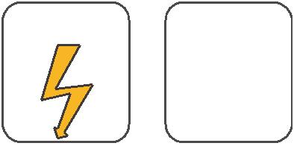
W

E
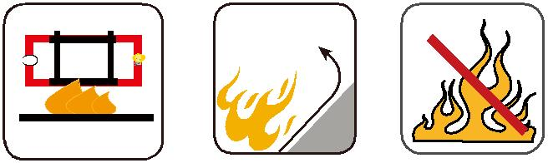

 |  | Circuit Integrity | Reduced Fire Propagation | Flame Retardancy
 |  | Circuit Integrity | NF C32-070-2.2(C1) | NF C32-070-2.1(C2)
Rated Voltage | Standard | IEC 60331/BS 6387 | NF C32-070-2.2(C1)
Rated Voltage | Standard | NF C32-070-2.3(CR1) | IEC60332-3-24/EN50266-2-4 IEC60332-1-2/EN50265-2-1
 |  |  | Zero | W | E
 | Low Corrosivity | Low Smoke Emission | Halogen Free
Low Toxicity | IEC60754-2 | Low Smoke Emission | Halogen Free
Low Toxicity | IEC60754-2 | IEC 61034-1&2 | IEC60754-1
Low Toxicity | EN50267-2-2/3 | IEC 61034-1&2 | IEC60754-1 | Functional Integrity
NES 02-713/NF C 20-454 | NF C 32-074 | EN 50268-1&2/NF C32-073 | EN50267-2-1 |  | DIN 4102-12
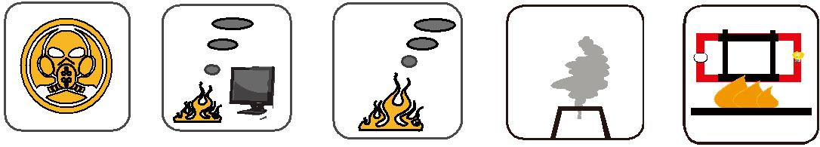

 ADDISON 43

