 ADDISON

300/500V Mica+XLPE Insulated & LSZH Sheathed Fire Alarm Cables

FFX200P 05mROZ1-R (CU/MICA+XLPE/OSCR/LSZH 300/500V Class 2 )
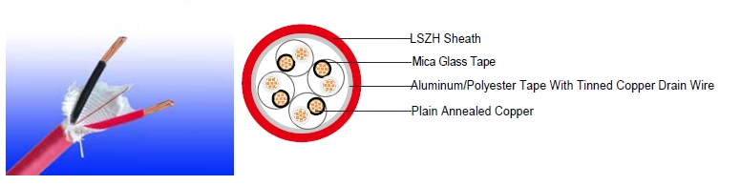

APPLICATION

The cables are designed, manufactured and tested as data transmission cables for emergency services. These are primarily intended for for indoor instrumentation and control cabling, electrically noisy environments and fire alarm systems in office buildings when high frequency signal transmission has to be assured in the event of a fire.

STANDARDS

Basic design to BS 7629-1

FIRE PERFORMANCE
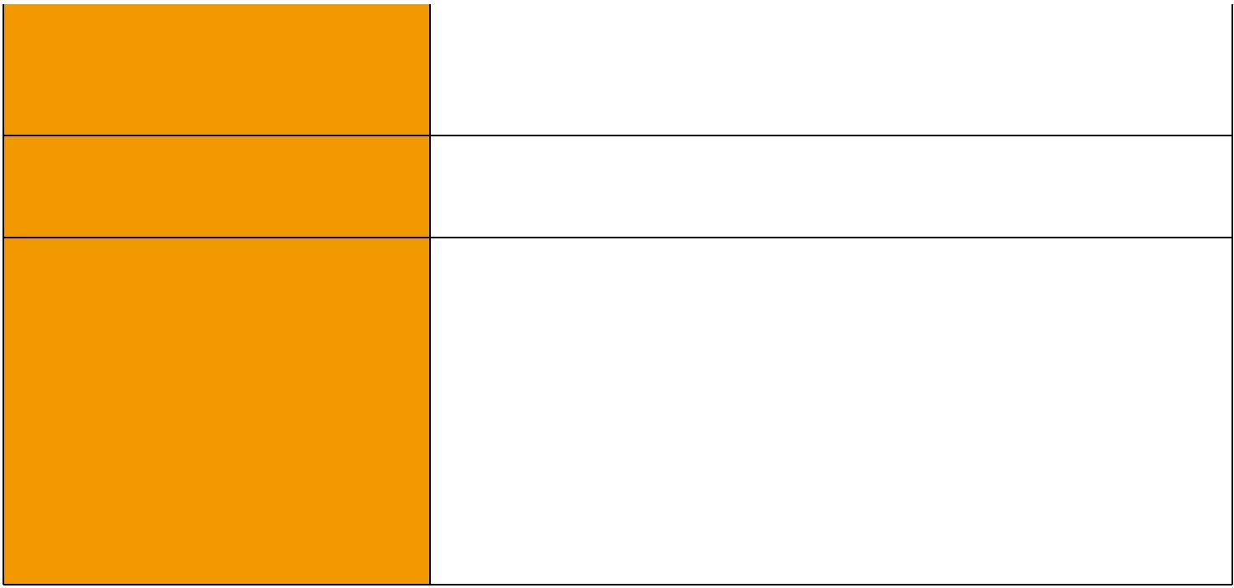
 | IEC 60331-21; BS 6387 CWZ; DIN VDE 0472-814(FE180);
Circuit Integrity | CEI 20-36/2-1; SS229-1; NBN C 30-004 (cat. F3);
 | NF C32-070-2.3(CR1)
System circuit integrity | DIN 4102-12, E30 depending on lay system
Flame Retardance (Single Vertical EN 60332-1-2; IEC 60332-1-2; BS EN 60332-1-2;

_{Wire Test)} VDE 0482-332-1 ; NBN C 30-004 (cat. F1); NF C32-070-2.1(C2); CEI 20-35/1-2; EN 50265-2-1*; DIN VDE 0482-265-2-1*

Reduced Fire Propagation | EN 60332-3-24 (cat. C); IEC 60332-3-24; BS EN 60332-3-24;
(Vertically-mounted bundled wires VDE 0482-332-3; NBN C 30-004 (cat. F2); NF C32-070-2.2(C1);
& cable test) | CEI 20-22/3-4; EN 50266-2-4*; DIN VDE 0482-266-2-4
Halogen Free | IEC 60754-1; EN 50267-2-1; DIN VDE 0482-267-2-1;
Halogen Free | CEI 20-37/2-1 ; BS 6425-1*
No Corrosive Gas Emission | IEC 60754-2; EN 50267-2-2; DIN VDE 0482-267-2-2;
No Corrosive Gas Emission | CEI 20-37/2-2 ; BS 6425-2*
Minimum Smoke Emission | IEC 61034-1&2; EN 61034 -1&2; DIN VDE 0482-1034-1&2;
Minimum Smoke Emission | CEI 20-37/3-1&2; EN 50268-1&2*; BS 7622-1&2*
No Toxic gases | NES 02-713; NF C 20-454

Note: Asterisk * denotes superseded standard.

106 Caledonian sales@caledonian-cables.net uk@caledonian-cables.net


Caledonian

Fire Resistant Fire Alarm Cables
www.caledonian-tech.net www.caledonian-tech.com

CABLE CONSTRUCTION

Conductors: Plain annealed copper wire, stranded according to IEC(EN) 60228 class 2.

Insulation: Mica glass tape covered by extruded cross-linked XLPE compound or cross-linked compound type EI5 as per BS 7655: section 5.1.

Cabling Elements: Insulated cores are twisted to form pairs with varying lay length to minimize crosstalk. Two-pair cable had four cores laid in quad formation.

Cabling: Pairs are cabled together. In cables with 8 pairs or more, 4 pairs are assembled to form a bunch, the bunches are then cabled together.

Overall screen: Aluminum/polyester tape with tinned copper drain wire.

Outer Sheath: Thermoplastic LSZH compound type LTS3 as per BS 7655-6.1 (Thermosetting LSZH compound type SW2-SW4 as per BS 7655-2.6 can be offered.)

COLOUR CODE

Insulation Colour: According to IEC 60189-2 (other colour code on request). Sheath Colour: Colour red (other colours on request).

Physical AND THERMAL PROPERTIES

Temperature range during operation (fixed state):-30°C - +90°C

Temperature range during installation (mobile state): -20°C - +50°C

Minimum bending radius: 8 x Overall Diameter

CONSTRUCTION PARAMETERS

 |  | Nominal | Nominal | Nominal | Approx.
Cable Code |  | Insulation | Sheath | Overall | Approx.
Cable Code |  | Insulation | Sheath | Overall | Weight
 |  | Thickness | Thickness | Diameter
mm² |  | mm | mm | mm | kg/km
1 Pairs
1x2x0.75 stranded FFX200P 05mROZ1-R (PH30) |  | 0.6 | 0.8 | 7.8 | 64
1x2x1 stranded FFX200P 05mROZ1-R (PH30) |  | 0.6 | 0.9 | 8.4 | 73
1x2x1.5 stranded FFX200P 05mROZ1-R (PH30) |  | 0.7 | 0.9 | 9.3 | 87
2 Pairs
2x2x0.75 stranded FFX200P 05mROZ1-R (PH30) |  | 0.6 | 0.9 | 10.7 | 118
2x2x1stranded FFX200P 05mROZ1-R (PH30) |  | 0.6 | 1.0 | 11.5 | 136
2x2x1.5 stranded FFX200P 05mROZ1-R (PH30) |  | 0.7 | 1.0 | 13.0 | 165
5 Pairs
5x2x0.75 stranded FFX200P 05mROZ1-R (PH30) |  | 0.6 | 1.1 | 14.8 | 218
5x2x1 stranded FFX200P 05mROZ1-R (PH30) |  | 0.6 | 1.2 | 15.7 | 266
5x2x1.5 stranded FFX200P 05mROZ1-R (PH30) |  | 0.7 | 1.3 | 18.1 | 342
10 Pairs

 ADDISON 107

ADDISON

10x2x0.75 stranded FFX200P 05mROZ1-R (PH30) | 0.6 | 1.3 | 20.1 | 380
10x2x1 stranded FFX200P 05mROZ1-R (PH30) | 0.6 | 1.4 | 21.3 | 455
10x2x1.5 stranded FFX200P 05mROZ1-R (PH30) | 0.7 | 1.5 | 24.8 | 606
15 Pairs
15x2x0.75 stranded FFX200P 05mROZ1-R (PH30) | 0.6 | 1.4 | 24.9 | 535
15x2x1 stranded FFX200P 05mROZ1-R (PH30) | 0.6 | 1.5 | 26.5 | 646
15x2x1.5 stranded FFX200P 05mROZ1-R (PH30) | 0.7 | 1.6 | 30.8 | 862
20 Pairs
20x2x0.75 stranded FFX200P 05mROZ1-R (PH30) | 0.6 | 1.5 | 28.2 | 680
20x2x1 stranded FFX200P 05mROZ1-R (PH30) | 0.6 | 1.6 | 30.2 | 839
20x2x1.5 stranded FFX200P 05mROZ1-R (PH30) | 0.7 | 1.8 | 34.9 | 1121

approximate values

300/500V _{N}^{BS7629-1}
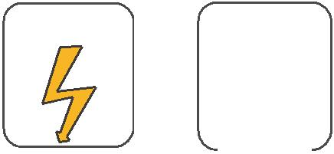
W

E
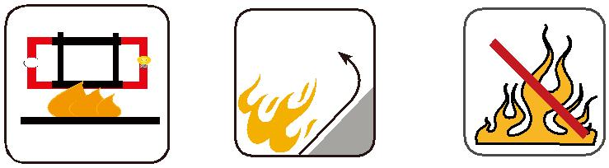

 |  |  |  |  | Circuit Integrity |  |  | Reduced Fire Propagation |  |  | Flame Retardancy
 |  |  |  |  |  |  |  | NF C32-070-2.2(C1) |  |  | NF C32-070-2.1(C2)
Rated Voltage |  |  |  | Standard | IEC 60331/BS 6387 |  |  |  |  |  | NF C32-070-2.1(C2)
 |  |  |  | Standard | NF C32-070-2.3(CR1) |  |  | IEC60332-3-24/EN50266-2-4 |  |  | IEC60332-1-2/EN50265-2-1
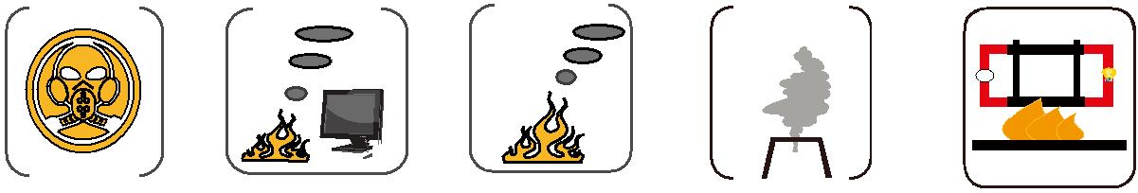

Zero

W

E

 |  |  | Low Corrosivity | Low Smoke Emission
 |  |  | Low Corrosivity | Low Smoke Emission | Halogen Free
 | Low Toxicity |  | IEC60754-2 | IEC 61034-1&2 | IEC60754-1 | Functional Integrity
 |  |  | EN50267-2-2/3 | EN 50268-1&2/NF C32-073 | IEC60754-1 | Functional Integrity
NES 02-713/NF C 20-454 |  |  | NF C 32-074 |  | EN50267-2-1 | DIN 4102-12

108 Caledonian sales@caledonian-cables.net uk@caledonian-cables.net

