 ADDISON

300/500V Mica+SR Insulated & Overall Screened Control Cables (2-4 Cores & Multicores)

FFX200E 05mSOZ1-U (PH120) (CU/MGT+SR/OSCR/LSZH 300/500V Class 1) FFX200E 05mSOZ1-R (PH120) (CU/MGT+SR/OSCR/LSZH 300/500V Class 2)
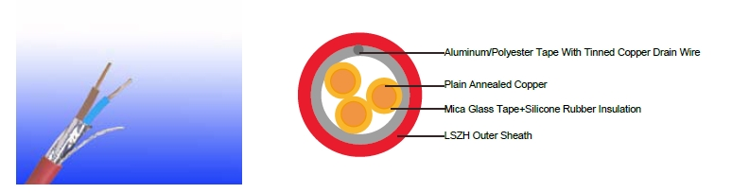

APPLICATION

The cables are primarly intended for use in the following applications:

BS 5266-1 for emergency lighting of premises

BS 5839-1 for fire detection and fire alarm systemsin and around building

BS 5839-8 for voice alarm systems

BS 5839-9 for emergency voice communication systems.

STANDARDS

Basic design to BS 7629-1

FIRE PERFORMANCE

 |  |  | IEC 60331-21; BS 6387 CWZ; DIN VDE 0472-814(FE180);
 | Circuit Integrity |  | BS 8434-2 (120mins); BS 5839-1 Clause 26 2e; CEI 20-36/2-1;
 |  |  | SS229-1; NBN C 30-004 (cat. F3); NF C32-070-2.3(CR1)
 | Circuit Integrity with mechanical |  | EN 50200(PH120); CEI 20-36/4-0
 | shock |  | EN 50200(PH120); CEI 20-36/4-0
 | Circuit Integrity with mechanical |  | EN 50200 annex E
 | shock & water spray |  | EN 50200 annex E
 | System circuit integrity |  | DIN 4102-12, E30 depending on lay system
 | Flame Retardance (Single Vertical |  | EN 60332-1-2; IEC 60332-1-2; BS EN 60332-1-2;
 | Wire Test) |  | VDE 0482-332-1 ; NBN C 30-004 (cat. F1); NF C32-070-2.1(C2);
 | Wire Test) |  | CEI 20-35/1-2; EN 50265-2-1*; DIN VDE 0482-265-2-1*
 | Reduced Fire Propagation |  | EN 60332-3-24 (cat. C); IEC 60332-3-24; BS EN 60332-3-24;
 | (Vertically-mounted bundled wires |  | VDE 0482-332-3; NBN C 30-004 (cat. F2); NF C32-070-2.2(C1);
 | & cable test) |  | CEI 20-22/3-4; EN 50266-2-4*; DIN VDE 0482-266-2-4
 | Halogen Free |  | IEC 60754-1; EN 50267-2-1; DIN VDE 0482-267-2-1;
 | Halogen Free |  | CEI 20-37/2-1 ; BS 6425-1*
 | No Corrosive Gas Emission |  | IEC 60754-2; EN 50267-2-2; DIN VDE 0482-267-2-2;
 |  |  | CEI 20-37/2-2 ; BS 6425-2*
60 | Caledonian | sales@caledonian-cables.net uk@caledonian-cables.net


Caledonian

Fire Resistant Power & Control Cables

www.caledonian-tech.net www.caledonian-tech.com


Minimum Smoke Emission | IEC 61034-1&2; EN 61034 -1&2; DIN VDE 0482-1034-1&2;
Minimum Smoke Emission | CEI 20-37/3-1&2; EN 50268-1&2*; BS 7622-1&2*
No Toxic gases | NES 02-713; NF C 20-454

Note: Asterisk * denotes superseded standard.

VOLTAGE RATING

300/500 V

CABLE CONSTRUCTION

Conductors: Plain annealed copper wire, solid according to IEC(EN) 60228 class 1, stranded according to IEC(EN) 60228 class 2.

Insulation: Mica glass fire resistant tape covered by fire resistant silicone rubber compound type EI2 as per BS 7655-1.1.

Cabling: The cores are cabled together in concentric layers with suitable non-hygroscopic fillers. Overall screen: Aluminum/polyester tape with tinned copper drain wire.

Circuit Protective Conductor: Uninsulated tinned copper conductor of the same section and class as the insulated conductors in the 2-, 3- and 4-core cables. Drain wire of 0.5mm² tinned copper conductor is provided in cables of more than 4 conductors.

Outer Sheath: Thermoplastic LSZH compound type LTS3 as per BS 7655-6.1 (Thermosetting LSZH compound type SW2-SW4 as per BS 7655-2.6 can be offered.)

COLOUR CODE

Insulation Colour

2 cores blue - brown

3 cores brown - black - grey

4 cores blue - brown - black - grey

(Colour Code Up To 4 Cores In Accordance to HD 308)

7 cores centre: brown 1st layer: brown - black - 4 cores white

12 cores centre: brown - black - white 1st layer: brown - black - 7 cores white 19 cores centre: brown 1st layer: brown - black - 4 cores white

2nd layer: brown - black - 10 cores white

(on request the cores can be one colour only, identified by printed numbers

Sheath Colour: Colour red or white (other colours on request)

Physical AND THERMAL PROPERTIES

Temperature range during operation (fixed state):-30°C – +90°C

Temperature range during installation (mobile state): -20°C – +50°C Minimum bending radius: 7.5 x Overall Diameter

Electrical PROPERTIES

Dielectric test: | 2000 V r.m.s. x 5’ (core/core)
Insulation resistance | ≥300 MΩ x km (at 20°C)
Short circuit temperature | 350°C

 ADDISON 61
ADDISON

CONSTRUCTION PARAMETERS

 | No. of Core | Nominal | Nominal | Nominal | Approx.
Cable Code | X Cross | Insulation | Sheath | Overall | Approx.
 |  |  |  |  | Weight
 | Section | Thickness | Thickness | Diameter | Weight
 | mm² | mm | mm | mm | kg/km
 | 2 core,
FFX200E 05mSOZ1-U(PH120) | 2x1.0 | 0.6 | 0.9 | 7.9 | 85
FFX200E 05mSOZ1-U(PH120) | 2x1.5 | 0.7 | 0.9 | 8.8 | 105
FFX200E 05mSOZ1-U(PH120) | 2x2.5 | 0.8 | 1.0 | 10.2 | 150
FFX200E 05mSOZ1-R(PH120) | 2x1.5 | 0.7 | 0.9 | 9.2 | 110
FFX200E 05mSOZ1-R(PH120) | 2x2.5 | 0.8 | 1.0 | 10.3 | 155
FFX200E 05mSOZ1-R(PH120) | 2x4.0 | 0.8 | 1.1 | 12.2 | 220
 | 3 core
FFX200E 05mSOZ1-U(PH120) | 3x1.0 | 0.6 | 0.9 | 8.4 | 105
FFX200E 05mSOZ1-U(PH120) | 3x1.5 | 0.7 | 0.9 | 9.3 | 130
FFX200E 05mSOZ1-U(PH120) | 3x2.5 | 0.8 | 1.0 | 10.8 | 190
FFX200E 05mSOZ1-R(PH120) | 3x1.5 | 0.7 | 0.9 | 9.4 | 135
FFX200E 05mSOZ1-R(PH120) | 3x2.5 | 0.8 | 1.0 | 10.9 | 190
FFX200E 05mSOZ1-R(PH120) | 3x4.0 | 0.8 | 1.1 | 13.0 | 280
 | 4 core
FFX200E 05mSOZ1-U(PH120) | 4x1.0 | 0.6 | 1.0 | 9.3 | 125
FFX200E 05mSOZ1-U(PH120) | 4x1.5 | 0.7 | 1.0 | 10.3 | 165
FFX200EE 05mSOZ1-U(PH120) | 4x2.5 | 0.8 | 1.1 | 12.0 | 240
FFX200E 05mSOZ1-R(PH120) | 4x1.5 | 0.7 | 1.0 | 10.5 | 170
FFX200E 05mSOZ1-R(PH120) | 4x2.5 | 0.8 | 1.1 | 12.1 | 250
FFX200E 05mSOZ1-R(PH120) | 4x4.0 | 0.8 | 1.2 | 14.4 | 350
 | 7 core
FFX200E 05mSOZ1-U(PH120) | 7x1.0 | 0.6 | 1.0 | 10.5 | 175
FFX200E 05mSOZ1-U(PH120) | 7x1.5 | 0.7 | 1.1 | 12.1 | 230
 | 12 core
FFX200E 05mSOZ1-U(PH120) | 12x1.0 | 0.6 | 1.1 | 14.5 | 300
FFX200E 05mSOZ1-U(PH120) | 12x1.5 | 0.7 | 1.2 | 16.0 | 380
 | 19 core
FFX200E 05mSOZ1-U(PH120) | 19x1.0 | 0.6 | 1.2 | 17.5 | 470
FFX200E 05mSOZ1-U(PH120) | 19x1.5 | 0.7 | 1.3 | 17.5 | 470

62 Caledonian sales@caledonian-cables.net uk@caledonian-cables.net

Caledonian

Fire Resistant Power & Control Cables

www.caledonian-tech.net www.caledonian-tech.com

ELECTRICAL PROPERTIES

Conductor Operating Temperature : 90°C

Ambient Temperature : 30°C

Current-Carrying Capacities (Amp)

 |  | Reference
 |  | Method 4 | Reference Method 3 |  |  |  |  |  |  |  | Reference Method 11
 |  | (enclosed in | (enclosed in conduit on |  |  |  | Reference Method 1 |  |  |  | (on a perforated cable
 |  | an conduit | a wall or ceiling, or in |  |  |  | (clipped direct) |  |  |  | tray), or Reference Method
Conductor |  | insulated wall | trunking) |  |  |  |  |  |  |  | 13 (free air)
cross- |  | etc)
sectional |  |  |  |  |  |  |  |  |  |  | one 2-core
area |  | one 3-core | one 2-core |  |  | one 3-core | one 2-core |  |  | one 3-core |  |  |  |  | one 3-core
area |  | one 3-core |  |  |  | one 3-core |  |  |  | one 3-core | cable |  |  |  | one 3-core
 |  | cable or one | cable |  |  | cable or one | cable |  |  | cable or one |  |  |  |  | cable or one
 |  | cable or one |  |  |  | cable or one |  |  |  | cable or one | singlephase |  |  |  | cable or one
 |  | 4-core cable | singlephase |  |  | 4-core cable | singlephase |  |  | 4-core cable |  |  |  |  | 4-core cable
 |  | 3-phase a.c. | a.c. or d.c. |  |  | 3-phase a.c. | a.c. or d.c. |  |  | 3-phase a.c. | a.c. or |  |  |  | 3-phase a.c.
 |  | 3-phase a.c. |  |  |  | 3-phase a.c. |  |  |  | 3-phase a.c. | d.c. |  |  |  | 3-phase a.c.
1 |  | 2 | 3 |  |  | 4 | 5 |  |  | 6 | 7 |  |  |  | 8
mm² |  | A | A |  |  | A | A |  |  | A | A |  |  |  | A
1.5 |  | 16.5 | 22 |  |  | 19.5 | 24 |  |  | 22 | 26 |  |  |  | 23
2.5 |  | 22 | 30 |  |  | 26 | 33 |  |  | 30 | 36 |  |  |  | 32
4 |  | 30 | 40 |  |  | 35 | 45 |  |  | 40 | 49 |  |  |  | 42
Voltage Drop (Per Amp Per Meter)
Nominal Cross |  |  |  | 2-core cable d.c. |  |  |  | 2-core cable single- |  |  |  | 3-core or 4-core cable
Section Area |  |  |  |  |  |  |  | phase a.c |  |  |  | 3-phase a.c.
 | 1 |  |  |  | 2 |  |  |  | 3 |  |  |  |  | 4
 | mm² |  |  | mV/A/m |  |  |  | mV/A/m |  |  |  |  | mV/A/m
 | 1.5 |  |  | 31 |  |  |  |  | 31 |  |  |  |  | 27
 | 2.5 |  |  | 19 |  |  |  |  | 19 |  |  |  |  | 16
 | 4 |  |  | 12 |  |  |  |  | 12 |  |  |  |  | 10


300/500V _{N}^{BS7629-1}
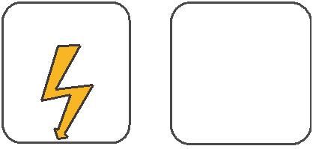
W

E
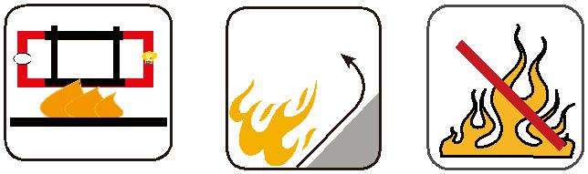

 |  | Circuit Integrity | Reduced Fire Propagation | Flame Retardancy
 |  | IEC 60331/BS 6387 | Reduced Fire Propagation | Flame Retardancy
 |  | IEC 60331/BS 6387 | NF C32-070-2.2(C1) | NF C32-070-2.1(C2)
Rated Voltage | Standard | EN 50200 | NF C32-070-2.2(C1) | NF C32-070-2.1(C2)
NF C32-070-2.3(CR1) IEC60332-3-24/EN50266-2-4 IEC60332-1-2/EN50265-2-1
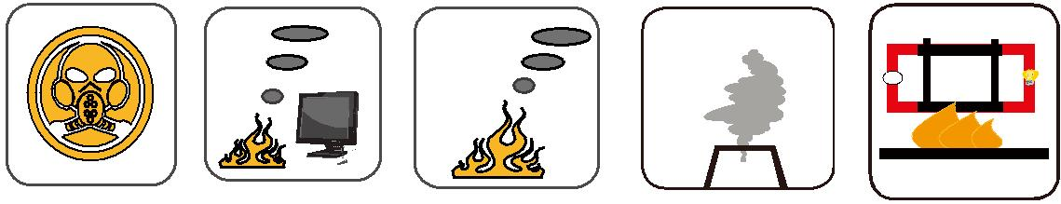

Zero

W

E

 | Low Corrosivity | Low Smoke Emission | Halogen Free
 | IEC60754-2 | Low Smoke Emission | Halogen Free
Low Toxicity | IEC60754-2 | IEC 61034-1&2 | IEC60754-1
Low Toxicity | EN50267-2-2/3 | IEC 61034-1&2 | IEC60754-1 | Functional Integrity
NES 02-713/NF C 20-454 | NF C 32-074 | EN 50268-1&2/NF C32-073 | EN50267-2-1 | DIN 4102-12

ADDISON 63

