IEC Standard Caledonian Offshore & Marine Cables

MariFlex Marine Fire Resistant Power & Control Cables

www.caledonian-cables.co.uk


MFX300 0.6/1 kV Mica Tape + XLPE Insulated, LSOH (SHF1) Sheathed Fire Resistant Power & Control Cables (Single Core)

Application

These unarmoured fire resistant cables are used on board of ships in all locations for fixed installations where cable protection is not required. These cables are fire resistant, flame retardant, low smoke & halogen free.


Standards

● IEC 60092-350/351/353/359
● IEC 60331-21
● IEC 60332-1
● IEC 60332-3-22
● IEC 60754-1/2
● IEC 61034
Stranded Copper Conductor Mica Tape + XLPE Insulation LSOH (SHF1) Sheath

Construction

- Conductors: Class 2 stranded copper conductor. Class 5 stranded conductors can be offered upon request.
- Insulation: Mica tape + XLPE.
- Outer Sheath: LSOH (SHF1). SHF2 can be offered upon request.

Core Identification

Single core: Black.

Mechanical and Thermal Properties

Bending Radius for Fixed Installations: 6×OD (OD>25mm); 4×OD (OD ≤25mm) Temperature Range: -30℃ ~ +80℃

30 ADDISON www.addison-cables.com

IEC Standard Caledonian Offshore & Marine Cables

MariFlex Marine Fire Resistant Power & Control Cables

www.caledonian-cables.co.uk


Dimensions and Weight

MFX300 1mRZ1-R Single Core 0.6/1kV (-R stands for class 2 conductor. For class 5 conductor, please change –R to –F)

Part No. | Construction  No. of cores×Cross  section(mm²) | Nominal Insulation Thickness  mm | Nominal Sheath Thickness  mm | Nominal Overall Diameter  mm | Nominal Weight kg/km
MFX300-1mRZ1-R-1C25 | 1×25 | 0.9 | 1.1 | 10.7 | 310
MFX300-1mRZ1-R-1C35 | 1×35 | 0.9 | 1.1 | 12.0 | 410
MFX300-1mRZ1-R-1C50 | 1×50 | 1.0 | 1.2 | 13.6 | 560
MFX300-1mRZ1-R-1C70 | 1×70 | 1.1 | 1.3 | 15.8 | 780
MFX300-1mRZ1-R-1C95 | 1×95 | 1.1 | 1.3 | 17.7 | 1030
MFX300-1mRZ1-R-1C120 | 1×120 | 1.2 | 1.4 | 19.7 | 1290

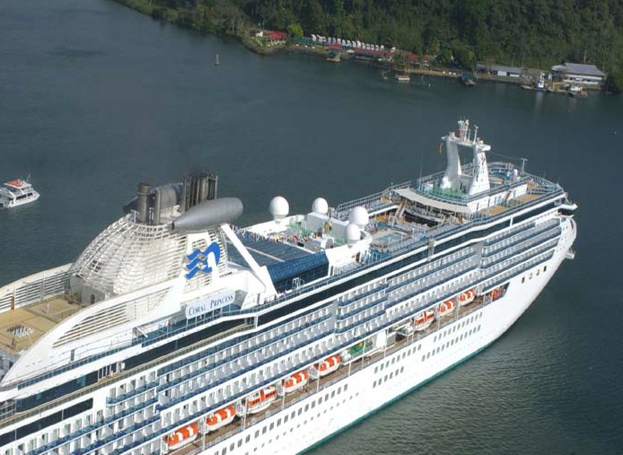

www.addison-cables.com
ADDISON 31

