
Caledonian

Fire Resistant Fire Alarm Cables
www.caledonian-tech.net www.caledonian-tech.com

225V SR Insulated & LSZH Sheathed Fire Alarm Cables

JE-H(St)H…Bd FE180 E30 (CU/SR/OSCR/LSZH 225V Class 1)

JE-H(St)HSWAH…Bd FE180 E30 (CU/SR/OSCR/LSZH/SWA/LSZH 225V Class 1)

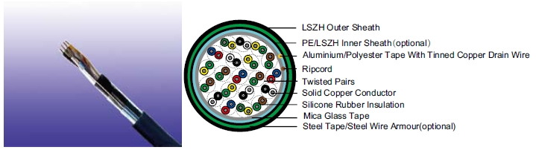
APPLICATION

The cables are used for the internal wiring of building when the circuit integrity during fire is paramount. The cables are intended for use in fire fighting plants with special ceramized silicone insulation, with and without aluminum foil and LSZH outer sheath. The fire alarm cables with 30 to 90 minutes circuit integrity should be used for control voltages and data transfer in alarm and fire alarm systems, where a system circuit integrity E30/E60/E90 depending on lay system in accordance with DIN 4102-12 is required. The circuit integrity is guaranteed with a test voltage of 110V.

STANDARDS

Basic design to VDE 0815

FIRE PERFORMANCE
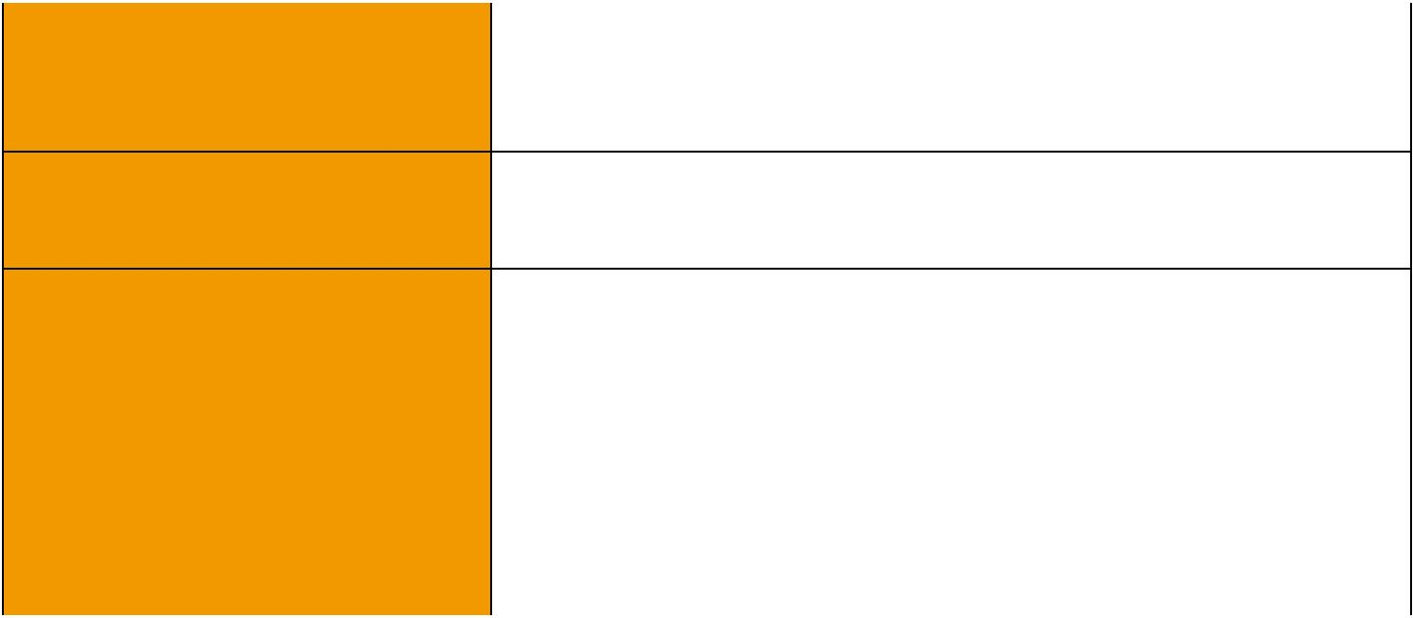
 | IEC 60331-23; BS 6387 CWZ; DIN VDE 0472-814(FE180);
Circuit Integrity | CEI 20-36/2-1; SS229-1; NBN C 30-004 (cat. F3);
 | NF C32-070-2.3(CR1)
System circuit integrity | DIN 4102-12, E30 depending on lay system
Flame Retardance (Single Vertical EN 60332-1-2; IEC 60332-1-2; BS EN 60332-1-2;

_{Wire Test)} VDE 0482-332-1 ; NBN C 30-004 (cat. F1); NF C32-070-2.1(C2); CEI 20-35/1-2; EN 50265-2-1*; DIN VDE 0482-265-2-1*

Reduced Fire Propagation | EN 60332-3-24 (cat. C); IEC 60332-3-24; BS EN 60332-3-24;
(Vertically-mounted bundled wires VDE 0482-332-3; NBN C 30-004 (cat. F2); NF C32-070-2.2(C1);
& cable test) | CEI 20-22/3-4; EN 50266-2-4*; DIN VDE 0482-266-2-4
Halogen Free | IEC 60754-1; EN 50267-2-1; DIN VDE 0482-267-2-1;
Halogen Free | CEI 20-37/2-1 ; BS 6425-1*
No Corrosive Gas Emission | IEC 60754-2; EN 50267-2-2; DIN VDE 0482-267-2-2;
No Corrosive Gas Emission | CEI 20-37/2-2 ; BS 6425-2*
Minimum Smoke Emission | IEC 61034-1&2; EN 61034 -1&2; DIN VDE 0482-1034-1&2;
Minimum Smoke Emission | CEI 20-37/3-1&2; EN 50268-1&2*; BS 7622-1&2*

 ADDISON 93

 ADDISON

No Toxic gases | NES 02-713; NF C 20-454

Note: Asterisk * denotes superseded standard.

CABLE CONSTRUCTION

Conductors: Solid annealed bare or tinned copper sized 0.6/0.8/0.9mm as per class 1 of VDE 0295/ IEC 60228.

Insulation: Silicone Rubber compound as per DIN VDE 0266.

Cabling Elements: Insulated cores are twisted to form pairs with varying lay length to minimize crosstalk. Two-pair cable had four cores laid in quad formation.

Cabling: Pairs are cabled together.In cables with 8 pairs or more, 4 pairs are assembled to form a bunch, and the bunches are then cabled together.

Cable Core Assembly: The twisted pairs are stranded to the core in layers.

Core Wrapping: One or more non hygroscopic polyester tapes are helically or longitudinally laid with an overlap prior to sheathing.

Screen: A laminated Aluminum/Polyester tape is placed in contact with solid copper 0.6mm or 0.8mm drain wire.

Inner Sheath(optional): PE or thermoplastic LSZH compound type.

Armour (optional): Either corrugated steel tape armour or galvanized steel wire is applied over an inner polyethylene sheath. For steel tape armour, the 0.15mm thick steel tape is coated with a copolymer and applied with an overlap. For steel wire armour, single layer of galvanized steel wire armour is applied.

Ripcord: Nylon ripcord may be placed parallel to the cores to facilitate sheath removal. Drain Wire: A solid tinned earth/continuity wire shall be laid longitudinally for screened cables. Outer Sheath: Thermoplastic LSZH compound HM2 as per DIN VDE 0207-24 .

COLOUR CODE

Quad colour in each bundle:

Pair 1: Blue-Red Pair 2: Green-Yellow Pair 3: Green-Brown Pair 4: White-Black The individual bundles are identified by a numbered helix.

TYPE CODE

JE- | Fire alarm cable | H | Halogen free & zero halogen
Bd | Unit stranding. | (St) | Static shield of Aluminum tape
FE180 | Insulation integrity (950°C 180 minutes) | E30 | 30 minutes system circuit integrity
STA | Corrugated steel tape | SWA | Steel wire armour
SWB | Steel wire braid

Physical AND THERMAL PROPERTIES

Temperature range during operation (fixed state):-30°C – +90°C

Temperature range during installation (mobile state): -20°C – +50°C

Minimum bending radius: 8 x Overall Diameter (unarmoured cable) 10 x Overall Diameter (armoured cables)

ELECTRICAL PROPERTIES

Conductor Diameter | mm | 0.6 | 0.8 | 0.9

94 Caledonian sales@caledonian-cables.net uk@caledonian-cables.net

Caledonian

Fire Resistant Fire Alarm Cables
www.caledonian-tech.net www.caledonian-tech.com


Conductor Size | mm² | 0.283 | 0.5 | 0.312
Maximum Conductor Resistance @20°C | Ω/km | 63 | 34.6 | 28.0
Maximum Loop Resistance @20°C | Ω/km | 130 | 73.2 | 60
Minimum Insulation Resistance @500V DC @20°C | MΩ.km | 100 | 100 | 100
Maximum Average Attenuation @0.8KHz | dB/km | 1.7 | 1.2 | 0.74
Nominal Mutual Capacitance @0.8KHz | nF/km | 120 | 120 | 120
Maximum Capacitance Unbalance K1 @0.8KHz pair-to-pair | pF/100m | 200 | 200 | 200
Working Voltage | V | 225 | 225 | 225
Nominal Insulation Thickness | mm | 0.3 | 0.4 | 0.45
Nominal Insulated Conductor Diameter | mm | 1.2 | 1.6 | 1.7

CONSTRUCTION PARAMETERS

VDE CODE: JE-SH(St)H…x2x0.8 Bd FE180/E30

 | No.of |  | Nominal |  | Nominal | Nominal |  | Approx.
Cable Code | No.of |  | Insulation |  | Sheath | Overall |  | Approx.
Cable Code | Pairs |  |  |  | Sheath |  |  | Weight
 | Pairs |  | Thickness |  | Thickness | Diameter |  | Weight
 |  |  | mm |  | mm | mm |  | kg/km
0.8mm Conductor, 1.6mm Insulated Wire
JE-H(St)H...1x2x0.8 Bd FE180/E30 | 1 |  | 0.4 |  | 1.0 | 6.0 |  | 46
JE-H(St)H...2x2x0.8 Bd FE180/E30 | 2 |  | 0.4 |  | 1.0 | 6.6 |  | 61
JE-H(St)H...4x2x0.8 Bd FE180/E30 | 4 |  | 0.4 |  | 1.0 | 8.8 |  | 104
JE-H(St)H...6x2x0.8 Bd FE180/E30 | 6 |  | 0.4 |  | 1.0 | 10.8 |  | 160
JE-H(St)H...8x2x0.8 Bd FE180/E30 | 8 |  | 0.4 |  | 1.0 | 12.8 |  | 218
JE-H(St)H...10x2x0.8 Bd FE180/E30 | 10 |  | 0.4 |  | 1.2 | 13.1 |  | 220
JE-H(St)H...12x2x0.8 Bd FE180/E30 | 12 |  | 0.4 |  | 1.2 | 13.5 |  | 235
JE-H(St)H...16x2x0.8 Bd FE180/E30 | 16 |  | 0.4 |  | 1.2 | 14.7 |  | 297
JE-H(St)H...20x2x0.8 Bd FE180/E30 | 20 |  | 0.4 |  | 1.2 | 16.1 |  | 367
JE-H(St)H...24x2x0.8 Bd FE180/E30 | 24 |  | 0.4 |  | 1.4 | 18.1 |  | 440
JE-H(St)H...30x2x0.8 Bd FE180/E30 | 30 |  | 0.4 |  | 1.4 | 20.1 |  | 645
JE-H(St)H...32x2x0.8 Bd FE180/E30 | 32 |  | 0.4 |  | 1.4 | 20.6 |  | 645
JE-H(St)H...40x2x0.8 Bd FE180/E30 | 40 |  | 0.4 |  | 1.4 | 22.5 |  | 656
JE-H(St)H...50x2x0.8 Bd FE180/E30 | 50 |  | 0.4 |  | 1.6 | 24.3 |  | 840
VDE CODE: JE-SH(St)HSWAH…x2x0.6/0.8/0.9 Bd FE180/E30
 | No. of | Nominal |  |  | Nominal | Nominal |  | Approx.
Cable Code | No. of | Insulation |  |  | Sheath | Overall |  | Approx.
Cable Code | Pairs |  |  |  | Sheath | Overall |  | Weight
 | Pairs | Thickness |  |  | Thickness | Diameter |  | Weight
 |  | mm |  |  | mm | mm |  | kg/km
0.6mm Conductor,1.2mm Insulated Wire


ADDISON 95

ADDISON

JE-H(St)HSWAH...2x2x0.6 Bd FE180/E30 | 2 | 0.3 | 1.0/1.8 | 12.1 | 305
JE-H(St)HSWAH...3x2x0.6 Bd FE180/E30 | 3 | 0.3 | 1.0/1.8 | 12.6 | 325
JE-H(St)HSWAH...6x2x0.6 Bd FE180/E30 | 6 | 0.3 | 1.0/1.8 | 12.6 | 380
JE-H(St)HSWAH...8x2x0.6 Bd FE180/E30 | 8 | 0.3 | 1.0/1.8 | 14.6 | 415
JE-H(St)HSWAH...10x2x0.6 Bd FE180/E30 | 10 | 0.3 | 1.0/1.8 | 16.5 | 450
JE-H(St)HSWAH...12x2x0.6 Bd FE180/E30 | 12 | 0.3 | 1.0/1.8 | 17.0 | 500
JE-H(St)HSWAH...20x2x0.6 Bd FE180/E30 | 20 | 0.3 | 1.0/1.8 | 20.5 | 580
JE-H(St)HSWAH...25x2x0.6 Bd FE180/E30 | 25 | 0.3 | 1.0/1.8 | 21.5 | 940
JE-H(St)HSWAH...30x2x0.6 Bd FE180/E30 | 30 | 0.3 | 1.0/1.8 | 22.5 | 1300
0.8mm Conductor, 1.6mm Insulated Wire
JE-H(St)HSWAH...2x2x0.8 Bd FE180/E30 | 2 | 0.4 | 1.0/1.8 | 14.0 | 415
JE-H(St)HSWAH...3x2x0.8 Bd FE180/E30 | 3 | 0.4 | 1.0/1.8 | 14.0 | 425
JE-H(St)HSWAH...6x2x0.8 Bd FE180/E30 | 6 | 0.4 | 1.0/1.8 | 15.0 | 485
JE-H(St)HSWAH...8x2x0.8 Bd FE180/E30 | 8 | 0.4 | 1.0/1.8 | 17.5 | 520
JE-H(St)HSWAH...10x2x0.8 Bd FE180/E30 | 10 | 0.4 | 1.2/1.8 | 19.0 | 540
JE-H(St)HSWAH...12x2x0.8 Bd FE180/E30 | 12 | 0.4 | 1.2/1.8 | 20.5 | 600
JE-H(St)HSWAH...20x2x0.8 Bd FE180/E30 | 20 | 0.4 | 1.4/1.8 | 24.5 | 1050
JE-H(St)HSWAH...25x2x0.8 Bd FE180/E30 | 25 | 0.4 | 1.4/1.8 | 27.0 | 1250
JE-H(St)HSWAH...30x2x0.8 Bd FE180/E30 | 30 | 0.4 | 1.4/1.8 | 28.5 | 1450
0.9mm Conductor, 1.8mm Insulated Wire
JE-H(St)HSWAH...10x2x0.9 Bd FE180/E30 | 10 | 0.45 | 1.2/1.8 | 19.7 | 600
JE-H(St)HSWAH...15x2x0.9 Bd FE180/E30 | 15 | 0.45 | 1.2/1.8 | 23.0 | 1020
JE-H(St)HSWAH...20x2x0.9 Bd FE180/E30 | 20 | 0.45 | 1.4/1.8 | 25.3 | 1160
JE-H(St)HSWAH...25x2x0.9 Bd FE180/E30 | 25 | 0.45 | 1.4/1.8 | 27.3 | 1330
JE-H(St)HSWAH...30x2x0.9 Bd FE180/E30 | 30 | 0.45 | 1.4/1.8 | 29.3 | 1520

225V _{N}VDE0815
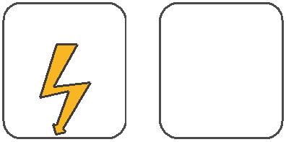
W

E
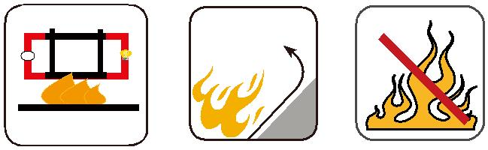

 |  | Circuit Integrity | Reduced Fire Propagation | Flame Retardancy
 |  | Circuit Integrity | NF C32-070-2.2(C1) | NF C32-070-2.1(C2)
Rated Voltage | Standard | IEC 60331/BS 6387 | NF C32-070-2.2(C1)
Rated Voltage | Standard | NF C32-070-2.3(CR1) | IEC60332-3-24/EN50266-2-4 IEC60332-1-2/EN50265-2-1
 |  |  | Zero | W | E
 | Low Corrosivity | Low Smoke Emission | Halogen Free
Low Toxicity | IEC60754-2 | IEC 61034-1&2 | Halogen Free
Low Toxicity | EN50267-2-2/3 | IEC 61034-1&2 | IEC60754-1 | Functional Integrity
NES 02-713/NF C 20-454 | EN50267-2-2/3 | EN 50268-1&2/NF C32-073 | IEC60754-1
NES 02-713/NF C 20-454 | NF C 32-074 | EN 50268-1&2/NF C32-073 | IEC60754-1
 |  |  | EN50267-2-1 |  | DIN 4102-12
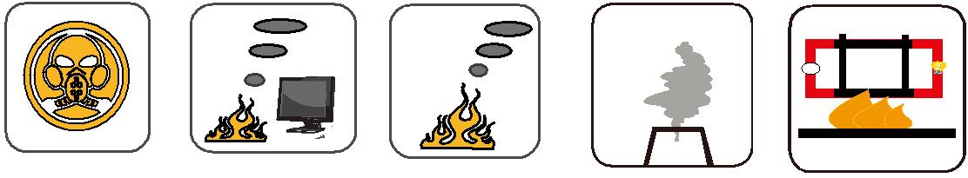

96 Caledonian sales@caledonian-cables.net uk@caledonian-cables.net

