
Caledonian

Flame Retardant Power & Control Cables

www.caledonian-cables.co.uk www.addison-cables.com

450/750V XLPE Insulated, LSZH Sheathed Power Cables (Multicore)

FTX200 07RZ1-R (CU/XLPE/LSZH 450/750V Class 2)

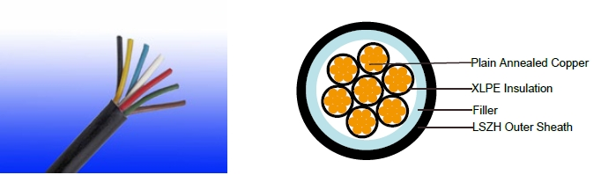

APPLICATION

The cables are mainly used in power stations, mass transit underground passenger systems, airports, petrochemical plants, hotels, hospitals, and high-rise buildings.

STANDARDS

Basic design adapted to BS 7211; IEC 60502-1

FIRE PERFORMANCE

Flame Retardance (Single Vertical | EN 60332-1-2; IEC 60332-1-2; BS EN 60332-1-2; VDE 0482-332-1 ;
Flame Retardance (Single Vertical | NBN C 30-004 (cat. F1); NF C32-070-2.1(C2);
Wire Test) | NBN C 30-004 (cat. F1); NF C32-070-2.1(C2);
Wire Test) | CEI 20-35/1-2; EN 50265-2-1*; DIN VDE 0482-265-2-1*
Reduced Fire Propagation | EN 60332-3-24 (cat. C); IEC 60332-3-24; BS EN 60332-3-24; VDE
(Vertically-mounted bundled wires & | 0482-332-3; NBN C 30-004 (cat. F2); NF C32-070-2.2(C1); CEI
cable test) | 20-22/3-4; EN 50266-2-4*; DIN VDE 0482-266-2-4
Halogen Free | IEC 60754-1; EN 50267-2-1; DIN VDE 0482-267-2-1;
Halogen Free | CEI 20-37/2-1 ; BS 6425-1*
No Corrosive Gas Emission | IEC 60754-2; EN 50267-2-2; DIN VDE 0482-267-2-2;
No Corrosive Gas Emission | CEI 20-37/2-2 ; BS 6425-2*
Minimum Smoke Emission | IEC 61034-1&2; EN 61034 -1&2; DIN VDE 0482-1034-1&2;
Minimum Smoke Emission | CEI 20-37/3-1&2; EN 50268-1&2*; BS 7622-1&2*
No Toxic gases | NES 02-713; NF C 20-454

Note: Asterisk * denotes superseded standard.

VOLTAGE RATING

450/750V

CABLE CONSTRUCTION

Conductor: Plain annealed copper wire, stranded according to IEC(EN) 60228 class 2.

 ADDISON 25

 ADDISON

Insulation: Extruded cross-linked XLPE compound.

Filler, binder (if any): PP, PET

Outer Sheath: Thermoplastic LSZH compound type LTS3 as per BS 7655-6.1 (Thermosetting LSZH compound type SW2-SW4 as per BS 7655-2.6 can be offered.). UV resistance, hydrocarbon resistance, oil resistance, anti rodent and anti termite properties can be offered as option.

COLOUR CODE

Insulation Colour as per BS7671
 | With Earth Conductor | Without Earth Conductor
2Cores | - | Brown, Blue
3Cores | Yellow/Green, Brown, Blue | Brown, Gray, Black
4Cores | Yellow/Green, Brown, Gray, Black | Brown, Gray, Black, Blue
5Cores | Yellow/Green, Brown, Gray, Black, Blue | Brown, Gray, Black, Blue, Black
Above 5 Cores | Yellow/Green, Black Numbered | Black Numbered

Sheath Colour: Black (other colors upon request)

Physical AND THERMAL PROPERTIES

Temperature range during operation: Max.90°C for XLPE

250°C in short-circuit for 5s max.

Minimum bending radius: 6 x Overall Diameter

CONSTRUCTION PARAMETERS

 | Conductor |  |  | FTX200 07RZ1-R
No. of | No./Nominal | Nominal | Nominal | Nominal | Nominal | Max.DC
Core X | Diameter of | Overall | Insulation | Sheath | Overall | resistance | Approx.
Cross | Diameter of | Diameter | Insulation | Sheath | Overall | of conductor | Weight
Section | Strands | Conductor | Thickness | Thickness | Diameter | @20°C
Noxmm² | No./mm | mm | mm | mm | mm | Ω/km | kg/km
7x1.0 | 7/0.44 | 1.32 | 0.7 | 1.3 | 11.6 | 18.1 | 210
7x1.5 | 7/0.53 | 1.59 | 0.7 | 1.3 | 12.5 | 12.1 | 258
7x2.5 | 7/0.67 | 2.01 | 0.7 | 1.3 | 13.8 | 7.41 | 347
12x1.5 | 7/0.53 | 1.59 | 0.7 | 1.4 | 16.5 | 12.1 | 413
12x2.5 | 7/0.67 | 2.01 | 0.7 | 1.5 | 18.3 | 7.41 | 561
19x1.5 | 7/0.53 | 1.59 | 0.7 | 1.5 | 19.3 | 12.1 | 609
19x2.5 | 7/0.67 | 2.01 | 0.7 | 1.6 | 21.6 | 7.41 | 836

Electrical PROPERTIES

Conductor Operating Temperature : 90°C

Ambient Temperature : 30°C

Current-Carrying Capacities (Amp)

26 Caledonian

Caledonian

Flame Retardant Power & Control Cables

www.caledonian-cables.co.uk www.addison-cables.com

 | Reference |  | Reference |  |  |  |  |  | Reference Method 12 (free
Conductor | Method 4 |  | Method 3 |  |  |  | Reference |  |  | air)
cross- | (enclosed |  | (enclosed in |  | Reference Method |  | Method 11 (on a
cross- | in conduit |  |  |  |  |  | perforated cable |  | Horizontal | Vertical
sectional | in thermally |  | conduit on |  | 1 (clipped direct) |  | tray, horizontal or |  | flat | flat | Trefoil
area | insulating wall |  | a wall or in |  |  |  | vertical) |  | spaced | spaced
 |  |  | trunking etc) |  |  |  |  |  | spaced | spaced
 | etc)
 |  |  |  |  |  |  |  |  | 2 cables, | 2
 |  |  |  |  |  |  |  |  | 2 cables, | cables,
 | 2 |  | 2 |  | 2 cables, | 3 or 4 | 2 cables, | 3 or 4 | single- | single-
 | 2 |  | 2 |  | single- | cables, | single- | cables, | phase | single-
 | cables, | 3 or 4 | cables, | 3 or 4 |  |  |  |  |  | phase | 3 cables,
 |  |  |  |  | phase | 3-phase | phase | 3-phase | a.c. or | phase | 3 cables,
 | single- | cables, | single- | cables, |  |  |  |  |  | a.c. or | trefoil
 | phase | 3-phase | phase | 3-phase | a.c. or | a.c. flat | a.c. or | a.c. flat | d.c. | d.c. | 3-phase
 | a.c. or | a.c. | a.c. or | a.c. | d.c. flat | and | d.c. or | and | or 3 c | or 3 | a.c.
 | d.c. |  | d.c |  | and | touching | flat and | touching | ables | cables
 | d.c. |  | d.c |  | touching | or trefoil | touching | or trefoil | three | cables
 |  |  |  |  |  |  |  |  |  | three
 |  |  |  |  |  |  |  |  | phase | three
 |  |  |  |  |  |  |  |  | phase | phase
1 | 2 | 3 | 4 | 5 | 6 | 7 | 8 | 9 | 10 | 11 | 12
mm² | A | A | A | A | A | A | A | A | A | A | A
1.0 | 13 | - | - | - | 15 | - | - | - | - | - | -
1.5 | 18 | 17 | 22 | 19 | 25 | 23 | - | - | - | - | -
2.5 | 24 | 23 | 30 | 26 | 34 | 31 | - | - | - | - | -

Voltage Drop (Per Amp Per Meter)

Nominal |  |  |  | 2 cables, single-phase a.c. |  |  |  | 3 or 4 cables, 3-phase a.c.
 |  |  |  | Ref. Methods 3 |  | Ref. Methods 1 |  | Ref. Methods 3 |  |  |  | Ref. Methods 1 and
Cross |  | 2 cables |  |  |  |  |  |  |  | Ref. Methods 1, |  | Ref. Methods 1 and
 |  |  |  | and 4 (enclosed |  | and 11 (clipped |  | and 4 (enclosed |  |  |  | 11
Section |  | d.c. |  | in conduit etc, |  | direct or on trays |  | in conduit etc, |  | 11 and 12 (in
Area |  |  |  |  |  |  |  |  |  |  |  | (Flat and touching)
 |  |  |  | in or on a wall) |  | touching) |  | in or on a wall) |  | trefoil) |  | (Flat and touching)
1 |  | 2 |  | 3 |  | 4 |  | 5 |  | 6 |  | 7
mm² |  | mV/A/m |  | mV/A/m |  | mV/A/m |  | mV/A/m |  | mV/A/m |  | mV/A/m
1.0 |  | 46 |  | 46 |  | - |  | - |  | - |  | -
1.5 |  | 31 |  | 31 |  | 27 |  | 27 |  | 27 |  | 27
2.5 |  | 19 |  | 19 |  | 16 |  | 16 |  | 16 |  | 16
 | 450/750V |  | _{N}BS7211 |  | IEC_{N}60502-1 |  | Flame Retardancy |  | Reduced Fire Propagation
 |  |  |  |  |  |  |  |  | NF C32-070-2.2(C1)
 | Rated Voltage |  | Standard |  | Standard |  | NF C32-070-2.1(C2) |  | IEC60332-3-24
 |  |  |  |  |  |  | IEC60332-1-2/EN50265-2-1 |  | EN50266-2-4
 |  |  |  |  |  |  | Zero
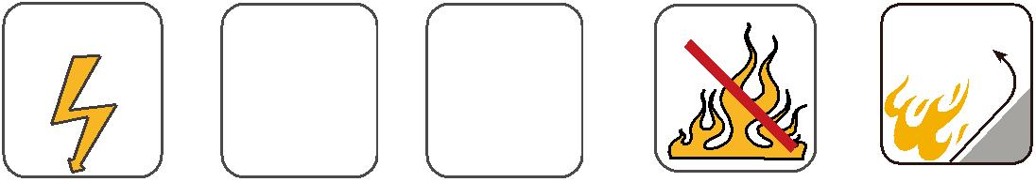
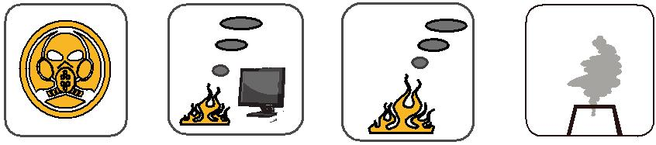

 | Low Corrosivity | Low Smoke Emission
 | IEC60754-2 | Low Smoke Emission
Low Toxicity | IEC60754-2 | IEC 61034-1&2
Low Toxicity | EN50267-2-2/3 | IEC 61034-1&2
NES 02-713/NF C 20-454 | NF C 32-074 | EN 50268-1&2/NF C32-073

Halogen Free IEC60754-1/ EN50267-2-1

ADDISON 27

