
Caledonian

Flame Retardant Power & Control Cables

www.caledonian-cables.co.uk www.addison-cables.com

600/1000V XLPE Insulated, LSZH Sheathed, Screened Power Cables (4 Cores)

FTX400 1RCZ1MZ1-R (CU/XLPE/CUTO/LSZH/SWA/LSZH 600/1000V Class 2)
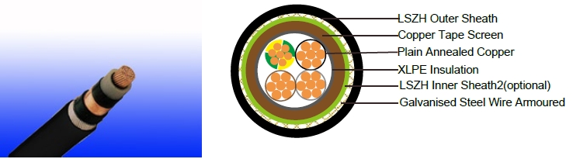

APPLICATION

This cable is designed specifi cally to suit the broad spectrum of requirements of Variable Speed Drives and also include features for reducing the transmission of electromagnetic interference.

This range of screened cables drastically reduce interferences from electrical noise, especially in

Variable Speed Drive (VSD) applications and are manufactured with fixed conductors.

With shield conductivity of 1/10th of phase conductor conductivity, this range of VSD cables effectively restrain radiated and conducted radio-frequency emissions.

STANDARDS

Basic design adapted to IEC 60502-1

FIRE PERFORMANCE

Flame Retardance (Single Vertical | EN 60332-1-2; IEC 60332-1-2; BS EN 60332-1-2; VDE
Flame Retardance (Single Vertical | 0482-332-1 ; NBN C 30-004 (cat. F1); NF C32-070-2.1(C2);
Wire Test) | CEI 20-35/1-2; EN 50265-2-1*; DIN VDE 0482-265-2-1*
Reduced Fire Propagation | EN 60332-3-24 (cat. C); IEC 60332-3-24; BS EN 60332-3-24;
(Vertically-mounted bundled wires | VDE 0482-332-3; NBN C 30-004 (cat. F2); NF C32-070-2.2(C1);
& cable test) | CEI 20-22/3-4; EN 50266-2-4*; DIN VDE 0482-266-2-4
Halogen Free | IEC 60754-1; EN 50267-2-1; DIN VDE 0482-267-2-1;
Halogen Free | CEI 20-37/2-1 ; BS 6425-1*
No Corrosive Gas Emission | IEC 60754-2; EN 50267-2-2; DIN VDE 0482-267-2-2;
No Corrosive Gas Emission | CEI 20-37/2-2 ; BS 6425-2*
Minimum Smoke Emission | IEC 61034-1&2; EN 61034 -1&2; DIN VDE 0482-1034-1&2;
Minimum Smoke Emission | CEI 20-37/3-1&2; EN 50268-1&2*; BS 7622-1&2*
No Toxic gases | NES 02-713; NF C 20-454

Note: Asterisk * denotes superseded standard.

VOLTAGE RATING

600/1000V

CABLE CONSTRUCTION

 ADDISON 65

 ADDISON

Conductor: Plain annealed copper wire, stranded according to IEC(EN) 60228 class 2. Insulation: Extruded cross-linked XLPE compound.

Inner sheath1: LSZH Compound

Screen: Copper Tape

Inner sheath2: LSZH Compound

Armouring: Galvanised Steel Wire

Outer Sheath: Thermoplastic LSZH compound type LTS3 as per BS 7655-6.1 (Thermosetting LSZH compound type SW2-SW4 as per BS 7655-2.6 can be offered.). UV resistance, hydrocarbon resistance, oil resistance, anti rodent and anti termite properties can be offered as option.

COLOUR CODE

Insulation Colour as per BS7671
 | With Earth Conductor | Without Earth Conductor
2Cores | - | Brown, Blue
3Cores | Yellow/Green, Brown, Blue | Brown, Gray, Black
4Cores | Yellow/Green, Brown, Gray, Black | Brown, Gray, Black, Blue
5Cores | Yellow/Green, Brown, Gray, Black, Blue | Brown, Gray, Black, Blue, Black
Above 5 Cores | Yellow/Green, Black Numbered | Black Numbered

Sheath Colour: Black (other colors upon request)

Physical AND THERMAL PROPERTIES

Temperature range during operation: Max.90°C for XLPE

250°C in short-circuit for 5s max. Minimum bending radius: 12 x Overall Diameter (for 1.5mm² to 300mm²)

CONSTRUCTION PARAMETERS

 | Conductor |  |  |  | FTX400 1RCZ1MZ1-R
 | No. of Core | No./
 | No. of Core | Nominal | Nominal | Nominal | Diameter | Diameter | Armour | Nominal
 | X | Diameter | Insulation | Sheath | Under | Over Inner | Wire | Overall | Approx.
 | Cross |  |  |  |  |  |  |  | Weight
 | Cross | of | Thickness | Thickness | Screen | Sheath | Diameter | Diameter | Weight
 | Section | Strands
 | mm² | No./mm | mm | mm | mm | mm | mm | mm | kg/km
 | 4x1.5 | 7/0.53 | 0.7 | 1.8 | 9.7 | 12.1 | 13.9 | 17.7 | 640
 | 4x2.5 | 7/0.67 | 0.7 | 1.8 | 10.7 | 13.1 | 14.9 | 18.7 | 730
 | 4x4 | 7/0.85 | 0.7 | 1.8 | 12.0 | 14.4 | 16.2 | 20.0 | 870
 | 4x6 | 7/1.04 | 0.7 | 1.8 | 13.4 | 15.8 | 18.3 | 22.1 | 1180
 | 4x10 | 7/1.35 | 0.7 | 1.8 | 15.6 | 18.0 | 20.5 | 24.3 | 1490
 | 4x16 | 7/1.70 | 0.7 | 1.8 | 18.1 | 20.5 | 23.7 | 27.5 | 2070
 | 4x25 | 7/2.14 | 0.9 | 1.8 | 22.3 | 24.1 | 27.3 | 31.1 | 2790
 | 4x35(S) | 7/2.52 | 0.9 | 1.8 | 25.0 | 26.8 | 30.0 | 33.8 | 2940
 | 4x50(S) | 19/1.78 | 1.0 | 2.0 | 27.8 | 29.6 | 32.8 | 37.0 | 3500
 | 4x70(S) | 19/2.14 | 1.1 | 2.2 | 31.6 | 33.4 | 37.4 | 42.0 | 5000
66 | Caledonian

Caledonian

Flame Retardant Power & Control Cables

www.caledonian-cables.co.uk www.addison-cables.com

4x95(S) | 19/2.52 | 1.1 | 2.3 | 35.4 | 37.2 | 41.2 | 46.0 | 6300
4x120(S) | 37/2.03 | 1.2 | 2.5 | 39.0 | 40.8 | 45.8 | 51.0 | 8200
4x150(S) | 37/2.25 | 1.4 | 2.6 | 42.0 | 43.8 | 48.8 | 54.2 | 9600
4x185(S) | 37/2.52 | 1.6 | 2.8 | 47.8 | 49.6 | 54.6 | 60.4 | 11500
4x240(S) | 61/2.25 | 1.7 | 3.0 | 54.0 | 55.8 | 60.8 | 67.0 | 14400
4x300(S) | 61/2.52 | 1.8 | 3.0 | 58.0 | 59.8 | 64.8 | 71.4 | 17200

(S) : Sectoral Stranded Conductors.

Electrical PROPERTIES

Conductor Operating Temperature : 90°C

Ambient Temperature : 30°C

Current-Carrying Capacities (Amp)

 |  |  | Reference Method
 | Reference Method |  | 11 (on a perforated |  | In single-way |  | Laid direct in
 | 1 (clipped |  | horizontal cable trayor
 |  |  |  |  | ducts |  | ground
Conductor | direct) |  | Reference Method 13
Conductor |  |  | [free air] )
cross-
cross- | one |  |  |  | one |  | one
sectional | one | one |  |  | one | one | one | one
sectional | 2-core | one |  | one 3-core | 2-core | one | 2-core | one
area | 2-core | 3-core or | one 2-core | one 3-core | 2-core | 3-core or | 2-core | 3-core or
 | cable | 4-core | cable single | or 4-core | cable | 4-core | cable | 4-core
 | single | 4-core | cable single | cable | single | 4-core | single | 4-core
 | single | cable | phase a.c. | cable | single | cable | single | cable
 | phase | cable | phase a.c. | 3-phase | phase | cable | phase | cable
 | phase | 3-phase | or d.c. | 3-phase | phase | 3-phase | phase | 3-phase
 | a.c. or | a.c. |  | a.c. | a.c. or | a.c. | a.c. or | a.c.
 | d.c. | a.c. |  |  | d.c. | a.c. | d.c. | a.c.
1 | 2 | 3 | 4 | 5 | 6 | 7 | 8 | 9
mm² | A | A | A | A | A | A | A | A
1.5 | 27 | 23 | 29 | 25 | - | 23 | - | 28
2.5 | 36 | 31 | 39 | 33 | - | 30 | - | 36
4 | 49 | 42 | 52 | 44 | - | 40 | - | 48
6 | 62 | 53 | 66 | 56 | - | 50 | - | 60
10 | 85 | 73 | 90 | 78 | - | 65 | - | 80
16 | 110 | 94 | 115 | 99 | 115 | 94 | 140 | 115
25 | 146 | 124 | 152 | 131 | 145 | 125 | 180 | 150
35 | 180 | 154 | 188 | 162 | 175 | 150 | 215 | 180
50 | 219 | 187 | 228 | 197 | 210 | 175 | 255 | 215
70 | 279 | 238 | 291 | 251 | 260 | 215 | 315 | 265
95 | 338 | 289 | 354 | 304 | 310 | 260 | 380 | 315
120 | 392 | 335 | 410 | 353 | 355 | 300 | 430 | 360
150 | 451 | 386 | 472 | 406 | 400 | 335 | 480 | 405
185 | 515 | 441 | 539 | 463 | 455 | 380 | 540 | 460
240 | 607 | 520 | 636 | 546 | 520 | 440 | 630 | 530
300 | 698 | 599 | 732 | 628 | 590 | 495 | 700 | 590

 ADDISON 67

ADDISON

Voltage Drop (Per Amp Per Meter)
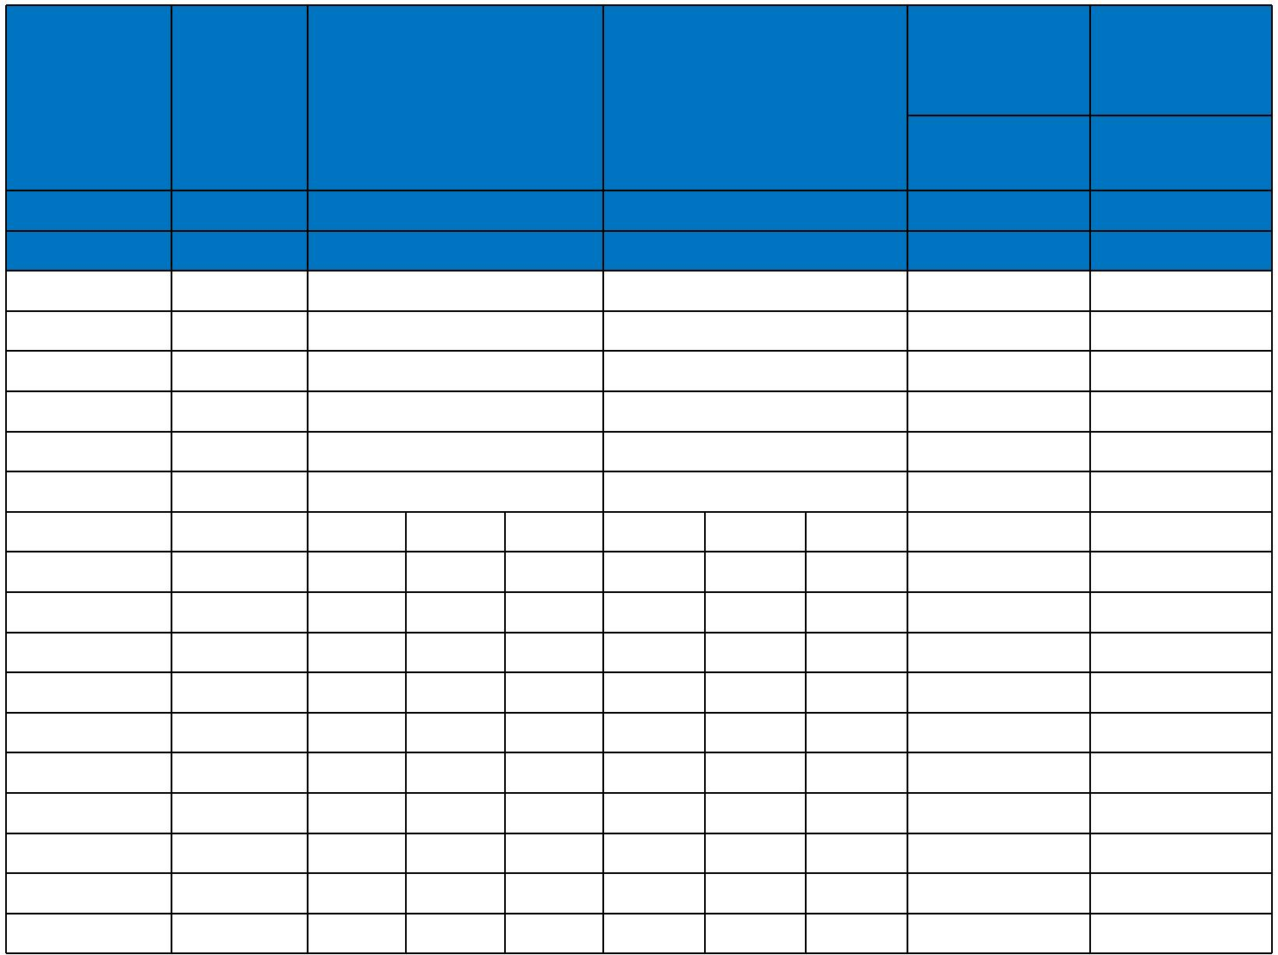
Conductor |  |  |  |  |  |  |  |  | 2 cables, | 3 or 4
Conductor | 2-core | 2 cables, single-phase 3 or 4 cables, 3-phase |  |  |  |  |  |  | single-phase | cables,
cross-
sectional | cable d.c. |  |  | a.c. |  |  | a.c. |  | a.c. | 3-phase a.c.
sectional | cable d.c. |  |  | a.c. |  |  | a.c. |  | In ducts or | In ducts or
area |  |  |  |  |  |  |  |  | In ducts or | In ducts or
area |  |  |  |  |  |  |  |  | in ground | in ground
1 | 2 |  |  | 3 |  |  | 4 |  | 5 | 6
mm² | mV/A/m |  |  | mV/A/m |  |  | mV/A/m |  | mV/A/m | mV/A/m
1.5 | 31.0 |  |  | 31.0 |  |  | 27.0 |  | 31.0 | 25.0
2.5 | 19.0 |  |  | 19.0 |  |  | 16.0 |  | 19.0 | 15.0
4 | 12.0 |  |  | 12.0 |  |  | 10.0 |  | 12.0 | 9.7
6 | 7.9 |  |  | 7.9 |  |  | 6.8 |  | 7.9 | 6.5
10 | 4.7 |  |  | 4.7 |  |  | 4.0 |  | 4.7 | 3.9
16 | 2.9 |  |  | 2.9 |  |  | 2.5 |  | 2.9 | 2.6
 |  |  | r | x | z | r | x | z
25 | 1.850 | 1.350 |  | 0.160 | 1.900 | 1.600 | 0.140 | 1.650 | 1.900 | 1.600
35 | 1.350 | 1.350 |  | 0.155 | 1.350 | 1.150 | 0.135 | 1.150 | 1.350 | 1.200
50 | 0.980 | 0.990 |  | 0.155 | 1.000 | 0.860 | 0.135 | 0.870 | 1.000 | 0.870
70 | 0.670 | 0.670 |  | 0.150 | 0.690 | 0.590 | 0.130 | 0.600 | 0.690 | 0.610
95 | 0.490 | 0.500 |  | 0.150 | 0.520 | 0.430 | 0.130 | 0.450 | 0.520 | 0.450
120 | 0.390 | 0.400 |  | 0.145 | 0.420 | 0.340 | 0.130 | 0.370 | 0.420 | 0.360
150 | 0.310 | 0.320 |  | 0.145 | 0.350 | 0.280 | 0.125 | 0.300 | 0.350 | 0.300
185 | 0.250 | 0.260 |  | 0.145 | 0.290 | 0.220 | 0.125 | 0.260 | 0.290 | 0.250
240 | 0.195 | 0.200 |  | 0.140 | 0.240 | 0.175 | 0.125 | 0.210 | 0.240 | 0.210
300 | 0.155 | 0.160 |  | 0.140 | 0.210 | 0.140 | 0.120 | 0.185 | 0.210 | 0.190
Note :
r = conductor resistance at operating temperature
x = reactance
z = impedance
600/1000V | IEC_{N}60502-1 |  |  | Flame Retardancy |  | Reduced Fire Propagation
 |  |  |  |  |  | NF C32-070-2.2(C1)
Rated Voltage | Standard |  |  | NF C32-070-2.1(C2) |  | IEC60332-3-24
Rated Voltage |  |  |  | IEC60332-1-2/EN50265-2-1 |  | EN50266-2-4
 |  |  |  |  |  | Zero
 | Low Corrosivity |  |  | Low Smoke Emission |  | Halogen Free
Low Toxicity | IEC60754-2 |  |  | IEC 61034-1&2 |  | IEC60754-1
Low Toxicity | EN50267-2-2/3 |  |  | IEC 61034-1&2
NES 02-713/NF C 20-454 |  |  | EN 50268-1&2/NF C32-073 |  |  | EN50267-2-1
NES 02-713/NF C 20-454 | NF C 32-074
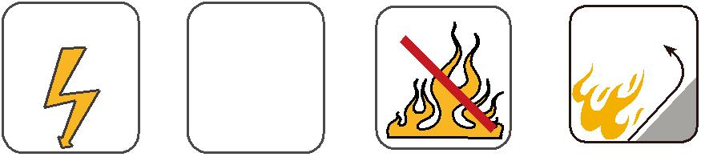
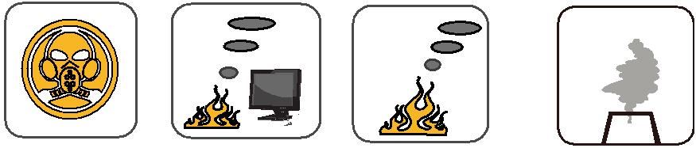

68 Caledonian

