 ADDISON

450/750V XLPE Insulated, LSZH Sheathed, Screened Power Cables (2-4 Cores)

FTX200 07RCZ1-R (CU/XLPE/CUTO/LSZH 450/750V Class 2)
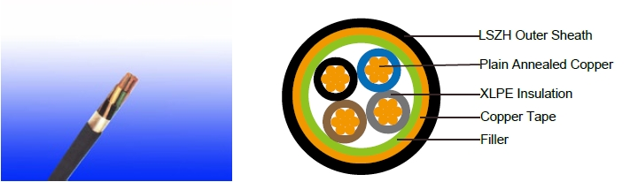

APPLICATION

The cables are mainly used in power stations, mass transit underground passenger systems, airports, petrochemical plants, hotels, hospitals, and high-rise buildings.

STANDARDS

Basic design adapted to BS 7211; IEC 60502-1

FIRE PERFORMANCE

Flame Retardance (Single Vertical EN 60332-1-2; IEC 60332-1-2; BS EN 60332-1-2; VDE _{Wire Test)} 0482-332-1 ; NBN C 30-004 (cat. F1); NF C32-070-2.1(C2);
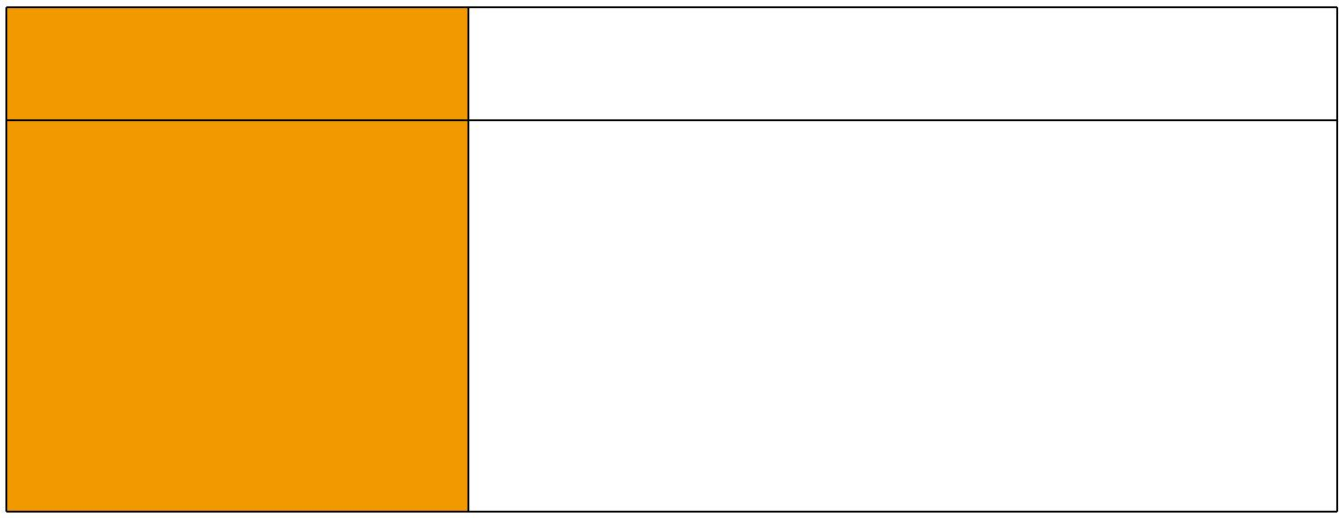
CEI 20-35/1-2; EN 50265-2-1*; DIN VDE 0482-265-2-1*

Reduced Fire Propagation | EN 60332-3-24 (cat. C); IEC 60332-3-24; BS EN 60332-3-24;
(Vertically-mounted bundled wires VDE 0482-332-3; NBN C 30-004 (cat. F2); NF C32-070-2.2(C1);
& cable test) | CEI 20-22/3-4; EN 50266-2-4*; DIN VDE 0482-266-2-4
Halogen Free | IEC 60754-1; EN 50267-2-1; DIN VDE 0482-267-2-1;
Halogen Free | CEI 20-37/2-1 ; BS 6425-1*
No Corrosive Gas Emission | IEC 60754-2; EN 50267-2-2; DIN VDE 0482-267-2-2;
No Corrosive Gas Emission | CEI 20-37/2-2 ; BS 6425-2*
Minimum Smoke Emission | IEC 61034-1&2; EN 61034 -1&2; DIN VDE 0482-1034-1&2;
Minimum Smoke Emission | CEI 20-37/3-1&2; EN 50268-1&2*; BS 7622-1&2*
No Toxic gases | NES 02-713; NF C 20-454

Note: Asterisk * denotes superseded standard.

VOLTAGE RATING

450/750V

28 Caledonian


Caledonian

Flame Retardant Power & Control Cables

www.caledonian-cables.co.uk www.addison-cables.com

CABLE CONSTRUCTION

Conductor: Plain annealed copper wire, stranded according to IEC(EN) 60228 class 2. Insulation: Extruded cross-linked XLPE compound.

Filler, binder (if any): PP, PET, LSZH Overall Screen: Copper tape

Outer Sheath: Thermoplastic LSZH compound type LTS3 as per BS 7655-6.1 (Thermosetting LSZH compound type SW2-SW4 as per BS 7655-2.6 can be offered.). UV resistance, hydrocarbon resistance, oil resistance, anti rodent and anti termite properties can be offered as option.

COLOUR CODE

Insulation Colour as per BS7671
 | With Earth Conductor | Without Earth Conductor
2Cores | - | Brown, Blue
3Cores | Yellow/Green, Brown, Blue | Brown, Gray, Black
4Cores | Yellow/Green, Brown, Gray, Black | Brown, Gray, Black, Blue
5Cores | Yellow/Green, Brown, Gray, Black, Blue | Brown, Gray, Black, Blue, Black
Above 5 Cores | Yellow/Green, Black Numbered | Black Numbered

Sheath Colour: Black (other colors upon request)

Physical AND THERMAL PROPERTIES

Temperature range during operation: Max.90°C for XLPE

250°C in short-circuit for 5s max.

Minimum bending radius: 8 x Overall Diameter

CONSTRUCTION PARAMETERS

 | Conductor |  |  |  | FTX200 07RCZ1-R
No. of | No./ | Nominal |  | Nominal |  |  | Max.DC
No. of | Nominal | Nominal | Nominal | Nominal | Nominal | Nominal | resistance
Core X | Nominal | Overall | Nominal | Copper | Nominal | Nominal | resistance | Approx.
Cross | Diameter | Diameter | Insulation | Tape | Sheath | Overall | of | Weight
Cross | of | Diameter | Thickness | Tape | Thickness | Diameter | conductor | Weight
Section | Strands | Conductor |  | Thickness |  |  | @20°C
Noxmm² | No./mm | mm | mm | mm | mm | mm | Ω/km | kg/km
2x1.0 | 7/0.44 | 1.32 | 0.7 | 0.1 | 1.2 | 10.7 | 18.1 | 172
2x1.5 | 7/0.53 | 1.59 | 0.7 | 0.1 | 1.3 | 11.3 | 12.1 | 197
2x2.5 | 7/0.67 | 2.01 | 0.7 | 0.1 | 1.3 | 12.2 | 7.41 | 239
2x4.0 | 7/0.85 | 2.55 | 0.7 | 0.1 | 1.3 | 13.4 | 4.61 | 300
3x1.0 | 7/0.44 | 1.32 | 0.7 | 0.1 | 1.3 | 11.2 | 18.1 | 194
3x1.5 | 7/O.53 | 1.59 | 0.7 | 0.1 | 1.3 | 11.8 | 12.1 | 224
3x2.5 | 7/0,67 | 2.01 | 0.7 | 0.1 | 1.3 | 12.8 | 7.41 | 276
3x4.0 | 7/0.85 | 2.55 | 0.7 | 0.1 | 1.3 | 14.1 | 4.61 | 353
4x1.0 | 7/0.44 | 1.32 | 0.7 | 0.1 | 1.3 | 12.0 | 18.1 | 224

 ADDISON 29

ADDISON

4x1.5 | 7/0.53 | 1.59 | 0.7 | 0.1 | 1.4 | 12.7 | 12.1 | 261
4x2.5 | 7/0.67 | 2.01 | 0.7 | 0.1 | 1.3 | 13.9 | 7.41 | 326
4x4.0 | 7/0.85 | 2.55 | 0.7 | 0.1 | 1.3 | 15.3 | 4.61 | 422

Electrical PROPERTIES

Conductor Operating Temperature : 90°C

Ambient Temperature : 30°C

Current-Carrying Capacities (Amp)

 | Reference |  | Reference |  |  |  |  |  | Reference Method 12 (free
 |  |  |  |  |  |  |  |  |  | air)
 | Method 4 |  |  |  |  |  | Reference |  |  | air)
Conductor |  |  | Method 3
Conductor | (enclosed |  |  |  |  |  | Method 11 (on a
cross- |  |  | (enclosed in |  | Reference Method
sectional | in conduit |  | conduit on |  | 1 (clipped direct) |  | perforated cable |  | Horizontal | Vertical
sectional | in thermally |  |  |  |  |  | tray, horizontal or |  | flat | flat | Trefoil
area | insulating wall |  | a wall or in |  |  |  | vertical) |  | spaced | spaced
 |  |  | trunking etc) |  |  |  |  |  | spaced | spaced
 | etc)
 |  |  |  |  |  |  |  |  | 2 cables, | 2
 |  |  |  |  |  |  |  |  | 2 cables, | cables,
 | 2 |  | 2 |  | 2 cables, | 3 or 4 | 2 cables, | 3 or 4 | single- | single-
 | 2 |  | 2 |  | single- | cables, | single- | cables, | phase | single-
 | cables, | 3 or 4 | cables, | 3 or 4 |  |  |  |  |  | phase | 3 cables,
 |  |  |  |  | phase | 3-phase | phase | 3-phase | a.c. or | phase | 3 cables,
 | single- | cables, | single- | cables, |  |  |  |  |  | a.c. or | trefoil
 | phase | 3-phase | phase | 3-phase | a.c. or | a.c. flat | a.c. or | a.c. flat | d.c. | d.c. | 3-phase
 | a.c. or | a.c. | a.c. or | a.c. | d.c. flat | and | d.c. or | and | or 3 c | or 3 | a.c.
 | d.c. |  | d.c |  | and | touching | flat and | touching | ables | cables
 | d.c. |  | d.c |  | touching | or trefoil | touching | or trefoil | three | cables
 |  |  |  |  |  |  |  |  |  | three
 |  |  |  |  |  |  |  |  | phase | three
 |  |  |  |  |  |  |  |  | phase | phase
1 | 2 | 3 | 4 | 5 | 6 | 7 | 8 | 9 | 10 | 11 | 12
mm² | A | A | A | A | A | A | A | A | A | A | A
1.0 | 13 | - | - | - | 15 | - | - | - | - | - | -
1.5 | 18 | 17 | 22 | 19 | 25 | 23 | - | - | - | - | -
2.5 | 24 | 23 | 30 | 26 | 34 | 31 | - | - | - | - | -
4 | 33 | 30 | 40 | 35 | 46 | 41 | - | - | - | - | -

30 Caledonian

Caledonian

Flame Retardant Power & Control Cables

www.caledonian-cables.co.uk www.addison-cables.com

Voltage Drop (Per Amp Per Meter)

Nominal |  |  |  |  |  |  |  |  |  | 2 cables, single-phase a.c. |  |  |  |  |  |  |  |  |  |  |  |  |  | 3 or 4 cables, 3-phase a.c.
 |  |  |  |  |  |  |  |  |  | Ref. Methods 3 |  |  |  |  | Ref. Methods 1 |  |  |  |  |  | Ref. Methods 3 |  |  |  |  |  |  | Ref. Methods 1 and
Cross |  |  |  | 2 cables |  |  |  |  |  |  |  |  |  |  |  |  |  |  |  |  |  |  |  |  |  | Ref. Methods 1, |  | Ref. Methods 1 and
Section |  |  |  |  |  | d.c. |  |  | and 4 (enclosed |  |  |  |  |  | and 11 (clipped |  |  |  |  |  | and 4 (enclosed |  |  |  |  |  |  | 11
 |  | Area |  |  |  |  |  |  |  | in conduit etc, |  |  |  |  | direct or on trays |  |  |  |  |  | in conduit etc, |  |  |  |  | 11 and 12 (in |  | (Flat and touching)
 |  |  |  |  |  |  |  |  |  | in or on a wall) |  |  |  |  | touching) |  |  |  |  |  | in or on a wall) |  |  |  |  | trefoil) |  | (Flat and touching)
1 |  |  |  |  | 2 |  |  |  | 3 |  |  |  |  | 4 |  |  |  |  |  |  | 5 |  |  |  |  | 6 |  | 7
 |  | mm² |  |  | mV/A/m |  |  |  |  | mV/A/m |  |  |  |  | mV/A/m |  |  |  |  |  | mV/A/m |  |  |  |  | mV/A/m |  | mV/A/m
1.0 |  |  |  |  | 46 |  |  |  | 46 |  |  |  |  | - |  |  |  |  |  |  | - |  |  |  |  | - |  | -
1.5 |  |  |  |  | 31 |  |  |  | 31 |  |  |  |  | 27 |  |  |  |  |  |  | 27 |  |  |  |  | 27 |  | 27
2.5 |  |  |  |  | 19 |  |  |  | 19 |  |  |  |  | 16 |  |  |  |  |  |  | 16 |  |  |  |  | 16 |  | 16
4 |  |  |  |  | 33 |  |  |  | 12 |  |  |  |  | 10 |  |  |  |  |  |  | 10 |  |  |  |  | 10 |  | 10
 |  |  | 450/750V |  |  |  |  |  |  | _{N}BS7211 |  |  |  |  | _{N}IEC60502-1
 |  |  |  |  |  |  |  |  |  | _{N}BS7211 |  |  |  |  | _{N}IEC60502-1 |  |  |  |  | Flame Retardancy |  |  |  | Reduced Fire Propagation
 |  |  |  |  |  |  |  |  |  |  |  |  |  |  |  |  |  |  |  |  |  |  |  |  | NF C32-070-2.2(C1)
 |  |  |  |  |  |  |  |  |  |  |  |  |  |  |  |  |  | NF C32-070-2.1(C2)
Rated Voltage |  |  |  |  |  |  |  |  |  | Standard |  |  |  |  | Standard |  |  |  |  |  |  |  |  |  |  | IEC60332-3-24
 |  |  |  |  |  |  |  |  |  |  |  |  |  |  |  |  |  | IEC60332-1-2/EN50265-2-1 |  |  |  |  |  |  |  | EN50266-2-4

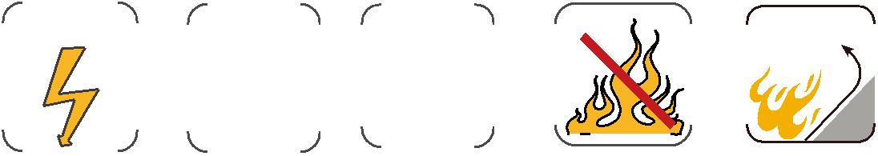
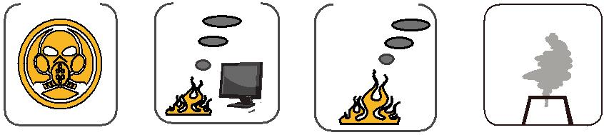
Zero

 | Low Corrosivity | Low Smoke Emission
Low Toxicity | IEC60754-2 | Low Smoke Emission
Low Toxicity | IEC60754-2 | IEC 61034-1&2
Low Toxicity | EN50267-2-2/3 | IEC 61034-1&2
NES 02-713/NF C 20-454 | NF C 32-074 | EN 50268-1&2/NF C32-073

Halogen Free IEC60754-1/ EN50267-2-1

ADDISON 31

