
Caledonian

Flame Retardant Power & Control Cables

www.caledonian-cables.co.uk www.addison-cables.com

300/500V XLPE Insulated, LSZH Sheathed Power Cables (2-4 Cores)

FTX200 05RZ1-R (CU/XLPE/LSZH 300/500V Class 2)

FTX200 05RZ1MZ1-R (CU/XLPE/LSZH/SWA/LSZH 300/500V Class 2)
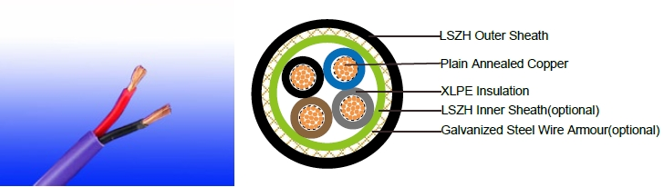

APPLICATION

The cables are mainly used in power stations, mass transit underground passenger systems, airports, petrochemical plants, hotels, hospitals, and high-rise buildings.

STANDARDS

Basic design adapted to IEC 60502-1; BS 6724

FIRE PERFORMANCE

Flame Retardance (Single Vertical EN 60332-1-2; IEC 60332-1-2; BS EN 60332-1-2; VDE _{Wire Test)} 0482-332-1 ; NBN C 30-004 (cat. F1); NF C32-070-2.1(C2);
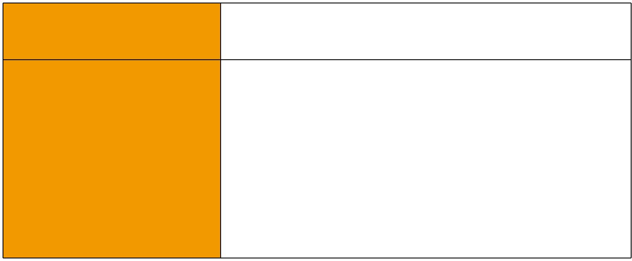
CEI 20-35/1-2; EN 50265-2-1*; DIN VDE 0482-265-2-1*

Reduced Fire Propagation | EN 60332-3-24 (cat. C); IEC 60332-3-24; BS EN 60332-3-24;
(Vertically-mounted bundled wires VDE 0482-332-3; NBN C 30-004 (cat. F2); NF C32-070-2.2(C1);
& cable test) | CEI 20-22/3-4; EN 50266-2-4*; DIN VDE 0482-266-2-4
Halogen Free | IEC 60754-1; EN 50267-2-1; DIN VDE 0482-267-2-1;
Halogen Free | CEI 20-37/2-1 ; BS 6425-1*
No Corrosive Gas Emission | IEC 60754-2; EN 50267-2-2; DIN VDE 0482-267-2-2;
No Corrosive Gas Emission | CEI 20-37/2-2 ; BS 6425-2*
Minimum Smoke Emission | IEC 61034-1&2; EN 61034 -1&2; DIN VDE 0482-1034-1&2;
Minimum Smoke Emission | CEI 20-37/3-1&2; EN 50268-1&2*; BS 7622-1&2*
No Toxic gases | NES 02-713; NF C 20-454

Note: Asterisk * denotes superseded standard.

VOLTAGE RATING

300/500V

 ADDISON 7

 ADDISON

CABLE CONSTRUCTION

Conductor: Plain annealed copper wire, stranded according to IEC(EN) 60228 class 2. Insulation: Extruded cross-linked XLPE compound.

Inner Sheath (optional): LSZH Compound Armouring (optional): Galvanized Steel Wire

Outer Sheath: Thermoplastic LSZH compound type LTS3 as per BS 7655-6.1 (Thermosetting LSZH compound type SW2-SW4 as per BS 7655-2.6 can be offered.). UV resistance, hydrocarbon resistance, oil resistance, anti rodent and anti termite properties can be offered as option.

COLOUR CODE

Insulation Colour as per BS7671
 | With Earth Conductor | Without Earth Conductor
2Cores | - | Brown, Blue
3Cores | Yellow/Green, Brown, Blue | Brown, Gray, Black
4Cores | Yellow/Green, Brown, Gray, Black | Brown, Gray, Black, Blue
5Cores | Yellow/Green, Brown, Gray, Black, Blue | Brown, Gray, Black, Blue, Black
Above 5 Cores | Yellow/Green, Black Numbered | Black Numbered

Sheath Colour: Black (other colors upon request)

Physical AND THERMAL PROPERTIES

Temperature range during operation: Max.90°C for XLPE

250°C in short-circuit for 5s max. Minimum bending radius: 6 x Overall Diameter (unarmoured cable)
10 x Overall Diameter (armoured cable)

CONSTRUCTION PARAMETERS

 |  | Conductor |  | FTX200 05RZ1-R |  |  | FTX200 05RZ1MZ1-R
 | No. of Core | No./Nominal | Nominal | Unarmoured |  |  | Armoured
 | No. of Core | No./Nominal | Nominal | Nominal |  | Diameter |  | Armour | Nominal
 | X | Diameter of | Insulation | Nominal | Approx. | Diameter |  | Armour | Nominal | Approx.
 | Cross | Strands | Thickness | Overall | Weight | Under |  | Wire | Overall | Weight
 | Section | Strands | Thickness | Diameter | Weight | Armour |  | Diameter | Diameter | Weight
 | Noxmm² | No./mm | mm | mm | kg/km | mm |  | mm | mm | kg/km
 | 2x1.5 | 7/0.53 | 0.50 | 6.5 | 65 | 6.5 |  | 0.9 | 11.2 | 246
 | 2x2.5 | 7/0.67 | 0.50 | 7.3 | 91 | 7.3 |  | 0.9 | 12.0 | 292
 | 2x4 | 7/0.85 | 0.50 | 8.4 | 131 | 8.4 |  | 0.9 | 13.1 | 360
 | 3x1.5 | 7/0.53 | 0.50 | 6.9 | 81 | 6.9 |  | 0.9 | 11.6 | 275
 | 3x2.5 | 7/0.67 | 0.50 | 7.8 | 116 | 7.8 |  | 0.9 | 12.5 | 331
 | 3x4 | 7/0.85 | 0.50 | 9.0 | 169 | 9.0 |  | 0.9 | 13.7 | 413
 | 4x1.5 | 7/0.53 | 0.50 | 7.6 | 101 | 7.6 |  | 0.9 | 12.3 | 309
 | 4x2.5 | 7/0.67 | 0.50 | 8.6 | 144 | 8.6 |  | 0.9 | 13.3 | 380
 | 4x4 | 7/0.85 | 0.50 | 9.9 | 213 | 9.9 |  | 0.9 | 14.6 | 479
8 | Caledonian

Caledonian

Flame Retardant Power & Control Cables

www.caledonian-cables.co.uk www.addison-cables.com

Electrical PROPERTIES

Conductor Operating Temperature : 90°C

Ambient Temperature : 30°C

FTX200 05RZ1-R

Current-Carrying Capacities (Amp)

 | Reference Method |  |  | Reference |  |  |  |  | Reference |  |  |  | Reference Method 12 (free
Conductor |  |  |  | Method 3 |  |  |  |  |  |  |  |  |  |  |  |  | air)
cross- | 4 (enclosed |  |  | (enclosed in |  |  | Reference Method |  | Method 11 (on a
cross- | in conduit |  |  |  |  |  |  |  | perforated cable |  |  |  | Horizontal |  |  |  | Vertical
sectional | in thermally |  |  | conduit on |  |  | 1 (clipped direct) |  | tray, horizontal or |  |  |  |  | flat |  |  | flat | Trefoil
area | insulating wall etc) |  |  | a wall or in |  |  |  |  | vertical) |  |  |  |  | spaced |  |  | spaced
 |  |  |  | trunking etc) |  |  |  |  |  |  |  |  |  |  |  |  | spaced
 |  |  |  |  |  |  |  |  |  |  |  |  | 2 cables, |  |  |  | 2
 |  |  |  |  |  |  |  |  |  |  |  |  |  |  |  |  | cables,
 | 2 |  |  | 2 |  |  | 2 cables, | 3 or 4 | 2 cables, |  |  | 3 or 4 |  | single- |  |  | single-
 | 2 |  |  |  |  |  | single- | cables, | single- |  |  | cables, |  | phase |  |  | single-
 | cables, |  | 3 or 4 | cables, |  | 3 or 4 | single- | cables, |  |  |  | cables, |  |  |  |  | phase | 3 cables,
 | cables, |  | 3 or 4 |  |  | 3 or 4 | phase | 3-phase | phase |  |  | 3-phase |  | a.c. or |  |  | phase
 | single- |  | cables, | single- |  | cables, |  |  |  |  |  |  |  |  |  |  | a.c. or | trefoil
 | phase |  | 3-phase | phase |  | 3-phase | a.c. or | a.c. flat | a.c. or |  |  | a.c. flat |  | d.c. |  |  | d.c. | 3-phase
 | a.c. or |  | a.c. | a.c. or |  | a.c. | d.c. flat | and | d.c. or |  |  | and |  | or 3 c |  |  | or 3 | a.c.
 | d.c. |  |  | d.c |  |  | and | touching | flat and |  |  | touching |  | ables |  |  | cables
 | d.c. |  |  |  |  |  | touching | or trefoil | touching |  |  | or trefoil |  | three |  |  | cables
 |  |  |  |  |  |  |  |  |  |  |  |  |  |  |  |  | three
 |  |  |  |  |  |  |  |  |  |  |  |  |  | phase |  |  | three
 |  |  |  |  |  |  |  |  |  |  |  |  |  |  |  |  | phase
1 | 2 |  | 3 | 4 |  | 5 | 6 | 7 | 8 |  |  | 9 |  | 10 |  |  | 11 | 12
mm² | A |  | A | A |  | A | A | A | A |  |  | A |  | A |  |  | A | A
1.5 | 18 |  | 17 | 22 |  | 19 | 25 | 23 | - |  |  | - |  | - |  |  | - | -
2.5 | 24 |  | 23 | 30 |  | 26 | 34 | 31 | - |  |  | - |  | - |  |  | - | -
4 | 33 |  | 30 | 40 |  | 35 | 46 | 41 | - |  |  | - |  | - |  |  | - | -
Voltage Drop (Per Amp Per Meter)
Nominal |  | 2 cables, single-phase a.c. |  |  |  |  |  |  | 3 or 4 cables, 3-phase a.c.
Nominal |  | Ref. Methods 3 |  |  |  | Ref. Methods 1 |  | Ref. Methods 3 |  |  |  |  |  |  | Ref. Methods 1 and
Cross | 2 cables |  |  |  |  |  |  |  |  |  | Ref. Methods 1,
Section | d.c. | and 4 (enclosed |  |  |  | and 11 (clipped |  | and 4 (enclosed |  |  |  |  |  |  |  |  | 11
 |  |  |  |  |  |  |  |  |  |  | 11 and 12 (in
Area |  | in conduit etc, |  |  | direct or on trays |  |  | in conduit etc, |  |  |  |  |  |  |  | (Flat and touching)
Area |  | in or on a wall) |  |  |  | touching) |  | in or on a wall) |  |  | trefoil)
1 | 2 | 3 |  |  |  | 4 |  | 5 |  |  | 6 |  |  |  |  |  | 7
mm² | mV/A/m | mV/A/m |  |  |  | mV/A/m |  | mV/A/m |  |  | mV/A/m |  |  |  |  |  | mV/A/m
1.5 | 31 | 31 |  |  |  | 27 |  | 27 |  |  | 27 |  |  |  |  |  | 27
2.5 | 19 | 19 |  |  |  | 16 |  | 16 |  |  | 16 |  |  |  |  |  | 16
4 | 33 | 12 |  |  |  | 10 |  | 10 |  |  | 10 |  |  |  |  |  | 10


ADDISON 9

ADDISON

FTX200 05RZ1MZ1-R

Current-Carrying Capacities (Amp)

Conductor | Reference Method 1 |  | Reference Method 11 (on
cross- | (clipped |  | a perforated horizontal |  | In single-way ducts |  | Laid direct in ground
sectional | direct) |  | cable tray or Reference
area |  |  | Method 13 [free air] )
 |  |  |  | one 3-core |  | one 3-core |  | one 3-core
 | one 2-core |  | one 2-core | one 3-core | one 2-core | or 4-core | one 2-core | or 4-core
 | one 2-core | one 3-core or | one 2-core | or 4-core
 | cable single | 4-core cable | cable single | cable | cable single | cable | cable single | cable
 | phase a.c. | 3-phase a.c. | phase a.c. or | 3-phase | phase a.c. | 3-phase | phase a.c. | 3-phase
 | or d.c. |  | d.c. | a.c. | or d.c. | a.c. | or d.c. | a.c.
1 | 2 | 3 | 4 | 5 | 6 | 7 | 8 | 9
mm² | A | A | A | A | A | A | A | A
1.5 | 27 | 23 | 29 | 25 | - | 23 | - | 28
2.5 | 36 | 31 | 39 | 33 | - | 30 | - | 36
4 | 49 | 42 | 52 | 44 | - | 40 | - | 48

Voltage Drop (Per Amp Per Meter)

 |  |  |  |  |  |  |  | 2 cables, |  | 3 or 4 cables,
Nominal |  |  |  |  |  |  |  | single-phase |  | 3 or 4 cables,
 |  | 2 cables |  | 2 cables, single- |  | 3 or 4 cables, 3-phase |  |  |  | 3-phase a.c.
Cross |  |  |  |  |  |  |  | a.c. |  | 3-phase a.c.
 |  | d.c. |  | phase a.c. |  | a.c.
Section Area |  |  |  |  |  |  |  | In ducts or in ground |  | In ducts or in ground
1 |  | 2 |  | 3 |  | 4 |  | 5 |  | 6
mm² |  | mV/A/m |  | mV/A/m |  | mV/A/m |  | mV/A/m |  | mV/A/m
1.5 |  | 31 |  | 31 |  | 27 |  | 31 |  | 25
2.5 |  | 19 |  | 19 |  | 16 |  | 19 |  | 15
4 |  | 12 |  | 12 |  | 10 |  | 12 |  | 9.7
 | 300/500V |  | IEC_{N}60502-1 |  | _{N}BS6724 |  | Flame Retardancy | Reduced Fire Propagation
 | Rated Voltage |  |  |  |  |  | NF C32-070-2.1(C2) | NF C32-070-2.2(C1)
 |  |  | Standard |  | Standard |  | IEC60332-1-2/EN50265-2-1 | IEC60332-3-24/EN50266-2-4
 |  |  |  |  |  |  | Zero
 |  |  | Low Corrosivity |  | Low Smoke Emission |  | Halogen Free
 |  |  | IEC60754-2 |  |  |  | Halogen Free
 | Low Toxicity |  |  |  | IEC 61034-1&2 |  | IEC60754-1
 |  |  | EN50267-2-2/3 |  |  |  | IEC60754-1
 | NES 02-713/NF C 20-454 |  | NF C 32-074 |  | EN 50268-1&2/NF C32-073 |  | EN50267-2-1
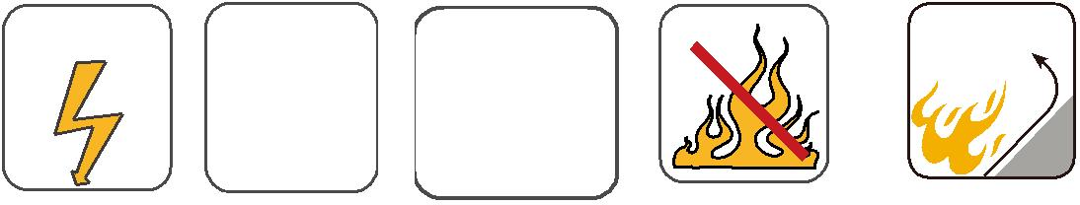
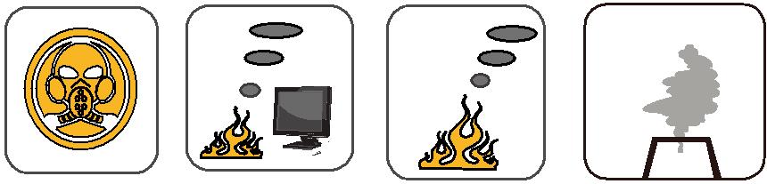

10 Caledonian

