
Caledonian

Flame Retardant Power & Control Cables

www.caledonian-cables.co.uk www.addison-cables.com

600/1000V XLPE Insulated, LSZH Sheathed, Double steel tape armoured Power Cables (2 Cores)

FTX400 1RZ1MZ1-R (CU/XLPE/LSZH/DSTA/LSZH 600/1000V Class 2)

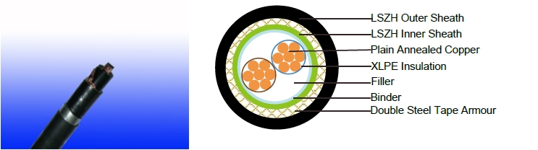

APPLICATION

The cables is mainly used in power stations, mass transit underground passenger systems, airports, petrochemical plants, hotels, hospitals, and high-rise buildings.

STANDARDS

Basic design adapted to IEC 60502 -1

FIRE PERFORMANCE

Flame Retardance (Single Vertical | EN 60332-1-2; IEC 60332-1-2; BS EN 60332-1-2; VDE
Flame Retardance (Single Vertical | 0482-332-1 ; NBN C 30-004 (cat. F1); NF C32-070-2.1(C2);
Wire Test) | CEI 20-35/1-2; EN 50265-2-1*; DIN VDE 0482-265-2-1*
Reduced Fire Propagation | EN 60332-3-24 (cat. C); IEC 60332-3-24; BS EN 60332-3-24;
(Vertically-mounted bundled wires | VDE 0482-332-3; NBN C 30-004 (cat. F2); NF C32-070-2.2(C1);
& cable test) | CEI 20-22/3-4; EN 50266-2-4*; DIN VDE 0482-266-2-4
Halogen Free | IEC 60754-1; EN 50267-2-1; DIN VDE 0482-267-2-1;
Halogen Free | CEI 20-37/2-1 ; BS 6425-1*
No Corrosive Gas Emission | IEC 60754-2; EN 50267-2-2; DIN VDE 0482-267-2-2;
No Corrosive Gas Emission | CEI 20-37/2-2 ; BS 6425-2*
Minimum Smoke Emission | IEC 61034-1&2; EN 61034 -1&2; DIN VDE 0482-1034-1&2;
Minimum Smoke Emission | CEI 20-37/3-1&2; EN 50268-1&2*; BS 7622-1&2*
No Toxic gases | NES 02-713; NF C 20-454

Note: Asterisk * denotes superseded standard.

VOLTAGE RATING

600/1000V

 ADDISON 73

 ADDISON

CABLE CONSTRUCTION

Conductor: Plain annealed copper wire, normal stranded or compact stranded according to IEC(EN) 60228 class 2.

Insulation: Extruded cross-linked XLPE compound.

Filler, binder and inner covering: PP, PET, LSZH

Armouring: Double steel tape

Outer Sheath: Thermoplastic LSZH compound type LTS3 as per BS 7655-6.1 (Thermosetting LSZH compound type SW2-SW4 as per BS 7655-2.6 can be offered.). UV resistance, hydrocarbon resistance, oil resistance, anti rodent and anti termite properties can be offered as option.

COLOUR CODE

Insulation Colour as per BS7671
 | With Earth Conductor | Without Earth Conductor
2Cores | - | Brown, Blue
3Cores | Yellow/Green, Brown, Blue | Brown, Gray, Black
4Cores | Yellow/Green, Brown, Gray, Black | Brown, Gray, Black, Blue
5Cores | Yellow/Green, Brown, Gray, Black, Blue | Brown, Gray, Black, Blue, Black
Above 5 Cores | Yellow/Green, Black Numbered | Black Numbered

Sheath Colour: Black (other colors upon request)

Physical AND THERMAL PROPERTIES

Temperature range during operation: Max.90°C for XLPE

250°C in short-circuit for 5s max.

Minimum bending radius: 10x Overall Diameter

CONSTRUCTION PARAMETERS

 |  | Conductor |  |  | FTX400 1RZ1MZ1-R
 | No. of |  |  |  |  |  |  | Max.DC
 | No. of | No./Nominal | Diameter | Nominal | Steel | Nominal | Nominal | resistance
 | Core X | Diameter of | Overall | Insulation | Tape | Sheath | Overall | of | Approx.
 | Cross | Strands | Conducrtor | Thickness | Thickness | Thickness | Diatemer | conductor | Weight
 | Section |  |  |  |  |  |  | @20°C
 | mm² | No/mm | mm | mm | mm | mm | mm | Ω/km | Kg/km
 | 2x6 | 7/1.04 | 2.90 | 0.7 | 0.2 | 1.8 | 16.8 | 3.08 | 417
 | 2x10 | 7/1.35 | 3.75 | 0.7 | 0.2 | 1.8 | 18.5 | 1.83 | 539
 | 2x16 | 7/1.70 | 4.75 | 0.7 | 0.2 | 1.8 | 20.5 | 1.15 | 704
 | 2x25 | 7/2.14 | 5.85 | 0.9 | 0.2 | 1.8 | 23.5 | 0.727 | 971
 | 2x35 | 7/2.52 | 6.90 | 0.9 | 0.2 | 1.8 | 25.6 | 0.524 | 1,216
 | 2x50 | 19/1.78 | 8.15 | 1.0 | 0.2 | 1.8 | 28.5 | 0.387 | 1,582
 | 2x70 | 19/2.14 | 9.75 | 1.1 | 0.2 | 1.9 | 32.3 | 0.268 | 2081
 | 2x95 | 19/2.52 | 11.45 | 1.1 | 0.2 | 2.0 | 36.4 | 0.193 | 2749
 | 2x120 | 37/2.03 | 12.85 | 1.2 | 0.5 | 2.2 | 41.1 | 0.153 | 3,727
74 | Caledonian

Caledonian

Flame Retardant Power & Control Cables

www.caledonian-cables.co.uk www.addison-cables.com

2x150 | 37/2.25 | 14.30 | 1.4 | 0.5 | 2.3 | 45.1 | 0.124 | 4,509
2x185 | 37/2.52 | 15.95 | 1.6 | 0.5 | 2.5 | 49.9 | 0.0991 | 5,523
2x240 | 61/2.25 | 18.25 | 1.7 | 0.5 | 2.6 | 55.3 | 0.0754 | 6981
2x300 | 61/2.52 | 20.40 | 1.8 | 0.5 | 2.8 | 60.7 | 0.0601 | 8,383
2x400 | 61/2.85 | 23.35 | 2.0 | 0.5 | 3.0 | 67.9 | 0.0470 | 10,897

Electrical PROPERTIES

Conductor Operating Temperature : 90°C

Ambient Temperature : 30°C

Current-Carrying Capacities (Amp)

 |  |  | Reference Method
 | Reference Method |  | 11 (on a perforated |  | In single-way |  | Laid direct in
 | 1 (clipped |  | horizontal cable trayor
 |  |  |  |  | ducts |  | ground
Conductor | direct) |  | Reference Method 13
Conductor |  |  | [free air] )
cross-
cross- | one |  |  |  | one |  | one
sectional | one | one |  |  | one | one | one | one
sectional | 2-core | one |  | one 3-core | 2-core | one | 2-core | one
area | 2-core | 3-core or | one 2-core | one 3-core | 2-core | 3-core or | 2-core | 3-core or
 | cable | 4-core | cable single | or 4-core | cable | 4-core | cable | 4-core
 | single | 4-core | cable single | cable | single | 4-core | single | 4-core
 | single | cable | phase a.c. | cable | single | cable | single | cable
 | phase | cable | phase a.c. | 3-phase | phase | cable | phase | cable
 | phase | 3-phase | or d.c. | 3-phase | phase | 3-phase | phase | 3-phase
 | a.c. or | a.c. |  | a.c. | a.c. or | a.c. | a.c. or | a.c.
 | d.c. | a.c. |  |  | d.c. | a.c. | d.c. | a.c.
1 | 2 | 3 | 4 | 5 | 6 | 7 | 8 | 9
mm² | A | A | A | A | A | A | A | A
6 | 62 | 53 | 66 | 56 | - | 50 | - | 60
10 | 85 | 73 | 90 | 78 | - | 65 | - | 80
16 | 110 | 94 | 115 | 99 | 115 | 94 | 140 | 115
25 | 146 | 124 | 152 | 131 | 145 | 125 | 180 | 150
35 | 180 | 154 | 188 | 162 | 175 | 150 | 215 | 180
50 | 219 | 187 | 228 | 197 | 210 | 175 | 255 | 215
70 | 279 | 238 | 291 | 251 | 260 | 215 | 315 | 265
95 | 338 | 289 | 354 | 304 | 310 | 260 | 380 | 315
120 | 392 | 335 | 410 | 353 | 355 | 300 | 430 | 360
150 | 451 | 386 | 472 | 406 | 400 | 335 | 480 | 405
185 | 515 | 441 | 539 | 463 | 455 | 380 | 540 | 460
240 | 607 | 520 | 636 | 546 | 520 | 440 | 630 | 530
300 | 698 | 599 | 732 | 628 | 590 | 495 | 700 | 590
400 | 787 | 673 | 847 | 728 | 660 | 560 | 790 | 670

ADDISON 75

ADDISON

Voltage Drop (Per Amp Per Meter)
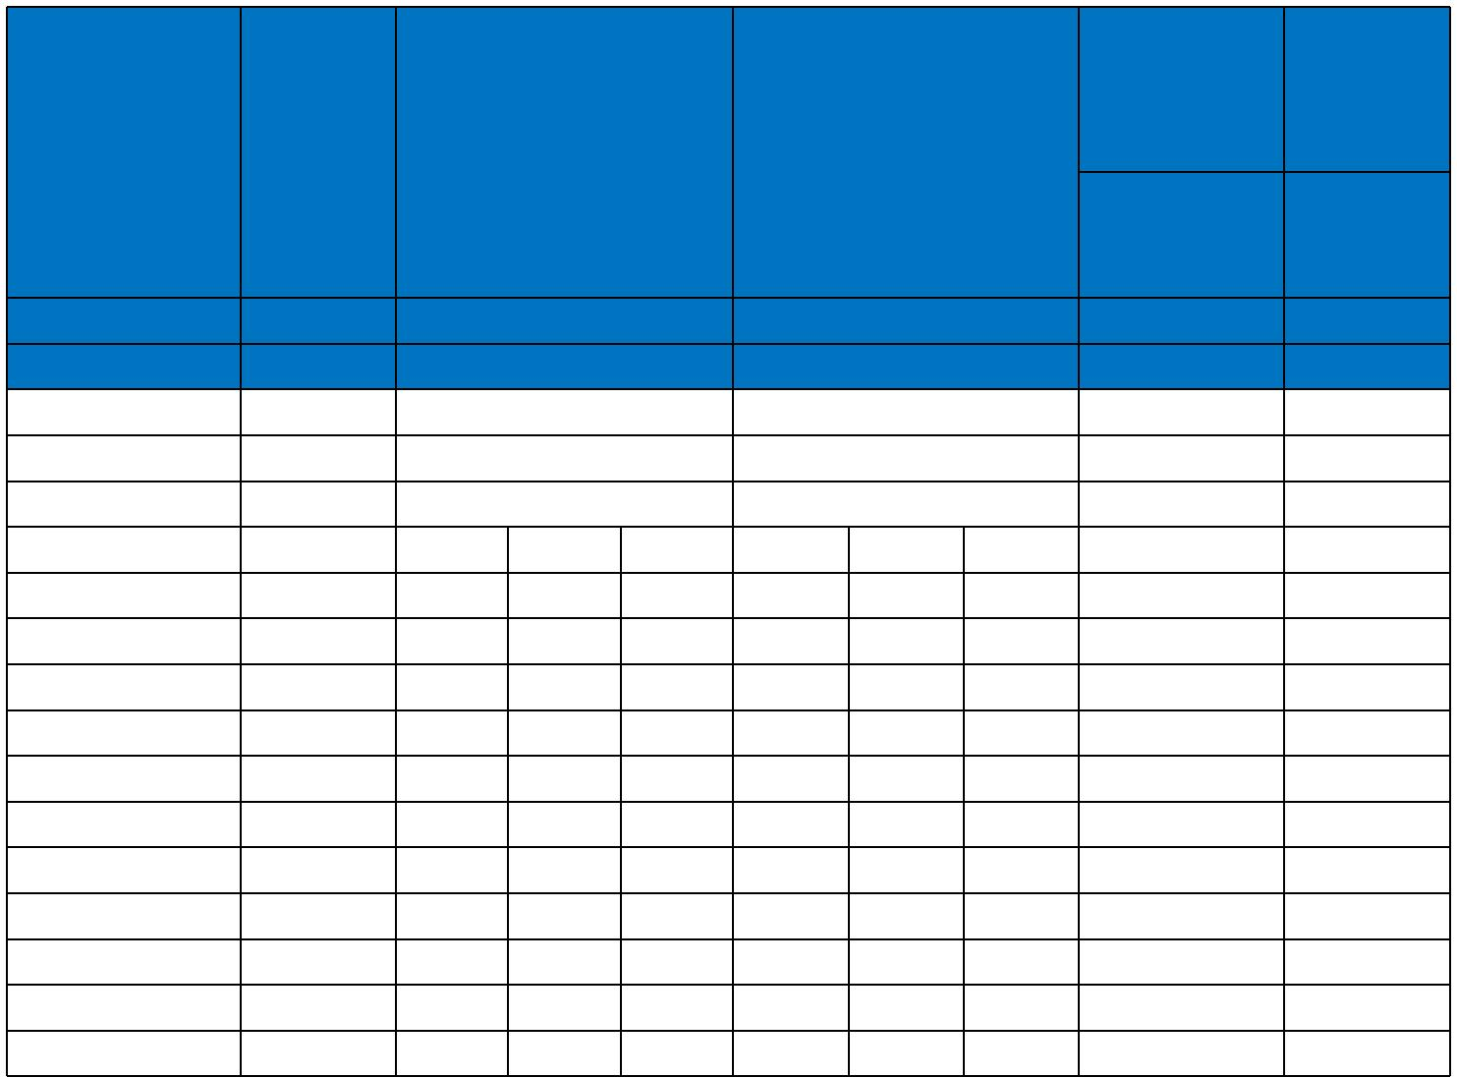
 |  |  |  |  |  |  |  | 2 cables, | 3 or 4
 |  |  |  |  |  |  |  | single- | cables,
Conductor | 2-core | 2 cables, single-phase |  |  | 3 or 4 cables, 3-phase |  |  | phase | 3-phase
cross-sectional | 2-core |  |  |  |  |  |  | a.c. | a.c.
cross-sectional | cable d.c. |  | a.c. |  |  | a.c. |  | a.c. | a.c.
area |  |  |  |  |  |  |  | In ducts or | In ducts
 |  |  |  |  |  |  |  | In ducts or | or
 |  |  |  |  |  |  |  | in ground | or
 |  |  |  |  |  |  |  | in ground | in ground
1 | 2 |  | 3 |  |  | 4 |  | 5 | 6
mm² | mV/A/m |  | mV/A/m |  |  | mV/A/m |  | mV/A/m | mV/A/m
6 | 7.9 |  | 7.9 |  |  | 6.8 |  | 7.9 | 6.5
10 | 4.7 |  | 4.7 |  |  | 4.0 |  | 4.7 | 3.9
16 | 2.9 |  | 2.9 |  |  | 2.5 |  | 2.9 | 2.6
 |  | r | x | z | r | x | z
25 | 1.850 | 1.350 | 0.160 | 1.900 | 1.600 | 0.140 | 1.650 | 1.900 | 1.600
35 | 1.350 | 1.350 | 0.155 | 1.350 | 1.150 | 0.135 | 1.150 | 1.350 | 1.200
50 | 0.980 | 0.990 | 0.155 | 1.000 | 0.860 | 0.135 | 0.870 | 1.000 | 0.870
70 | 0.670 | 0.670 | 0.150 | 0.690 | 0.590 | 0.130 | 0.600 | 0.690 | 0.610
95 | 0.490 | 0.500 | 0.150 | 0.520 | 0.430 | 0.130 | 0.450 | 0.520 | 0.450
120 | 0.390 | 0.400 | 0.145 | 0.420 | 0.340 | 0.130 | 0.370 | 0.420 | 0.360
150 | 0.310 | 0.320 | 0.145 | 0.350 | 0.280 | 0.125 | 0.300 | 0.350 | 0.300
185 | 0.250 | 0.260 | 0.145 | 0.290 | 0.220 | 0.125 | 0.260 | 0.290 | 0.250
240 | 0.195 | 0.200 | 0.140 | 0.240 | 0.175 | 0.125 | 0.210 | 0.240 | 0.210
300 | 0.155 | 0.160 | 0.140 | 0.210 | 0.140 | 0.120 | 0.185 | 0.210 | 0.190
400 | 0.120 | 0.130 | 0.140 | 0.190 | 0.115 | 0.120 | 0.165 | 0.190 | 0.180
Note :
r = conductor resistance at operating temperature
x = reactance
z = impedance
600/1000V | IEC_{N}60502-1 | Flame Retardancy |  | Reduced Fire Propagation
 |  |  |  | NF C32-070-2.2(C1)
Rated Voltage | Standard | NF C32-070-2.1(C2) |  | IEC60332-3-24
Rated Voltage | Standard | IEC60332-1-2/EN50265-2-1 |  |  | EN50266-2-4
 |  |  |  | Zero
 | Low Corrosivity | Low Smoke Emission |  |  | Halogen Free
Low Toxicity | IEC60754-2 | IEC 61034-1&2 |  |  | IEC60754-1
Low Toxicity | EN50267-2-2/3 |  |  |  | IEC60754-1
NES 02-713/NF C 20-454 | EN50267-2-2/3 | EN 50268-1&2/NF C32-073 |  |  | EN50267-2-1
NES 02-713/NF C 20-454 | NF C 32-074 |  |  |  | EN50267-2-1
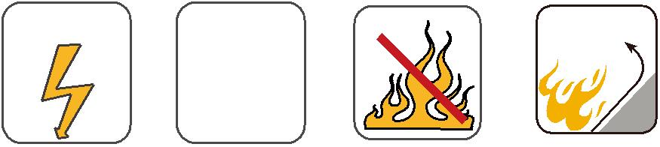
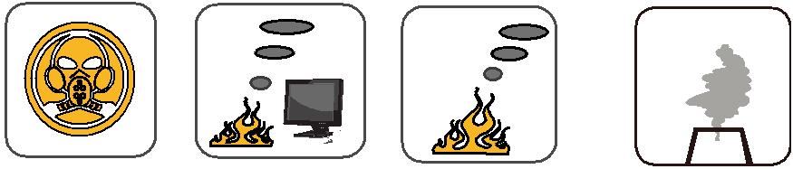

76 Caledonian

