 ADDISON

600/1000V XLPE Insulated, LSZH Sheathed, Armoured Power Cables (Multicore)

FTX400 1RZ1-R (CU/XLPE/LSZH 600/1000V Class 2)

FTX400 1RZ1MZ1-R (CU/XLPE/LSZH/SWA/LSZH 600/1000V Class 2)
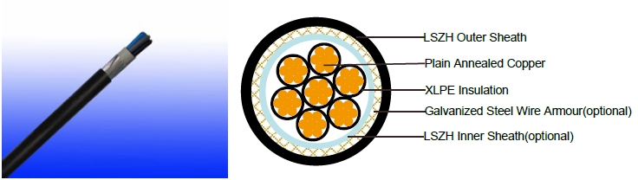

APPLICATION

The cables are mainly used in power stations, mass transit underground passenger systems, airports, petrochemical plants, hotels, hospitals, and high-rise buildings.

STANDARDS

Basic design adapted to IEC 60502-1; BS 6724

FIRE PERFORMANCE

Flame Retardance (Single Vertical | EN 60332-1-2; IEC 60332-1-2; BS EN 60332-1-2; VDE
Flame Retardance (Single Vertical | 0482-332-1 ; NBN C 30-004 (cat. F1); NF C32-070-2.1(C2);
Wire Test) | CEI 20-35/1-2; EN 50265-2-1*; DIN VDE 0482-265-2-1*
Reduced Fire Propagation | EN 60332-3-24 (cat. C); IEC 60332-3-24; BS EN 60332-3-24;
(Vertically-mounted bundled wires | VDE 0482-332-3; NBN C 30-004 (cat. F2); NF C32-070-2.2(C1);
& cable test) | CEI 20-22/3-4; EN 50266-2-4*; DIN VDE 0482-266-2-4
Halogen Free | IEC 60754-1; EN 50267-2-1; DIN VDE 0482-267-2-1;
Halogen Free | CEI 20-37/2-1 ; BS 6425-1*
No Corrosive Gas Emission | IEC 60754-2; EN 50267-2-2; DIN VDE 0482-267-2-2;
No Corrosive Gas Emission | CEI 20-37/2-2 ; BS 6425-2*
Minimum Smoke Emission | IEC 61034-1&2; EN 61034 -1&2; DIN VDE 0482-1034-1&2;
Minimum Smoke Emission | CEI 20-37/3-1&2; EN 50268-1&2*; BS 7622-1&2*
No Toxic gases | NES 02-713; NF C 20-454

Note: Asterisk * denotes superseded standard.

VOLTAGE RATING

600/1000V

60 Caledonian


Caledonian

Flame Retardant Power & Control Cables

www.caledonian-cables.co.uk www.addison-cables.com

CABLE CONSTRUCTION

Conductor: Plain annealed copper wire, stranded according to IEC(EN) 60228 class 2. Insulation: Extruded cross-linked XLPE compound.

Inner Sheath(optional): LSZH Compound Armouring(optional): Galvanized Steel Wire

Outer Sheath: Thermoplastic LSZH compound type LTS3 as per BS 7655-6.1 (Thermosetting LSZH compound type SW2-SW4 as per BS 7655-2.6 can be offered.). UV resistance, hydrocarbon resistance, oil resistance, anti rodent and anti termite properties can be offered as option.

COLOUR CODE

Insulation Colour as per BS7671
 | With Earth Conductor | Without Earth Conductor
2Cores | - | Brown, Blue
3Cores | Yellow/Green, Brown, Blue | Brown, Gray, Black
4Cores | Yellow/Green, Brown, Gray, Black | Brown, Gray, Black, Blue
5Cores | Yellow/Green, Brown, Gray, Black, Blue | Brown, Gray, Black, Blue, Black
Above 5 Cores | Yellow/Green, Black Numbered | Black Numbered

Sheath Colour: Black (other colors upon request)

Physical AND THERMAL PROPERTIES

Temperature range during operation: Max.90°C for XLPE

250°C in short-circuit for 5s max. Minimum bending radius: 8 x Overall Diameter (unarmoured cable)

10 x Overall Diameter (armoured cable)

CONSTRUCTION PARAMETERS

 | Conductor |  | FTX400 1RZ1-R |  |  | FTX400 1RZ1MZ1-R
No. of Core | No./ |  | Unarmoured |  |  | Armoured
No. of Core | Nominal | Nominal | Nominal |  | Diameter | Armour | Nominal
X | Diameter | Insulation | Nominal | Approx. | Diameter | Armour | Nominal | Approx.
Cross | of | Thickness | Overall | Weight | Under | Wire | Overall | Weight
Section | of | Thickness | Diameter | Weight | Armour | Diameter | Diameter | Weight
 | Strands
mm² | No./mm | mm | mm | kg/km | mm | mm | mm | kg/km
5x1.5 | 7/0.53 | 0.7 | 11.3 | 184 | 9.9 | 0.9 | 14.5 | 402
7x1.5 | 7/0.53 | 0.7 | 12.4 | 225 | 11.2 | 0.9 | 16.0 | 490
10x1.5 | 7/0.53 | 0.7 | 15.6 | 325 | 14.3 | 1.25 | 20.0 | 761
12x1.5 | 7/0.53 | 0.7 | 16.2 | 370 | 14.8 | 1.25 | 20.5 | 827
19x1.5 | 7/0.53 | 0.7 | 19.0 | 516 | 17.4 | 1.6 | 24.0 | 1186
27x1.5 | 7/0.53 | 0.7 | 22.7 | 712 | 21.3 | 1.6 | 28.1 | 1537
37x1.5 | 7/0.53 | 0.7 | 25.5 | 941 | 23.9 | 1.6 | 30.7 | 1856
48x1.5 | 7/0.53 | 0.7 | 29.0 | 1186 | 27.5 | 1.6 | 34.6 | 2276
5x2.5 | 7/0.67 | 0.7 | 12.8 | 237 | 11.2 | 0.9 | 15.8 | 496

 ADDISON 61

ADDISON

7x2.5 | 7/0.67 | 0.7 | 13.8 | 303 | 12.4 | 0.9 | 17.2 | 602
10x2.5 | 7/0.67 | 0.7 | 17.5 | 426 | 15.9 | 1.25 | 21.8 | 943
12x2.5 | 7/0.67 | 0.7 | 18.1 | 489 | 16.5 | 1.25 | 22.4 | 1020
19x2.5 | 7/0.67 | 0.7 | 21.3 | 725 | 19.9 | 1.6 | 26.7 | 1498
27x2.5 | 7/0.67 | 0.7 | 25.5 | 1004 | 23.9 | 1.6 | 30.9 | 1933
37x2.5 | 7/0.67 | 0.7 | 28.7 | 1334 | 26.9 | 1.6 | 33.9 | 2372
48x2.5 | 7/0.67 | 0.7 | 32.9 | 1706 | 31.3 | 2.0 | 39.6 | 3252
5x4 | 7/0.85 | 0.7 | 14.2 | 324 | 12.6 | 1.25 | 18.2 | 712
7x4 | 7/0.85 | 0.7 | 15.5 | 422 | 14.1 | 1.25 | 19.8 | 871
10x4 | 7/0.85 | 0.7 | 19.7 | 597 | 18.5 | 1.25 | 24.4 | 1213
12x4 | 7/0.85 | 0.7 | 20.3 | 690 | 19.1 | 1.6 | 25.7 | 1462
19x4 | 7/0.85 | 0.7 | 24.0 | 1037 | 22.6 | 1.6 | 29.4 | 1931
27x4 | 7/0.85 | 0.7 | 28.8 | 1445 | 27.2 | 1.6 | 34.4 | 2532
37x4 | 7/0.85 | 0.7 | 32.5 | 1932 | 31.1 | 2.0 | 39.3 | 3448
48x4 | 7/0.85 | 0.7 | 37.3 | 2479 | 35.7 | 2.0 | 44.2 | 4273

Note : Other conductor sizes & core confi gurations are available upon request.

Electrical PROPERTIES

Conductor Operating Temperature : 90°C

Ambient Temperature : 30°C

FTX400 1RZ1-R

Current-Carrying Capacities (Amp)

 | Reference |  | Reference |  |  |  |  |  | Reference Method 12 (free
 | Method 4 |  |  |  |  |  | Reference |  |  | air)
Conductor |  |  | Method 3 |  |  |  |  |  |  | air)
Conductor | (enclosed |  |  |  |  |  | Method 11 (on a
cross- |  |  | (enclosed in |  | Reference Method
sectional | in conduit |  | conduit on |  | 1 (clipped direct) |  | perforated cable |  | Horizontal | Vertical
area | in thermally |  | a wall or in |  |  |  | tray, horizontal or |  | flat | flat | Trefoil
area | insulating wall |  |  |  |  |  | vertical) |  | spaced | spaced
 |  |  | trunking etc) |  |  |  |  |  | spaced | spaced
 | etc)
 |  |  |  |  |  |  |  |  | 2 cables, | 2
 |  |  |  |  |  |  |  |  | 2 cables, | cables,
 | 2 |  | 2 |  | 2 cables, | 3 or 4 | 2 cables, | 3 or 4 | single- | single-
 | 2 |  | 2 |  | single- | cables, | single- | cables, | phase | single-
 | cables, | 3 or 4 | cables, | 3 or 4 |  |  |  |  |  | phase | 3 cables,
 |  |  |  |  | phase | 3-phase | phase | 3-phase | a.c. or | phase | 3 cables,
 | single- | cables, | single- | cables, |  |  |  |  |  | a.c. or | trefoil
 | phase | 3-phase | phase | 3-phase | a.c. or | a.c. flat | a.c. or | a.c. flat | d.c. | d.c. | 3-phase
 | a.c. or | a.c. | a.c. or | a.c. | d.c. flat | and | d.c. or | and | or 3 c | or 3 | a.c.
 | d.c. |  | d.c |  | and | touching | flat and | touching | ables | cables
 | d.c. |  | d.c |  | touching | or trefoil | touching | or trefoil | three | cables
 |  |  |  |  |  |  |  |  |  | three
 |  |  |  |  |  |  |  |  | phase | three
 |  |  |  |  |  |  |  |  | phase | phase
1 | 2 | 3 | 4 | 5 | 6 | 7 | 8 | 9 | 10 | 11 | 12

62 Caledonian

Caledonian

Flame Retardant Power & Control Cables

www.caledonian-cables.co.uk www.addison-cables.com

mm² | A | A | A | A | A | A | A | A | A | A | A
1.5 | 18 | 17 | 22 | 19 | 25 | 23 | - | - | - | - | -
2.5 | 24 | 23 | 30 | 26 | 34 | 31 | - | - | - | - | -
4 | 33 | 30 | 40 | 35 | 46 | 41 | - | - | - | - | -

Voltage Drop (Per Amp Per Meter)

 |  | 2 cables, single-phase a.c. |  | 3 or 4 cables, 3-phase a.c.
Nominal |  | Ref. Methods | Ref. Methods 1 | Ref. Methods | Ref. Methods 1, | Ref. Methods 1
Cross | 2 cables | 3 and 4 | Ref. Methods 1 | 3 and 4 |  | and 11
Section | d.c. | (enclosed in | and 11 (clipped | (enclosed in
Area |  | conduit etc, in | direct or on trays | conduit etc, in | 11 and 12 (in | (Flat and
 |  | or on a wall) | touching) | or on a wall) | trefoil) | touching)
1 | 2 | 3 | 4 | 5 | 6 | 7
mm² | mV/A/m | mV/A/m | mV/A/m | mV/A/m | mV/A/m | mV/A/m
1.5 | 31 | 31 | 27 | 27 | 27 | 27
2.5 | 19 | 19 | 16 | 16 | 16 | 16
4 | 33 | 12 | 10 | 10 | 10 | 10

FTX400 1RZ1MZ1-R

Current-Carrying Capacities (Amp)

 |  |  | Reference Method
 | Reference Method |  | 11 (on a perforated |  | In single-way |  | Laid direct in
 | 1 (clipped |  | horizontal cable trayor
 |  |  |  |  | ducts |  | ground
Conductor | direct) |  | Reference Method 13
Conductor |  |  | [free air] )
cross-
cross- | one |  |  |  | one |  | one
sectional | one | one |  |  | one | one | one | one
sectional | 2-core | one |  | one 3-core | 2-core | one | 2-core | one
area | 2-core | 3-core or | one 2-core | one 3-core | 2-core | 3-core or | 2-core | 3-core or
 | cable | 4-core | cable single | or 4-core | cable | 4-core | cable | 4-core
 | single | 4-core | cable single | cable | single | 4-core | single | 4-core
 | single | cable | phase a.c. | cable | single | cable | single | cable
 | phase | cable | phase a.c. | 3-phase | phase | cable | phase | cable
 | phase | 3-phase | or d.c. | 3-phase | phase | 3-phase | phase | 3-phase
 | a.c. or | a.c. |  | a.c. | a.c. or | a.c. | a.c. or | a.c.
 | d.c. | a.c. |  |  | d.c. | a.c. | d.c. | a.c.
1 | 2 | 3 | 4 | 5 | 6 | 7 | 8 | 9
mm² | A | A | A | A | A | A | A | A
1.5 | 27 | 23 | 29 | 25 | - | 23 | - | 28
2.5 | 36 | 31 | 39 | 33 | - | 30 | - | 36
4 | 49 | 42 | 52 | 44 | - | 40 | - | 48

ADDISON 63

ADDISON

Voltage Drop (Per Amp Per Meter)
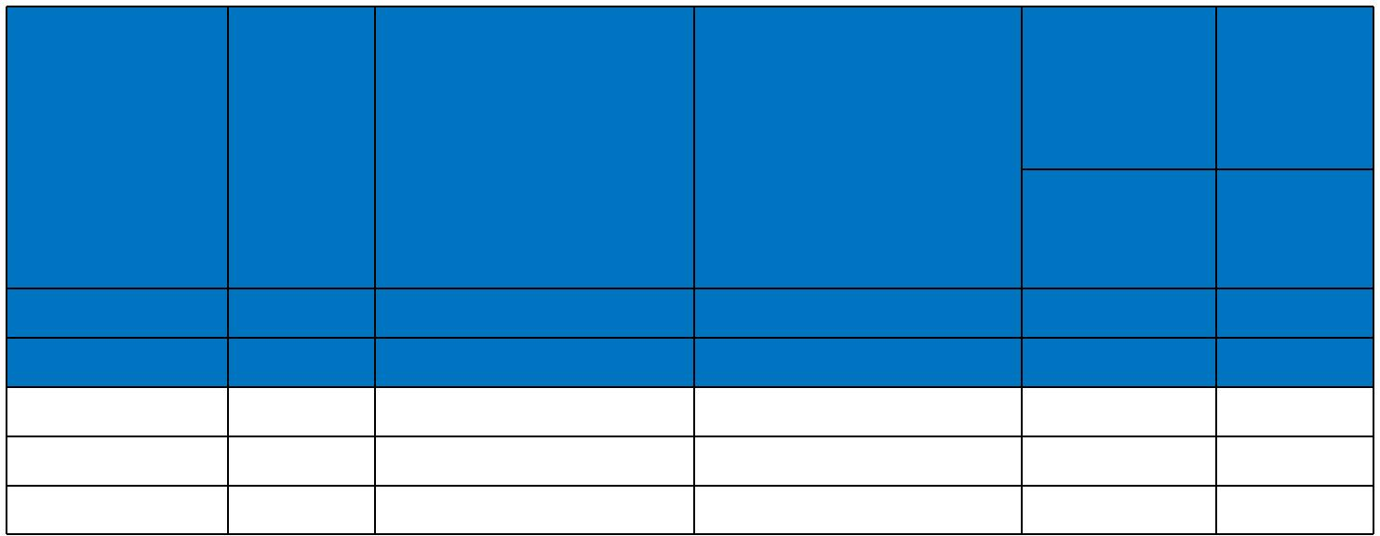
 |  |  |  |  |  | 2 cables, | 3 or 4
 |  |  |  |  |  | single- | cables,
Conductor | 2-core | 2 cables, single-phase 3 or 4 cables, 3-phase |  |  |  | phase | 3-phase
cross-sectional | 2-core |  |  |  |  | a.c. | a.c.
cross-sectional | cable d.c. | a.c. |  | a.c. |  | a.c. | a.c.
area |  |  |  |  |  | In ducts or | In ducts
 |  |  |  |  |  | In ducts or | or
 |  |  |  |  |  | in ground | or
 |  |  |  |  |  | in ground | in ground
1 | 2 | 3 |  | 4 |  | 5 | 6
mm² | mV/A/m | mV/A/m | mV/A/m |  |  | mV/A/m | mV/A/m
1.5 | 31.0 | 31.0 |  | 27.0 |  | 31.0 | 25.0
2.5 | 19.0 | 19.0 |  | 16.0 |  | 19.0 | 15.0
4 | 12.0 | 12.0 |  | 10.0 |  | 12.0 | 9.7
600/1000V | IEC_{N}60502-1 | _{N}BS6724 | Flame Retardancy | Reduced Fire Propagation
 |  |  | Flame Retardancy | NF C32-070-2.2(C1)
Rated Voltage | Standard | Standard | NF C32-070-2.1(C2) | IEC60332-3-24
Rated Voltage | Standard | Standard | IEC60332-1-2/EN50265-2-1 |  | EN50266-2-4
 |  |  | Zero
 | Low Corrosivity | Low Smoke Emission | Halogen Free
Low Toxicity | IEC60754-2 | IEC 61034-1&2 | IEC60754-1
Low Toxicity | EN50267-2-2/3 | IEC 61034-1&2 | IEC60754-1
Low Toxicity | EN50267-2-2/3 | EN 50268-1&2/NF C32-073 | EN50267-2-1
NES 02-713/NF C 20-454 | NF C 32-074 | EN 50268-1&2/NF C32-073 | EN50267-2-1
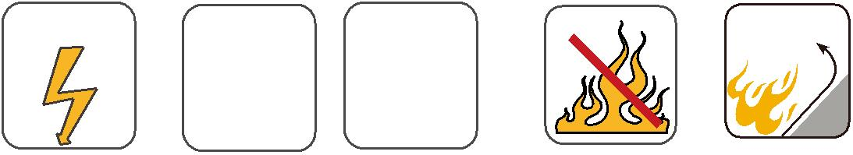
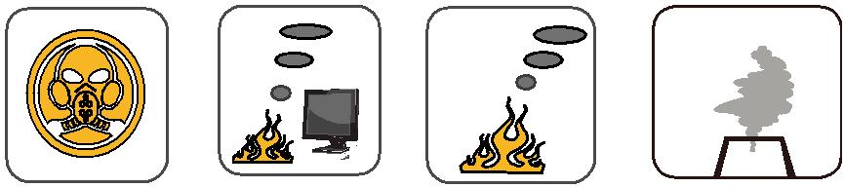

64 Caledonian

