
Caledonian

Flame Retardant Optic Fiber Cables

www.caledonian-cables.co.uk www.addison-cables.com

Flame Retardant Tight Buffered Distribution Fiber Optic cables

MTA-B-C-D-H

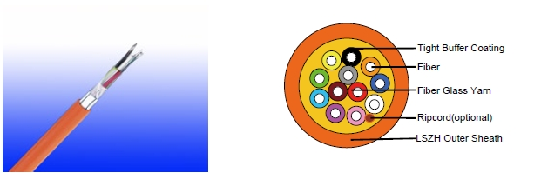

APPLICATION

This cables are used for interconnection of distribution boxes and end devices, where continued functionality is required during a fire situation. The cables are very suitable for various indoor and outdoor applications, including routing between buildings within ducts and inside building up to riser shafts.

STANDARDS

Basic design adapted to Telcordia GR409-CORE / TIA/EIA 568B.3 / ICEA-S-83-596

FIRE PERFORMANCE

Flame Retardance (Single Vertical EN 60332-1-2; IEC 60332-1-2; BS EN 60332-1-2; VDE _{Wire Test)} 0482-332-1 ; NBN C 30-004 (cat. F1); NF C32-070-2.1(C2);
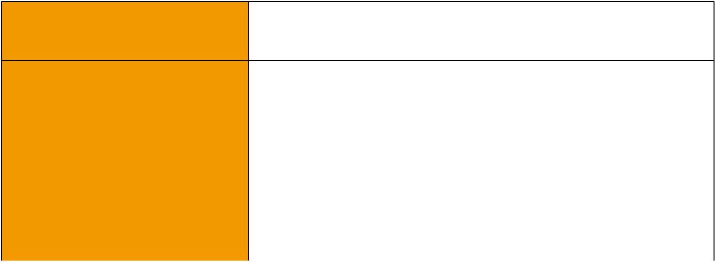
CEI 20-35/1-2; EN 50265-2-1*; DIN VDE 0482-265-2-1*

Reduced Fire Propagation | EN 60332-3-24 (cat. C); IEC 60332-3-24; BS EN 60332-3-24;
(Vertically-mounted bundled wires VDE 0482-332-3; NBN C 30-004 (cat. F2); NF C32-070-2.2(C1);
& cable test) | CEI 20-22/3-4; EN 50266-2-4*; DIN VDE 0482-266-2-4
Halogen Free | IEC 60754-1; EN 50267-2-1; DIN VDE 0482-267-2-1;
Halogen Free | CEI 20-37/2-1 ; BS 6425-1*
No Corrosive Gas Emission | IEC 60754-2; EN 50267-2-2; DIN VDE 0482-267-2-2;
No Corrosive Gas Emission | CEI 20-37/2-2 ; BS 6425-2*
Minimum Smoke Emission | IEC 61034-1&2; EN 61034 -1&2; DIN VDE 0482-1034-1&2;
Minimum Smoke Emission | CEI 20-37/3-1&2; EN 50268-1&2*; BS 7622-1&2*
No Toxic gases | NES 02-713; NF C 20-454
Note: Asterisk * denotes superseded standard.

CABLE CONSTRUCTION

Optical fibers: Singlemode and multimode tight fibers, with tight buffer coating.

Reinforcement: Either aramid yarn or fiber glass is wound around the tube to provide physical

 ADDISON 141

 ADDISON

protection and tensile strength, with added fire protection.

Inner Sheath(optional): Thermoplastic LSZH compound type LTS3 as per BS 7655-6.1 Ripcord(optional): An optional ripcord can be located under the outer sheath to facilitate jacket removal.

Armouring(optional):

STA: Corrugated steel tape armour SWB: Steel wire braid

Outer Sheath: Thermoplastic LSZH compound type LTS3 as per BS 7655-6.1 (Thermosetting LSZH compound type SW2-SW4 as per BS 7655-2.6 can be offered.). UV resistance, hydrocarbon resistance, oil resistance, anti rodent and anti termite properties can be offered as option.

Physical AND THERMAL PROPERTIES

Temperature range during operation (fixed state):-20°C - +60°C

Temperature range during installation (mobile state): 0°C - +50°C

Minimum bending radius: 10 times the outer diameter for unarmoured cables 20 times the outer diameter for armoured cables

CONSTRUCTION PARAMETERS

 | N° of | Nominal | Max. Tensile | Minimum | Approx.
Cable Code | N° of | Overall | Max. Tensile | bending | Approx.
Cable Code | Fibers | Overall | Strength | bending | Weight
 | Fibers | Diameter | Strength | radius | Weight
 |  | mm | N | mm | kg/km
MTA-B-2-0-H | 2 | 7,6 | 250 | 76 | 55
MTA-B-4-0-H | 4 | 7,8 | 250 | 78 | 67
MTA-B-6-0-H | 6 | 8,6 | 400 | 86 | 77
MTA-B-8-0-H | 8 | 8,8 | 400 | 88 | 81
MTA-B-12-0-H | 12 | 9,3 | 400 | 93 | 90


142 Caledonian

Caledonian

Flame Retardant Optic Fiber Cables

www.caledonian-cables.co.uk www.addison-cables.com

TYPE CODES

MTA-B-C-D-E-F-G-H
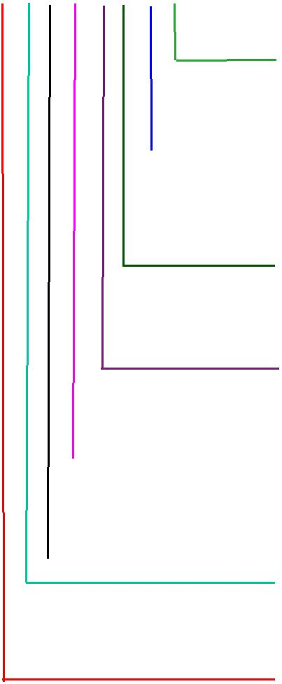
Outer Sheath

H: LSZH

Armour
Blank: No armour

STA: Corrugated steel tape armour SWB: Steel wire braid

Inner Sheath 2Y: PE
Y: PVC

H: LSZH

Central strength member

Blank: No Central strength member A: Aramid yarn

F: Fiber reinforced plastic(FRP) Sub Unit

0: No Sub Unit Y: PVC

H: LSZH C No of Fibers
Fiber Type
4: 50/125 um(OM3) 7: NZDS SM fiber per ITU-T G.656 5: 50/125 um(OM2) 8: NZDS SM fiber per ITU-T G.655

6: 62.5/125um(OM1) 9: Standard SM fiber per ITU-T G.652.D

Sub Unit Diameter
- 0.9mm (up to 12 fibers)
- 3.6mm (12-36 fibers)
- 4.2mm (24-72 fibers)

GR-20/RUS 7 CFR1755N.900 (REA PE-90)


Standard
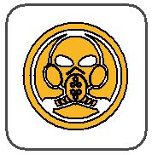
ICEA_{N}S87-640
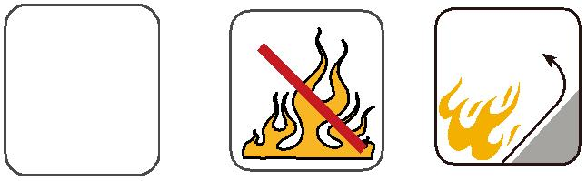 | Flame Retardancy | Reduced Fire Propagation
 | Flame Retardancy | NF C32-070-2.2(C1)
Standard | NF C32-070-2.1(C2) | IEC60332-3-24
Standard | IEC60332-1-2/EN50265-2-1 | EN50266-2-4
 |  | Zero
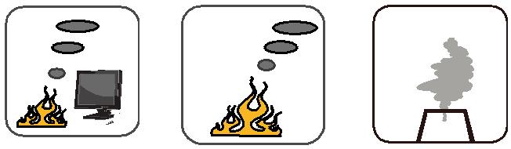

 | Low Corrosivity | Low Smoke Emission | Halogen Free
 | IEC60754-2 | Low Smoke Emission | Halogen Free
Low Toxicity | IEC60754-2 | IEC 61034-1&2 | IEC60754-1
Low Toxicity | EN50267-2-2/3 | IEC 61034-1&2 | IEC60754-1
NES 02-713/NF C 20-454 | NF C 32-074 | EN 50268-1&2/NF C32-073 | EN50267-2-1

ADDISON 143

