 ADDISON

Flame Retardant RG59 B/U CWB/SWB/SWA Armoured Coaxial cables
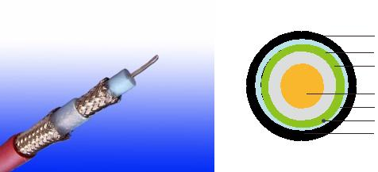

LSZH Outer Sheath

Tinned Copper Braid

Aluminium+polyester/Aluminium Tape

PE

Solid Bare Copper

LSZH Inner Sheath

Tinned Copper Drain Wire

Braid or Wire Armoured

Application

These 75Ω coaxial cables are suitable for installation on board of ships and other indoor marine environments.

STANDARDS

Basic design adapted to MIL-C-17

FIRE PERFORMANCE

Flame Retardance (Single Vertical EN 60332-1-2; IEC 60332-1-2; BS EN 60332-1-2; VDE _{Wire Test)} 0482-332-1 ; NBN C 30-004 (cat. F1); NF C32-070-2.1(C2);
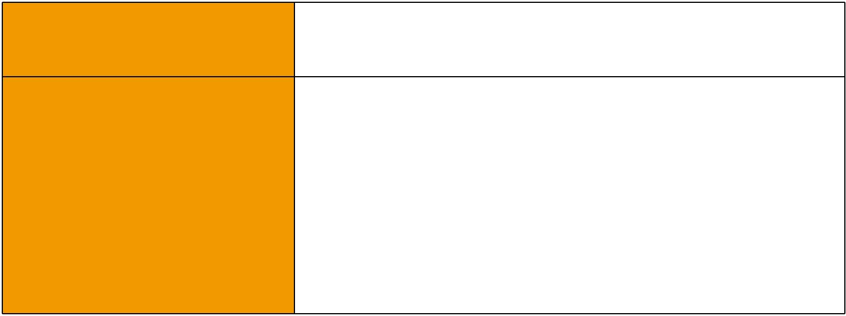
CEI 20-35/1-2; EN 50265-2-1*; DIN VDE 0482-265-2-1*

Reduced Fire Propagation | EN 60332-3-24 (cat. C); IEC 60332-3-24; BS EN 60332-3-24;
(Vertically-mounted bundled wires VDE 0482-332-3; NBN C 30-004 (cat. F2); NF C32-070-2.2(C1);
& cable test) | CEI 20-22/3-4; EN 50266-2-4*; DIN VDE 0482-266-2-4
Halogen Free | IEC 60754-1; EN 50267-2-1; DIN VDE 0482-267-2-1;
Halogen Free | CEI 20-37/2-1 ; BS 6425-1*
No Corrosive Gas Emission | IEC 60754-2; EN 50267-2-2; DIN VDE 0482-267-2-2;
No Corrosive Gas Emission | CEI 20-37/2-2 ; BS 6425-2*
Minimum Smoke Emission | IEC 61034-1&2; EN 61034 -1&2; DIN VDE 0482-1034-1&2;
Minimum Smoke Emission | CEI 20-37/3-1&2; EN 50268-1&2*; BS 7622-1&2*
No Toxic gases | NES 02-713; NF C 20-454

Note: Asterisk * denotes superseded standard.

CABLE CONSTRUCTION

Conductors: 20AWG solid bare copper.

Insulation: PE compound.

Screen1: Aluminium/polyester or aluminium tape.

Screen2: Tinned copper braid.

126 Caledonian


Caledonian

Flame Retardant Coaxial Cables
www.caledonian-cables.co.uk www.addison-cables.com

Inner Sheath: Low smoke and halogen-free polyolefin, coloured black.

Armouring:

cwb: copper Wire Braid swb: Steel Wire Braid swa: Steel Wire Armour

Outer Sheath: Thermoplastic LSZH compound type LTS3 as per BS 7655-6.1 (Thermosetting LSZH compound type SW2-SW4 as per BS 7655-2.6 can be offered.) . UV resistance, hydrocarbon resistance, oil resistance, anti rodent and anti termite properties can be offered as option.

Physical AND THERMAL PROPERTIES

Temperature Range: -30°C - +75°C

Minimum Bending Radius: 15 X Overall Diameter

Electrical Properties

AWG |  | 20
Nominal Conductor Diameter | mm | 0.58
Impedance | Ω | 75+/-5
Nominal Attenuation@100MHz | dB/100m | 7.6
Nominal Attenuation@270MHz | dB/100m | 12.5
Nominal Attenuation@540MHz | dB/100m | 17.9
Nominal Attenuation@720MHz | dB/100m | 20.9
Nominal Attenuation@750MHz | dB/100m | 21.3
Nominal Attenuation@1000MHz | dB/100m | 24.9
Capacitance | pF/m | 53.5
Velocity of Propagation | % | 83
Conductor DCR | Ω/km | 32.8
Shield DCR | Ω/km | 12.5
Inductance | μH/m | 0.318
Time Delay | ns/m | 4.0

 ADDISON 127

ADDISON

CONSTRUCTION PARAMETERS

 |  | Nominal Inner |  | Nominal |  | Nominal |  |  | Nominal | Nominal
Cable Code |  | Conductor |  | Insulation |  | Sheath |  |  | Overall | Nominal
 |  |  |  |  |  |  |  |  |  | Weight
 |  | Diameter |  | Thickness |  | Thickness |  |  | Diameter | Weight
 |  | mm |  | mm |  | mm |  |  | mm | kg/km
FTX-RG59 CWB |  | 0.58 |  | 1.4 |  | 1.2 |  |  | 9.78 | 146
FTX-RG59 SWB |  | 0.58 |  | 1.4 |  | 1.2 |  |  | 9.78 | 114
FTX-RG59 SWA |  | 0.58 |  | 1.4 |  | 1.2 |  |  | 10.8 | 220
300/500V | _{N}MIL-C-17 |  | Flame Retardancy |  | Reduced Fire Propagation
 |  |  |  |  | NF C32-070-2.2(C1)
Rated Voltage |  |  | NF C32-070-2.1(C2) |  | IEC60332-3-24
Rated Voltage | Standard |  | IEC60332-1-2/EN50265-2-1 |  | EN50266-2-4
 |  |  |  |  | Zero
 | Low Corrosivity |  | Low Smoke Emission |  | Halogen Free
 | IEC60754-2
Low Toxicity |  |  | IEC 61034-1&2 |  | IEC60754-1
Low Toxicity | EN50267-2-2/3
NES 02-713/NF C 20-454 | NF C 32-074 |  | EN 50268-1&2/NF C32-073 |  | EN50267-2-1
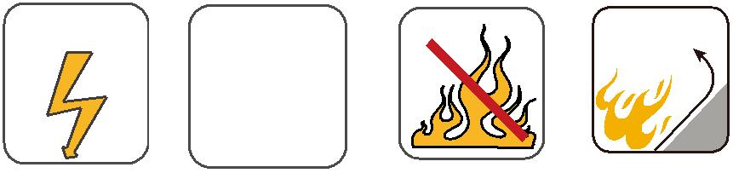
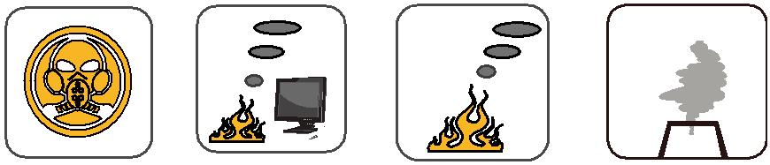

128 Caledonian

