
Caledonian

Flame Retardant Coaxial Cables
www.caledonian-cables.co.uk www.addison-cables.com

Flame Retardant RG59 B/U Coaxial cables
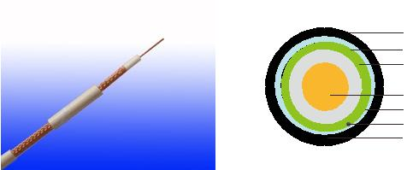

LSZH Outer Sheath

Tinned Copper Braid

Aluminium+polyester/Aluminium Tape

PE

Solid Bare Copper

LSZH Inner Sheath

Tinned Copper Drain Wire

Braid or Wire Armoured

APPLICATION

The cables are designed for CCTV, security, smoke detection and evacuation monitoring applications, where continued functionality is required during a fire situationDue. to the zero halogen low smoke construction, this cable is ideal for use in public, commercial and industrial environments.

STANDARDS

Basic design adapted to MIL-C-17

FIRE PERFORMANCE

Flame Retardance (Single Vertical EN 60332-1-2; IEC 60332-1-2; BS EN 60332-1-2; VDE _{Wire Test)} 0482-332-1 ; NBN C 30-004 (cat. F1); NF C32-070-2.1(C2);
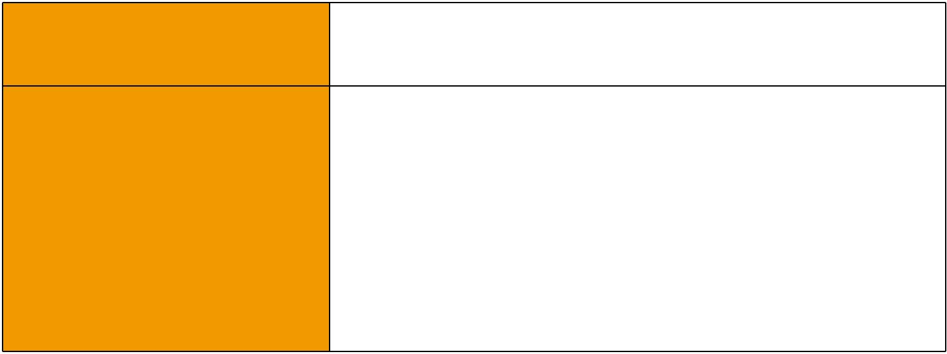
CEI 20-35/1-2; EN 50265-2-1*; DIN VDE 0482-265-2-1*

Reduced Fire Propagation | EN 60332-3-24 (cat. C); IEC 60332-3-24; BS EN 60332-3-24;
(Vertically-mounted bundled wires VDE 0482-332-3; NBN C 30-004 (cat. F2); NF C32-070-2.2(C1);
& cable test) | CEI 20-22/3-4; EN 50266-2-4*; DIN VDE 0482-266-2-4
Halogen Free | IEC 60754-1; EN 50267-2-1; DIN VDE 0482-267-2-1;
Halogen Free | CEI 20-37/2-1 ; BS 6425-1*
No Corrosive Gas Emission | IEC 60754-2; EN 50267-2-2; DIN VDE 0482-267-2-2;
No Corrosive Gas Emission | CEI 20-37/2-2 ; BS 6425-2*
Minimum Smoke Emission | IEC 61034-1&2; EN 61034 -1&2; DIN VDE 0482-1034-1&2;
Minimum Smoke Emission | CEI 20-37/3-1&2; EN 50268-1&2*; BS 7622-1&2*
No Toxic gases | NES 02-713; NF C 20-454

Note: Asterisk * denotes superseded standard.

CABLE CONSTRUCTION

Conductors: Copper clad steel, solid according to IEC(EN) 60228 class 1.

Insulation: PE compound.

Overall Screen: Plain copper wire braid

Outer Sheath: Thermoplastic LSZH compound type LTS3 as per BS 7655-6.1(Thermosetting LSZH compound type SW2-SW4 as per BS 7655-2.6 can be offered.). UV resistance, hydrocarbon

 ADDISON 123

 ADDISON

resistance, oil resistance, anti rodent and anti termite properties can be offered as option.

Physical AND THERMAL PROPERTIES

Temperature range during operation (fixed state):-30°C - +70°C

Temperature range during installation (mobile state): -5ºC - +60ºC Minimum bending radius: 8 x Overall Diameter

Electrical Properties

Impedance | 75±5Ω
Capacitance | 67 nF/km
Velocity ratio(%) | 66
Insulation resistance | >2000 Mohm.Km
Shield coverage | 95%
DC resistance
Inner conductor | 158 Ω/km
Outer conductor | 9.0 Ω/km

Attenuation
Frequency(MHz) | Attenuation (dB/100 m) | Attenuation (dB/100ft)
50 | 7.4 | 2.26
100 | 10.7 | 3.26
200 | 15.7 | 4.79
400 | 22.7 | 6.92
500 | 25.7 | 7.84
600 | 28.7 | 8.75
860 | 34.8 | 10.61
1000 | 38.0 | 11.59

Return Loss
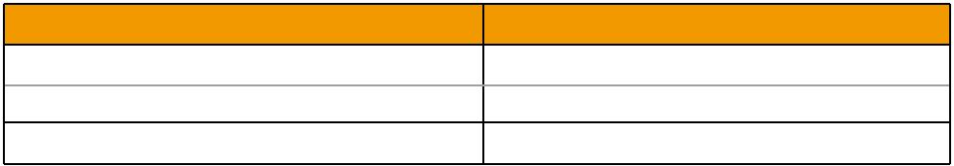
Frequency(MHz) | Return Loss (dB)
30-300 MHz | >31dB
300-600 MHz | >28dB
600-900 MHz | >24dB

124 Caledonian

Caledonian

Flame Retardant Coaxial Cables
www.caledonian-cables.co.uk www.addison-cables.com

CONSTRUCTION PARAMETERS
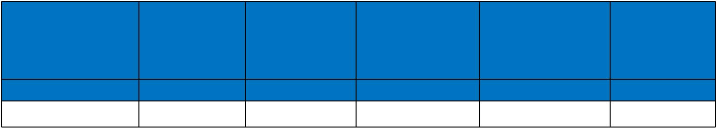

Cable | Conductor |  | Nominal |  |  | Nominal | Nominal | Approx.
Cable |  |  | Insulation |  |  | Screen | Overall | Approx.
Code | Diameter |  |  |  |  | Screen | Overall | Weight
Code |  |  | Diameter |  |  | No.x Diameter | Diameter | Weight
 | mm |  | mm |  |  | No. x mm | mm | kg/km
FTX-RG59 B/U | 0.58 ± 0.03 3.70 ± 0.10 m |  |  |  |  | 120 x 0.15 | 6.20 | 60.3
300/500V | _{N}MIL-C-17 |  | Flame Retardancy | Reduced Fire Propagation
 |  |  | Flame Retardancy |  | NF C32-070-2.2(C1)
Rated Voltage |  |  | NF C32-070-2.1(C2) |  | IEC60332-3-24
Rated Voltage | Standard | IEC60332-1-2/EN50265-2-1 |  |  |  | EN50266-2-4
 |  |  |  |  | Zero
 | Low Corrosivity |  | Low Smoke Emission |  |  | Halogen Free
 | IEC60754-2 |  | Low Smoke Emission |  |  | Halogen Free
Low Toxicity | IEC60754-2 |  | IEC 61034-1&2 |  |  | IEC60754-1
Low Toxicity | EN50267-2-2/3 |  | IEC 61034-1&2 |  |  | IEC60754-1
NES 02-713/NF C 20-454 | NF C 32-074 | EN 50268-1&2/NF C32-073 |  |  |  | EN50267-2-1
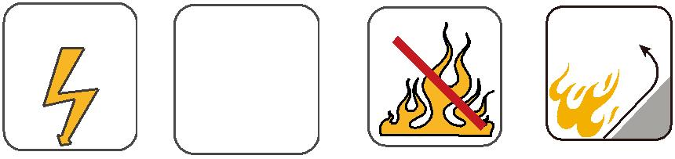
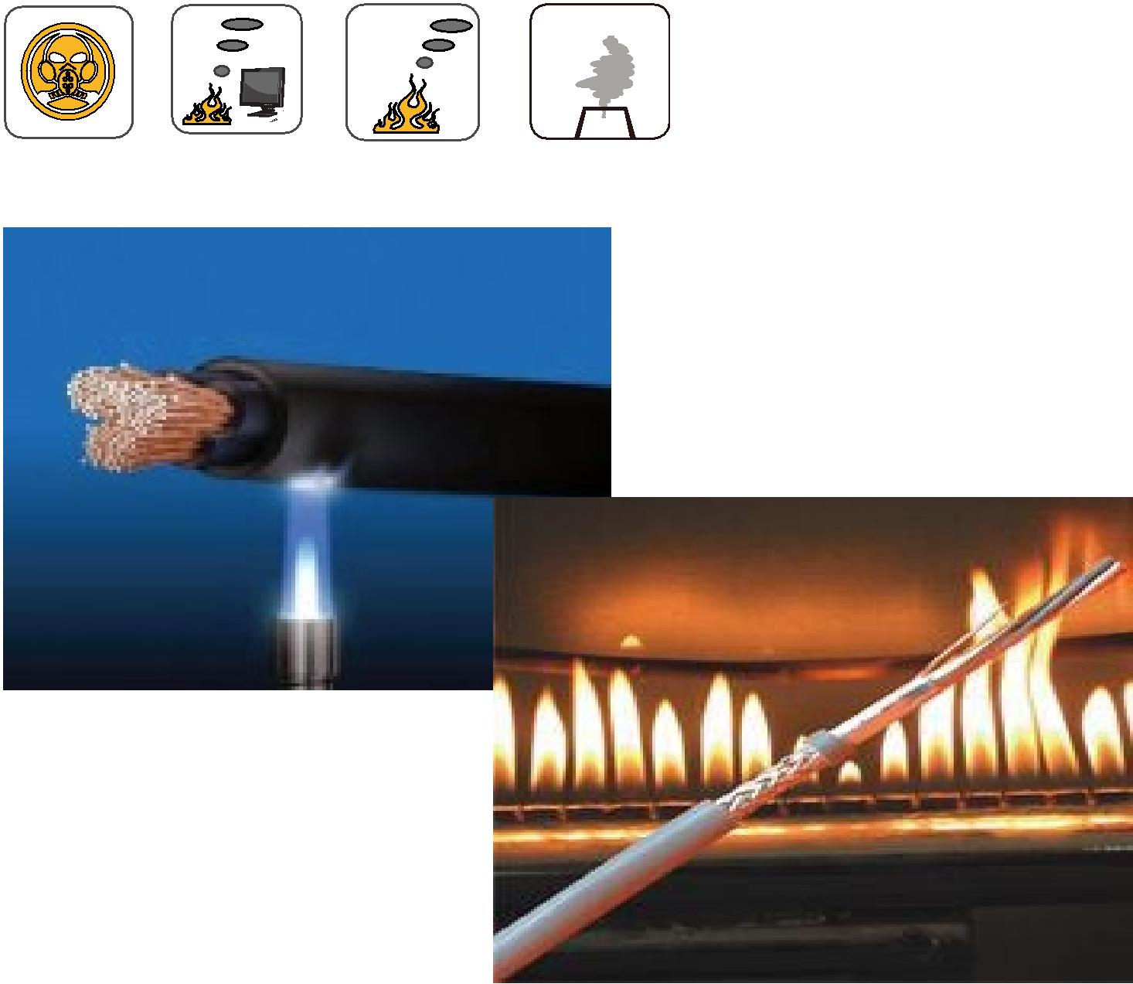

ADDISON 125

