 ADDISON

Flame Retardant Overall Screened Instrumentation Cables (Multipair)

RE-2X(St)H
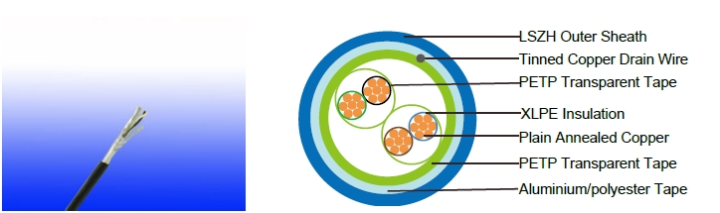

APPLICATION

The unarmoured LSZH versions (Part 1 Type 1) cables are generally use for indoor installation and suitable for wet and damp areas. Generally used within industrial process manufacturing plants for communication, data and voice transmission signals and services, Also used for the interconnection of electrical equipment and instruments, the LSZH sheath can reduce toxic smoke and fume emission.

STANDARDS

Basic design adapted to BS 5308 Part 1 Type 1

FIRE PERFORMANCE

Flame Retardance (Single Vertical | EN 60332-1-2; IEC 60332-1-2; BS EN 60332-1-2; VDE
Flame Retardance (Single Vertical | 0482-332-1 ; NBN C 30-004 (cat. F1); NF C32-070-2.1(C2);
Wire Test) | CEI 20-35/1-2; EN 50265-2-1*; DIN VDE 0482-265-2-1*
Reduced Fire Propagation | EN 60332-3-24 (cat. C); IEC 60332-3-24; BS EN 60332-3-24;
(Vertically-mounted bundled wires | VDE 0482-332-3; NBN C 30-004 (cat. F2); NF C32-070-2.2(C1);
& cable test) | CEI 20-22/3-4; EN 50266-2-4*; DIN VDE 0482-266-2-4
Halogen Free | IEC 60754-1; EN 50267-2-1; DIN VDE 0482-267-2-1;
Halogen Free | CEI 20-37/2-1 ; BS 6425-1*
No Corrosive Gas Emission | IEC 60754-2; EN 50267-2-2; DIN VDE 0482-267-2-2;
No Corrosive Gas Emission | CEI 20-37/2-2 ; BS 6425-2*
Minimum Smoke Emission | IEC 61034-1&2; EN 61034 -1&2; DIN VDE 0482-1034-1&2;
Minimum Smoke Emission | CEI 20-37/3-1&2; EN 50268-1&2*; BS 7622-1&2*
No Toxic gases | NES 02-713; NF C 20-454

Note: Asterisk * denotes superseded standard.

VOLTAGE RATING

300/500V

86 Caledonian


Caledonian

Flame Retardant Instrumentation Cables

www.caledonian-cables.co.uk www.addison-cables.com

CABLE CONSTRUCTION

Conductor: Annealed or tinned copper, sizes: 0.5mm² and 0.75mm² mulitistranded(Class 5), 0.5 mm², 1.0 mm² solid(Class 1), 1.5mm² or 2.5mm², multistranded(Class 2) to BS6360

Insulation: XLPE (Cross Linked Polyethylene), or PE (optional)

Pairs: Two insulated conductors uniformly twisted together with a lay not exceeding 100mm Binder tape: PETP transparent tape

Overall Screen: Aluminium/polyester tape is applied over the laid up pairs metallic side down in contact with tinned copper drain wire, 0.5mm²

Outer Sheath: Thermoplastic LSZH compound type LTS3 as per BS 7655-6.1 (Thermosetting LSZH compound type SW2-SW4 as per BS 7655-2.6 can be offered.). UV resistance, hydrocarbon resistance, oil resistance, anti rodent and anti termite properties can be offered as option.

COLOUR CODE

Insulation Colour: See technical information

Outer sheath: Black or blue

Physical AND THERMAL PROPERTIES

Maximum Operating temperature: -20˚C - + 90˚C( fixed installation) 0˚C - +50˚C(during operation)

Minimum bending radius: 5 x Overall Diameter

Electrical Properties

Conductor Area Size |  |  | mm ² | 0.5 | 0.5 | 0.75 | 1.0 | 1.5
Conductor Stranding |  |  | No. x | 1 x | 16 x | 24 x | 1 x | 7 x 0.53
 |  |  | mm | 0.8 | 0.2 | 0.2 | 1.13 | 7 x 0.53
Conductor resistance max |  |  | ohm/km | 36.8 | 39.7 | 26.5 | 18.2 | 12.3
Insulation resistance min |  |  | Gohm/ | 5 | 5 | 5 | 5 | 5
 |  |  | km
Capacitance unbalance at 1 |  |  | pF/250m |  |  |  | 250
kHz(pair to pair screen) |  |  | pF/250m |  |  |  | 250
Max. Mutual Capacitance @ 1
kHz forNon OS or OS cables |  |  | pF/m | 115 | 115 | 115 | 115 | 115
(except one-pair and two-
pairs)
Max. Mutual Capacitance @
1 kHz IS/OS cables (include 1 |  |  | pF/m | 75 | 75 | 75 | 75 | 75
pair and 2 pair)
Max. L/R Ratio for adjacent |  |  | μH/ohm | 25 | 25 | 25 | 25 | 40
cores(Inductance/Resistance)
Test voltage |  | Core to core | V | 1000 | 1000 | 1000 | 1000 | 1000
Test voltage |  | Core to screen | V | 1000 | 1000 | 1000 | 1000 | 1000


 ADDISON 87

ADDISON

CONSTRUCTION PARAMETERS

 | Conductor |  |  | RE-2X(st)H
 |  | Nominal
 | No./ | Conductor | Nominal | Nominal | Nominal | Approx.
Number of | Nominal | Cross- | Insulation | Sheath | Overall | Approx.
Number of | Diameter of |  |  |  |  | Weight
Pairs | Diameter of | Section | Thickness | Thickness | Diameter | Weight
Pairs | Strands
 |  | Area
 | no./mm | mm² | mm | mm | mm | kg/km
1 | 1/0.80 | 0.5 | 0.5 | 0.8 | 5.5 | 35
2 | 1/0.80 | 0.5 | 0.5 | 0.8 | 6.8 | 55
5 | 1/0.80 | 0.5 | 0.5 | 1.1 | 10.9 | 125
10 | 1/0.80 | 0.5 | 0.5 | 1.2 | 14.4 | 215
15 | 1/0.80 | 0.5 | 0.5 | 1.2 | 16.5 | 300
20 | 1/0.80 | 0.5 | 0.5 | 1.3 | 18.8 | 385
30 | 1/0.80 | 0.5 | 0.5 | 1.3 | 22.3 | 545
50 | 1/0.80 | 0.5 | 0.5 | 1.5 | 28.5 | 875
1 | 16/0.20 | 0.5 | 0.6 | 0.8 | 6.2 | 60
2 | 16/0.20 | 0.5 | 0.6 | 0.8 | 7.6 | 80
5 | 16/0.20 | 0.5 | 0.6 | 1.1 | 12.4 | 210
10 | 16/0.20 | 0.5 | 0.6 | 1.2 | 16.5 | 340
15 | 16/0.20 | 0.5 | 0.6 | 1.3 | 19.2 | 440
20 | 16/0.20 | 0.5 | 0.6 | 1.3 | 21.7 | 570
30 | 16/0.20 | 0.5 | 0.6 | 1.5 | 26.4 | 780
50 | 16/0.20 | 0.5 | 0.6 | 1.7 | 33.4 | 1130
1 | 24/0.2 | 0.75 | 0.6 | 0.8 | 6.7 | 75
2 | 24/0.2 | 0.75 | 0.6 | 0.9 | 8.4 | 100
5 | 24/0.2 | 0.75 | 0.6 | 1.2 | 13.8 | 250
10 | 24/0.2 | 0.75 | 0.6 | 1.3 | 18.4 | 450
15 | 24/0.2 | 0.75 | 0.6 | 1.5 | 21.1 | 600
20 | 24/0.2 | 0.75 | 0.6 | 1.5 | 24.4 | 920
30 | 24/0.2 | 0.75 | 0.6 | 1.7 | 29.5 | 980
50 | 24/0.2 | 0.75 | 0.6 | 2 | 37.6 | 1690
1 | 1/1.13 | 1 | 0.6 | 0.8 | 6.6 | 85
2 | 1/1.13 | 1 | 0.6 | 0.8 | 8 | 115
5 | 1/1.13 | 1 | 0.6 | 1.2 | 13.5 | 290
10 | 1/1.13 | 1 | 0.6 | 1.2 | 17.7 | 500
15 | 1/1.13 | 1 | 0.6 | 1.3 | 20.6 | 670

88 Caledonian

Caledonian

Flame Retardant Instrumentation Cables

www.caledonian-cables.co.uk www.addison-cables.com

 | Conductor | Nominal |  | RE-2X(st)H
 | No./ | Conductor | Nominal | Nominal | Nominal | Approx.
Number of | Nominal | Cross- | Insulation | Sheath | Overall | Approx.
Number of | Diameter of |  |  |  |  | Weight
Pairs | Diameter of | Section | Thickness | Thickness | Diameter | Weight
Pairs | Strands
 |  | Area
 | no./mm | mm² | mm | mm | mm | kg/km
20 | 1/1.13 | 1 | 0.6 | 1.5 | 23.8 | 950
30 | 1/1.13 | 1 | 0.6 | 1.5 | 28.4 | 1030
50 | 1/1.13 | 1 | 0.6 | 2 | 36.6 | 1750
1 | 7/0.53 | 1.5 | 0.6 | 0.8 | 7.5 | 100
2 | 7/0.53 | 1.5 | 0.6 | 0.9 | 9.3 | 150
5 | 7/0.53 | 1.5 | 0.6 | 1.2 | 15.6 | 360
10 | 7/0.53 | 1.5 | 0.6 | 1.3 | 20.9 | 690
15 | 7/0.53 | 1.5 | 0.6 | 1.5 | 24.6 | 880
20 | 7/0.53 | 1.5 | 0.6 | 1.5 | 27.8 | 1230
30 | 7/0.53 | 1.5 | 0.6 | 1.7 | 33.7 | 1560
50 | 7/0.53 | 1.5 | 0.6 | 2 | 43 | 2400
300/500V | _{N}BS5308 | Flame Retardancy | Reduced Fire Propagation
 |  | NF C32-070-2.1(C2) | NF C32-070-2.2(C1)
Rated Voltage | Standard | NF C32-070-2.1(C2) | IEC60332-3-24
Rated Voltage | Standard | IEC60332-1-2/EN50265-2-1 | IEC60332-3-24
Rated Voltage | Standard | IEC60332-1-2/EN50265-2-1 | EN50266-2-4
 |  |  | Zero
 | Low Corrosivity | Low Smoke Emission | Halogen Free
 | IEC60754-2 | Low Smoke Emission | Halogen Free
Low Toxicity | IEC60754-2 | IEC 61034-1&2 | IEC60754-1
Low Toxicity | EN50267-2-2/3 | IEC 61034-1&2 | IEC60754-1
NES 02-713/NF C 20-454 | NF C 32-074 | EN 50268-1&2/NF C32-073 | EN50267-2-1

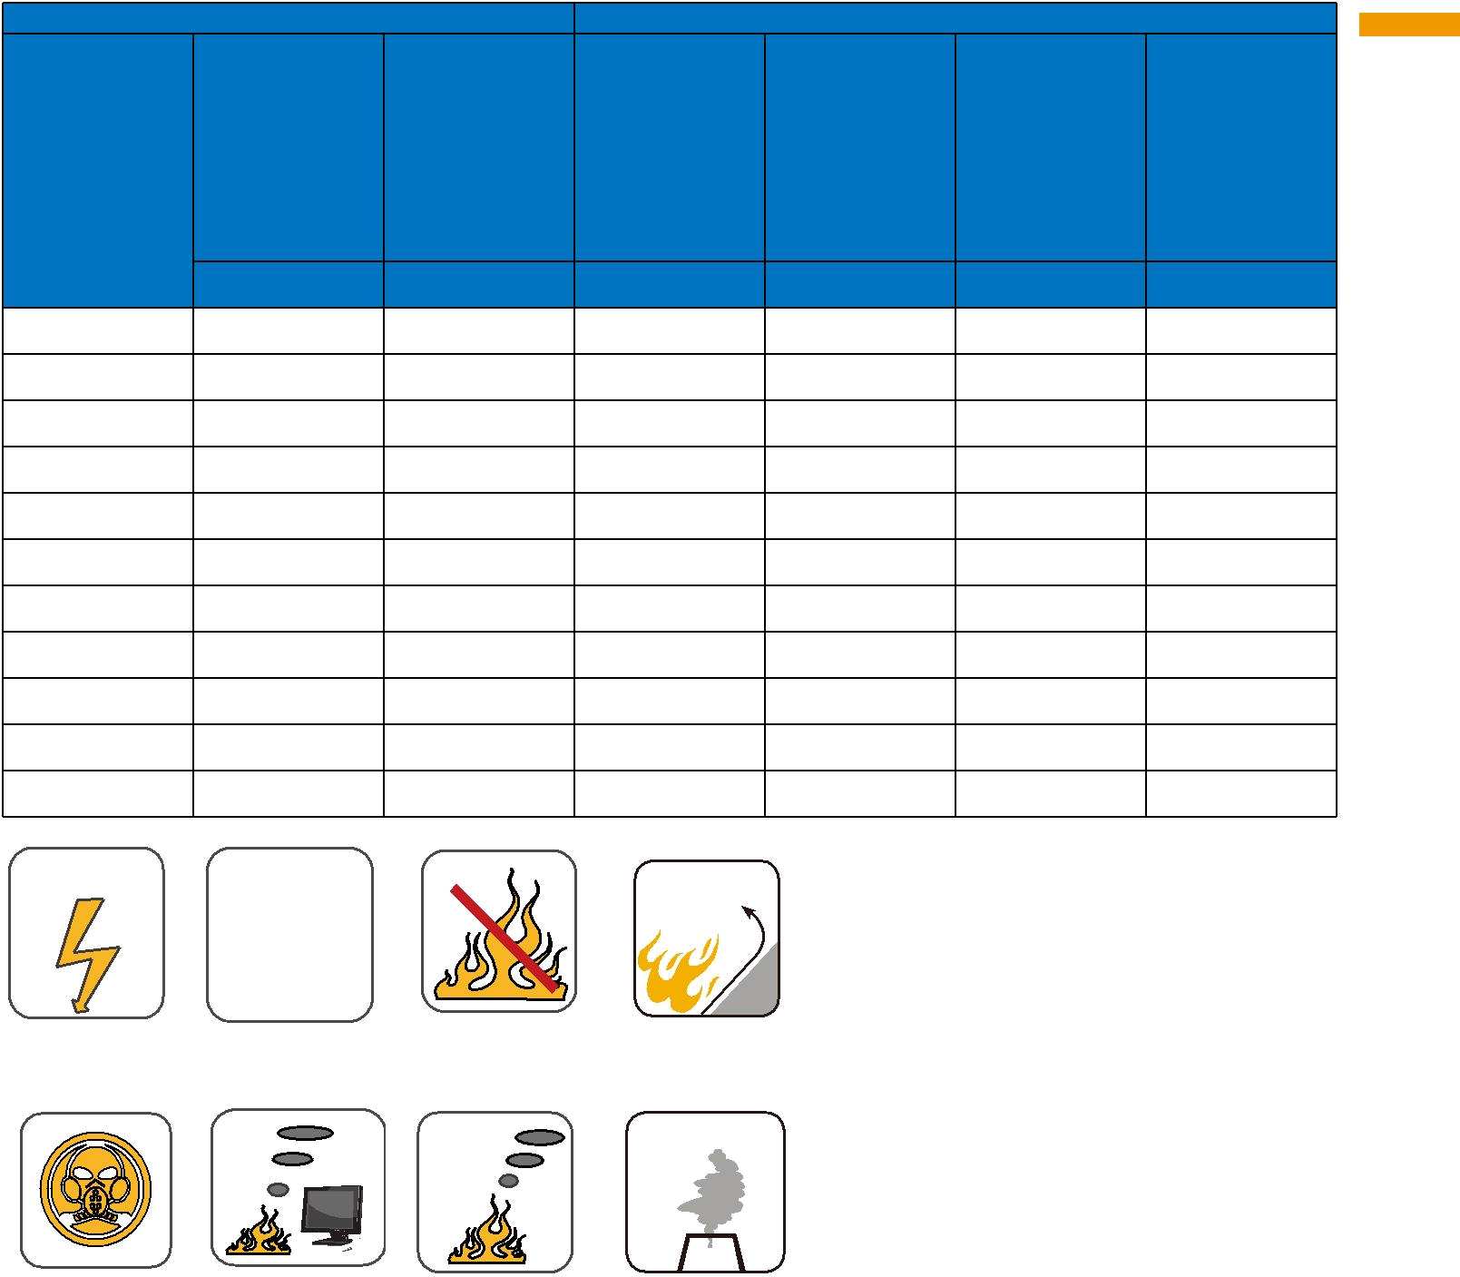

ADDISON 89

