
Caledonian

Flame Retardant Optic Fiber Cables

www.caledonian-cables.co.uk www.addison-cables.com

Flame Retardant Multi Loose Tube Fiber Optic cables

Application

The multi loose tube non metallic cables are designed for outside plant, which is prone to electrical interference. They are mainly installed inside buildings, tunnels,subways or closed areas in general, specially designed to guarantee the signal transmission even in case of fire. The cable can also be used for direct burial for armoured version.

STANDARDS

Basic design adapted to Telcordia GR-20 / RUS 7 CFR 1755.900 (REA PE-90) / ICEA S 87-640

FIRE PERFORMANCE

Flame Retardance (Single Vertical EN 60332-1-2; IEC 60332-1-2; BS EN 60332-1-2; VDE _{Wire Test)} 0482-332-1 ; NBN C 30-004 (cat. F1); NF C32-070-2.1(C2);
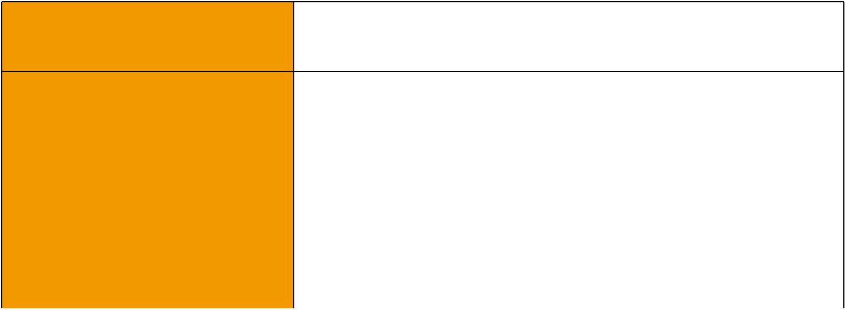
CEI 20-35/1-2; EN 50265-2-1*; DIN VDE 0482-265-2-1*

Reduced Fire Propagation | EN 60332-3-24 (cat. C); IEC 60332-3-24; BS EN 60332-3-24;
(Vertically-mounted bundled wires VDE 0482-332-3; NBN C 30-004 (cat. F2); NF C32-070-2.2(C1);
& cable test) | CEI 20-22/3-4; EN 50266-2-4*; DIN VDE 0482-266-2-4
Halogen Free | IEC 60754-1; EN 50267-2-1; DIN VDE 0482-267-2-1;
Halogen Free | CEI 20-37/2-1 ; BS 6425-1*
No Corrosive Gas Emission | IEC 60754-2; EN 50267-2-2; DIN VDE 0482-267-2-2;
No Corrosive Gas Emission | CEI 20-37/2-2 ; BS 6425-2*
Minimum Smoke Emission | IEC 61034-1&2; EN 61034 -1&2; DIN VDE 0482-1034-1&2;
Minimum Smoke Emission | CEI 20-37/3-1&2; EN 50268-1&2*; BS 7622-1&2*
No Toxic gases | NES 02-713; NF C 20-454
Note: Asterisk * denotes superseded standard.

CABLE CONSTRUCTION

Fibers: Singlemode and multimode fibers, with loose tube technology.

Structure: The cable consists of 5 to 36 fibers containing tubes or fillers stranded in up to 3 layers around a central strength member and bound under a LSZH sheath. Each tube contains 4 -12 fibers, which is filled with water blocking gel.

Central Strength Member: Solid or stranded steel wire coated with polyethylene is usually used as central strength member. Fiber glass reinforced plastics (FRP) will be used as central strength member if non metallic construction is required.

Water Blocking: The jelly filled tube is waterblocked by using swellable tape and thread.

Reinforcement: Either aramid yarn or fiber glass is wound around the tube to provide physical protection and tensile strength, with added fire protection.

Inner Sheath (optional): The cable can be jacketed with either PE or Thermoplastic LSZH inner sheath. PE is the preferred option in outdoor environment for water protection purpose. Armouring(optional): For diect burial, either galvanized steel wire braid, corrugated steel tape armour or galvanized steel wire armour is applied over an inner polyethylene or LSZH sheath.

 ADDISON 149

 ADDISON

For steel tape armour, the 0.15mm thick steel tape is coated with a copolymer and applied with an overlap. For steel wire braid or armour, single layer of galvanized steel wire braid or armour is applied.

Moisture Barrier Tape (optional): An aluminum moisture tape can be incorporated under the sheath for water blocking and shielding purpose.

Ripcord (optional): An optional ripcord can be located under the jacket to facilitate jacket removal. Outer Sheath: Thermoplastic LSZH compound type LTS3 as per BS 7655-6.1(Thermosetting LSZH compound type SW2-SW4 as per BS 7655-2.6 can be offered.). UV resistance, hydrocarbon resistance, oil resistance, anti rodent and anti termite properties can be offered as option.

Fiber colour code
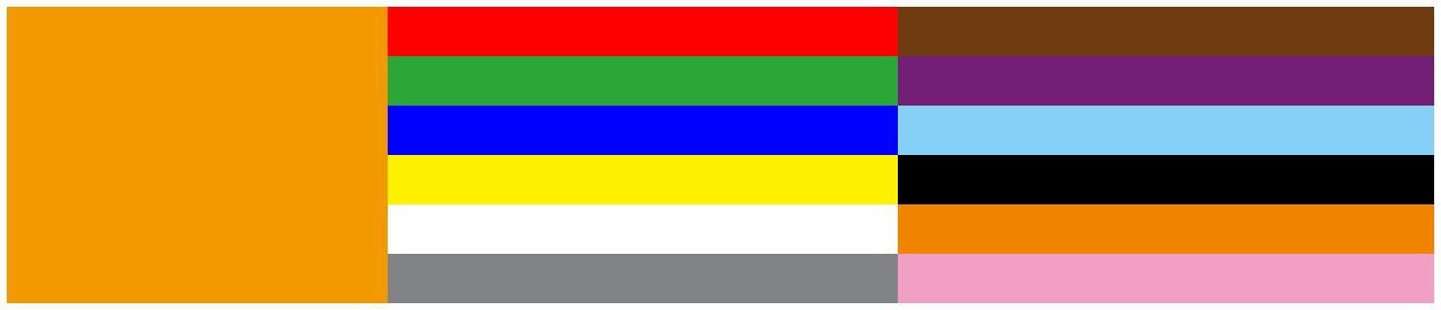
Fiber colour code | 1 | Red | 7 | Brown
 | 2 | Green | 8 | Violet
 | 3 | Blue | 9 | Turquoise
 | 4 | Yellow | 10 | Black
 | 5 | White | 11 | Orange
 | 6 | Grey | 12 | Pink

Construction

Unarmoured type

 |  |  |  | Fiber
 |  |  |  | Jelly Filled Loose Tube
 |  |  |  | Water -blocking Tape (optional)
 |  |  |  | Dielectric /Steel Wire Central Strength Member
 |  |  |  | Aramid Yarn /Fiber Glass Yarn
 |  |  |  | Aluminum Moisture Barrier Tape (optional)
 |  |  |  | Ripcord (optional)
 |  |  |  | Filler
 |  |  |  | LSZH Outer Sheath
CONSTRUCTION PARAMETERS
 | Fiber | Tube | Nominal | Approx. | Tension
Cable Code | Fiber | Tube | Overall | Approx. | Tension | Crush
Cable Code | Count | Diameter | Overall | Weight | load | Crush
 | Count | Diameter | Diameter | Weight | load
 | (n°) | mm | mm | kg/km | N | N/100mm
MLA-B-C×D-F-H-J | 72 | 2.5 | 15.0 | 230 | 4000 | 3000
MLA-B-C×D-F-H-J | 96 | 2.5 | 16.5 | 250 | 4000 | 3000
MLA-B-C×D-F-H-J | 144 | 2.5 | 20.5 | 280 | 4000 | 3000
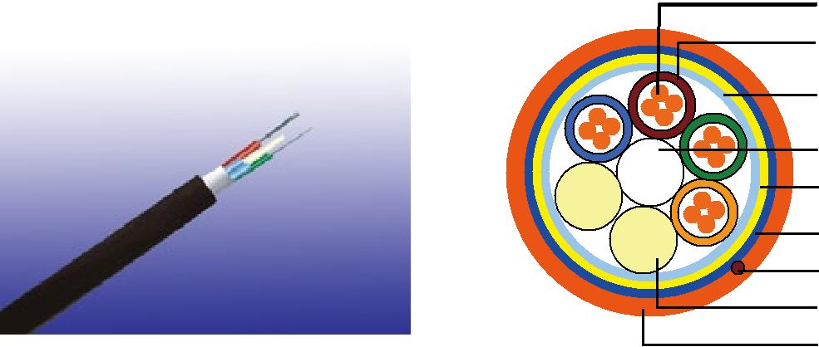
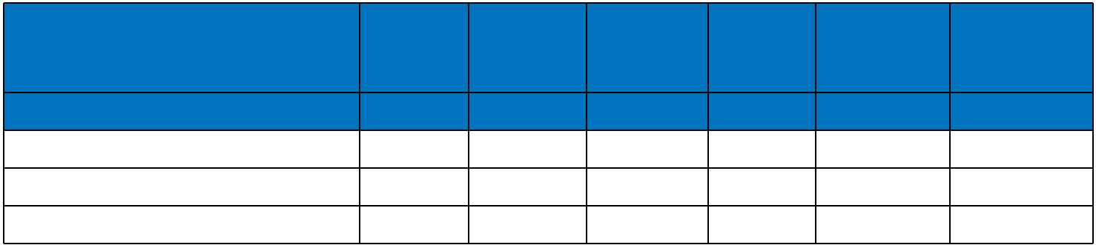

150 Caledonian

Caledonian

Flame Retardant Optic Fiber Cables

www.caledonian-cables.co.uk www.addison-cables.com

Steel Wire BRAID

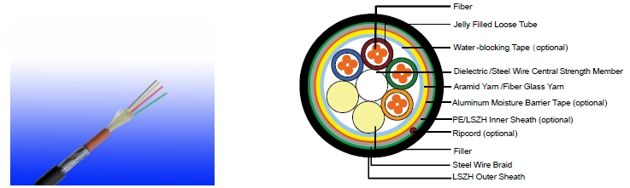

LSZH Outer Sheath

CONSTRUCTION PARAMETERS

 | Fiber | Tube | Nominal | Approx. | Tension
Cable Code | Fiber | Tube | Overall | Approx. | Tension | Crush
Cable Code | Count | Diameter | Overall | Weight | load | Crush
 | Count | Diameter | Diameter | Weight | load
 | (n°) | mm | mm | kg/km | N | N/100mm
MLA-B-C×D-F-2Y(SWB)H-J | 72 | 2.5 | 15.0 | 280 | 3000 | 3500
MLA-B-C×D-F-2Y(SWB)H-J | 96 | 2.5 | 17.5 | 310 | 3000 | 3500
MLA-B-C×D-F-2Y(SWB)H-J | 144 | 2.5 | 21.5 | 350 | 3500 | 3500

Corrugated steel tape armour
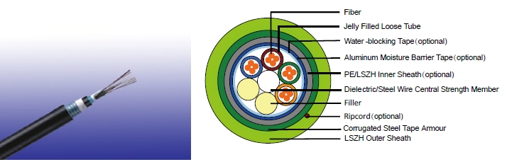

CONSTRUCTION PARAMETERS

 | Fiber | Tube | Nominal | Approx. | Tension
Cable Code | Fiber | Tube | Overall | Approx. | Tension | Crush
Cable Code | Count | Diameter | Overall | Weight | load | Crush
 | Count | Diameter | Diameter | Weight | load
 | (n°) | mm | mm | kg/km | N | N/100mm
MLA-B-C×D-F-2Y(STA)H-J | 72 | 2.5 | 16.5 | 290 | 3000 | 7500
MLA-B-C×D-F-2Y(STA)H-J | 96 | 2.5 | 18.5 | 350 | 3000 | 7500
MLA-B-C×D-F-2Y(STA)H-J | 144 | 2.5 | 22.5 | 450 | 3500 | 7500

ADDISON 151

ADDISON

Steel Wire armour
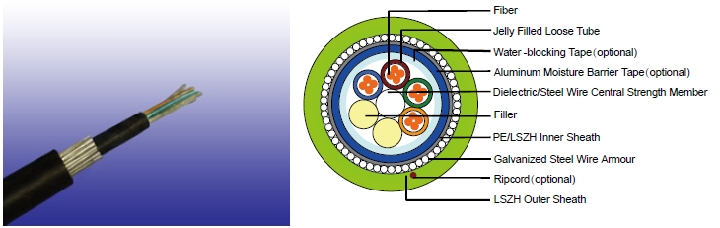

CONSTRUCTION PARAMETERS

 | Fiber | Tube | Nominal | Approx. | Tension
Cable Code | Fiber | Tube | Overall | Approx. | Tension | Crush
Cable Code | Count | Diameter | Overall | Weight | load | Crush
 | Count | Diameter | Diameter | Weight | load
 | (n°) | mm | mm | kg/km | N | N/100mm
MLA-B-C×D-F-2Y(SWA)H-J | 72 | 2.0 | 15.0 | 360 | 3500 | 5000
MLA-B-C×D-F-2Y(SWA)H-J | 96 | 2.0 | 16.5 | 390 | 4000 | 5000
MLA-B-C×D-F-2Y(SWA)H-J | 144 | 2.0 | 18.5 | 430 | 4500 | 5000

Physical AND THERMAL PROPERTIES

Temperature range during operation (fixed state):-20°C - +60°C

Temperature range during installation (mobile state): 0°C - +50°C Minimum Installation Bending Radius: 20 times the outer diameter

Minimum operation Bending Radius: 10 times the outer diameter for unarmoured cables

 | 20 times the outer diameter for armoured cables
MECHANICAL Properties
Maximum Compressive Load: |  | 4000N for unarmoured cables
Maximum Compressive Load: |  | 6000N for armoured cables
Repeated Impact: |  | 4.4 N.m (J)
Twist (Torsion): |  | 180×10 times, 125×OD
Cyclic Flexing: |  | 25 cycles for armoured cables
Cyclic Flexing: |  | 100 cycles for unarmoured cables
Crush Resistance: |  | 220N/cm(125lb/in)


152 Caledonian

Caledonian

Flame Retardant Optic Fiber Cables

www.caledonian-cables.co.uk www.addison-cables.com

Fiber Compliance

Temperature Cycling | IEC60794-1-2-F2
Tensile Strength | IEC60794-1-2-E1A
Crush | IEC60794-1-2-E3
Impact | IEC60794-1-2-E4
Repeated Bending | IEC60794-1-2-E6
Torsion | IEC60794-1-2-E7
Kink | IEC60794-1-2-E10
Cable Bend | IEC60794-1-2-E11
Cool Bend | IEC60794-1-2-E11
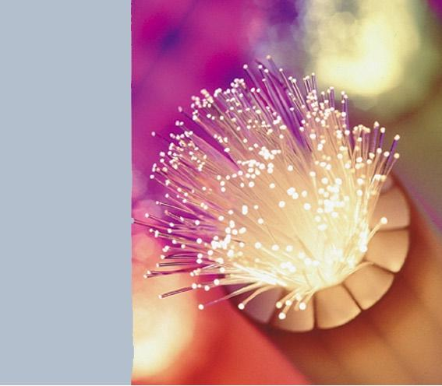

ADDISON 153

ADDISON

TYPE CODEs

MLA-B-CxD-E-F-G-H-I
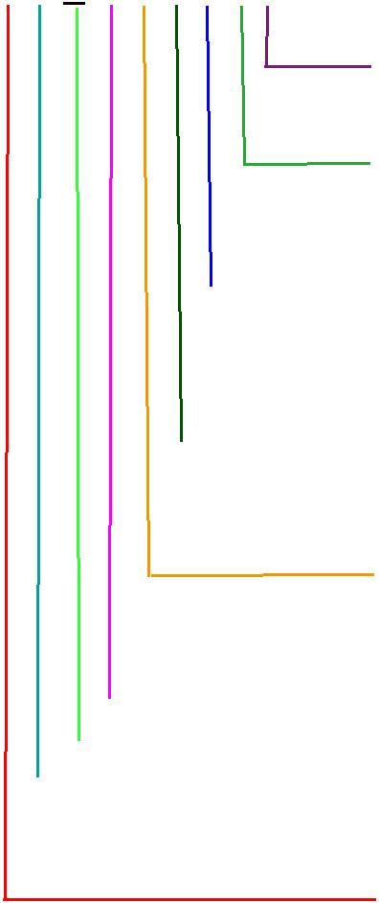
Water blocking gel in tubes
X: No water-blocking J: Water blocking gel between jackets;
D: Dry water-blocking between cable jackets
Outer Sheath
H: LSZH

Armour
Blank: No armour

STA: Corrugated steel tape SWA: Steel wire

SWB: Armour steel wire braided

Inner Sheath 2Y: PE
Y: PVC

H: LSZH

Central strength member S: Solid steel
SR: Stranded steel

F: Fiber reinforced plastic(FRP)

Fiber per tubes: 2-12

C No of tubes: 1-36 Fiber Type
- 50/125 um(OM3) 7: NZDS SM fiber per ITU-T G.656
- 50/125 um(OM2) 8: NZDS SM fiber per ITU-T G.655
- 62.5/125um(OM1) 9: Standard SM fiber per ITU-T G.652.D
Loose Tube Diameter
- 2.0mm D: 3.0mm
- 2.5mm E: 3.2mm
- 2.8mm

GR-20/RUS 7 CFR1755N.900 (REA PE-90)
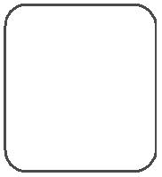

Standard
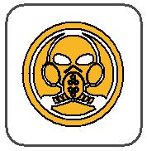
ICEA_{N}S87-640
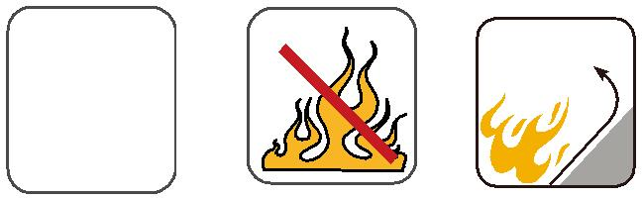 | Flame Retardancy | Reduced Fire Propagation
 | NF C32-070-2.1(C2) | NF C32-070-2.2(C1)
Standard | NF C32-070-2.1(C2) | IEC60332-3-24
Standard | IEC60332-1-2/EN50265-2-1 | IEC60332-3-24
Standard | IEC60332-1-2/EN50265-2-1 | EN50266-2-4
 |  | Zero
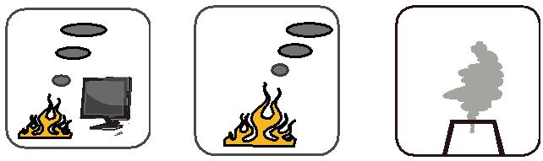

 | Low Corrosivity | Low Smoke Emission | Halogen Free
 | IEC60754-2 | Low Smoke Emission | Halogen Free
Low Toxicity | IEC60754-2 | IEC 61034-1&2 | IEC60754-1
Low Toxicity | EN50267-2-2/3 | IEC 61034-1&2 | IEC60754-1
NES 02-713/NF C 20-454 | NF C 32-074 | EN 50268-1&2/NF C32-073 | EN50267-2-1

154 Caledonian

