 ADDISON

Flame Retardant Individual and Overall Screened, Armoured Instrumentation Cables (Multipair)

RE-2X(st)HSWAH Pimf

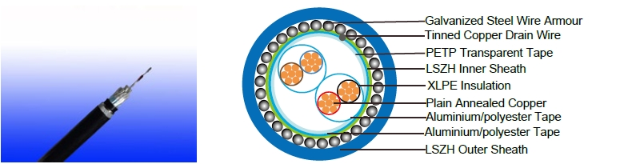

APPLICATION

The armoured LSZH versions (Part 1 Type 2) cables are generally used when the risk of mechanical damage is increased. The galvanized steel wire armour provides excellent protection. Generally used within industrial process manufacturing plants for communication, data and voice transmission signals and services, Also used for the interconnection of electrical equipment and instruments, the LSZH sheath can reduce toxic smoke and fume emission.

STANDARDS

Basic design adapted to BS 5308 Part 1 Type 2

FIRE PERFORMANCE

Flame Retardance (Single Vertical | EN 60332-1-2; IEC 60332-1-2; BS EN 60332-1-2; VDE
Flame Retardance (Single Vertical | 0482-332-1 ; NBN C 30-004 (cat. F1); NF C32-070-2.1(C2);
Wire Test) | CEI 20-35/1-2; EN 50265-2-1*; DIN VDE 0482-265-2-1*
Reduced Fire Propagation | EN 60332-3-24 (cat. C); IEC 60332-3-24; BS EN 60332-3-24;
(Vertically-mounted bundled wires | VDE 0482-332-3; NBN C 30-004 (cat. F2); NF C32-070-2.2(C1);
& cable test) | CEI 20-22/3-4; EN 50266-2-4*; DIN VDE 0482-266-2-4
Halogen Free | IEC 60754-1; EN 50267-2-1; DIN VDE 0482-267-2-1;
Halogen Free | CEI 20-37/2-1 ; BS 6425-1*
No Corrosive Gas Emission | IEC 60754-2; EN 50267-2-2; DIN VDE 0482-267-2-2;
No Corrosive Gas Emission | CEI 20-37/2-2 ; BS 6425-2*
Minimum Smoke Emission | IEC 61034-1&2; EN 61034 -1&2; DIN VDE 0482-1034-1&2;
Minimum Smoke Emission | CEI 20-37/3-1&2; EN 50268-1&2*; BS 7622-1&2*
No Toxic gases | NES 02-713; NF C 20-454

Note: Asterisk * denotes superseded standard.

98 Caledonian


Caledonian

Flame Retardant Instrumentation Cables

www.caledonian-cables.co.uk www.addison-cables.com

VOLTAGE RATING

300/500V

CABLE CONSTRUCTION

Conductor: Annealed or tinned copper, sizes: 0.5mm² and 0.75mm² mulitistranded(Class 5), 0.5 mm², 1.0 mm² solid(Class 1), 1.5mm² or 2.5mm², multistranded(Class 2) to BS6360

Insulation: XLPE (Cross Linked Polyethylene), or PE (optional)

Pairs: Two insulated conductors uniformly twisted together with a lay not exceeding 100mm Individual Screen: Aluminium/polyester tape is applied over the laid up pairs metallic side down in contact with tinned copper drain wire, 0.5mm²

Binder tape: PETP transparent tape

Overall Screen: Aluminium/polyester tape is applied over the laid up pairs metallic side down in contact with tinned copper drain wire, 0.5mm²

Inner Sheath: LSOH(Low Smoke Zero Halogen) sheath Amouring: Galvanized steel wire armour

Outer Sheath: Thermoplastic LSZH compound type LTS3 as per BS 7655-6.1 (Thermosetting LSZH compound type SW2-SW4 as per BS 7655-2.6 can be offered.). UV resistance, hydrocarbon resistance, oil resistance, anti rodent and anti termite properties can be offered as option.

COLOUR CODE

Insulation Colour: See technical information

Outer Sheath: Black or blue

Physical AND THERMAL PROPERTIES

Maximum Operating temperature: -20˚C - + 90˚C( fixed installation) 0˚C - +50˚C(during operation)

Minimum bending radius: 6 x Overall Diameter

Electrical Properties

Conductor Area Size | mm² | 0.5 | 0.5 | 0.75 | 1.0 | 1.5
Conductor Stranding | No. x mm | 1 x 0.8 | 16 x 0.2 | 24 x 0.2 | 1 x 1.13 | 7 x 0.53
Conductor resistance max | ohm/km | 36.8 | 39.7 | 26.5 | 18.2 | 12.3
Insulation resistance min | Gohm/km | 5 | 5 | 5 | 5 | 5
Capacitance unbalance at 1 | pF/250m |  |  | 250
kHz(pair to pair screen) | pF/250m |  |  | 250
Max. Mutual Capacitance @ 1
kHz forNon OS or OS cables | pF/m | 115 | 115 | 115 | 115 | 120
(except one-pair and two-pairs)
Max. Mutual Capacitance @ 1
kHz IS/OS cables (include 1 pair | pF/m | 75 | 75 | 75 | 75 | 85
and 2 pair)

 ADDISON 99

ADDISON


Max. L/R Ratio for adjacent |  | μH/ohm | 25 | 25 | 25 | 25 | 40
cores(Inductance/Resistance)
Test voltage | Core to core | V | 1000 | 1000 | 1000 | 1000 | 1000
Test voltage | Core to screen | V | 1000 | 1000 | 1000 | 1000 | 1000
Rated voltage max |  | V | 300/500 | 300/500 | 300/500 | 300/500 | 300/500

CONSTRUCTION PARAMETERS

 |  | No./ | Nominal |  | Nominal | Nominal | Nominal | Nominal | Nominal
 |  | Nominal | Conductor | Nominal | Inner | Diameter | Nominal | Nominal | Nominal | Approx.
 | No.of | Diameter | Cross- | Insulation | Inner | Overall | Armour | Sheath | Overall | Approx.
 |  |  |  |  | Sheath |  |  |  |  | Weight
 | Pairs | of | Section | Thickness | Sheath | Inner | Thickness | Thickness | Diameter | Weight
 | Pairs | Strands | Section | Thickness | Thickness
 |  |  | Area |  |  | Sheath
 |  | no./mm | mm² | mm | mm | mm | mm | mm | mm | kg/km
 | 2 | 1/0.80 | 0.5 | 0.5 | 0.9 | 9.7 | 0.9 | 1.4 | 14.3 | 380
 | 5 | 1/0.80 | 0.5 | 0.5 | 1.2 | 13 | 1.25 | 1.5 | 18.5 | 640
 | 10 | 1/0.80 | 0.5 | 0.5 | 1.2 | 16.9 | 1.25 | 1.7 | 22.8 | 890
 | 15 | 1/0.80 | 0.5 | 0.5 | 1.3 | 19.7 | 1.6 | 1.7 | 26.3 | 1350
 | 20 | 1/0.80 | 0.5 | 0.5 | 1.3 | 22.3 | 1.6 | 1.8 | 29.1 | 1470
 | 30 | 1/0.80 | 0.5 | 0.5 | 1.5 | 27.1 | 1.6 | 1.9 | 34.1 | 1870
 | 50 | 1/0.80 | 0.5 | 0.5 | 2 | 35 | 2 | 2.2 | 43.4 | 3000
 | 2 | 16/0.2 | 0.5 | 0.6 | 1.1 | 11.2 | 0.9 | 1.5 | 16 | 460
 | 5 | 16/0.2 | 0.5 | 0.6 | 1.2 | 14.5 | 1.25 | 1.6 | 20.2 | 760
 | 10 | 16/0.2 | 0.5 | 0.6 | 1.3 | 19.3 | 1.6 | 1.8 | 26.1 | 1300
 | 15 | 16/0.2 | 0.5 | 0.6 | 1.5 | 22.6 | 1.6 | 1.8 | 29.4 | 1440
 | 20 | 16/0.2 | 0.5 | 0.6 | 1.5 | 25.7 | 1.6 | 1.9 | 32.7 | 1870
 | 30 | 16/0.2 | 0.5 | 0.6 | 1.7 | 31 | 2 | 2.1 | 39.2 | 2400
 | 50 | 16/0.2 | 0.5 | 0.6 | 2.2 | 39.9 | 2.5 | 2.4 | 49.7 | 3930
 | 2 | 24/0.2 | 0.75 | 0.6 | 1.1 | 12.1 | 0.9 | 1.5 | 16.9 | 500
 | 5 | 24/0.2 | 0.75 | 0.6 | 1.2 | 15.7 | 1.25 | 1.6 | 21.4 | 920
 | 10 | 24/0.2 | 0.75 | 0.6 | 1.3 | 20.9 | 1.6 | 1.7 | 27.5 | 1610
 | 15 | 24/0.2 | 0.75 | 0.6 | 1.5 | 24.6 | 1.6 | 1.9 | 31.6 | 1960
 | 20 | 24/0.2 | 0.75 | 0.6 | 1.5 | 27.9 | 1.6 | 1.9 | 34.9 | 2420
 | 30 | 24/0.2 | 0.75 | 0.6 | 2 | 34.4 | 2 | 2.2 | 42.8 | 3180
 | 50 | 24/0.2 | 0.75 | 0.6 | 2.2 | 43.5 | 2.5 | 2.5 | 53.5 | 4506
 | 2 | 1/1.13 | 1 | 0.6 | 1.1 | 11.9 | 0.9 | 1.5 | 16.7 | 515
 | 5 | 1/1.13 | 1 | 0.6 | 1.2 | 15.4 | 1.25 | 1.6 | 21.1 | 950
 | 10 | 1/1.13 | 1 | 0.6 | 1.3 | 20.5 | 1.6 | 1.8 | 27.3 | 1330
100 | Caledonian

Caledonian

Flame Retardant Instrumentation Cables

www.caledonian-cables.co.uk www.addison-cables.com

 | No./ |  | Nominal |  |  | Nominal |  | Nominal | Nominal |  |  | Nominal | Nominal
 | Nominal |  | Conductor | Nominal |  | Inner |  | Diameter |  |  |  | Nominal | Nominal | Approx.
No.of | Diameter |  | Cross- | Insulation |  |  |  | Overall | Armour |  |  | Sheath | Overall | Approx.
 |  |  |  |  |  | Sheath |  |  |  |  |  |  |  | Weight
Pairs | of |  | Section | Thickness |  |  |  | Inner | Thickness |  |  | Thickness | Diameter | Weight
Pairs | Strands |  | Section |  |  | Thickness
 |  |  | Area |  |  |  |  | Sheath
 | no./mm |  | mm² | mm |  | mm |  | mm | mm |  |  | mm | mm | kg/km
15 | 1/1.13 |  | 1 | 0.6 |  | 1.5 |  | 24.1 | 1.6 |  |  | 1.9 | 31.1 | 1680
20 | 1/1.13 |  | 1 | 0.6 |  | 1.7 |  | 27.7 | 2 |  |  | 2 | 35.7 | 2540
30 | 1/1.13 |  | 1 | 0.6 |  | 2 |  | 33.7 | 2 |  |  | 2.2 | 42.1 | 2900
50 | 1/1.13 |  | 1 | 0.6 |  | 2.2 |  | 42.5 | 2.5 |  |  | 2.5 | 52.5 | 4800
2 | 7/0.53 |  | 1.5 | 0.6 |  | 1.2 |  | 13.6 | 1.25 |  |  | 1.6 | 19.3 | 730
5 | 7/0.53 |  | 1.5 | 0.6 |  | 1.3 |  | 17.7 | 1.6 |  |  | 1.7 | 24.3 | 1180
10 | 7/0.53 |  | 1.5 | 0.6 |  | 1.5 |  | 23.9 | 1.6 |  |  | 1.9 | 30.9 | 1820
15 | 7/0.53 |  | 1.5 | 0.6 |  | 1.7 |  | 28 | 2 |  |  | 2 | 36 | 2350
20 | 7/0.53 |  | 1.5 | 0.6 |  | 1.7 |  | 31.7 | 2 |  |  | 2.1 | 39.9 | 3030
30 | 7/0.53 |  | 1.5 | 0.6 |  | 2 |  | 38.6 | 2 |  |  | 2.5 | 48.6 | 4050
50 | 7/0.53 |  | 1.5 | 0.6 |  | 2.2 |  | 48.9 | 2 |  |  | 2.7 | 59.3 | 5960
  300/500V |  | _{N}BS5308 |  |  | Flame Retardancy |  | Reduced Fire Propagation
 |  |  |  |  |  |  | NF C32-070-2.2(C1)
Rated Voltage |  | Standard |  |  | NF C32-070-2.1(C2) |  | IEC60332-3-24
 |  |  |  |  | IEC60332-1-2/EN50265-2-1 |  | EN50266-2-4
 |  |  |  |  |  |  | Zero
 |  | Low Corrosivity |  |  | Low Smoke Emission |  | Halogen Free
Low Toxicity |  | IEC60754-2 |  |  | IEC 61034-1&2 |  | IEC60754-1
 |  | EN50267-2-2/3
NES 02-713/NF C 20-454 |  |  |  |  | EN 50268-1&2/NF C32-073 |  | EN50267-2-1
 |  | NF C 32-074
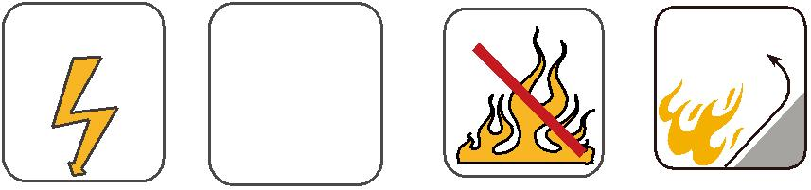
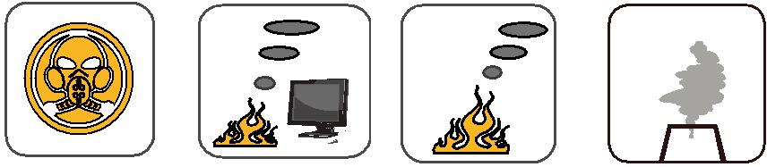
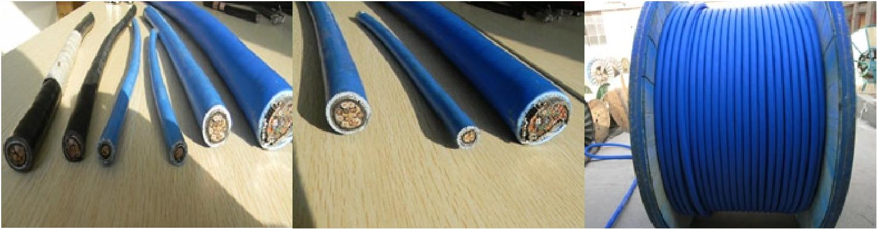

ADDISON 101

ADDISON

BS 5308 Part 1 Colour Code

BS 5308 Part 1 Colour Identification
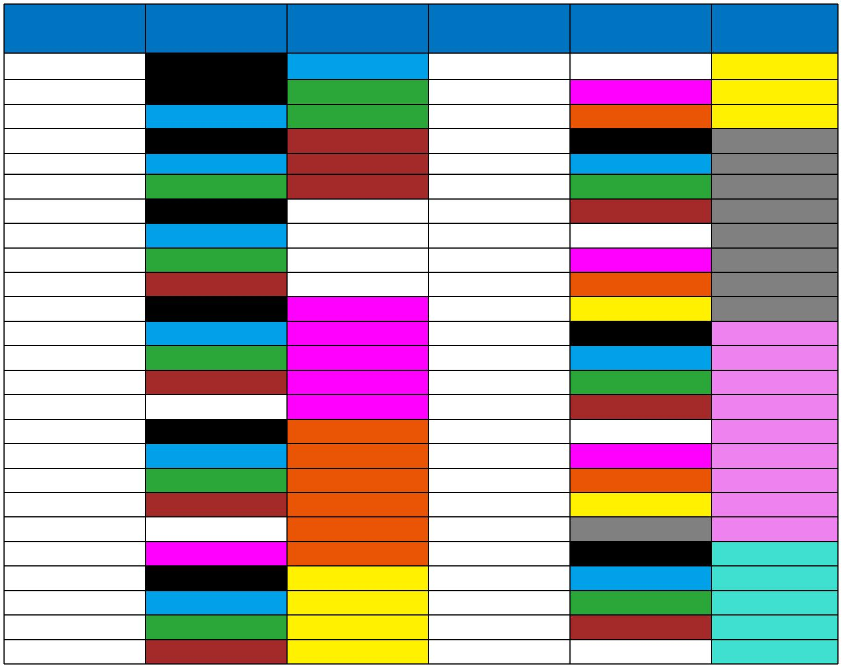

Pair No. | a-wire | b-wire | Pair No. | a-wire | b-wire
1 | Black | Blue | 26 | White | Yellow
2 | Black | Green | 27 | Red | Yellow
3 | Blue | Green | 28 | Orange | Yellow
4 | Black | Brown | 29 | Black | Grey
5 | Blue | Brown | 30 | Blue | Grey
6 | Green | Brown | 31 | Green | Grey
7 | Black | White | 32 | Brown | Grey
8 | Blue | White | 33 | White | Grey
9 | Green | White | 34 | Red | Grey
10 | Brown | White | 35 | Orange | Grey
11 | Black | Red | 36 | Yellow | Grey
12 | Blue | Red | 37 | Black | Violet
13 | Green | Red | 38 | Blue | Violet
14 | Brown | Red | 39 | Green | Violet
15 | White | Red | 40 | Brown | Violet
16 | Black | Orange | 41 | White | Violet
17 | Blue | Orange | 42 | Red | Violet
18 | Green | Orange | 43 | Orange | Violet
19 | Brown | Orange | 44 | Yellow | Violet
20 | White | Orange | 45 | Grey | Violet
21 | Red | Orange | 46 | Black | Turquoise
22 | Black | Yellow | 47 | Blue | Turquoise
23 | Blue | Yellow | 48 | Green | Turquoise
24 | Green | Yellow | 49 | Brown | Turquoise
25 | Brown | Yellow | 50 | White | Turquoise

Single Quad (2 pair) are colour coded in clockwise order of rotation: Black, Blue, Green and Brown

Individually screened pairs can also be identified by means of a polyester tape over blue and black pairs

For cables in triple configuration please request colour code at time of enquiry

Instrument Cables BS 5308 Part 2 Colour code

102 Caledonian

Caledonian

Flame Retardant Instrumentation Cables

www.caledonian-cables.co.uk www.addison-cables.com

BS 5308 Part 2 Colour Identification
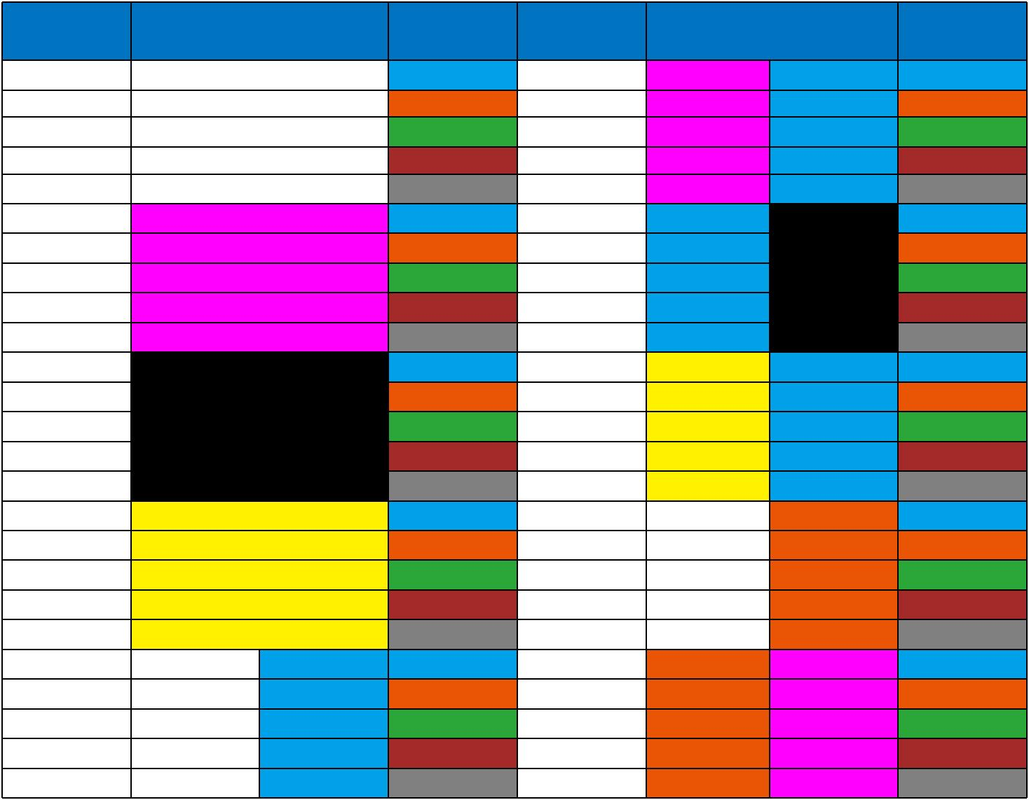

Pair No. | a-wire |  | b-wire | Pair No. | a-wire |  | b-wire
1 | White |  | Blue | 26 | Red | Blue | Blue
2 | White |  | Orange | 27 | Red | Blue | Orange
3 | White |  | Green | 28 | Red | Blue | Green
4 | White |  | Brown | 29 | Red | Blue | Brown
5 | White |  | Grey | 30 | Red | Blue | Grey
6 | Red |  | Blue | 31 | Blue | Black | Blue
7 | Red |  | Orange | 32 | Blue | Black | Orange
8 | Red |  | Green | 33 | Blue | Black | Green
9 | Red |  | Brown | 34 | Blue | Black | Brown
10 | Red |  | Grey | 35 | Blue | Black | Grey
11 | Black |  | Blue | 36 | Yellow | Blue | Blue
12 | Black |  | Orange | 37 | Yellow | Blue | Orange
13 | Black |  | Green | 38 | Yellow | Blue | Green
14 | Black |  | Brown | 39 | Yellow | Blue | Brown
15 | Black |  | Grey | 40 | Yellow | Blue | Grey
16 | Yellow |  | Blue | 41 | White | Orange | Blue
17 | Yellow |  | Orange | 42 | White | Orange | Orange
18 | Yellow |  | Green | 43 | White | Orange | Green
19 | Yellow |  | Brown | 44 | White | Orange | Brown
20 | Yellow |  | Grey | 45 | White | Orange | Grey
21 | White | Blue | Blue | 46 | Orange | Red | Blue
22 | White | Blue | Orange | 47 | Orange | Red | Orange
23 | White | Blue | Green | 48 | Orange | Red | Green
24 | White | Blue | Brown | 49 | Orange | Red | Brown
25 | White | Blue | Grey | 50 | Orange | Red | Grey

*For bi- coloured cores the first colour is the base colour

Single Quad (2 pair) are colour coded in clockwise order of rotation: Black, Blue, Green and Brown

Individually screened pairs can also be identified | by means | of a polyester tape over blue and black
pairs
For cables in triple configuration please request | colour code | at time of enquiry

ADDISON 103

