 ADDISON

Flame Retardant Central Loose Tube Fiber Optic cables

Application

These cables are characterized by light weight and small diameter, suitable for both aerial and duct installation. They are mainly installed inside buildings, tunnels,subways or closed areas in general, specially designed to guarantee the signal transmission even in case of fire. The cable can also be used for direct burial for armoured version.

STANDARDS

Basic design adapted to Telcordia GR-20 / RUS 7 CFR 1755.900 (REA PE-90) / ICEA S 87-640

FIRE PERFORMANCE

Flame Retardance (Single Vertical EN 60332-1-2; IEC 60332-1-2; BS EN 60332-1-2; VDE _{Wire Test)} 0482-332-1 ; NBN C 30-004 (cat. F1); NF C32-070-2.1(C2);
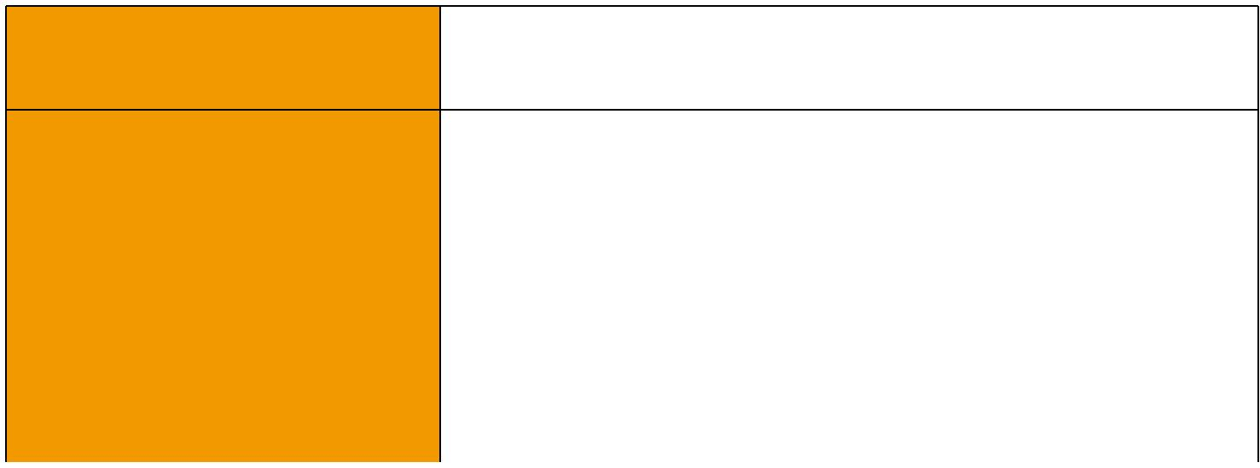
CEI 20-35/1-2; EN 50265-2-1*; DIN VDE 0482-265-2-1*

Reduced Fire Propagation | EN 60332-3-24 (cat. C); IEC 60332-3-24; BS EN 60332-3-24;
(Vertically-mounted bundled wires VDE 0482-332-3; NBN C 30-004 (cat. F2); NF C32-070-2.2(C1);
& cable test) | CEI 20-22/3-4; EN 50266-2-4*; DIN VDE 0482-266-2-4
Halogen Free | IEC 60754-1; EN 50267-2-1; DIN VDE 0482-267-2-1;
Halogen Free | CEI 20-37/2-1 ; BS 6425-1*
No Corrosive Gas Emission | IEC 60754-2; EN 50267-2-2; DIN VDE 0482-267-2-2;
No Corrosive Gas Emission | CEI 20-37/2-2 ; BS 6425-2*
Minimum Smoke Emission | IEC 61034-1&2; EN 61034 -1&2; DIN VDE 0482-1034-1&2;
Minimum Smoke Emission | CEI 20-37/3-1&2; EN 50268-1&2*; BS 7622-1&2*
No Toxic gases | NES 02-713; NF C 20-454
Note: Asterisk * denotes superseded standard.

CABLE CONSTRUCTION

Fibers: Singlemode and multimode fibers, with loose tube technology.

Structure: Central loose tube cable contains one tube with 2-24 single or multimode fibers, which are filled with water blocking gel.

Water blocking: The jelly filled tube is waterblocked by using swellable tape and thread.

Reinforcement: Either aramid yarn or fiber glass is wound around the tube to provide physical protection and tensile strength, with added fire protection.

Inner sheath (optional): The cable can be jacketed with either PE or thermoplastic LSZH inner sheath. PE is the preferred option in outdoor environment for water protection purpose.

Moisture Barrier Tape (optional): An aluminum moisture tape can be incorporated under the sheath for water blocking and shielding purpose.

Armouring(optional):

For diect burial, either galvanized steel wire braid, corrugated steel tape armour or galvanized steel wire armour is applied over an inner polyethylene or LSZH sheath. For steel tape armour, the 0.15mm thick steel tape is coated with a copolymer and applied with an overlap. For steel wire braid or armour, single layer of galvanized steel wire braid or armour is applied.

144 Caledonian


Caledonian

Flame Retardant Optic Fiber Cables

www.caledonian-cables.co.uk www.addison-cables.com

Ripcord (optional): An optional ripcord can be located under the jacket to facilitate jacket removal.

Outer Sheath: Thermoplastic LSZH compound type LTS3 as per BS 7655-6.1(Thermosetting LSZH compound type SW2-SW4 as per BS 7655-2.6 can be offered.). UV resistance, hydrocarbon resistance, oil resistance, anti rodent and anti termite properties can be offered as option.

Fiber colour code
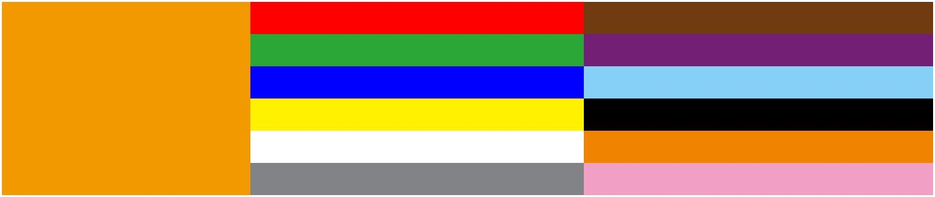
Fiber colour code | 1 | Red | 7 | Brown
 | 2 | Green | 8 | Violet
 | 3 | Blue | 9 | Turquoise
 | 4 | Yellow | 10 | Black
 | 5 | White | 11 | Orange
 | 6 | Grey | 12 | Pink

CONSTRUCTION

Unarmoured type
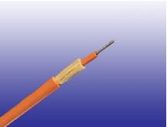
 |  |  |  | Fiber
 |  |  |  | Jelly Filled Central Loose Tube
 |  |  |  | Water -blocking Tape(optional)
 |  |  |  | Aramid Yarn/Fiber Glass Yarn
 |  |  |  | Ripcord(optional)
 |  |  |  | Aluminum Moisture Barrier Tape(optional)
 |  |  |  | LSZH Outer Sheath
CONSTRUCTION PARAMETERS
 | Fiber | Tube | Nominal | Approx.
Cable Code | Fiber | Tube | Overall | Approx. | Tension load | Crush
Cable Code | Count | Diameter | Overall | Weight | Tension load | Crush
 | Count | Diameter | Diameter | Weight
 | (n°) | mm | mm | kg/km | N | N/100mm
CLA-B-C-H-J | 02-06 | 2.7 | 8.0 | 70 | 1000 | 1500
CLA-B-C-H-J | 08-16 | 3.5 | 9.0 | 90 | 1200 | 1500
CLA-B-C-H-J | 18-24 | 4.2 | 10.0 | 100 | 1500 | 1500
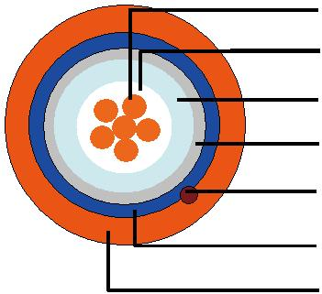

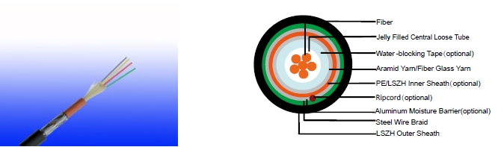
Steel Wire Braid

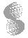 ADDISON 145

ADDISON

CONSTRUCTION PARAMETERS
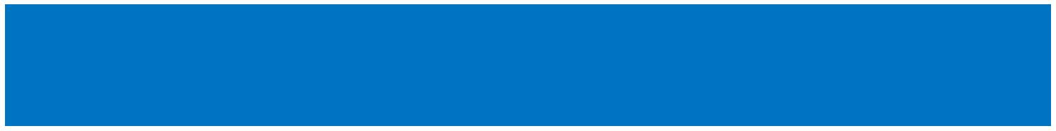
 | Fiber |  | Tube |  |  | Nominal |  |  |  |  |  |  |  | Approx.
Cable Code |  |  |  |  |  | Overall |  |  |  |  |  |  |  |  |  |  |  | Tension load |  | Crush
Cable Code | Count |  | Diameter |  |  |  |  |  |  |  |  |  |  | Weight
 |  |  |  |  |  | Diameter
 | (n°) |  | mm |  |  | mm |  |  |  |  |  |  |  | kg/km |  |  |  | N |  | N/100mm
CLA-B-C-2Y(SWB)H-J | 02-06 |  | 2.7 |  |  | 11.5 |  |  |  |  |  |  |  | 160 |  |  |  | 1000 |  | 2000
CLA-B-C-2Y(SWB)H-J | 08-16 |  | 3.5 |  |  | 12.0 |  |  |  |  |  |  |  | 180 |  |  |  | 1200 |  | 2000
CLA-B-C-2Y(SWB)H-J | 18-24 |  | 4.2 |  |  | 13.0 |  |  |  |  |  |  |  | 200 |  |  |  | 1500 |  | 2000
Corrugated Steel Tape Armour
 |  |  |  |  |  |  |  |  |  |  |  |  |  | Fiber
 |  |  |  |  |  |  |  |  |  |  |  |  |  | Jelly Filled Central Loose Tube
 |  |  |  |  |  |  |  |  |  |  |  |  |  | Water -blocking Tape(optional)
 |  |  |  |  |  |  |  |  |  |  |  |  |  | Aramid Yarn/Fiber Glass Yarn
 |  |  |  |  |  |  |  |  |  |  |  |  |  | Aluminum Moisture Barrier Tape(optional)
 |  |  |  |  |  |  |  |  |  |  |  |  |  | Ripcord(optional)
 |  |  |  |  |  |  |  |  |  |  |  |  |  | PE/LSZH Inner Sheath(optional)
 |  |  |  |  |  |  |  |  |  |  |  |  |  | Corrugated Steel Tape Armour
 |  |  |  |  |  |  |  |  |  |  |  |  |  | LSZH Outer Sheath
CONSTRUCTION PARAMETERS
Cable Code |  | Fiber |  | Tube |  |  | Diameter |  |  |  |  |  |  |  | Approx. |  |  | Tension |  | Crush
Cable Code |  | Count |  | Diameter |  |  |  |  |  |  |  |  |  |  | Weight |  |  | load |  | Crush
 |  | (n°) |  | mm |  |  | mm |  |  |  |  |  |  |  | kg/km |  |  | N |  | N/100mm
CLA-B-C-2Y(STA)H-J |  | 02-06 |  | 2.7 |  |  | 13.0 |  |  |  |  |  |  |  | 200 |  |  | 1000 |  | 2500
CLA-B-C-2Y(STA)H-J |  | 08-16 |  | 3.5 |  |  | 14.0 |  |  |  |  |  |  |  | 220 |  |  | 1200 |  | 2500
CLA-B-C-2Y(STA)H-J |  | 18-24 |  | 4.2 |  |  | 14.5 |  |  |  |  |  |  |  | 250 |  |  | 1500 |  | 2500
Steel Wire armour
 |  |  |  |  |  |  |  |  |  |  |  |  |  |  |  |  | Fiber
 |  |  |  |  |  |  |  |  |  |  |  |  |  |  |  |  | Jelly Filled Loose Tube
 |  |  |  |  |  |  |  |  |  |  |  |  |  |  |  | Water -blocking Tape(optional)
 |  |  |  |  |  |  |  |  |  |  |  |  |  |  |  |  | PE/LSZH Inner Sheath
 |  |  |  |  |  |  |  |  |  |  |  |  |  |  |  |  | Aluminum Moisture Barrier Tape(optional)
 |  |  |  |  |  |  |  |  |  |  |  |  |  |  |  |  | Galvanized Steel Wire Armour
 |  |  |  |  |  |  |  |  |  |  |  |  |  |  |  |  | Ripcord(optional)
 |  |  |  |  |  |  |  |  |  |  |  |  |  |  |  |  | LSZH Outer Sheath
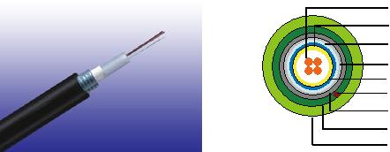
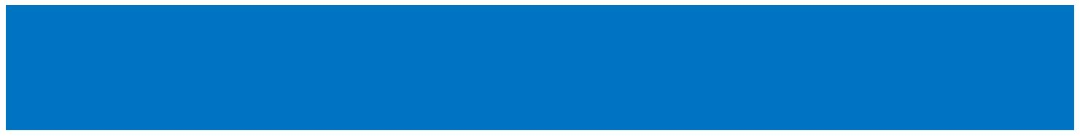
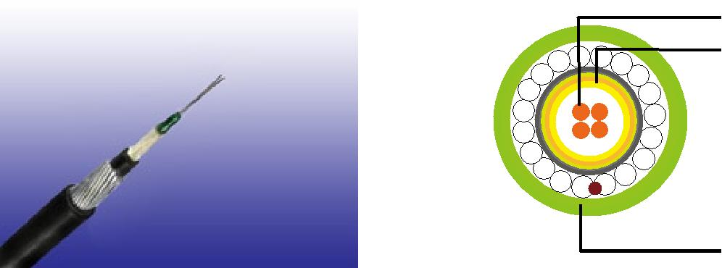

146 Caledonian

Caledonian

Flame Retardant Optic Fiber Cables

www.caledonian-cables.co.uk www.addison-cables.com

CONSTRUCTION PARAMETERS

 | Fiber | Tube | Nominal | Approx. | Tension
Cable Code | Fiber | Tube | Overall | Approx. | Tension | Crush
Cable Code | Count | Diameter | Overall | Weight | load | Crush
 | Count | Diameter | Diameter | Weight | load
 | (n°) | mm | mm | kg/km | N | N/100mm
CLA-B-C-2Y(SWA)H-J | 02-12 | 2.7 | 10.5 | 180 | 2500 | 4000
CLA-B-C-2Y(SWA)H-J | 16-24 | 3.5 | 11.0 | 210 | 2500 | 4000

Physical AND THERMAL PROPERTIES

Temperature range during operation (fixed state):-20°C - +60°C

Temperature range during installation (mobile state): 0°C - +50°C

Minimum operation Bending Radius: 10 times the outer diameter for unarmoured cables 20 times the outer diameter for armoured cables

Minimum Installation Bending Radius: 20 times the outer diameter

mechanical PROPERTIES
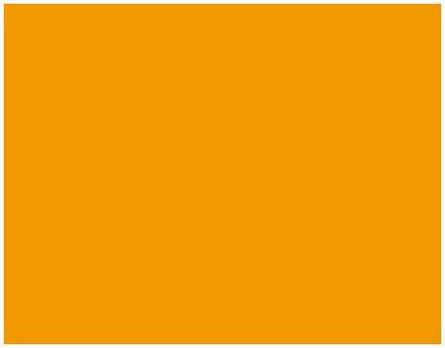
Maximum Compressive Load | 4000N for unarmoured cables
Maximum Compressive Load | 5000N for armoured cables
Repeated Impact: | 4.4 N.m (J)
Twist (Torsion): | 180×10 times, 125×OD
Cyclic Flexing: | 25 cycles for armoured cables;
Cyclic Flexing: | 100 cycles for unarmoured cables.
Crush Resistance: | 263N/cm (150lb/in)
Fiber Compliance
Temperature Cycling | IEC60794-1-2-F2
Tensile Strength | IEC60794-1-2-E1A
Crush | IEC60794-1-2-E3
Impact | IEC60794-1-2-E4
Repeated Bending | IEC60794-1-2-E6
Torsion | IEC60794-1-2-E7
Kink | IEC60794-1-2-E10
Cable Bend | IEC60794-1-2-E11
Cool Bend | IEC60794-1-2-E11
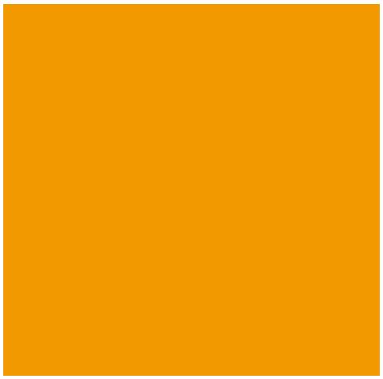

ADDISON 147

ADDISON

TYPE CODES

CLA-B-C-D-E-F-G
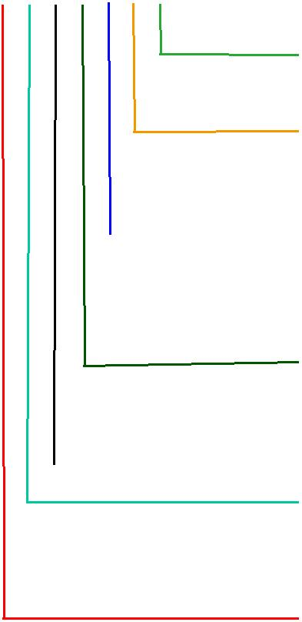
Water blocking gel in tubes

X: No water-blocking J: Water blocking gel between jackets; D: Dry water-blocking between cable jackets

Outer Sheath 2Y: PE
Y: PVC
H: LSZH
Armour
Blank: No armour
STA: Corrugated steel tape armour
SWA: Steel wire armour
SWB: Steel wire braid
Inner Sheath
H: LSZH

C No of Fibers

B Fiber Type
- 50/125 um(OM3) 7: NZDS SM fiber per ITU-T G.656
- 50/125 um(OM2) 8: NZDS SM fiber per ITU-T G.655
- 62.5/125um(OM1) 9: Standard SM fiber per ITU-T G.652.D

Tube Diameter
A: 2.7mm
B: 3.5mm
C: 4.2mm

GR-20/RUS 7 CFR1755N.900 (REA PE-90)
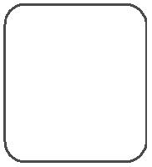

Standard
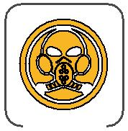
ICEA_{N}S87-640
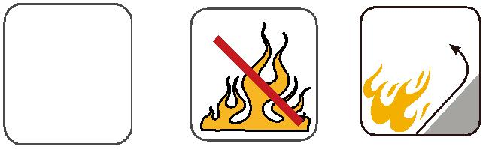 | Flame Retardancy | Reduced Fire Propagation
 | Flame Retardancy | NF C32-070-2.2(C1)
Standard | NF C32-070-2.1(C2) | IEC60332-3-24
Standard | IEC60332-1-2/EN50265-2-1 | EN50266-2-4
 |  | Zero
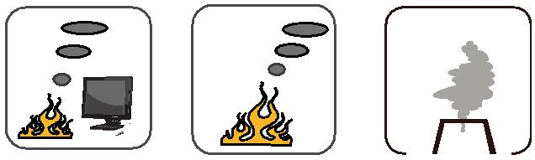

 |  |  | Low Corrosivity | Low Smoke Emission
 |  |  | Low Corrosivity | Low Smoke Emission | Halogen Free
 | Low Toxicity |  | IEC60754-2 | IEC 61034-1&2 | IEC60754-1
 |  |  | EN50267-2-2/3 | IEC 61034-1&2 | IEC60754-1
NES 02-713/NF C 20-454 |  |  | EN50267-2-2/3 | EN 50268-1&2/NF C32-073 | EN50267-2-1
 |  |  | NF C 32-074 | EN 50268-1&2/NF C32-073 | EN50267-2-1

148 Caledonian

