 ADDISON

Flame Retardant CAT6 CWB/SWB/SWA Armoured Data Cables

FTX-CAT6 U/UTP4P23 cwb/swb/swa

FTX-CAT6 F/UTP4P23 cwb/swb/swa

FTX-CAT6 SF/UTP4P23 cwb/swb/swa
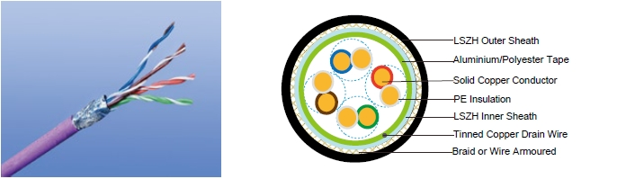

APPLICATION

Cat6 Cable is a cable standard for Gigabit Ethernet and other network protocol, suitable for 10BaseT, 100BaseTx & 1000BaseT (Gigabit Ethernet) application. In addition, these cables are with copper wire braid armoured & flame retardant mud resistant outer sheath, providing additional mechanically protection still maintaining the flexibility of the cable.

STANDARDS

Basic design adapted to EN50173

FIRE PERFORMANCE

Flame Retardance (Single Vertical | EN 60332-1-2; IEC 60332-1-2; BS EN 60332-1-2; VDE
Flame Retardance (Single Vertical | 0482-332-1 ; NBN C 30-004 (cat. F1); NF C32-070-2.1(C2);
Wire Test) | CEI 20-35/1-2; EN 50265-2-1*; DIN VDE 0482-265-2-1*
Reduced Fire Propagation | EN 60332-3-24 (cat. C); IEC 60332-3-24; BS EN 60332-3-24;
(Vertically-mounted bundled wires | VDE 0482-332-3; NBN C 30-004 (cat. F2); NF C32-070-2.2(C1);
& cable test) | CEI 20-22/3-4; EN 50266-2-4*; DIN VDE 0482-266-2-4
Halogen Free | IEC 60754-1; EN 50267-2-1; DIN VDE 0482-267-2-1;
Halogen Free | CEI 20-37/2-1 ; BS 6425-1*
No Corrosive Gas Emission | IEC 60754-2; EN 50267-2-2; DIN VDE 0482-267-2-2;
No Corrosive Gas Emission | CEI 20-37/2-2 ; BS 6425-2*
Minimum Smoke Emission | IEC 61034-1&2; EN 61034 -1&2; DIN VDE 0482-1034-1&2;
Minimum Smoke Emission | CEI 20-37/3-1&2; EN 50268-1&2*; BS 7622-1&2*
No Toxic gases | NES 02-713; NF C 20-454

Note: Asterisk * denotes superseded standard.

VOLTAGE RATING

60V

114 Caledonian


Caledonian

Flame Retardant Data Cables
www.caledonian-cables.co.uk www.addison-cables.com

CABLE CONSTRUCTION

Conductors: 23AWG solid bare copper.

Insulation: HDPE .

Twinning: Two coloured insulated conductors twisted together to form a pair.

Inner Sheath: Flame retardant, low smoke and halogen-free polyolefin, coloured black.

Armouring:

cwb: copper Wire Braid swb: Steel Wire Braid swa: Steel Wire Armour

Outer Sheath: Thermoplastic LSZH compound type LTS3 as per BS 7655-6.1 (Thermosetting LSZH compound type SW2-SW4 as per BS 7655:section 2.6 can be offered.). UV resistance, hydrocarbon resistance, oil resistance, anti rodent and anti termite properties can be offered as option.

Cat6 F/UTP: These cables have collective shielding of aluminium/Polyester tape with drain wire. Cat6 SF/UTP: These cables have double collective shieldings of aluminium/Polyester tape & copper wire braid with drain wire.

Physical AND THERMAL PROPERTIES

Temperature range: -30°C ~ +75°C

Minimum bending radius during installation (mobile state): 8 x Overall Diameter

Minimum bending radius during operation (fixed state):4 x Overall Diameter

Electrical Properties

AWG |  | 23
Nominal Conductor Diameter | mm | 0.56/0.57/0.58
Maximum DC Resistant@20°C | Ω/100m | 9.38
Maximum DCR Unbalance | % | 3
Maximum Mutual Capacitance | pF/m | 5.8
Maximum Capacitance Unbalance | pF/100m | 30
Characteristic Impedance@1-100MHz | Ω | 100+/-15
Maximum Propagation Delay Skew | ns/100m | 18

Transmission Properties

FREQ | Maximum | Minimum | Minimum | Minimum | Minimum | Minimum
FREQ | Attenuation | NEXT | PSNEXT | ELFEXT | PSELFEXT | RL
MHz
MHz | dB/100m | dB | dB | dB/100m | dB/100m | dB
0.772 | 1.8 | 76.0 | 74. | 70.0 | 67.0 | —
1 | 2.0 | 74.3 | 72.3 | 67.8 | 64.8 | 20.0
4 | 3.8 | 65.3 | 63.3 | 55.7 | 52.7 | 23.0
8 | 5.3 | 60.8 | 58.8 | 49.7 | 46.7 | 24.5
10 | 6.0 | 59.3 | 57.3 | 47.8 | 44.8 | 25.0
16 | 7.6 | 56.3 | 54.3 | 43.7 | 40.7 | 25.0
20 | 8.5 | 54.8 | 52.8 | 41.7 | 38.7 | 25.0

 ADDISON 115

ADDISON


FREQ | Maximum | Minimum | Minimum | Minimum | Minimum | Minimum
FREQ | Attenuation | NEXT | PSNEXT | ELFEXT | PSELFEXT | RL
MHz
MHz | dB/100m | dB | dB | dB/100m | dB/100m | dB
25 | 9.5 | 53.3 | 51.3 | 39.8 | 36.8 | 24.3
31.25 | 10.7 | 51.9 | 49.9 | 37.9 | 34.9 | 23.6
62.5 | 15.4 | 47.4 | 45.4 | 31.8 | 28.8 | 21.5
100 | 19.8 | 44.3 | 42.3 | 27.8 | 24.8 | 20.1
155 | 25.2 | 41.5 | 39.5 | 23.9 | 20.9 | 18.8
200 | 29.0 | 39.8 | 37.8 | 21.7 | 18.7 | 18.0
250 | 32.8 | 38.3 | 36.3 | 19.8 | 16.8 | 17.3

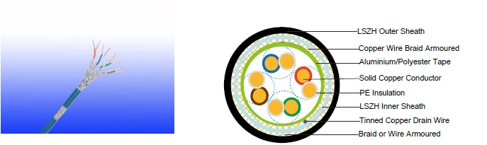

Cat6 SF/UTP

CONSTRUCTION PARAMETERS

 |  | Construction |  | Nominal | Nominal
 |  | No. of elements×No. | Nominal | Nominal | Nominal | Nominal
 | Cable Code | of cores in | Insulation | Inner | Outer | Overall | Nominal
 |  | element×Conductor | Thickness | Sheath | Sheath | Diameter | Weight
 |  | element×Conductor | Thickness | Thickness | Thickness | Diameter
 |  | diameter
 |  | mm | mm | mm | mm | mm | kg/km
 | FTX-CAT6 U/UTP CWB | 4×2×0.56/0.57 | 0.2 | 0.6 | 1.0 | 7.88 | 115
 | FTX-CAT6 U/UTP SWB | 4×2×0.56/0.57 | 0.2 | 0.6 | 1.0 | 7.88 | 109
 | FTX-CAT6 U/UTP SWA | 4×2×0.56/0.57 | 0.2 | 0.6 | 1.0 | 8.88 | 189
 | FTX-CAT6 F/UTP CWB | 4×2×0.57/0.58 | 0.2 | 0.6 | 1.0 | 8.48 | 126
 | FTX-CAT6 F/UTP SWB | 4×2×0.57/0.58 | 0.2 | 0.6 | 1.0 | 8.48 | 132
 | FTX-CAT6 F/UTP SWA | 4×2×0.57/0.58 | 0.2 | 0.6 | 1.0 | 9.48 | 213
 | FTX-CAT6 SF/UTP CWB | 4×2×0.57/0.58 | 0.2 | 0.6 | 1.0 | 8.96 | 154
116 | Caledonian

