
Caledonian

Flame Retardant Data Cables
www.caledonian-cables.co.uk www.addison-cables.com

Flame Retardant CAT5e CWB/SWB/SWA Armoured Data Cables

FTX-CAT5e U/UTP4P24 cwb/swb/swa

FTX-CAT5e f/UTP4P24 cwb/swb/swa

FTX-CAT5e sf/FTP4P24 cwb/swb/swa

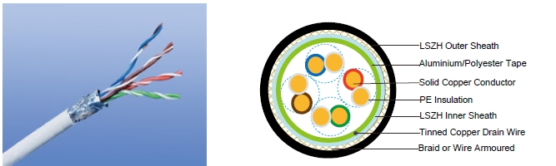

APPLICATION

Cat5E is a cable standard for Gigabit Ethernet and other network protocol, suitable for basic voice and data installations up to 100 MHz. In addition, these cables can be offered with copper wire braid armoured & flame retardant outer sheath, providing additional mechanically protection still maintaining the flexibility of the cable.

STANDARDS

Basic design adapted to EN50173

FIRE PERFORMANCE

Flame Retardance (Single Vertical | EN 60332-1-2; IEC 60332-1-2; BS EN 60332-1-2; VDE
Flame Retardance (Single Vertical | 0482-332-1 ; NBN C 30-004 (cat. F1); NF C32-070-2.1(C2);
Wire Test) | CEI 20-35/1-2; EN 50265-2-1*; DIN VDE 0482-265-2-1*
Reduced Fire Propagation | EN 60332-3-24 (cat. C); IEC 60332-3-24; BS EN 60332-3-24;
(Vertically-mounted bundled wires | VDE 0482-332-3; NBN C 30-004 (cat. F2); NF C32-070-2.2(C1);
& cable test) | CEI 20-22/3-4; EN 50266-2-4*; DIN VDE 0482-266-2-4
Halogen Free | IEC 60754-1; EN 50267-2-1; DIN VDE 0482-267-2-1;
Halogen Free | CEI 20-37/2-1 ; BS 6425-1*
No Corrosive Gas Emission | IEC 60754-2; EN 50267-2-2; DIN VDE 0482-267-2-2;
No Corrosive Gas Emission | CEI 20-37/2-2 ; BS 6425-2*
Minimum Smoke Emission | IEC 61034-1&2; EN 61034 -1&2; DIN VDE 0482-1034-1&2;
Minimum Smoke Emission | CEI 20-37/3-1&2; EN 50268-1&2*; BS 7622-1&2*
No Toxic gases | NES 02-713; NF C 20-454

Note: Asterisk * denotes superseded standard.

VOLTAGE RATING

60V

 ADDISON 107

 ADDISON

CABLE CONSTRUCTION

Conductors: 24AWG solid bare copper.

Insulation: HDPE.

Twinning: Two coloured insulated conductors twisted together to form a pair.

Inner Sheath: Flame retardant, low smoke and halogen-free polyolefin, coloured black.

Armouring:

cwb: copper Wire Braid swb: Steel Wire Braid swa: Steel Wire Armour

Outer Sheath: Thermoplastic LSZH compound type LTS3 as per BS 7655-6.1 (Thermosetting LSZH compound type SW2-SW4 as per BS 7655:section 2.6 can be offered.). UV resistance, hydrocarbon resistance, oil resistance, anti rodent and anti termite properties can be offered as option.

Cat5E F/UTP: These cables have collective shielding of aluminium/Polyester tape with drain wire. Cat5E SF/UTP: These cables have double collective shieldings of aluminium/Polyester tape & copper wire braid.

Physical AND THERMAL PROPERTIES

Temperature range: -30°C ~ +75°C

Minimum bending radius during installation (mobile state): 8 x Overall Diameter

Minimum bending radius during operation (fixed state):4 x Overall Diameter

Electrical Properties

AWG |  | 24
Nominal Conductor Diameter | mm | 0.5/0.51/0.53
Maximum DC Resistant@20°C | Ω/100m | 9.38
Maximum DCR Unbalance | % | 5
Maximum Mutual Capacitance | pF/m | 55.8
Maximum Capacitance Unbalance | pF/100m | 330
Characteristic Impedance@1-100MHz | Ω | 100+/-15
Maximum Propagation Delay Skew | ns/100m | 45

Transmission Properties

FREQ | Maximum | Minimum | Minimum | Minimum | Minimum | Minimum
FREQ | Attenuation | NEXT | PSNEXT | ELFEXT | PSELFEXT | RL
MHz
MHz | dB/100m | dB | dB | dB/100m | dB/100m | dB
0.772 | 1.8 | 67.0 | 64.0 | 66.0 | 63.0 | —
1 | 2.0 | 65.3 | 62.3 | 63.8 | 60.8 | 20.0
4 | 4.1 | 56.3 | 53.3 | 51.7 | 48.7 | 23.0
8 | 5.8 | 51.8 | 48.8 | 45.7 | 42.7 | 24.5

108 Caledonian

Caledonian

Flame Retardant Data Cables
www.caledonian-cables.co.uk www.addison-cables.com


FREQ | Maximum | Minimum | Minimum | Minimum | Minimum | Minimum
FREQ | Attenuation | NEXT | PSNEXT | ELFEXT | PSELFEXT | RL
MHz
MHz | dB/100m | dB | dB | dB/100m | dB/100m | dB
10 | 6.5 | 50.3 | 47.3 | 43.8 | 40.8 | 25.0
16 | 8.2 | 47.3 | 44.3 | 39.7 | 36.7 | 25.0
20 | 9.3 | 45.8 | 42.8 | 37.7 | 34.7 | 25.0
25 | 10.4 | 44.3 | 41.3 | 35.8 | 32.8 | 24.3
31.25 | 11.7 | 42.9 | 39.9 | 33.9 | 30.9 | 23.6
62.5 | 17.0 | 38.4 | 35.4 | 27.8 | 24.8 | 21.5
100 | 22.0 | 35.3 | 32.3 | 23.8 | 20.8 | 20.1
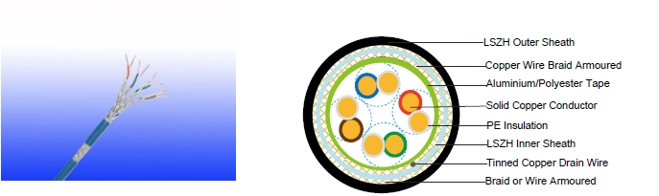

Cat5E SF/UTP

CONSTRUCTION PARAMETERS

 | Construction |  | Nominal | Nominal
 | No. of elements×No. | Nominal | Nominal | Nominal | Nominal
Cable Code | of cores in | Insulation | Inner | Outer | Overall | Nominal
 | element×Conductor | Thickness | Sheath | Sheath | Diameter | Weight
 | Diameter |  | Thickness | Thickness
 | mm | mm | mm | mm | mm | kg/km
FTX-CAT5e U/UTP CWB | 4×2×0.5/0.51 | 0.2 | 0.6 | 1.0 | 7.68 | 97
FTX-CAT5e U/UTP SWB | 4×2×0.5/0.51 | 0.2 | 0.6 | 1.0 | 7.68 | 93
FTX-CAT5e U/UTP SWA | 4×2×0.5/0.51 | 0.2 | 0.6 | 1.0 | 8.68 | 165
FTX-CAT5e F/UTP CWB | 4×2×0.53 | 0.2 | 0.6 | 1.0 | 8.28 | 116
FTX-CAT5e F/UTP SWB | 4×2×0.53 | 0.2 | 0.6 | 1.0 | 8.28 | 112
FTX-CAT5e F/UTP SWA | 4×2×0.53 | 0.2 | 0.6 | 1.0 | 9.28 | 192

ADDISON 109

ADDISON
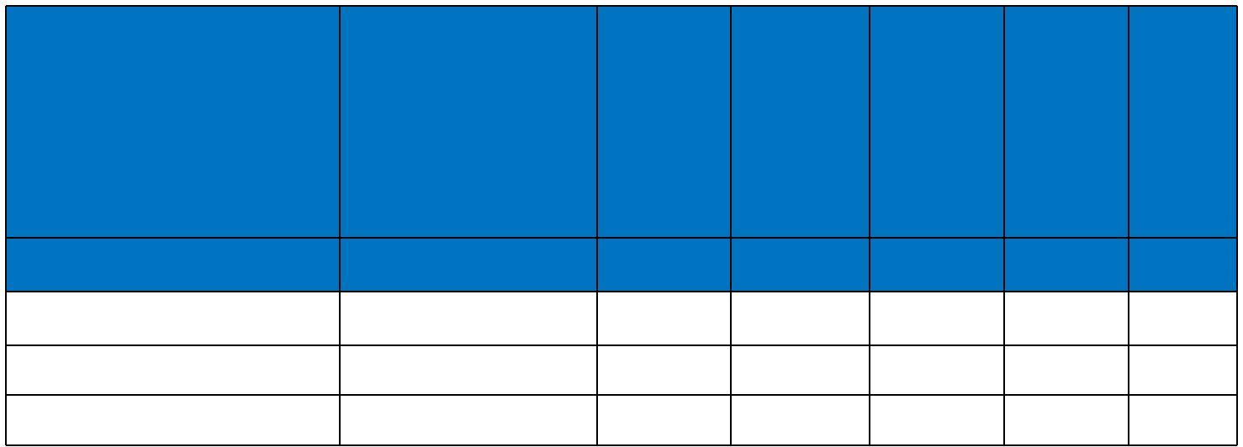

 |  | Construction |  | Nominal | Nominal
 |  | No. of elements×No. Nominal |  | Nominal | Nominal | Nominal
Cable Code |  | of cores in | Insulation | Inner | Outer | Overall | Nominal
 |  | element×Conductor Thickness _{Thickness}^{Sheath} |  |  | Thickness^{Sheath} | Diameter | Weight
 |  | Diameter
 |  | mm | mm | mm | mm | mm | kg/km
FTX-CAT5e SF/UTP CWB |  | 4×2×0.53 | 0.2 | 0.6 | 1.0 | 8.76 | 123
FTX-CAT5e SF/UTP SWB |  | 4×2×0.53 | 0.2 | 0.6 | 1.0 | 8.76 | 119
FTX-CAT5e SF/UTP SWA |  | 4×2×0.53 | 0.2 | 0.6 | 1.0 | 9.76 | 216
60V | _{N}EN50173 | Flame Retardancy | Reduced Fire Propagation
 |  | NF C32-070-2.1(C2) | NF C32-070-2.2(C1)
Rated Voltage | Standard | NF C32-070-2.1(C2) | IEC60332-3-24
Rated Voltage | Standard | IEC60332-1-2/EN50265-2-1 | IEC60332-3-24
 |  | IEC60332-1-2/EN50265-2-1 | EN50266-2-4
 |  |  | Zero
 | Low Corrosivity | Low Smoke Emission | Halogen Free
 | IEC60754-2 | Low Smoke Emission | Halogen Free
Low Toxicity | IEC60754-2 | IEC 61034-1&2 | IEC60754-1
Low Toxicity | EN50267-2-2/3 | IEC 61034-1&2 | IEC60754-1
NES 02-713/NF C 20-454 | NF C 32-074 | EN 50268-1&2/NF C32-073 | EN50267-2-1
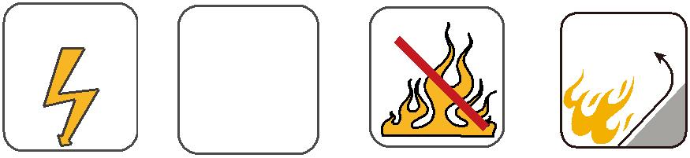
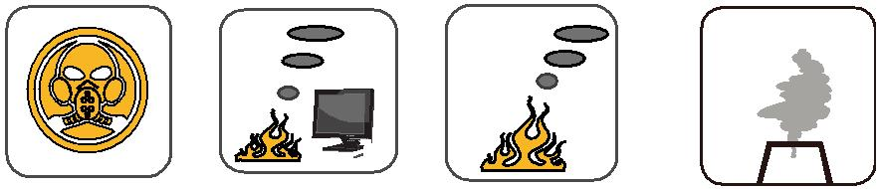

110 Caledonian

