 ADDISON

300/500V XLPE Insulated, PVC Sheathed, Screened Power Cables (Multicore)

FGD200 05ROV-R (CU/XLPE/OSCR/PVC 300/500V Class 2)
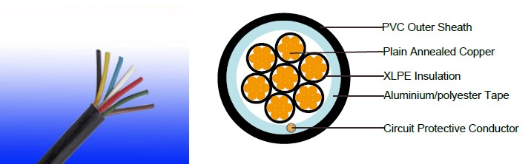

APPLICATION

The cables are mainly used in power stations, mass transit underground passenger systems, airports, petrochemical plants, hotels, hospitals, and high-rise buildings.

STANDARDS

Basic design adapted to BS 5308

FIRE PERFORMANCE

Flame Retardance (Single Vertical EN 60332-1-2; IEC 60332-1-2; BS EN 60332-1-2; VDE _{Wire Test)**} 0482-332-1 ; NBN C 30-004 (cat. F1); NF C32-070-2.1(C2);
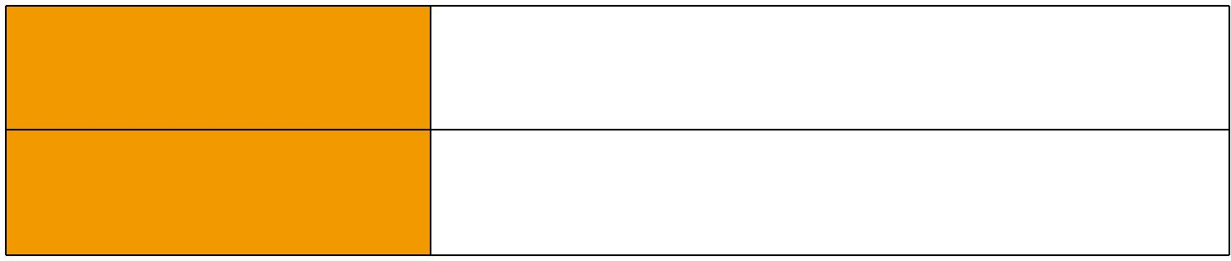
CEI 20-35/1-2; EN 50265-2-1*; DIN VDE 0482-265-2-1*

Reduced Fire Propagation | EN 60332-3-24 (cat. C); IEC 60332-3-24; BS EN 60332-3-24;
(Vertically-mounted bundled wires VDE 0482-332-3; NBN C 30-004 (cat. F2); NF C32-070-2.2(C1);
& cable test)** | CEI 20-22/3-4; EN 50266-2-4*; DIN VDE 0482-266-2-4

Note: Asterisk ** denotes that the standard compliance is optional, depending on the oxygen index of the PVC compound and the cable design.

VOLTAGE RATING

300/500V

CABLE CONSTRUCTION

Conductor: Plain annealed copper wire, stranded according to IEC(EN) 60228 class 2. Insulation: Extruded cross-linked XLPE compound.

Filler, binder(if any): PP, Mylar tape

Circuit Protective Conductor: Annealed plain copper (class 2)

Overall Screen: Aluminium/polyester tape

Outer Sheath: Thermoplastic PVC compound. UV resistance, hydrocarbon resistance, oil resistance,

14 Caledonian


Caledonian

Flame Retardant Power & Control Cables

www.caledonian-cables.co.uk www.addison-cables.com

anti rodent and anti termite properties can be offered as option. Compliance to fire performance standard (IEC 60332-1, IEC 60332-3, UL 1581, UL 1666 etc) depends on the oxygen index of the PVC compound and the overall cable design. LSPVC can also be provided upon request.

COLOUR CODE

Insulation Colour as per BS7671
 | With Earth Conductor | Without Earth Conductor
2Cores | - | Brown, Blue
3Cores | Yellow/Green, Brown, Blue | Brown, Gray, Black
4Cores | Yellow/Green, Brown, Gray, Black | Brown, Gray, Black, Blue
5Cores | Yellow/Green, Brown, Gray, Black, Blue | Brown, Gray, Black, Blue, Black
Above 5 Cores | Yellow/Green, Black Numbered | Black Numbered

Sheath Colour: Black (other colors upon request)

Physical AND THERMAL PROPERTIES

Temperature range during operation: Max.90°C for XLPE

250°C in short-circuit for 5secs max.

Minimum bending radius: 6 x Overall Diameter

CONSTRUCTION PARAMETERS

 | Conductor |  |  |  | FGD200 05roV-R
 | No./ |  |  | Cross- |  |  | Max.Dc
No. Of | No./ | Nominal |  | Section |  |  | Max.Dc
No. Of | Nominal | Nominal | Nominal | Section | Nominal | Nominal | Resistance
Core X | Nominal | Overall | Nominal | Area Of | Nominal | Nominal | Resistance | Approx.
Core X | Diameter | Overall | Insulation | Area Of | Sheath | Overall | Of | Approx.
Cross | Of | Diameter | Thickness | Circuit | Thickness | Diameter | Conductor | Weight
Section | Strands | Conductor |  | Protective |  |  | @20°C
 |  |  |  | Conductor
Noxmm² | No./mm | mm | mm | mm² | mm | mm | Ω/km | Kg/km
7x1.0 | 7i0.44 | 1.32 | 0.6 | 1.0 | 1.0 | 11.2 | 18.1 | 186
7x1.5 | 7i0.53 | 1.59 | 0.7 | 1.5 | 1.1 | 12.9 | 12.1 | 253
7x2.5 | 7i0.67 | 2.01 | 0.8 | 2.5 | 1.2 | 14.9 | 7.41 | 365
12x1.5 | 7i0.53 | 1.59 | 0.7 | 1.5 | 1.2 | 16.8 | 12.1 | 404
12x2.5 | 7i0.67 | 2.01 | 0.8 | 2.5 | 1.4 | 19.8 | 7.41 | 595
19x1.5 | 7i0.53 | 1.59 | 0.7 | 1.5 | 1.3 | 19.7 | 12.1 | 600
19x2.5 | 7i0.67 | 2.01 | 0.8 | 2.5 | 1.5 | 23.2 | 7.41 | 885

Electrical PROPERTIES

Conductor Operating Temperature : 90°C

Ambient Temperature : 30°C

 ADDISON 15

ADDISON

Current-Carrying Capacities (Amp)

 |  |  | Reference |  |  |  | Reference |  | Reference Method 12 (free
Conductor | Reference Method |  | Method 3 |  |  |  |  |  |  | air)
Conductor |  |  |  |  |  |  | Method 11 (on a |  |  | air)
cross- | 4 (enclosed in |  | (enclosed in |  | Reference Method
 |  |  |  |  |  |  | perforated cable |  | Horizontal | Vertical
sectional | conduit in thermally |  | conduit on |  | 1 (clipped direct) |  | tray, horizontal or |  | flat | flat | Trefoil
area | insulating wall etc) |  | a wall or in |  |  |  | vertical) |  | spaced | spaced
 |  |  | trunking etc) |  |  |  |  |  | spaced | spaced
 |  |  |  |  |  |  |  |  | 2 cables, | 2
 |  |  |  |  |  |  |  |  | 2 cables, | cables,
 | 2 |  | 2 |  | 2 cables, | 3 or 4 | 2 cables, | 3 or 4 | single- | single- | 3
 | 2 |  | 2 |  | single- | cables, | single- | cables, | phase | single- | 3
 | cables, | 3 or 4 | cables, | 3 or 4 |  |  |  |  |  | phase | cables,
 |  |  |  |  | phase | 3-phase | phase | 3-phase | a.c. or | phase | cables,
 | single- | cables, | single- | cables, |  |  |  |  |  | a.c. or | trefoil
 | phase | 3-phase | phase | 3-phase | a.c. or | a.c. flat | a.c. or | a.c. flat | d.c. | d.c. | 3-
 | a.c. or | a.c. | a.c. or | a.c. | d.c. flat | and | d.c. or | and | or 3 c | or 3 | phase
 | d.c. |  | d.c |  | and | touching | flat and | touching | ables | cables | a.c.
 | d.c. |  | d.c |  | touching | or trefoil | touching | or trefoil | three | cables | a.c.
 |  |  |  |  |  |  |  |  |  | three
 |  |  |  |  |  |  |  |  | phase | three
 |  |  |  |  |  |  |  |  | phase | phase
1 | 2 | 3 | 4 | 5 | 6 | 7 | 8 | 9 | 10 | 11 | 12
mm² | A | A | A | A | A | A | A | A | A | A | A
1.5 | 18 | 17 | 22 | 19 | 25 | 23 | - | - | - | - | -
2.5 | 24 | 23 | 30 | 26 | 34 | 31 | - | - | - | - | -

Voltage Drop (Per Amp Per Meter)

Nominal |  |  |  |  |  |  |  |  | 2 cables, single-phase a.c. |  |  |  |  |  |  |  |  | 3 or 4 cables, 3-phase a.c.
 |  |  |  |  |  |  |  |  | Ref. Methods 3 |  |  |  |  | Ref. Methods 1 |  |  |  | Ref. Methods 3 |  | Ref. Methods 1, | Ref. Methods 1 and
Cross |  |  | 2 cables
Section |  |  |  | d.c. |  |  |  |  | and 4 (enclosed |  |  |  |  | and 11 (clipped |  |  |  | and 4 (enclosed |  |  | 11
 |  |  |  |  |  |  |  |  | in conduit etc, |  |  |  |  | direct or on trays |  |  |  | in conduit etc, |  | 11 and 12 (in
Area |  |  |  |  |  |  |  |  |  |  |  |  |  |  |  |  |  |  |  |  | (Flat and touching)
 |  |  |  |  |  |  |  |  | in or on a wall) |  |  |  |  | touching) |  |  |  | in or on a wall) |  | trefoil)
1 |  |  | 2 |  |  |  |  |  | 3 |  |  |  |  | 4 |  |  |  | 5 |  | 6 | 7
 |  | mm² | mV/A/m |  |  |  |  |  | mV/A/m |  |  |  |  | mV/A/m |  |  |  | mV/A/m |  | mV/A/m | mV/A/m
1.5 |  |  | 31 |  |  |  |  |  | 31 |  |  |  |  | 27 |  |  |  | 27 |  | 27 | 27
2.5 |  |  | 19 |  |  |  |  |  | 19 |  |  |  |  | 16 |  |  |  | 16 |  | 16 | 16
 |  | 300/500V |  |  |  |  |  | _{N}BS5308
 |  |  |  |  |  |  |  |  |  |  |  | Flame Retardancy** |  |  |  | Reduced Fire Propagation**
Rated Voltage |  |  |  |  |  |  |  |  | Standard |  |  | NF C32-070-2.1(C2) |  |  |  | NF C32-070-2.2(C1)
 |  |  |  |  |  |  |  |  |  |  |  | IEC60332-1-2/EN50265-2-1 |  |  |  | IEC60332-3-24/EN50266-2-4
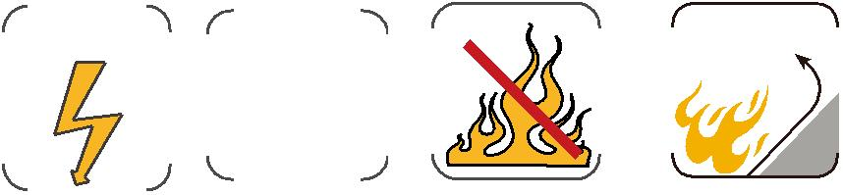

16 Caledonian

