
Caledonian

Flame Retardant Power & Control Cables

www.caledonian-cables.co.uk www.addison-cables.com

450/750V XLPE Insulated, PVC Sheathed, Screened Power Cables (2-4 Cores)

FGD200 07RCV-R (CU/XLPE/CUTO/PVC 450/750V Class 2)
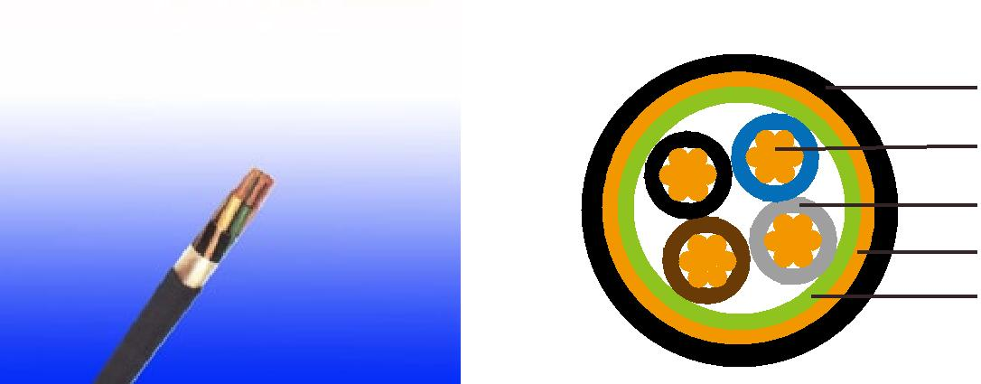

PVC Outer Sheath

Plain Annealed Copper

XLPE Insulation

Copper Tape

Filler

APPLICATION

The cables are mainly used in power stations, mass transit underground passenger systems, airports, petrochemical plants, hotels, hospitals, and high-rise buildings.

STANDARDS

Basic design adapted to IEC 60502-1

FIRE PERFORMANCE

Flame Retardance (Single Vertical EN 60332-1-2; IEC 60332-1-2; BS EN 60332-1-2; VDE _{Wire Test)**} 0482-332-1 ; NBN C 30-004 (cat. F1); NF C32-070-2.1(C2);
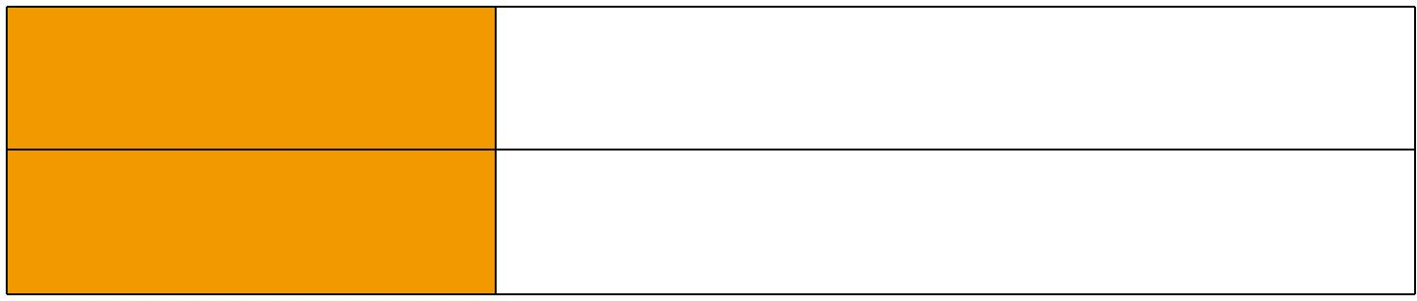
CEI 20-35/1-2; EN 50265-2-1*; DIN VDE 0482-265-2-1*

Reduced Fire Propagation | EN 60332-3-24 (cat. C); IEC 60332-3-24; BS EN 60332-3-24;
(Vertically-mounted bundled wires VDE 0482-332-3; NBN C 30-004 (cat. F2); NF C32-070-2.2(C1);
& cable test)** | CEI 20-22/3-4; EN 50266-2-4*; DIN VDE 0482-266-2-4

Note: Asterisk ** denotes that the standard compliance is optional, depending on the oxygen index of the PVC compound and the cable design.

VOLTAGE RATING

450/750V

CABLE CONSTRUCTION

Conductor: Plain annealed copper wire, stranded according to IEC(EN) 60228 class 2. Insulation: Extruded cross-linked XLPE compound.

Filler, binder (if any): PP, PET, PVC Overall Screen: Copper tape

Outer Sheath: Thermoplastic PVC compound. UV resistance, hydrocarbon resistance, oil resistance, anti rodent and anti termite properties can be offered as option. Compliance to fire performance standard (IEC 60332-1, IEC 60332-3, UL 1581, UL 1666 etc) depends on the oxygen index of the

 ADDISON 27

 ADDISON

PVC compound and the overall cable design. LSPVC can also be provided upon request.

COLOUR CODE

Insulation Colour as per BS7671
 | With Earth Conductor | Without Earth Conductor
2Cores | - | Brown, Blue
3Cores | Yellow/Green, Brown, Blue | Brown, Gray, Black
4Cores | Yellow/Green, Brown, Gray, Black | Brown, Gray, Black, Blue
5Cores | Yellow/Green, Brown, Gray, Black, Blue | Brown, Gray, Black, Blue, Black
Above 5 Cores | Yellow/Green, Black Numbered | Black Numbered

Sheath Colour: Black (other colors upon request)

Physical AND THERMAL PROPERTIES

Temperature range during operation: Max.90°C for XLPE

250°C in short-circuit for 5secs max.

Minimum bending radius: 8 x Overall Diameter

CONSTRUCTION PARAMETERS

 | Conductor |  |  |  | FGD200 07RCV-R
No. of | No./ | Nominal |  | Nominal |  |  | Max.DC
No. of | Nominal | Nominal | Nominal | Nominal | Nominal | Nominal | resistance
Core X | Nominal | Overall | Nominal | Copper | Nominal | Nominal | resistance | Approx.
Cross | Diameter | Diameter | Insulation | Tape | Sheath | Overall | of | Weight
Cross | of | Diameter | Thickness | Tape | Thickness | Diameter | conductor | Weight
Section | Strands | Conductor |  | Thickness |  |  | @20°C
Noxmm² | No./mm | mm | mm | mm | mm | mm | Ω/km | kg/km
2x1.0 | 7/0.44 | 1.32 | 0.7 | 0.1 | 1.2 | 10.7 | 18.1 | 172
2x1.5 | 7/0.53 | 1.59 | 0.7 | 0.1 | 1.3 | 11.3 | 12.1 | 197
2x2.5 | 7/0.67 | 2.01 | 0.7 | 0.1 | 1.3 | 12.2 | 7.41 | 239
2x4.0 | 7/0.85 | 2.55 | 0.7 | 0.1 | 1.3 | 13.4 | 4.61 | 300
3x1.0 | 7/0.44 | 1.32 | 0.7 | 0.1 | 1.3 | 11.2 | 18.1 | 194
3x1.5 | 7/O.53 | 1.59 | 0.7 | 0.1 | 1.3 | 11.8 | 12.1 | 224
3x2.5 | 7/0,67 | 2.01 | 0.7 | 0.1 | 1.3 | 12.8 | 7.41 | 276
3x4.0 | 7/0.85 | 2.55 | 0.7 | 0.1 | 1.3 | 14.1 | 4.61 | 353
4x1.0 | 7/0.44 | 1.32 | 0.7 | 0.1 | 1.3 | 12.0 | 18.1 | 224
4x1.5 | 7/0.53 | 1.59 | 0.7 | 0.1 | 1.4 | 12.7 | 12.1 | 261
4x2.5 | 7/0.67 | 2.01 | 0.7 | 0.1 | 1.3 | 13.9 | 7.41 | 326
4x4.0 | 7/0.85 | 2.55 | 0.7 | 0.1 | 1.3 | 15.3 | 4.61 | 422

Electrical PROPERTIES

Conductor Operating Temperature : 90°C

28 Caledonian

Caledonian

Flame Retardant Power & Control Cables

www.caledonian-cables.co.uk www.addison-cables.com

Ambient Temperature : 30°C

Current-Carrying Capacities (Amp)

 |  |  |  | Reference |  |  |  |  |  | Reference |  |  |  |  |  |  |  |  |  |  |  |  |  |  |  |  |  |  | Reference Method 12 (free
 |  |  |  | Method 4 |  |  |  |  |  |  |  |  |  |  |  |  |  |  |  |  |  |  |  | Reference
Conductor |  |  |  |  |  |  |  |  |  | Method 3 |  |  |  |  |  |  |  |  |  |  |  |  |  |  |  |  |  |  |  |  |  | air)
 |  |  |  | (enclosed |  |  |  |  |  |  |  |  |  |  |  |  |  |  |  |  |  |  |  | Method 11 (on a
cross- |  |  |  |  |  |  |  |  |  | (enclosed in |  |  |  |  |  |  | Reference Method
 |  |  |  | in conduit |  |  |  |  |  |  |  |  |  |  |  |  |  |  |  |  |  |  |  | perforated cable |  |  |  |  | Horizontal |  |  | Vertical
sectional |  |  |  | in thermally |  |  |  |  |  | conduit on |  |  |  |  |  |  | 1 (clipped direct) |  |  |  |  |  |  | tray, horizontal or |  |  |  |  | flat |  |  | flat | Trefoil
 |  | area |  | insulating wall |  |  |  |  |  | a wall or in |  |  |  |  |  |  |  |  |  |  |  |  |  | vertical) |  |  |  |  | spaced |  |  | spaced
 |  |  |  |  |  |  |  |  |  | trunking etc) |  |  |  |  |  |  |  |  |  |  |  |  |  |  |  |  |  |  |  |  |  | spaced
 |  |  |  | etc)
 |  |  |  |  |  |  |  |  |  |  |  |  |  |  |  |  |  |  |  |  |  |  |  |  |  |  |  |  | 2 cables, |  |  | 2
 |  |  |  |  |  |  |  |  |  |  |  |  |  |  |  |  |  |  |  |  |  |  |  |  |  |  |  |  |  |  |  | cables,
 |  |  |  | 2 |  |  |  |  | 2 |  |  |  |  |  |  |  | 2 cables, |  |  | 3 or 4 |  |  |  | 2 cables, |  |  |  | 3 or 4 | single- |  |  | single-
 |  |  |  |  |  |  |  |  |  |  |  |  |  |  |  |  | single- |  |  | cables, |  |  |  | single- |  |  |  | cables, | phase |  |  | single-
 |  |  |  | cables, |  |  |  | 3 or 4 | cables, |  |  |  | 3 or 4 |  |  |  |  |  |  |  |  |  |  |  |  |  |  |  |  |  |  | phase | 3 cables,
 |  |  |  |  |  |  |  | 3 or 4 |  |  |  |  |  |  |  |  | phase |  |  | 3-phase |  |  |  | phase |  |  |  | 3-phase | a.c. or |  |  | phase | 3 cables,
 |  |  |  | single- |  |  |  | cables, | single- |  |  |  | cables, |  |  |  |  |  |  |  |  |  |  |  |  |  |  |  |  |  |  | a.c. or | trefoil
 |  |  |  | phase |  |  |  | 3-phase | phase |  |  |  | 3-phase |  |  |  | a.c. or |  |  | a.c. flat |  |  |  | a.c. or |  |  |  | a.c. flat | d.c. |  |  | d.c. | 3-phase
 |  |  |  | a.c. or |  |  |  | a.c. | a.c. or |  |  |  | a.c. |  |  |  | d.c. flat |  |  | and |  |  |  | d.c. or |  |  |  | and | or 3 c |  |  | or 3 | a.c.
 |  |  |  | d.c. |  |  |  |  |  | d.c |  |  |  |  |  |  | and |  |  | touching |  |  |  | flat and |  |  |  | touching | ables |  |  | cables
 |  |  |  |  |  |  |  |  |  |  |  |  |  |  |  |  | touching |  |  | or trefoil |  |  |  | touching |  |  |  | or trefoil | three |  |  | cables
 |  |  |  |  |  |  |  |  |  |  |  |  |  |  |  |  |  |  |  |  |  |  |  |  |  |  |  |  |  |  |  | three
 |  |  |  |  |  |  |  |  |  |  |  |  |  |  |  |  |  |  |  |  |  |  |  |  |  |  |  |  | phase |  |  | three
 |  |  |  |  |  |  |  |  |  |  |  |  |  |  |  |  |  |  |  |  |  |  |  |  |  |  |  |  |  |  |  | phase
1 |  |  |  | 2 |  |  |  | 3 | 4 |  |  |  | 5 |  |  |  | 6 |  |  | 7 |  |  |  | 8 |  |  |  | 9 | 10 |  |  | 11 | 12
 |  | mm² |  | A |  |  |  | A |  | A |  |  |  |  |  | A | A |  |  | A |  |  |  | A |  |  |  | A | A |  |  | A | A
1.0 |  |  |  | 13 |  |  |  | - | - |  |  |  | - |  |  |  | 15 |  |  | - |  |  |  | - |  |  |  | - | - |  |  | - | -
1.5 |  |  |  | 18 |  |  |  | 17 | 22 |  |  |  | 19 |  |  |  | 25 |  |  | 23 |  |  |  | - |  |  |  | - | - |  |  | - | -
2.5 |  |  |  | 24 |  |  |  | 23 | 30 |  |  |  | 26 |  |  |  | 34 |  |  | 31 |  |  |  | - |  |  |  | - | - |  |  | - | -
4 |  |  |  | 33 |  |  |  | 30 | 40 |  |  |  | 35 |  |  |  | 46 |  |  | 41 |  |  |  | - |  |  |  | - | - |  |  | - | -
Voltage Drop (Per Amp Per Meter)
Nominal |  |  |  |  |  |  | 2 cables, single-phase a.c. |  |  |  |  |  |  |  |  |  |  |  |  |  |  |  |  | 3 or 4 cables, 3-phase a.c.
 |  |  |  |  |  |  | Ref. Methods 3 |  |  |  |  |  | Ref. Methods 1 |  |  |  |  |  |  |  | Ref. Methods 3 |  |  |  |  |  |  |  |  | Ref. Methods 1 and
Cross |  |  | 2 cables |  |  |  |  |  |  |  |  |  |  |  |  |  |  |  |  |  |  |  |  |  |  |  |  | Ref. Methods 1,
Section |  |  |  | d.c. |  |  | and 4 (enclosed |  |  |  |  |  | and 11 (clipped |  |  |  |  |  |  |  | and 4 (enclosed |  |  |  |  |  |  |  |  |  |  | 11
 |  | Area |  |  |  |  | in conduit etc, |  |  |  |  | direct or on trays |  |  |  |  |  |  |  |  | in conduit etc, |  |  |  |  |  |  | 11 and 12 (in |  |  | (Flat and touching)
 |  |  |  |  |  |  | in or on a wall) |  |  |  |  |  |  |  |  | touching) |  |  |  |  | in or on a wall) |  |  |  |  |  |  | trefoil)
1 |  |  |  | 2 |  |  | 3 |  |  |  |  |  |  |  |  |  | 4 |  |  |  | 5 |  |  |  |  |  |  | 6 |  |  |  | 7
 |  | mm² |  | mV/A/m |  |  | mV/A/m |  |  |  |  |  |  |  |  | mV/A/m |  |  |  |  | mV/A/m |  |  |  |  |  |  | mV/A/m |  |  |  | mV/A/m
1.0 |  |  |  | 46 |  |  | 46 |  |  |  |  |  |  |  |  |  | - |  |  |  | - |  |  |  |  |  |  | - |  |  |  | -
1.5 |  |  |  | 31 |  |  | 31 |  |  |  |  |  | 27 |  |  |  |  |  |  |  | 27 |  |  |  |  |  |  | 27 |  |  |  | 27
2.5 |  |  |  | 19 |  |  | 19 |  |  |  |  |  | 16 |  |  |  |  |  |  |  | 16 |  |  |  |  |  |  | 16 |  |  |  | 16
4 |  |  |  | 33 |  |  | 12 |  |  |  |  |  | 10 |  |  |  |  |  |  |  | 10 |  |  |  |  |  |  | 10 |  |  |  | 10
 |  | 450/750V |  |  |  |  | _{N}IEC60502-1
 |  |  |  |  |  |  |  |  |  |  |  |  |  |  |  | Flame Retardancy** |  |  |  | Reduced Fire Propagation**
Rated Voltage |  |  |  |  |  |  |  |  |  |  |  |  | NF C32-070-2.1(C2) |  |  |  |  |  |  | NF C32-070-2.2(C1)
 |  |  |  |  |  |  | Standard |  |  |  |  |  | IEC60332-1-2/EN50265-2-1 |  |  |  |  |  |  | IEC60332-3-24/EN50266-2-4


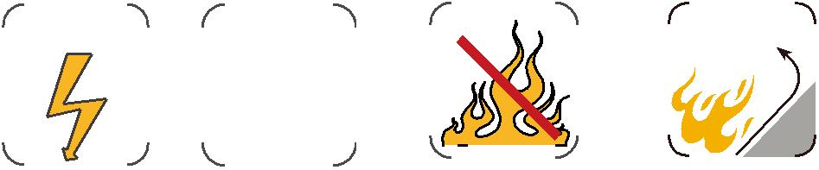

ADDISON 29

