
Caledonian

Flame Retardant Power & Control Cables

www.caledonian-cables.co.uk www.addison-cables.com

450/750V XLPE Insulated, PVC Sheathed Power Cables (2-4 Cores)

FGD200 07RV-R (CU/XLPE/PVC 450/750V Class 2)
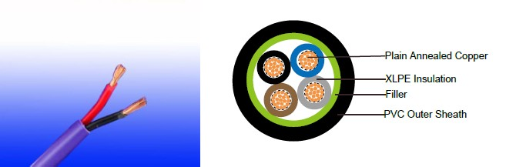

APPLICATION

The cables are mainly used in power stations, mass transit underground passenger systems, airports, petrochemical plants, hotels, hospitals, and high-rise buildings.

STANDARDS

Basic design adapted to IEC 60502-1

FIRE PERFORMANCE

Flame Retardance (Single Vertical EN 60332-1-2; IEC 60332-1-2; BS EN 60332-1-2; VDE _{Wire Test)**} 0482-332-1 ; NBN C 30-004 (cat. F1); NF C32-070-2.1(C2);
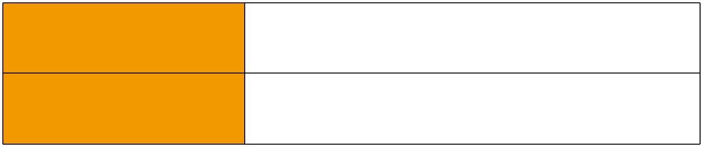
CEI 20-35/1-2; EN 50265-2-1*; DIN VDE 0482-265-2-1*

Reduced Fire Propagation | EN 60332-3-24 (cat. C); IEC 60332-3-24; BS EN 60332-3-24;
(Vertically-mounted bundled wires VDE 0482-332-3; NBN C 30-004 (cat. F2); NF C32-070-2.2(C1);
& cable test)** | CEI 20-22/3-4; EN 50266-2-4*; DIN VDE 0482-266-2-4

Note: Asterisk ** denotes that the standard compliance is optional, depending on the oxygen index of the PVC compound and the cable design.

VOLTAGE RATING

450/750V

CABLE CONSTRUCTION

Conductor: Plain annealed copper wire, stranded according to IEC(EN) 60228 class 2. Insulation: Extruded cross-linked XLPE compound.

Filler, binder (if any): PP, PET

Outer Sheath: Thermoplastic PVC compound. UV resistance, hydrocarbon resistance, oil resistance, anti rodent and anti termite properties can be offered as option. Compliance to fire performance standard (IEC 60332-1, IEC 60332-3, UL 1581, UL 1666 etc) depends on the oxygen index of the PVC compound and the overall cable design. LSPVC can also be provided upon request.

 ADDISON 21

 ADDISON

COLOUR CODE

Insulation Colour as per BS7671
 | With Earth Conductor | Without Earth Conductor
2Cores | - | Brown, Blue
3Cores | Yellow/Green, Brown, Blue | Brown, Gray, Black
4Cores | Yellow/Green, Brown, Gray, Black | Brown, Gray, Black, Blue
5Cores | Yellow/Green, Brown, Gray, Black, Blue | Brown, Gray, Black, Blue, Black
Above 5 Cores | Yellow/Green, Black Numbered | Black Numbered

Sheath Colour: Black (other colors upon request)

Physical AND THERMAL PROPERTIES

Temperature range during operation: Max.90°C for XLPE

250°C in short-circuit for 5secs max.

Minimum bending radius: 6 x Overall Diameter

CONSTRUCTION PARAMETERS

 | Conductor |  |  | FGD200 07RV-R
No. of | No./Nominal | Nominal | Nominal | Nominal | Nominal | Max.DC
Core X | Diameter of | Overall | Insulation | Sheath | Overall | resistance | Approx.
Cross | Diameter of | Diameter | Insulation | Sheath | Overall | of conductor | Weight
Section | Strands | Conductor | Thickness | Thickness | Diameter | @20°C
Noxmm² | No./mm | mm | mm | mm | mm | Ω/km | kg/km
2x1.0 | 7/0.44 | 1.32 | 0.7 | 1.2 | 8.5 | 18.1 | 101
2x1.5 | 7/0.53 | 1.59 | 0.7 | 1.2 | 9.1 | 12.1 | 120
2x2.5 | 7/0.67 | 2.01 | 0.7 | 1.2 | 10.0 | 7.41 | 154
2x4.0 | 7/0.85 | 2.55 | 0.7 | 1.3 | 11.1 | 4.61 | 205
3x1.0 | 7/0.44 | 1.32 | 0.7 | 1.2 | 9.0 | 18.1 | 118
3x1.5 | 7/0.53 | 1.59 | 0.7 | 1.2 | 9.6 | 12.1 | 142
3x2.5 | 7/0,67 | 2.01 | 0.7 | 1.2 | 10.6 | 7.41 | 185
3x4.0 | 7/0.85 | 2.55 | 0.7 | 1.3 | 11.8 | 4.61 | 251
4x1.0 | 7/0.44 | 1.32 | 0.7 | 1.2 | 9.8 | 18.1 | 141
4x1.5 | 7/0.53 | 1.59 | 0.7 | 1.2 | 10.5 | 12.1 | 171
4x2.5 | 7/0.67 | 2.01 | 0.7 | 1.3 | 11.6 | 7.41 | 226
4x4.0 | 7/0.85 | 2.55 | 0.7 | 1.3 | 13.0 | 4.61 | 309

Electrical PROPERTIES

Conductor Operating Temperature : 90°C

Ambient Temperature : 30°C

22 Caledonian

Caledonian

Flame Retardant Power & Control Cables

www.caledonian-cables.co.uk www.addison-cables.com

Current-Carrying Capacities (Amp)

 |  |  |  |  |  |  |  |  |  | Reference |  |  |  |  |  |  |  |  |  | Reference |  |  |  | Reference Method 12 (free
Conductor |  |  | Reference Method |  |  |  |  |  |  | Method 3 |  |  |  |  |  |  |  |  |  |  |  |  |  |  |  |  |  | air)
 |  |  |  |  |  |  |  |  |  |  |  |  |  |  |  |  |  |  |  | Method 11 (on a |  |  |  |  |  |  |  | air)
cross- |  |  |  | 4 (enclosed in |  |  |  |  |  | (enclosed in |  |  |  | Reference Method
sectional |  |  | conduit in thermally |  |  |  |  |  |  | conduit on |  |  |  | 1 (clipped direct) |  |  |  |  |  | perforated cable |  |  |  | Horizontal |  |  |  | Vertical
area |  |  | insulating wall etc) |  |  |  |  |  |  | a wall or in |  |  |  |  |  |  |  |  |  | tray, horizontal or |  |  |  |  | flat |  |  | flat | Trefoil
 |  |  |  |  |  |  |  |  |  |  |  |  |  |  |  |  |  |  |  | vertical) |  |  |  | spaced |  |  |  | spaced
 |  |  |  |  |  |  |  |  |  | trunking etc) |  |  |  |  |  |  |  |  |  |  |  |  |  |  |  |  |  | spaced
 |  |  |  |  |  |  |  |  |  |  |  |  |  |  |  |  |  |  |  |  |  |  |  | 2 cables, |  |  |  | 2 cables,
 |  |  | 2 |  |  |  |  |  |  | 2 |  |  |  | 2 cables, |  |  |  |  | 3 or 4 | 2 cables, |  |  | 3 or 4 | single- |  |  |  | single- | 3
 |  |  |  |  |  |  |  |  |  |  |  |  |  | single- |  |  |  |  | cables, | single- |  |  | cables, | phase |  |  |  | phase | 3
 |  |  | cables, |  |  |  |  | 3 or 4 |  | cables, |  |  | 3 or 4 |  |  |  |  |  |  |  |  |  |  |  |  |  |  |  | cables,
 |  |  |  |  |  |  |  |  |  |  |  |  | 3 or 4 | phase |  |  |  |  | 3-phase | phase |  |  | 3-phase | a.c. or |  |  |  | a.c. or
 |  |  | single- |  |  |  |  | cables, |  | single- |  |  | cables, | a.c. or |  |  |  |  | a.c. flat | a.c. or |  |  | a.c. flat |  | d.c. |  |  | d.c. | trefoil
 |  |  | phase |  |  |  |  | 3-phase |  | phase |  |  | 3-phase | d.c. flat |  |  |  |  | and | d.c. or |  |  | and | or 3 c |  |  |  | or 3 | 3-
 |  |  | a.c. or |  |  |  |  | a.c. |  | a.c. or |  |  | a.c. | and |  |  |  |  | touching | flat |  | and | touching | ables |  |  |  | cables | phase
 |  |  |  | d.c. |  |  |  |  |  | d.c |  |  |  | touching |  |  |  |  | or trefoil | touching |  |  | or trefoil | three |  |  |  | three | a.c.
 |  |  |  |  |  |  |  |  |  |  |  |  |  |  |  |  |  |  |  |  |  |  |  | phase |  |  |  | phase
1 |  |  | 2 |  |  |  |  | 3 |  | 4 |  |  | 5 |  |  | 6 |  |  | 7 | 8 |  |  | 9 |  | 10 |  |  | 11 | 12
mm² |  |  |  | A |  |  |  | A |  | A |  |  | A |  |  | A |  |  | A | A |  |  | A |  | A |  |  | A | A
1.0 |  |  | 13 |  |  |  |  | - |  | - |  |  | - | 15 |  |  |  |  | - | - |  |  | - |  | - |  |  | - | -
1.5 |  |  | 18 |  |  |  |  | 17 |  | 22 |  |  | 19 | 25 |  |  |  |  | 23 | - |  |  | - |  | - |  |  | - | -
2.5 |  |  | 24 |  |  |  |  | 23 |  | 30 |  |  | 26 | 34 |  |  |  |  | 31 | - |  |  | - |  | - |  |  | - | -
4 |  |  | 33 |  |  |  |  | 30 |  | 40 |  |  | 35 | 46 |  |  |  |  | 41 | - |  |  | - |  | - |  |  | - | -
Voltage Drop (Per Amp Per Meter)
Nominal |  |  |  |  |  |  | 2 cables, single-phase a.c. |  |  |  |  |  |  |  |  |  |  |  |  | 3 or 4 cables, 3-phase a.c.
 |  |  |  |  |  |  | Ref. Methods 3 |  |  |  |  | Ref. Methods 1 |  |  |  |  |  | Ref. Methods 3 |  |  |  |  |  |  |  |  | Ref. Methods 1 and
Cross |  |  | 2 cables |  |  |  |  |  |  |  |  |  |  |  |  |  |  |  |  |  |  | Ref. Methods 1,
 |  |  |  |  |  |  | and 4 (enclosed |  |  |  |  | and 11 (clipped |  |  |  |  |  | and 4 (enclosed |  |  |  |  |  |  |  |  |  | 11
Section |  |  |  | d.c. |  |  | in conduit etc, |  |  |  | direct or on trays |  |  |  |  |  |  | in conduit etc, |  |  |  | 11 and 12 (in
Area |  |  |  |  |  |  |  |  |  |  |  |  |  |  |  |  |  |  |  |  |  |  |  |  |  |  | (Flat and touching)
 |  |  |  |  |  |  | in or on a wall) |  |  |  |  |  | touching) |  |  |  |  | in or on a wall) |  |  |  |  | trefoil)
1 |  |  | 2 |  |  |  | 3 |  |  |  |  |  | 4 |  |  |  |  |  | 5 |  |  |  | 6 |  |  |  |  | 7
mm² |  |  | mV/A/m |  |  |  | mV/A/m |  |  |  |  |  | mV/A/m |  |  |  |  |  | mV/A/m |  |  |  | mV/A/m |  |  |  |  | mV/A/m
1.0 |  |  | 46 |  |  |  | 46 |  |  |  |  |  | - |  |  |  |  |  | - |  |  |  | - |  |  |  |  | -
1.5 |  |  | 31 |  |  |  | 31 |  |  |  |  |  | 27 |  |  |  |  |  | 27 |  |  |  | 27 |  |  |  |  | 27
2.5 |  |  | 19 |  |  |  | 19 |  |  |  |  |  | 16 |  |  |  |  |  | 16 |  |  |  | 16 |  |  |  |  | 16
4 |  |  | 33 |  |  |  | 12 |  |  |  |  |  | 10 |  |  |  |  |  | 10 |  |  |  | 10 |  |  |  |  | 10
 |  | 450/750V |  |  |  |  | IEC_{N}60502-1
 |  |  |  |  |  |  |  |  |  |  |  | Flame Retardancy** |  |  |  | Reduced Fire Propagation**
Rated Voltage |  |  |  |  |  |  | Standard |  |  |  |  | NF C32-070-2.1(C2) |  |  |  |  |  | NF C32-070-2.2(C1)
 |  |  |  |  |  |  |  |  |  | IEC60332-1-2/EN50265-2-1 |  |  |  |  |  | IEC60332-3-24/EN50266-2-4


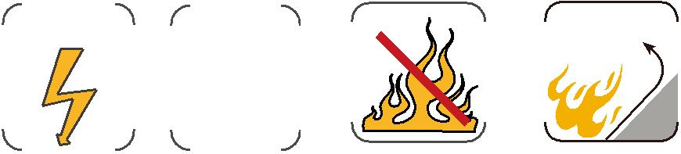

ADDISON 23

