
Caledonian

Flame Retardant Databus Cables
www.caledonian-cables.co.uk www.addison-cables.com

Flame Retardant RS485 Databus Cables

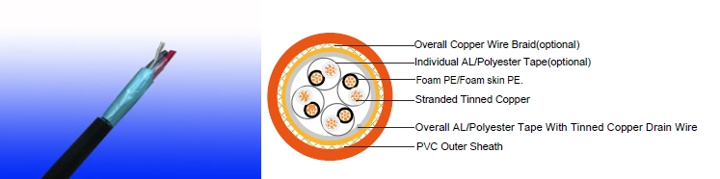

APPLICATION

The cables are designed for RS485 data connections where continued functionality is required during a fire situation. This cable combines low capacitance insulation with one of the highest levels of screening to provide high speed, interference free, data transmission where continued functionality is required during a fire situation.

STANDARDS

Basic design adapted to EIA/TIA 485

FIRE PERFORMANCE

Flame Retardance (Single Vertical EN 60332-1-2; IEC 60332-1-2; BS EN 60332-1-2; VDE _{Wire Test)**} 0482-332-1 ; NBN C 30-004 (cat. F1); NF C32-070-2.1(C2);

CEI 20-35/1-2; EN 50265-2-1*; DIN VDE 0482-265-2-1*

Reduced Fire Propagation | EN 60332-3-24 (cat. C); IEC 60332-3-24; BS EN 60332-3-24;
(Vertically-mounted bundled wires VDE 0482-332-3; NBN C 30-004 (cat. F2); NF C32-070-2.2(C1);
& cable test)** | CEI 20-22/3-4; EN 50266-2-4*; DIN VDE 0482-266-2-4

Note: Asterisk ** denotes that the standard compliance is optional, depending on the oxygen index of the PVC compound and the cable design.

CABLE CONSTRUCTION

Multipair RS 485 Overall Screened Databus Cable

Conductors: tinned copper wire, stranded according to IEC(EN) 60228 class 2. Insulation: Foam PE or foam skin PE.

Cabling Elements: Insulated cores are twisted to form pairs with varying lay length to minimize crosstalk. Two pair cable had four cores laid in quad formation.

Cabling: Pairs are cabled together in concentric layers.

Overall screen: Aluminum/polyester tape with tinned copper drain wire.

Outer Sheath: Thermoplastic PVC compound. UV resistance, hydrocarbon resistance, oil resistance, anti rodent and anti termite properties can be offered as option. Compliance to fire performance standard (IEC 60332-1, IEC 60332-3, UL 1581, UL 1666 etc) depends on the oxygen index of the PVC compound and the overall cable design. LSPVC can also be provided upon request.

 ADDISON 111

 ADDISON

Multipair RS 485 Overall Double Screened Databus Cable

Conductors: tinned copper wire, stranded according to IEC(EN) 60228 class 2. Insulation: Foam PE or foam skin PE.

Cabling Elements: Insulated cores are twisted to form pairs with varying lay length to minimize crosstalk. Two pair cable had four cores laid in quad formation.

Cabling: Pairs are cabled together in concentric layers. Overall screen: Aluminium/polyester tape+copper wire braid.

Outer Sheath: Thermoplastic PVC compound. UV resistance, hydrocarbon resistance, oil resistance, anti rodent and anti termite properties can be offered as option. Compliance to fire performance standard (IEC 60332-1, IEC 60332-3, UL 1581, UL 1666 etc) depends on the oxygen index of the PVC compound and the overall cable design. LSPVC can also be provided upon request.

Multipair RS 485 Individual & Overall screened Databus Cable Conductors: tinned copper wire, stranded according to IEC(EN) 60228 class 2. Insulation: Foam PE or foam skin PE.

Cabling Elements: Insulated cores are twisted to form pairs with varying lay length to minimize crosstalk. Two pair cable had four cores laid in quad formation.

Cabling: Pairs are cabled together in concentric layers. Individual Screen: Individual aluminium/polyester tape. Overall Screen: Copper wire braid.

Outer Sheath: Thermoplastic PVC compound. UV resistance, hydrocarbon resistance, oil resistance, anti rodent and anti termite properties can be offered as option. Compliance to fire performance standard (IEC 60332-1, IEC 60332-3, UL 1581, UL 1666 etc) depends on the oxygen index of the PVC compound and the overall cable design. LSPVC can also be provided upon request.

Multipair RS 485 Overall Screened Databus Cable

Conductors: tinned copper wire, stranded according to IEC(EN) 60228 class 2. Insulation: Foam PE or foam skin PE.

Cabling Elements: Insulated cores are twisted to form pairs with varying lay length to minimize crosstalk. Two pair cable had four cores laid in quad formation.

Cabling: Pairs are cabled together in concentric layers. Overall Screen: Copper wire braid.

Outer Sheath: Thermoplastic PVC compound. UV resistance, hydrocarbon resistance, oil resistance, anti rodent and anti termite properties can be offered as option. Compliance to fire performance standard (IEC 60332-1, IEC 60332-3, UL 1581, UL 1666 etc) depends on the oxygen index of the PVC compound and the overall cable design. LSPVC can also be provided upon request.

Physical AND THERMAL PROPERTIES

Temperature range during operation (fixed state):-20°C - +90°C

Temperature range during installation (mobile state): -5°C - +60°C Minimum bending radius: 8 x Overall Diameter

Electrical Properties

Dielectric test | 1000 | V r.m.s. for 5’ (core-core)
 | 1000 | V r.m.s. for 5’ (core-screen)
Impedance | 120Ω
Capacitance | 45 nF/km conductor to conductor

112 Caledonian

Caledonian

Flame Retardant Databus Cables
www.caledonian-cables.co.uk www.addison-cables.com

90 nF/km conductor to shield

CONSTRUCTION PARAMETERS

Multipair RS 485 Overall Screened Databus Cable

RE-02Y(St)Y / RE-02YS(St)Y

 | Nominal |  |  | No./Nominal |  |  | Nominal |  |  | Nominal |  |  | Nominal
No.of | Cross |  |  |  |  |  |  |  |  |  |  |  | Nominal | Approx.
No.of |  |  |  | Diameter of |  |  | Insulation |  |  | Sheath |  |  | Overall
pair x | Sectional |  |  |  |  |  |  |  |  |  |  |  | Overall | Weight
pair x |  |  |  | Strands |  |  | Thickness |  |  | Thickness |  |  | Diameter
 | Area |  |  |  |  |  |  |  |  |  |  |  | Diameter
 | mm² |  |  | No/mm |  |  | mm |  |  | mm |  |  | mm | kg/km
1 | 0.22 |  |  | 7/0.2 |  |  | 0.55 |  |  | 0.40 |  |  | 4.0 | 21
2 | 0.22 |  |  | 7/0.2 |  |  | 0.55 |  |  | 0.40 |  |  | 7.1 | 42
4 | 0.22 |  |  | 7/0.2 |  |  | 0.55 |  |  | 0.40 |  |  | 8.3 | 68
1 | 0.50 |  |  | 16/0.2 |  |  | 0.55 |  |  | 0.40 |  |  | 4.6 | 32
2 | 0.50 |  |  | 16/0.2 |  |  | 0.55 |  |  | 0.40 |  |  | 8.2 | 68
4 | 0.50 |  |  | 16/0.2 |  |  | 0.55 |  |  | 0.40 |  |  | 9.8 | 115
1 | 0.75 |  |  | 24/0.2 |  |  | 0.55 |  |  | 0.40 |  |  | 5.1 | 40
2 | 0.75 |  |  | 24/0.2 |  |  | 0.55 |  |  | 0.40 |  |  | 9.1 | 84
4 | 0.75 |  |  | 24/0.2 |  |  | 0.55 |  |  | 0.40 |  |  | 10.9 | 144
1 | 1.00 |  |  | 30/0.2 |  |  | 0.55 |  |  | 0.40 |  |  | 5.2 | 49
2 | 1.00 |  |  | 30/0.2 |  |  | 0.55 |  |  | 0.40 |  |  | 9.5 | 105
4 | 1.00 |  |  | 30/0.2 |  |  | 0.55 |  |  | 0.40 |  |  | 11.2 | 182
Multipair RS 485 Overall Double Screened Databus Cable
RE-02Y(St)CY / RE-02YS(St)CY
 |  | Nominal |  |  | No./Nominal |  |  | Nominal |  |  | Nominal |  | Nominal
No.of |  | Cross |  |  |  |  |  |  |  |  |  |  | Nominal |  | Approx.
No.of |  |  |  |  | Diameter of |  |  | Insulation |  |  | Sheath |  | Overall |  | Approx.
pair x |  | Sectional |  |  |  |  |  |  |  |  |  |  | Overall |  | Weight
pair x |  |  |  |  | Strands |  |  | Thickness |  |  | Thickness |  | Diameter |  | Weight
 |  | Area |  |  |  |  |  |  |  |  |  |  | Diameter
 |  | mm² |  |  | No/mm |  |  | mm |  |  | mm |  | mm |  | kg/km
1 |  | 0.22 |  |  | 7/0.2 |  |  | 0.55 |  |  | 0.40 |  | 4.5 |  | 34
2 |  | 0.22 |  |  | 7/0.2 |  |  | 0.55 |  |  | 0.40 |  | 7.5 |  | 67
4 |  | 0.22 |  |  | 7/0.2 |  |  | 0.55 |  |  | 0.40 |  | 8.8 |  | 97
1 |  | 0.50 |  |  | 16/0.2 |  |  | 0.55 |  |  | 0.40 |  | 5.1 |  | 48
2 |  | 0.50 |  |  | 16/0.2 |  |  | 0.55 |  |  | 0.40 |  | 8.7 |  | 97
4 |  | 0.50 |  |  | 16/0.2 |  |  | 0.55 |  |  | 0.40 |  | 10.3 |  | 150
1 |  | 0.75 |  |  | 24/0.2 |  |  | 0.55 |  |  | 0.40 |  | 5.6 |  | 57
2 |  | 0.75 |  |  | 24/0.2 |  |  | 0.55 |  |  | 0.40 |  | 9.7 |  | 116
4 |  | 0.75 |  |  | 24/0.2 |  |  | 0.55 |  |  | 0.40 |  | 11.4 |  | 182
1 |  | 1.00 |  |  | 30/0.2 |  |  | 0.55 |  |  | 0.40 |  | 5.7 |  | 67
2 |  | 1.00 |  |  | 30/0.2 |  |  | 0.55 |  |  | 0.40 |  | 10.0 |  | 138


ADDISON 113

ADDISON

4 |  | 1.00 | 30/0.2 |  |  |  | 0.55 |  |  | 0.40 | 11.8 |  | 222
Multipair RS 485 Individual & Overall screened Databus Cable
RE-02Y(St)Y pimf / RE-02YS(St)Y pimf
 |  | Nominal
 |  | Nominal | No./Nominal |  | Nominal |  |  |  |  | Nominal | Nominal
No.of pair |  | Cross |  |  |  |  |  |  |  | Nominal |  |  |  | Approx.
 |  | Cross | Diameter of |  | Insulation |  |  |  |  | Sheath | Overall |  |  | Approx.
x |  | Sectional |  |  |  |  |  |  |  | Sheath |  |  |  | Weight
 |  | Sectional | Strands |  | Thickness |  |  |  |  | Thickness | Diameter |  |  | Weight
 |  | Area |  |  |  |  |  |  |  | Thickness
 |  | mm² | No/mm |  | mm |  |  |  |  | mm | mm |  |  | kg/km
1 |  | 0.22 | 7/0.2 |  | 0.55 |  |  |  |  | 0.40 | 4.4 |  |  | 35
2 |  | 0.22 | 7/0.2 |  | 0.55 |  |  |  |  | 0.40 | 7.5 |  |  | 69
4 |  | 0.22 | 7/0.2 |  | 0.55 |  |  |  |  | 0.40 | 8.8 |  |  | 106
1 |  | 0.50 | 16/0.2 |  | 0.55 |  |  |  |  | 0.40 | 5.0 |  |  | 49
2 |  | 0.50 | 16/0.2 |  | 0.55 |  |  |  |  | 0.40 | 8.7 |  |  | 100
4 |  | 0.50 | 16/0.2 |  | 0.55 |  |  |  |  | 0.40 | 10.3 |  |  | 159
1 |  | 0.75 | 24/0.2 |  | 0.55 |  |  |  |  | 0.40 | 5.5 |  |  | 58
2 |  | 0.75 | 24/0.2 |  | 0.55 |  |  |  |  | 0.40 | 9.7 |  |  | 119
4 |  | 0.75 | 24/0.2 |  | 0.55 |  |  |  |  | 0.40 | 11.2 |  |  | 174
1 |  | 1.00 | 30/0.2 |  | 0.55 |  |  |  |  | 0.40 | 5.6 |  |  | 68
2 |  | 1.00 | 30/0.2 |  | 0.55 |  |  |  |  | 0.40 | 10.0 |  |  | 142
4 |  | 1.00 | 30/0.2 |  | 0.55 |  |  |  |  | 0.40 | 11.8 |  |  | 234
Multipair RS 485 Overall Screened Databus Cable
RE-02YCY / RE-02YSCY
 |  | Nominal |  | No./Nominal |  | Nominal |  |  |  | Nominal |  | Nominal
No.of pair |  | Cross |  | No./Nominal |  |  |  |  |  | Nominal |  | Nominal |  | Approx.
 |  | Cross |  | Diameter of |  | Insulation |  |  |  | Sheath |  | Overall |  | Approx.
x |  | Sectional |  | Diameter of |  |  |  |  |  | Sheath |  | Overall |  | Weight
 |  | Sectional |  | Strands |  | Thickness |  |  |  | Thickness |  | Diameter |  | Weight
 |  | Area |  | Strands |  |  |  |  |  | Thickness |  | Diameter
 |  | mm² |  | No/mm |  | mm |  |  |  | mm |  | mm |  | kg/km
1 |  | 0.22 |  | 7/0.2 |  | 0.55 |  |  |  | 0.40 |  | 4.3 |  | 31
2 |  | 0.22 |  | 7/0.2 |  | 0.55 |  |  |  | 0.40 |  | 7.3 |  | 61
4 |  | 0.22 |  | 7/0.2 |  | 0.55 |  |  |  | 0.40 |  | 8.5 |  | 91
1 |  | 0.50 |  | 16/0.2 |  | 0.55 |  |  |  | 0.40 |  | 4.9 |  | 44
2 |  | 0.50 |  | 16/0.2 |  | 0.55 |  |  |  | 0.40 |  | 8.5 |  | 91
4 |  | 0.50 |  | 16/0.2 |  | 0.55 |  |  |  | 0.40 |  | 10.0 |  | 142
1 |  | 0.75 |  | 24/0.2 |  | 0.55 |  |  |  | 0.40 |  | 5.4 |  | 53
2 |  | 0.75 |  | 24/0.2 |  | 0.55 |  |  |  | 0.40 |  | 9.5 |  | 109
4 |  | 0.75 |  | 24/0.2 |  | 0.55 |  |  |  | 0.40 |  | 11.2 |  | 174
1 |  | 1.00 |  | 30/0.2 |  | 0.55 |  |  |  | 0.40 |  | 5.5 |  | 63
2 |  | 1.00 |  | 30/0.2 |  | 0.55 |  |  |  | 0.40 |  | 9.8 |  | 131
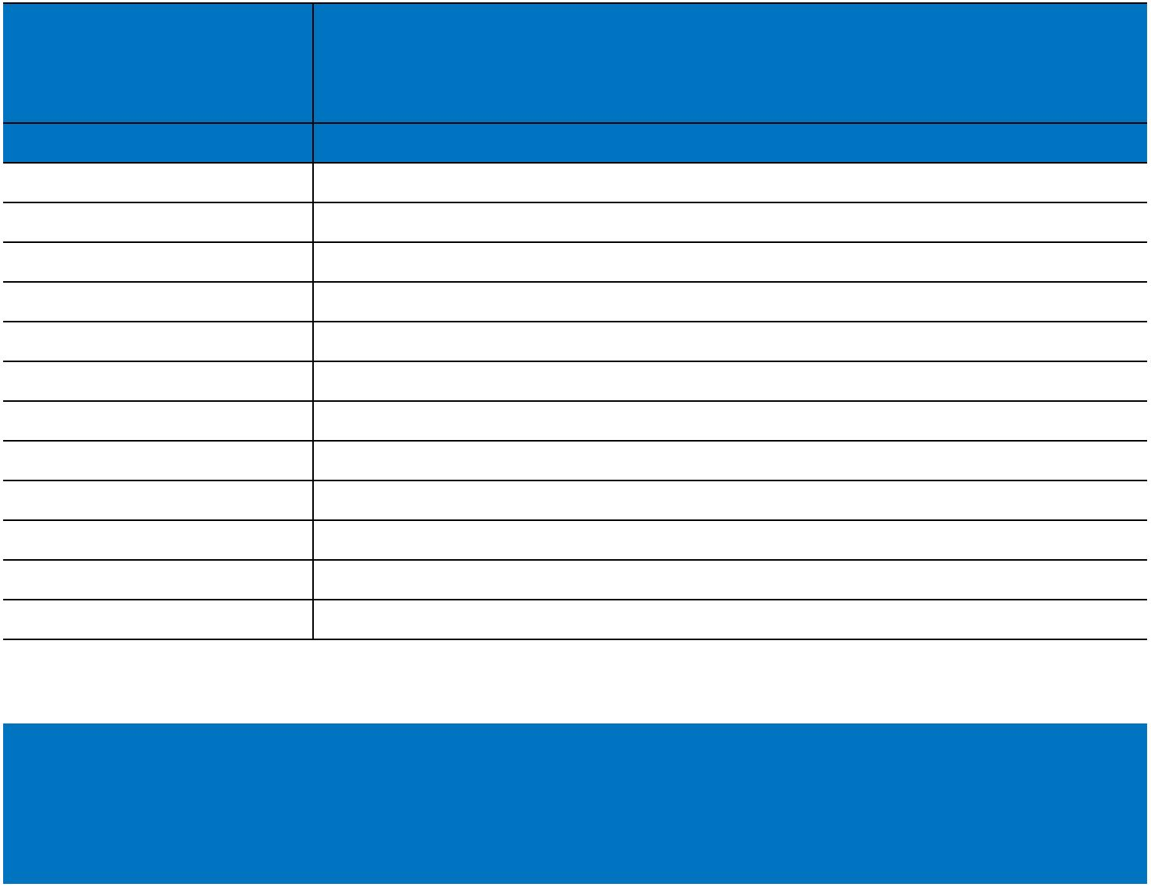

114 Caledonian

Caledonian

Flame Retardant Databus Cables
www.caledonian-cables.co.uk www.addison-cables.com

4 | 1.00 | 30/0.2 | 0.55 | 0.40 | 11.5 | 213

TYPE CODES

RE-A-B-D
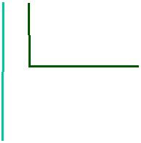

Outer Sheath

Y: PVC

Screen

St: Aluminum tape C: Copper braid
Insulation 02Y: Foam PE

02YS: Foam Skin PE
450/750V | _{N}EIA/TIA485 | Flame Retardancy** | Reduced Fire Propagation**
Rated Voltage | Standard | NF C32-070-2.1(C2) | NF C32-070-2.2(C1)
 |  | IEC60332-1-2/EN50265-2-1 | IEC60332-3-24/EN50266-2-4
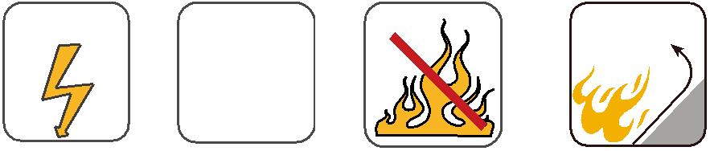

ADDISON 115

