 ADDISON

Flame Retardant RG59 B/U Coaxial cables

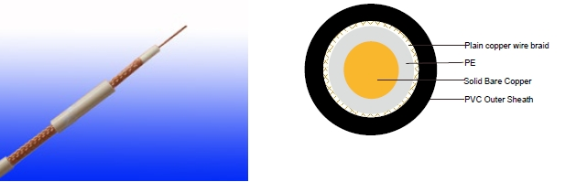

APPLICATION

The cables are designed for CCTV, security, smoke detection and evacuation monitoring applications, where continued functionality is required during a fire situationDue. to the zero halogen low smoke construction, this cable is ideal for use in public, commercial and industrial environments.

STANDARDS

Basic design adapted to MIL-C-17

FIRE PERFORMANCE

Flame Retardance (Single Vertical EN 60332-1-2; IEC 60332-1-2; BS EN 60332-1-2; VDE _{Wire Test)**} 0482-332-1 ; NBN C 30-004 (cat. F1); NF C32-070-2.1(C2);

CEI 20-35/1-2; EN 50265-2-1*; DIN VDE 0482-265-2-1*

Reduced Fire Propagation | EN 60332-3-24 (cat. C); IEC 60332-3-24; BS EN 60332-3-24;
(Vertically-mounted bundled wires VDE 0482-332-3; NBN C 30-004 (cat. F2); NF C32-070-2.2(C1);
& cable test)** | CEI 20-22/3-4; EN 50266-2-4*; DIN VDE 0482-266-2-4

Note: Asterisk ** denotes that the standard compliance is optional, depending on the oxygen index of the PVC compound and the cable design.

CABLE CONSTRUCTION

Conductors: Copper clad steel, solid according to IEC(EN) 60228 class 1.

Insulation: PE compound.

Overall Screen: Plain copper wire braid

Outer Sheath: Thermoplastic PVC compound. UV resistance, hydrocarbon resistance, oil resistance, anti rodent and anti termite properties can be offered as option. Compliance to fire performance standard (IEC 60332-1, IEC 60332-3, UL 1581, UL 1666 etc) depends on the oxygen index of the PVC compound and the overall cable design. LSPVC can also be provided upon request.

Physical AND THERMAL PROPERTIES

Temperature range during operation (fixed state):-30°C - +70°C

Temperature range during installation (mobile state): -5ºC - +60ºC

Minimum bending radius: 8 x Overall Diameter

116 Caledonian


Caledonian

Flame Retardant Coaxial Cables
www.caledonian-cables.co.uk www.addison-cables.com

Electrical Properties

Impedance | 75±5Ω
Capacitance | 67 nF/km
Velocity ratio(%) | 66
Insulation resistance | >2000 Mohm.Km
Shield coverage | 95%
DC resistance
Inner conductor | 158 Ω/km
Outer conductor | 9.0 Ω/km

Attenuation
Frequency(MHz) | Attenuation (dB/100 m) | Attenuation (dB/100ft)
50 | 7.4 | 2.26
100 | 10.7 | 3.26
200 | 15.7 | 4.79
400 | 22.7 | 6.92
500 | 25.7 | 7.84
600 | 28.7 | 8.75
860 | 34.8 | 10.61
1000 | 38.0 | 11.59

Return Loss
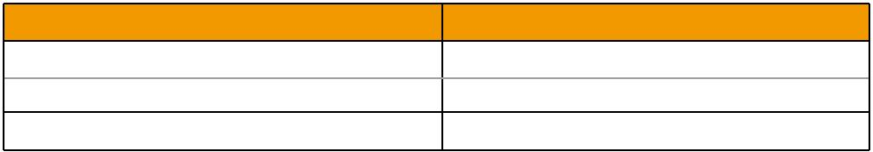
Frequency(MHz) | Return Loss (dB)
30-300 MHz | >31dB
300-600 MHz | >28dB
600-900 MHz | >24dB

CONSTRUCTION PARAMETERS
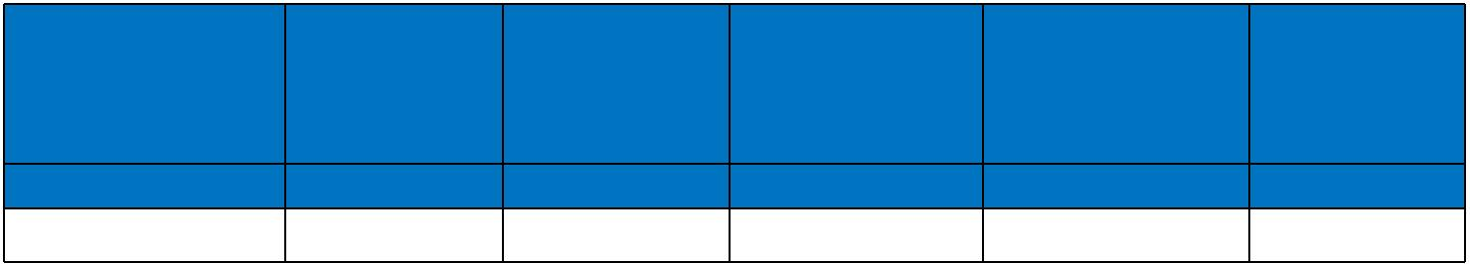
Cable | Conductor |  |  | Nominal |  | Nominal | Nominal | Approx.
Cable |  |  |  | Insulation |  | Screen | Overall | Approx.
Code | Diameter |  |  |  |  | Screen | Overall | Weight
Code |  |  |  | Diameter |  | No.x Diameter | Diameter | Weight
 | mm |  |  | mm |  | No. x mm | mm | kg/km
FGD-RG59 B/U | 0.58 ± 0.03 3.70 ± 0.10 m |  |  |  |  | 120 x 0.15 | 6.20 | 60.3
300/500V | _{N}MIL-C-17 |  | Flame Retardancy**Reduced Fire Propagation**
Rated Voltage |  |  | NF C32-070-2.1(C2) |  | NF C32-070-2.2(C1)
Rated Voltage | Standard | IEC60332-1-2/EN50265-2-1 |  |  | IEC60332-3-24/EN50266-2-4
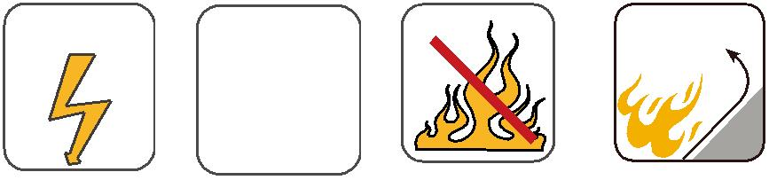

 ADDISON 117

