IEC Standard Caledonian Offshore & Marine Cables

MariTox Marine Flame Retardant Power & Control Cables

www.caledonian-cables.co.uk


MTX300 0.6/1 kV HEPR Insulated, LSOH (SHF1) Sheathed Flame Retardant Power & Control Cables (Single Core)

Application

These cables are used for fixed installations on ships and offshore units in all locations. These cables are flame retardant, low smoke & halogen free.


Standards

● DIN 89160/98
● IEC 60092-353
● IEC 60332-1
● IEC 60332-3-22
● IEC 60754-1/2
● IEC 61034
Stranded Copper Conductor HEPR Insulation
LSOH (SHF1) Sheath

Construction

- Conductors: Class 2 stranded copper conductor.
- Insulation: HEPR.
- Outer Sheath: LSOH (SHF1).

Core Identification

Single core: Natural colour (beige).

Mechanical and Thermal Properties

Bending Radius for Fixed Installations: 6×OD (OD>25mm); 4×OD (OD ≤25mm) Temperature Range: -20℃ ~ +75℃

www.addison-cables.com
ADDISON 21

IEC Standard Caledonian Offshore & Marine Cables

MariTox Marine Flame Retardant Power & Control Cables

www.caledonian-cables.co.uk


Dimensions and Weight

Part No. | Construction  No. of cores×Cross  section(mm²) | Nominal Insulation Thickness  mm | Nominal Sheath Thickness  mm | Nominal Overall Diameter  mm | Nominal Weight kg/km
MTX300-1G7Z1-R-1C4 | 1×4 | 0.7 | 1.2 | 6.5 | 80
MTX300-1G7Z1-R-1C6 | 1×6 | 0.7 | 1.2 | 7.5 | 110
MTX300-1G7Z1-R-1C10 | 1×10 | 0.7 | 1.2 | 8.5 | 150
MTX300-1G7Z1-R-1C16 | 1×16 | 0.7 | 1.2 | 9.5 | 220
MTX300-1G7Z1-R-1C25 | 1×25 | 0.9 | 1.2 | 11.0 | 320
MTX300-1G7Z1-R-1C35 | 1×35 | 0.9 | 1.2 | 12.0 | 420
MTX300-1G7Z1-R-1C50 | 1×50 | 1.0 | 1.3 | 13.5 | 560
MTX300-1G7Z1-R-1C70 | 1×70 | 1.1 | 1.3 | 15.5 | 780
MTX300-1G7Z1-R-1C95 | 1×95 | 1.1 | 1.4 | 17.8 | 1030
MTX300-1G7Z1-R-1C120 | 1×120 | 1.2 | 1.4 | 19.3 | 1290
MTX300-1G7Z1-R-1C150 | 1×150 | 1.4 | 1.5 | 21.3 | 1590
MTX300-1G7Z1-R-1C185 | 1×185 | 1.6 | 1.5 | 23.5 | 1960
MTX300-1G7Z1-R-1C240 | 1×240 | 1.7 | 1.6 | 26.5 | 2560
MTX300-1G7Z1-R-1C300 | 1×300 | 1.8 | 1.7 | 29.5 | 3200

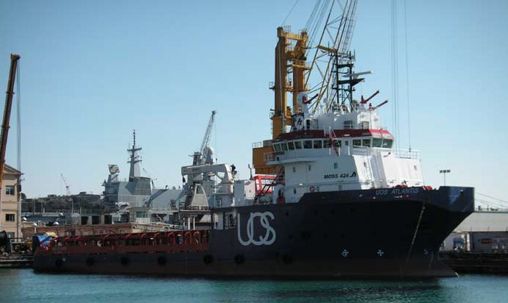

22 ADDISON www.addison-cables.com

